Supplemental Figures
Supplementary Fig. 1.
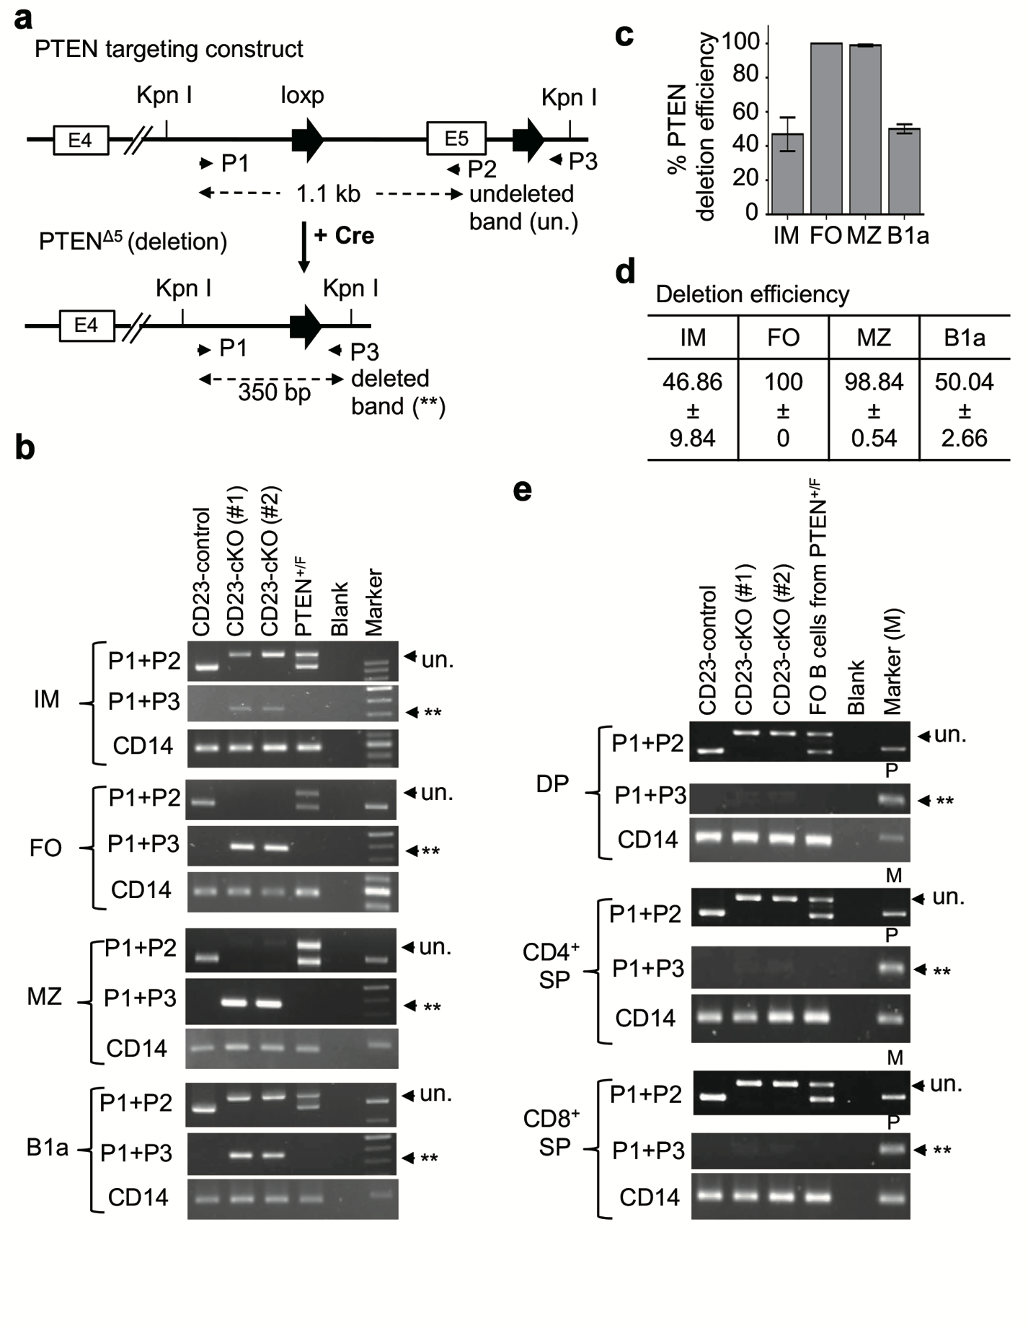
Supplementary Fig. 1. RT-PCR analysis to show the PTEN deletion in B cell subsets and thymocytes from CD23-cKO mice.
a Sketches of primer design for RT-PCR reaction to distinguish targeted PTEN sequence before deletion (1.1 kb) synthesized by primers P1 plus P2 (P1+P2) and the deleted PTEN form PTENΔ5 (350 bp) synthesized by P1+P3.
b RT-PCR results to show PTEN deletion efficiency in sorted IM, FO, MZ, and B1a B cells, respectively.
c The histogram to show the deletion efficiency of PTEN gene as described in (b).
d A table to show the deletion efficiency of PTEN gene as described in (b).
e RT-PCR results to show PTEN deletion efficiency in sorted DP, CD4⁺ SP, and CD8⁺ SP thymocytes, respectively.

Supplementary Fig. 2.
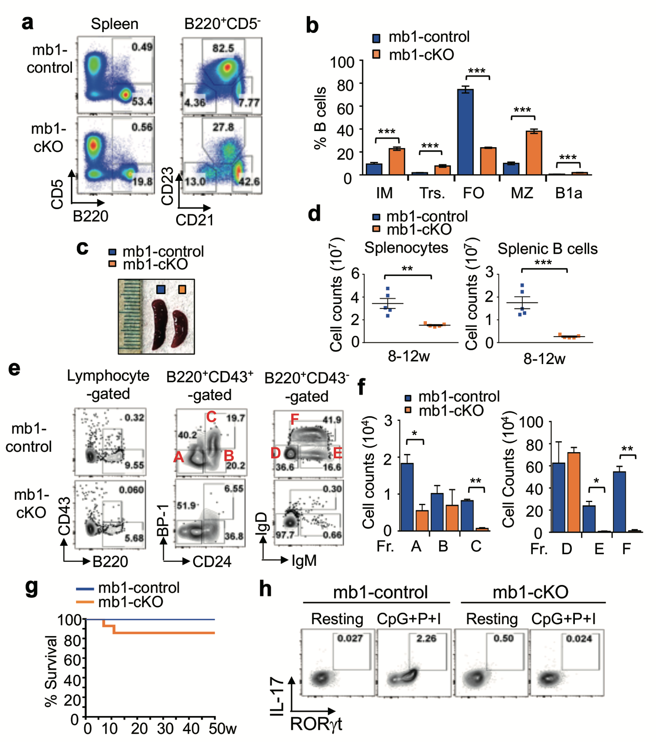
Supplementary Fig. 2. The phenotype of mb1-cKO mice.
a FACS profiles of B220 versus CD5 in gated lymphocytes (left), and CD21 versus CD23 in CD5⁺-gated B cells (right), from spleens of mb1-control and mb1-cKO mice at 8-12w. Data were from 3 independent experiments.
b Histograms to show the percentages of immature (IM), transitional (Trs.), follicular (FO), marginal zone (MZ), and B1a B cells in spleens from mice in (a). Unpaired two-tailed t-test; ***, p<0.001. Data represented the mean ± S.E.M.
c Representative images of spleens from mice in (a).
d Cell counts of total splenocytes (left) and splenic B cells (right) from mice in (a). Unpaired two-tailed t-test; **, p<0.005; ***, p<0.001. Data represented the mean ± S.E.M.
e FACS profiles of CD43 versus B220, BP-1 versus CD24, and IgD versus IgM (from left to right) to show the frequencies of B cell subsets including Hardy fractions A to F in the bone marrow of mb1-control and mb1-cKO mice at 8-12w.
f Histograms to show the cell counts of fractions A to C (left), and D to F (right) from mice in (e). Unpaired two-tailed t-test; *, p<0.05; **, p<0.005. Data represented the mean ± S.E.M.
g Kaplan-Meier curves of mb1-cKO (n=14) and mb1-control (n=10) mice.
h FACS profile of IL-17 versus RORγt by CD4⁺ T cells of mb1-control and mb1-cKO mice at 50w. CD4⁺ T cells were either left unstimulated (resting) or stimulated for 5h with CpG+P+I. Data were from 2 independent experiments.

Supplementary Fig. 3.
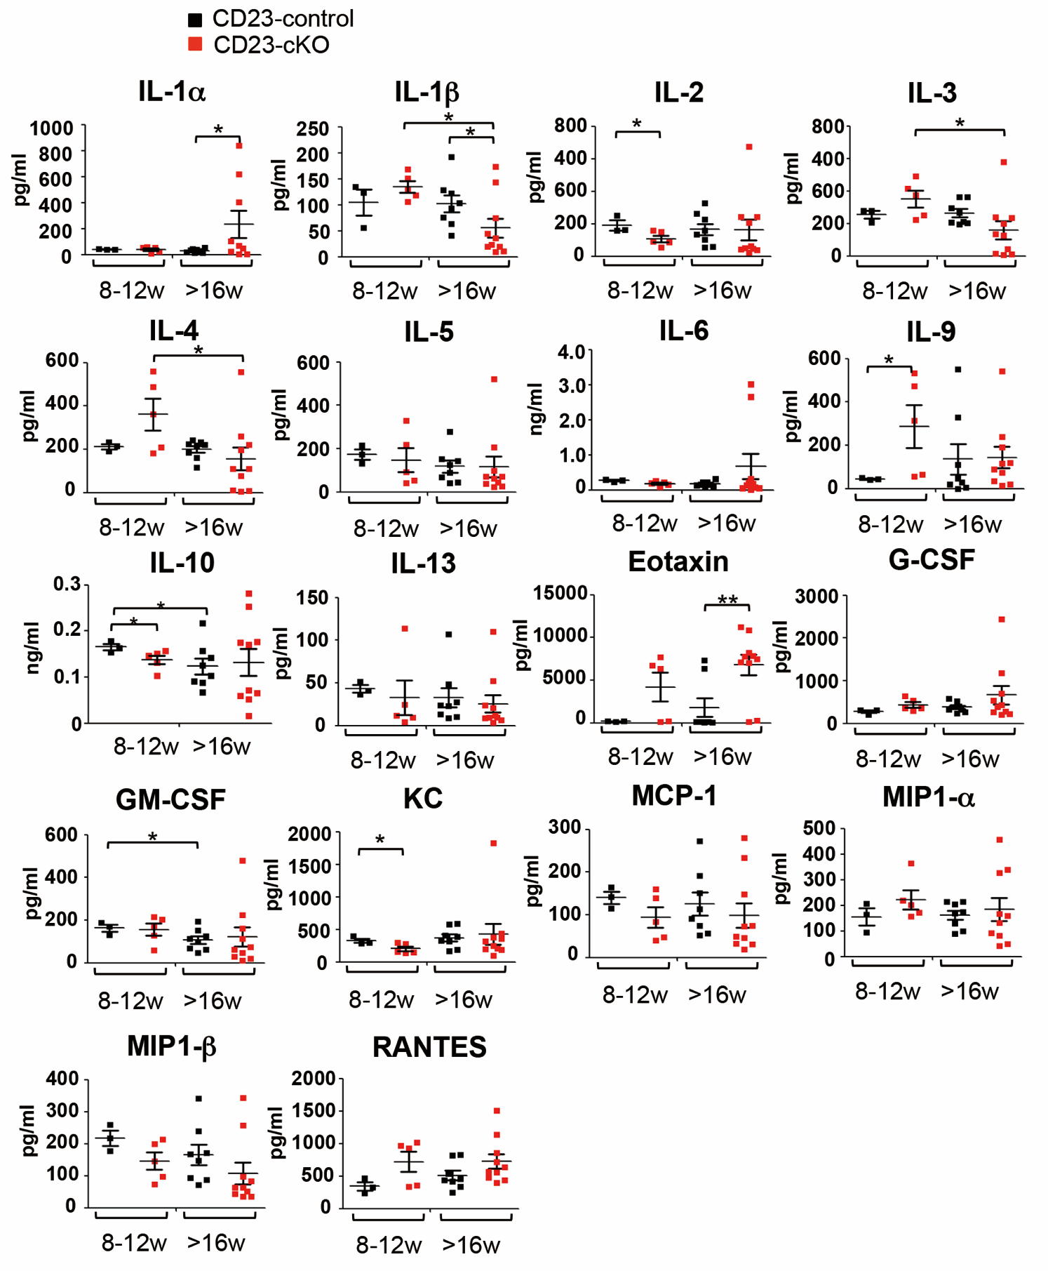
Supplementary Fig. 3. The serum cytokine profiles in CD23-cKO mice.
The levels of serum IL-1α, IL-1β, IL-2, IL-3, IL-4, IL-5, IL-6, IL-9, IL-10, IL-13, eotaxin, G-CSF, GM-CSF, KC, MCP-1/CCL2, MIP-1α/CCL3, MIP1-β/CCL4, RANTES/CCL5 by Bio-Rad Bio-PlexProTM mouse cytokine 23-plex assay in mice of 8-12w or older than (>) 16w. Unpaired two-tailed t-test; *, p<0.05; **, p<0.005. Data represented the mean ± S.E.M.

Supplementary Fig. 4.
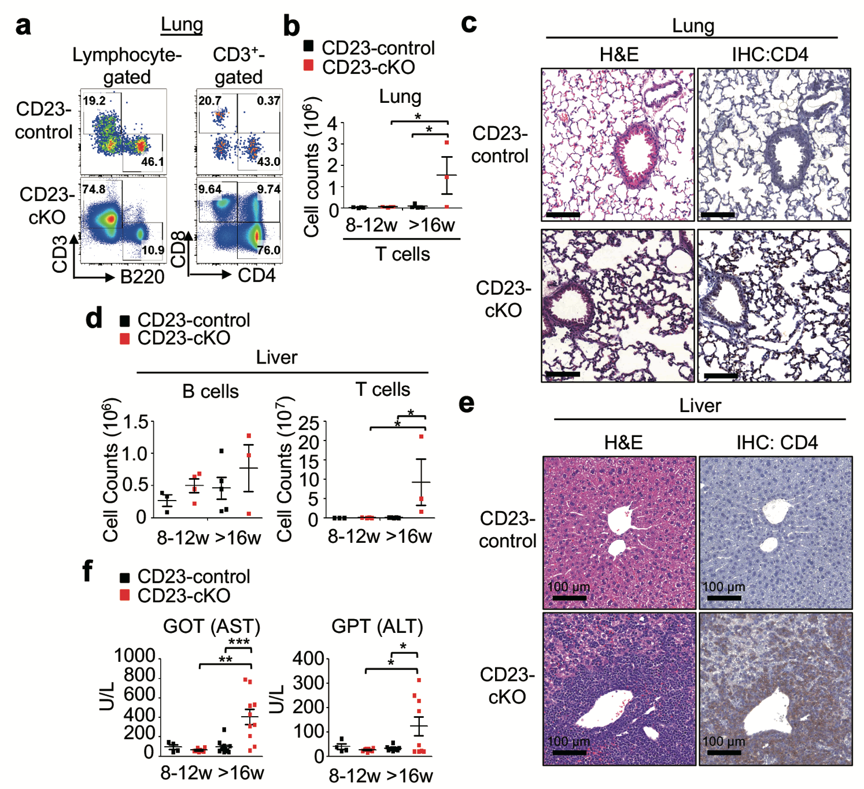
Supplementary Fig. 4. A severe immune cell-infiltration in lungs and livers of CD23-cKO mice.
a FACS profiles of B220 versus CD3 (left) or CD4 versus CD8 (right) in CD3⁺-gated T cells in the lung.
b Cell count of CD3⁺ T cells in lungs from mice in (a). Unpaired two-tailed t-test; *, p<0.05. Data represented the mean ± S.E.M.
c IHC images of H&E staining (left) and anti-CD4 (right) in lung sections of indicated mice. Scale bars: 100 µm.
d Cell counts of B220⁺ B cells, CD3⁺ T cells in livers from mice of 8-12w or mice older than 16w (>16w). Unpaired two-tailed t-test; *, p<0.05. Data represented the mean ± S.E.M.
e IHC images of H&E staining (left) and anti-CD4 (right) in liver sections from indicated mice. Scale bars: 100 µm.
f The levels of serum GOT/AST (left) and GPT/ALT (right) from mice of 8-12w or mice older than 16w (>16w). Unpaired two-tailed t-test; *, p<0.05; **, p<0.005; ***, p<0.001. Data represented the mean ± S.E.M.

Supplementary Fig. 5.
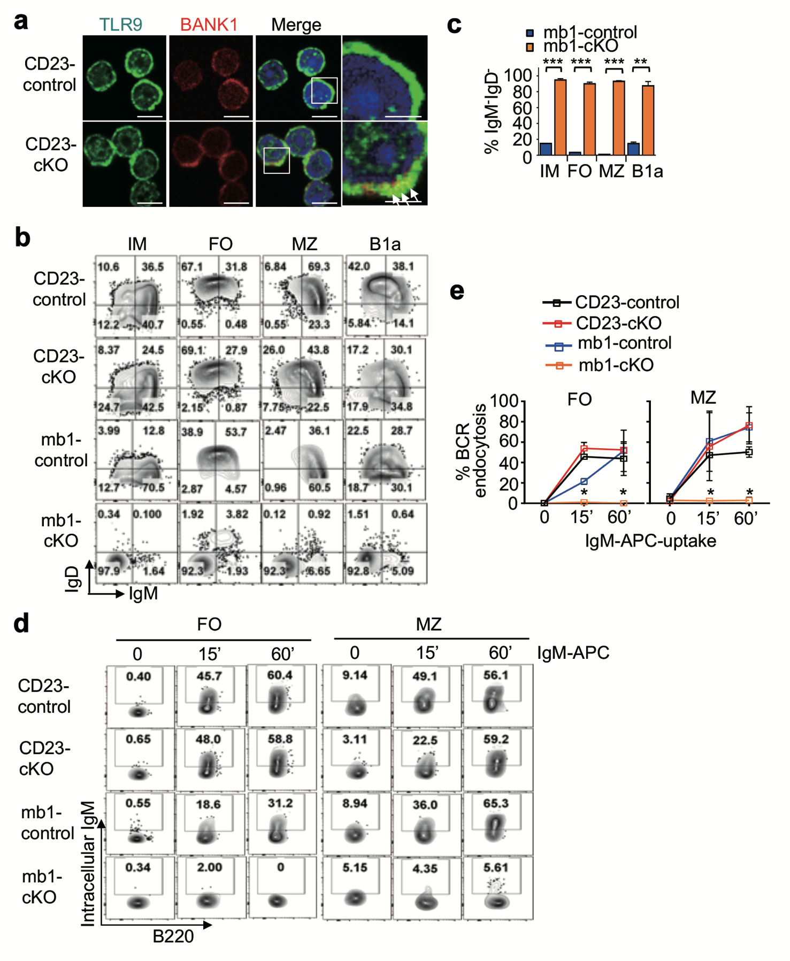
Supplementary Fig. 5. BCR endocytosis is defect in mb1-cKO B cells.
a Immunofluorescence images of TLR9 and BANK1 dual staining in the indicated B cells. The white arrows indicated the colocalization between TLR9 and BANK1 (yellow). Scale bars, 5 μm and 2 μm (far right).
b FACS profiles of IgM versus IgD in IM, FO, MZ, and B1a B cells of indicated mice. Data were from 3 independent experiments.
c Histograms to show the frequencies of IgM⁻IgD⁻ B cells in each B cell subset as described in (b). Unpaired two-tailed t-test; ***, p<0.001. Data represented the mean ± S.E.M.
d FACS profiles of BCR-engulfed APC fluorescence versus B220 to show the dynamic of BCR-directed endocytosis in FO (left) and MZ (right) B cells in the resting state (0), or upon engagement by anti-IgM-APC for 15 min and 60 min, from the indicated mice. Data were from 2 independent experiments.
e Curves to show the dynamic of BCR-directed endocytosis from (d). Unpaired two-tailed t-test; *, p<0.05. Data represented the mean ± S.E.M.

Supplementary Fig. 6.
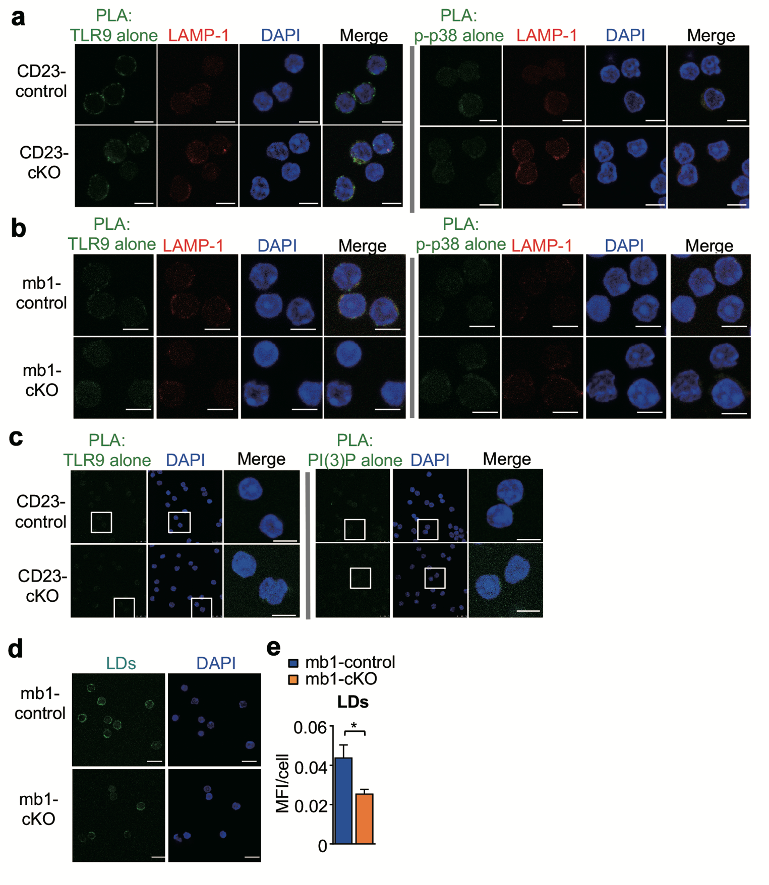
Supplementary Fig. 6. PTEN deficiency in mature B cells leads to PI(3)P accumulation that accelerates the lysosomal translocation of TLR9.
a, b Immunofluorescence images to show the negative controls of PLA by TLR9 and LAMP-1 dual staining (left) or p-p38 and LAMP-1 dual staining in the indicated B cells (right).
c Immunofluorescence images to show the negative controls of PLA with TLR9 staining (left) or PI(3)P staining (right). From (a) to (c), all scale bars are 5 μm.
d Immunofluorescence images to show LDs staining. Bars are 5 μm.
e A histogram to show the quantification of LDs showed in (d). *, p<0.05. Data represented the mean ± S.E.M.

Supplementary Fig. 7.
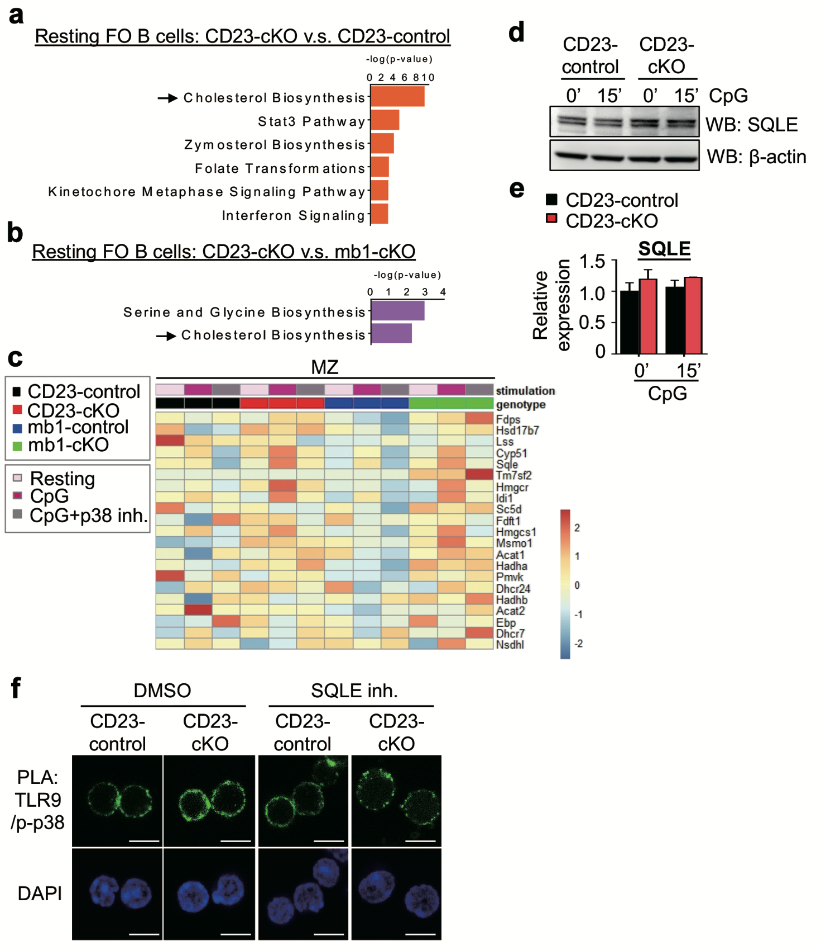

Supplementary Fig. 7. ScRNA-seq. analysis predicts the upregulation of cholesterol biosynthesis pathway in the TLR9/IL-6 loop in PTEN-deficient mature B cells.
a The statistic histogram of p-value from IPA analysis to show top 6 upregulated pathways in CD23-cKO FO B cells compared to CD23-control.
b The statistic histogram of p-value from IPA analysis to show upregulated pathways in CD23-cKO FO B cells compared to mb1-cKO FO B cells.
c Heatmap of scRNA-seq. analysis to show the genes involved in the cholesterol biosynthesis in MZ B cells that were left unstimulated or stimulated for 2 h with CpG alone or CpG plus SB203580.
d SQLE- and β-actin-immunoblots to show the protein expression of SQLE and β-actin in splenic B cells, which were left unstimulated (0) or stimulated with CpG for 15 min.
e Histograms to show the quantification of SQLE expression relative to β-actin from images in (d).
f Immunofluorescence images to show PLA signals between TLR9 and p-p38 in splenic B cells, which were untreated (DMSO), or treated with SQLE inhibitor for 2 h.

Supplementary Fig. 8.
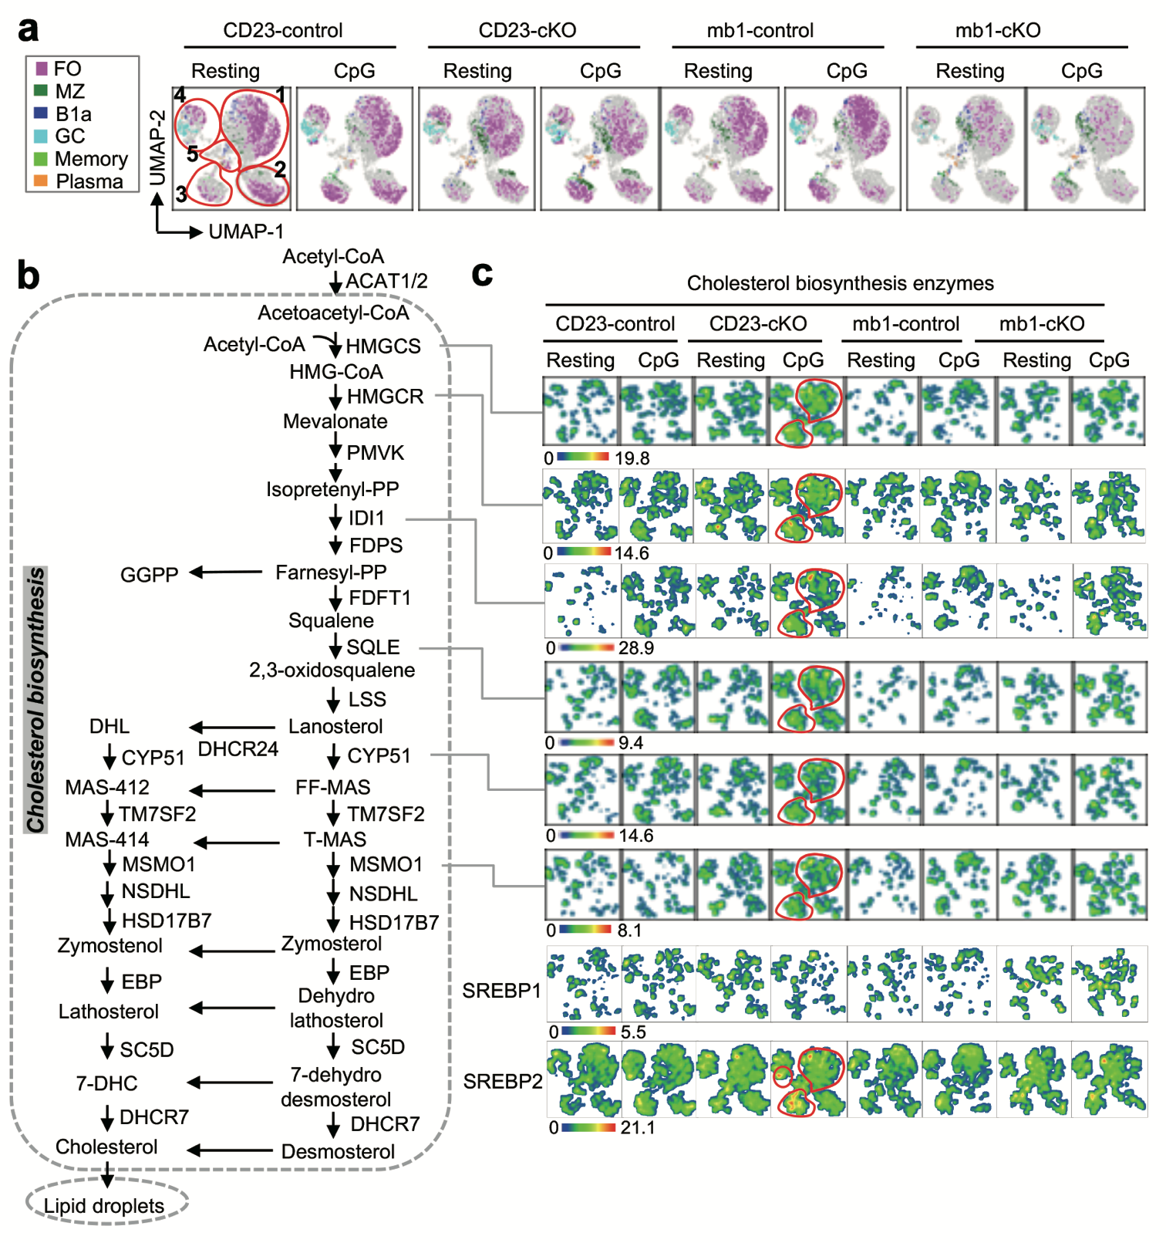
Supplementary Fig. 8. ScRNA-seq. analysis reveals that the upregulation of cholesterol biosynthesis-associated genes encompasses CpG-stimulated CD23-cKO B cells mostly in clusters 1 and 3.
a UMAPs from scRNA-seq. data to cluster FO (pink), MZ (dark green), B1a (prussian blue), GC (light blue), memory-like B cells (fluorescent green) and plasma cells (orange) distributed in 5 groups (gate with red circle) in mice as indicated. Samples were left unstimulated (resting) or stimulated with CpG for 2h as described in (b).
b A diagram to show cholesterol biosynthesis pathway taking place in the ER.
c Heatmap statistic type of UMAP generated from scRNA-seq. to show the genes encoding HMGCS, HMGCR, IDl1, SQLE, CYP51, MSMO1, SREBP1 and SREBP2 (from top to bottom), respectively. The color map statistic value of gene expression was median.

