SUPPLEMENTARY INFORMATION.
Supplementary Table 1 Patient characteristics (n = 165).
Characteristics | Patients (n)=165)
Age, median (range) | 59 (31-65)
Group, n (%)
Grupo A - Melphalan 200 mg/m² | 80 (49)
Grupo B - Busulfan/Melphalan | 85 (51)
Sex, n(%)
Male | 87 (52)
Female | 78 (48)
M-protein type, n (%)
IgG | 105 (64)
IgA | 37 (22)
Light chain | 21 (13)
IgD | 0 (0)
Non-secretory | 2 (1)
ISS stage, n (%)
I | 52 (31)
II | 67 (41)
III | 43 (26)
Missing | 3 (2)
ISS-R stage, n (%)
I | 74 (45)
II | 65 (39)
III | 12 (7)
Missing | 14 (9)
ECOG performance status, n (%)
0 | 67 (41)
1 | 66 (40)
2 | 21 (12)
3 | 8 (5)
Missing | 3 (2)
Hemoglobin (g/dL), median (range) | 10.7 (6.7-15.5)
Creatinine (mg/dL), median (range) | 0.9 (0.4-2)
B2-microglobulin (mg/L), median (range) | 3.9 (1.5-17.4)
Elevated lactate dehydrogenase, n (%)
Yes | 19 (12)
No | 141 (85)
Missing | 5 (3)
Plasmacytoma, n(%)
Yes | 33 (20)
No | 132 (80)
Cytogenetics, n (%)
t(11;14) | 23 (17)
11q13 gain | 38 (51)
t(4;14) | 17 (13)
t(14;16) | 4 (3)
del(17p) | 18 (12)
del(1p) | 21 (14)
1q gain | 77 (49)
Follow-up (months): median (range) | 69 (9.4-88.5)
ECOG, Eastern Cooperative Oncology Group; ISS, International Staging System; ISS-R, Revised International Staging System.
Supplementary Figure 1. A) Distribution of cyclin D2 protein expression in the groups generated after dichotomizing the samples. Patients with cyclin D2 expression ≤ 0.058 and > 0.058 were classified as “Low” and “High”, respectively (***, p < 0.001). B) Percentage of patients with chromosomal abnormalities by cyclin D2 protein-expression groups. None of the contrasts between low and high levels of Cyclin D2 within the cytogenetic groups were statistically significant (p > 0.05), as demonstrated by the Mann-Whitney U test or Fisher's exact test, as appropriate.
A
B
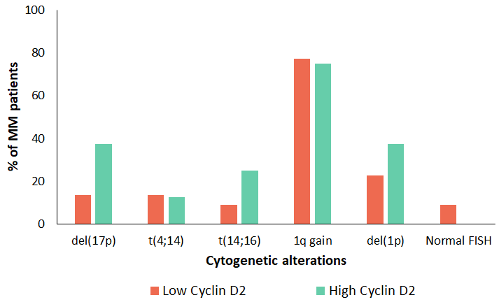
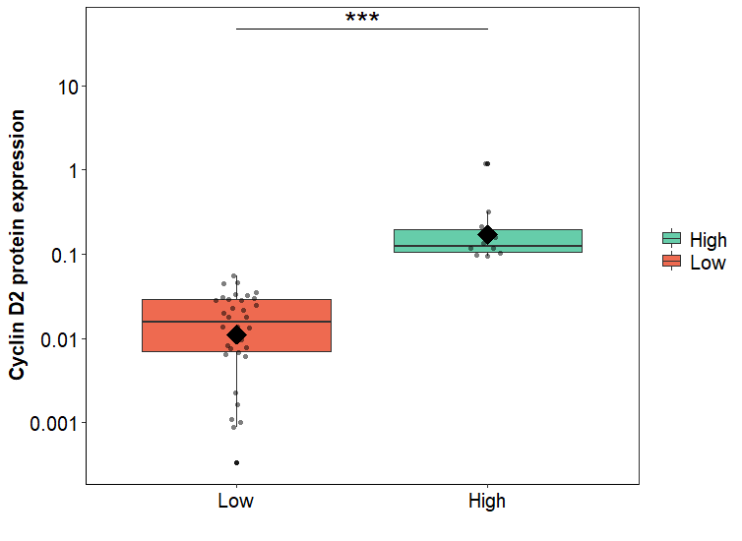

Supplementary Table 2. Distribution of cytogenetic abnormalities by cyclin D-expression groups.
Cytogenetic alteration | Cyclin D1* | Cyclin D2* | Coexpression* | No expression* | Total**
t(11;14) | 23 (100) | 0 (0) | 0 (0) | 0 (0) | 23
11q13 gain | 21 (55) | 3 (8) | 3 (8) | 11 (29) | 38
t(4;14) | 2 (12) | 4 (24) | 2 (12) | 9 (53) | 17
t(14;16) | 0 (0) | 4 (100) | 0 (0) | 0 (0) | 4
del(17p) | 3 (17) | 6 (33) | 1 (6) | 8 (44) | 18
del(1p) | 4 (19) | 8 (38) | 3 (14) | 6 (29) | 21
1q gain | 16 (21) | 24 (31) | 10 (13) | 27 (35) | 77
*n (%); **n

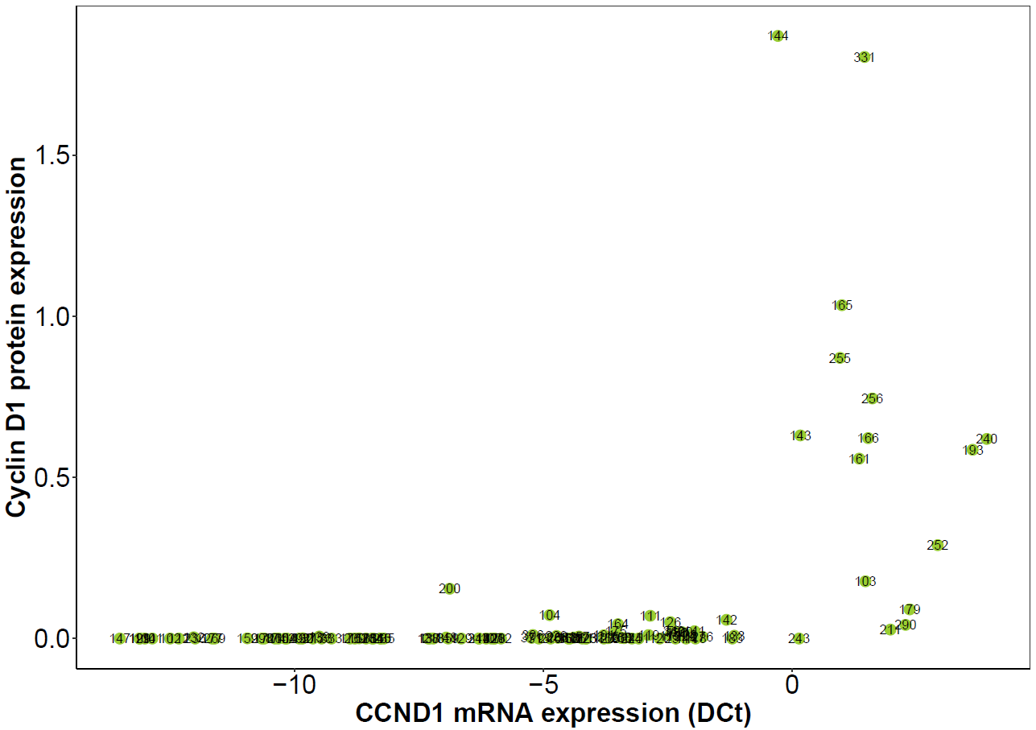
Supplementary Figure 2. Spearman’s correlation between protein and mRNA. A and B) Scatter plot showing protein and mRNA expression for cyclin D1/CCND1 and cyclin D2/CCND2, respectively.
A
Spearman’s rho = 0.7
p < 0.001

B
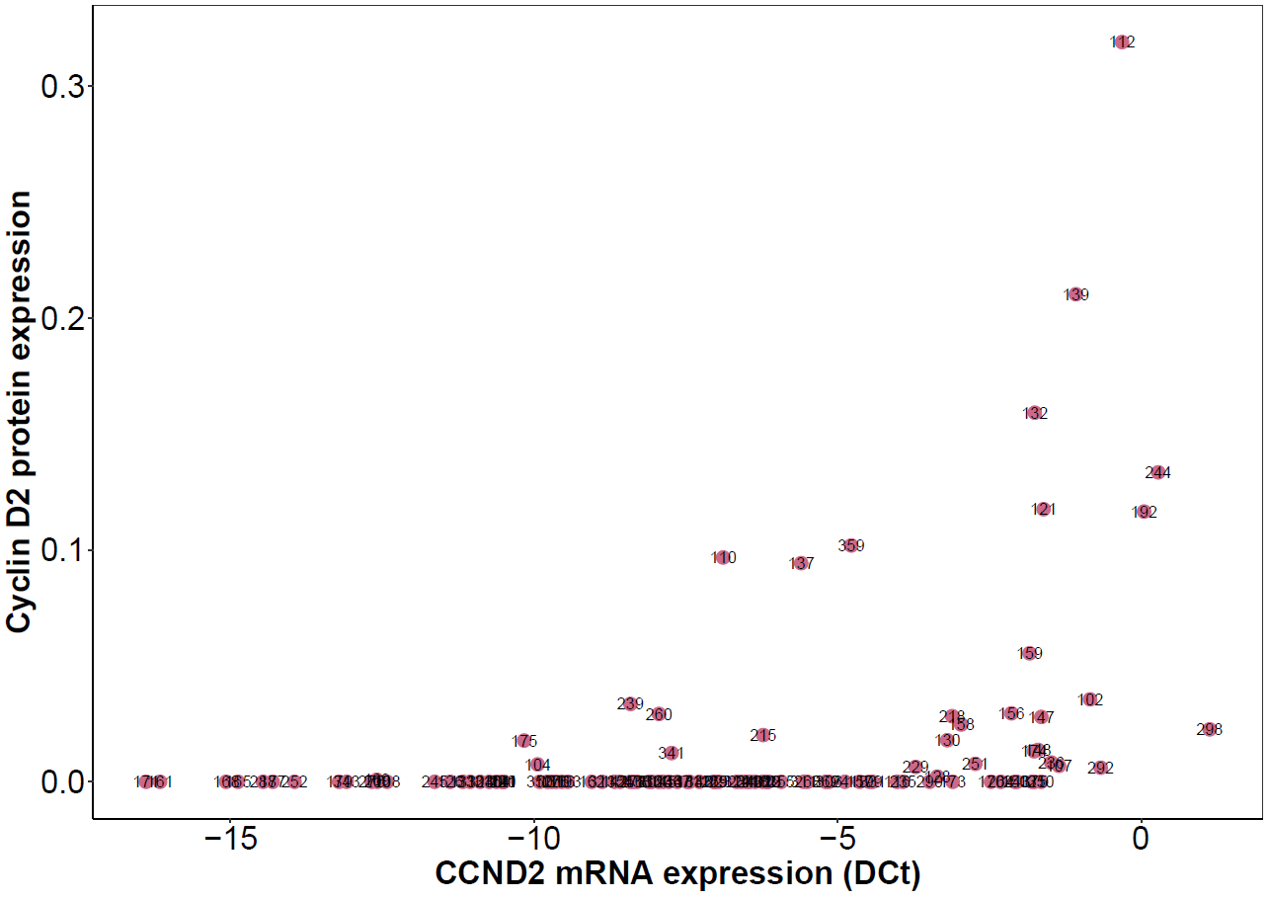
Spearman’s rho = 0.53
p < 0.001

Supplementary Figure 3. Survival analysis of CCND1 and CCND2 mRNAs. A and B) Kaplan-Meier curves of OS and TTP, respectively, according to CCND1 mRNA expression. Log-rank (Mantel-Cox) test p values are shown.
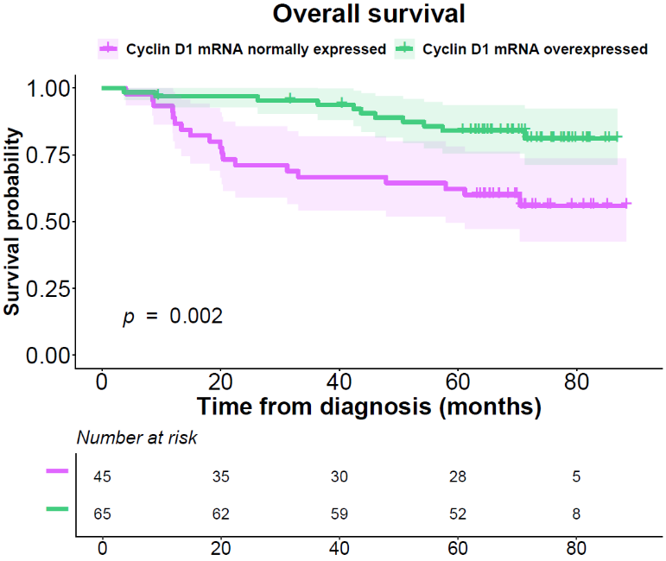
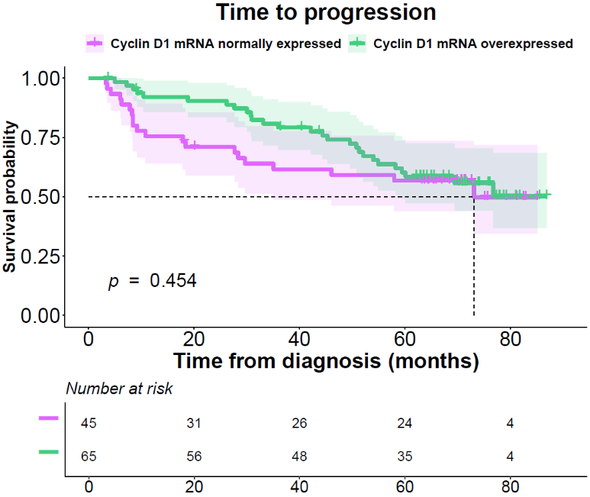
B
A

