Appendix
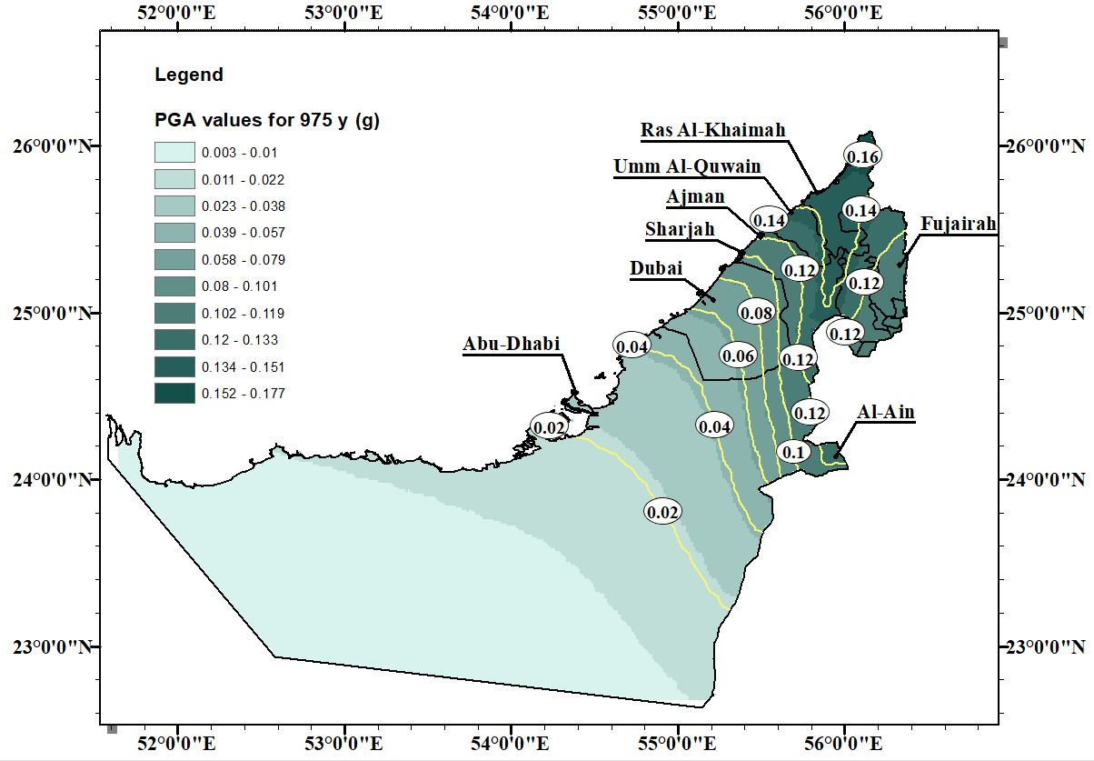
Fig. 6 (a) PGA values in g for a return period of 975 y

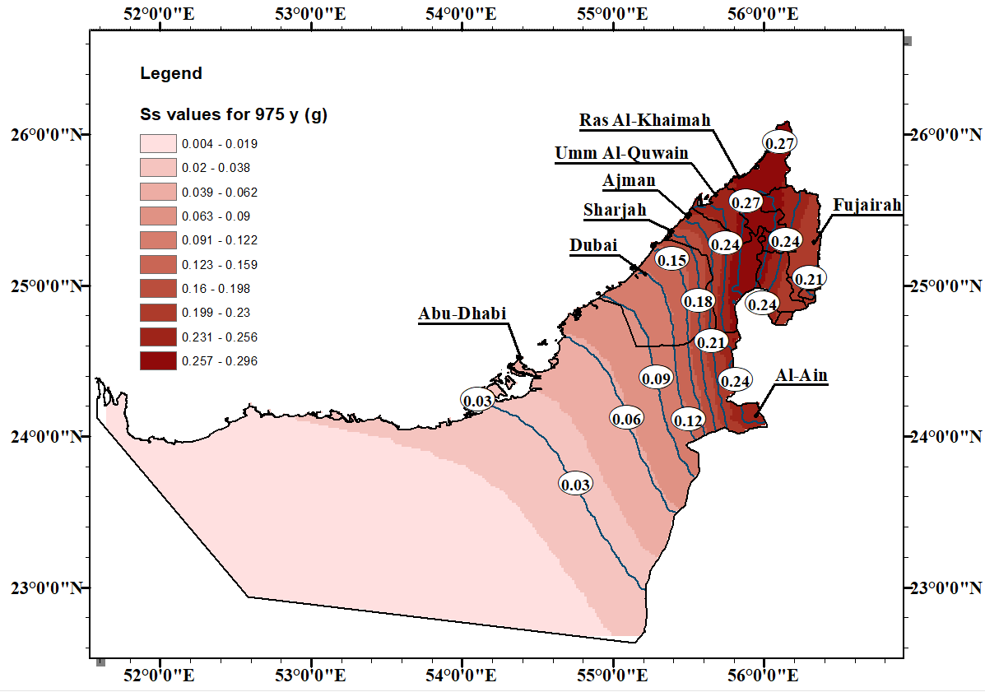
Fig. 6 (b) S_{s} values in g for a return period of 975 y

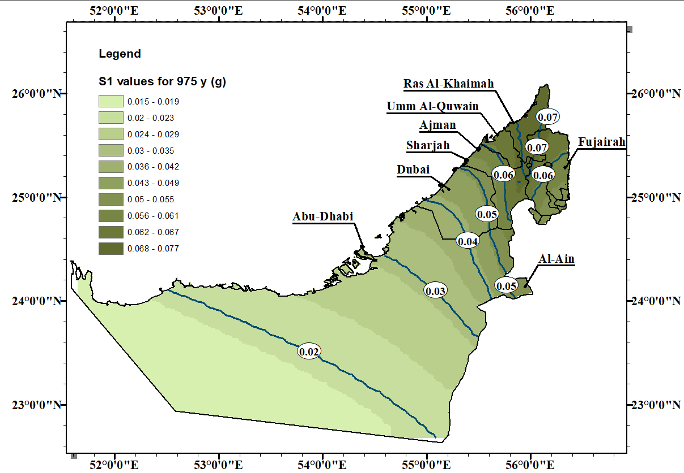
Fig. 6 (c) S₁ values in g for a return period of 975 y

