SUPPLEMENT

Empagliflozin effects on iron metabolism as a possible mechanism for improved clinical outcomes in non-diabetic patients with systolic heart failure

Christiane E. Angermann MD¹; Carlos G Santos-Gallego MD²; Juan Antonio Requena-Ibanez MD ²; Susanne Sehner³; Tanja Zeller PhD⁴; Louisa M. S. Gerhardt MD^{5,6}, Christoph Maack MD¹; Javier Sanz MD ²; Stefan Frantz MD¹; Valentin Fuster MD, PhD²; Georg Ertl MD¹; Juan J Badimon PhD²

¹Comprehensive Heart Failure Center Würzburg, University and University Hospital Würzburg, and Department of Medicine 1, University Hospital Würzburg, Würzburg, Germany; ²Cardiovascular Institute, Icahn School of Medicine at Mount Sinai, New York, NY, USA; ³Institute of Medical Biometry and Epidemiology, University Hospital Hamburg-Eppendorf, Hamburg, Germany; ⁴University Center of Cardiovascular Science, University Heart and Vascular Center, University Hospital Hamburg-Eppendorf, and German Center of Cardiovascular Research, Partner Site Hamburg, Kiel Lübeck, Hamburg, Germany; ⁵Department of Stem Cell Biology and Regenerative Medicine, Eli and Edythe Broad Center for Regenerative Medicine and Stem Cell Research, Keck School of Medicine of the University of Southern California, Los Angeles, CA, USA; ⁶Department of Medicine V, University Medical Centre Mannheim, Mannheim, Germany

SUPPLEMENTAL METHODS
Cardiopulmonary exercise testing
Exercise began with unloaded cycling and increased by 25 W every 3 minutes. Oxygen consumption (VO₂), carbon dioxide release (VCO₂), minute ventilation (VE), perceived level of exertion (Borg Scale 6 to 20), pulse oximetry, heart rate, and blood pressure measurements were recorded. Patients were encouraged to exercise until the respiratory exchange ratio was at least 1.1 or the level of perceived exertion was at least 15. The reason for stopping exercise was recorded. Peak VO₂ was defined as the highest 30-second average of oxygen consumption. The ventilatory threshold was identified as the point at which the ventilatory equivalent for O₂ (VE/VO₂) is minimal, followed by a progressive increase. Ventilation was assessed by correlation of VE and VCO₂ throughout exercise.

Laboratory assessments
Laboratory markers of iron status, erythropoietin and high sensitivity C-reactive protein
The following duplicate measurements were performed on an ARCHITECT c8000 system: iron (Colormetric Multigent Iron Assay, assay range 0.79–179 µmol/L); transferrin (immunoturbidimetric transferrin assay, assay range 0.19–4.77 g/L); ferritin (Quantia Ferritin assay, assay range 10–500 µg/L); all Abbott Diagnostics, Delkenheim, Germany. Soluble transferrin receptor (sTfR), hepcidin and erythropoietin were measured with an enzyme-linked immunosorbent assay (ELISA): sTfR using the sTfR HS ELISA (assay range 0.145–160 ng/mL); hepcidin using the Hepcidin 25 bioactive HS ELISA (assay range 0–81 ng/mL), both DRG, Marburg, Germany; erythropoietin using the Quantikine IVD ELISA Human Erythropoietin Immunoassay (assay range 2.5–200 mlU/mL), R&D Systems, Minneapolis, USA. High sensitivity C-reactive protein using the immunoturbidometric Multigent CRP vario assay (Abbott Diagnostics, Delkenheim, Germany) on an ARCHITECT c8000 system (assay range 0,1–160 mg/L).

Coefficients of variation
The following coefficients of variations (CV) were determined from the duplicate measurements: iron, inter CV 1.96%, intra CV 1.37%; transferrin, inter CV 0.28%, intra CV 1.08%; sTfR, inter CV 11.94%, intra CV 9.31%; ferritin, inter CV 0.14 %, intra CV 1.07%; hepcidin, inter CV 4.86%, intra CV 7.52%; erythropoietin, inter CV 5.19%, intra CV 3.64%.
hsCRP, inter CV 0,72 %, intra CV 0,89 %.

SUPPLEMENTAL RESULTS
Figure S1. Agreement between two investigators for assessment of myocardial T2*.
Shown are correlations of the results at baseline (left) and 6-month follow-up (right). The line of identity (y=x) and the range of the 20% deviation of agreement are given, correlations outside this range are depicted in red. CI indicates confidence interval.
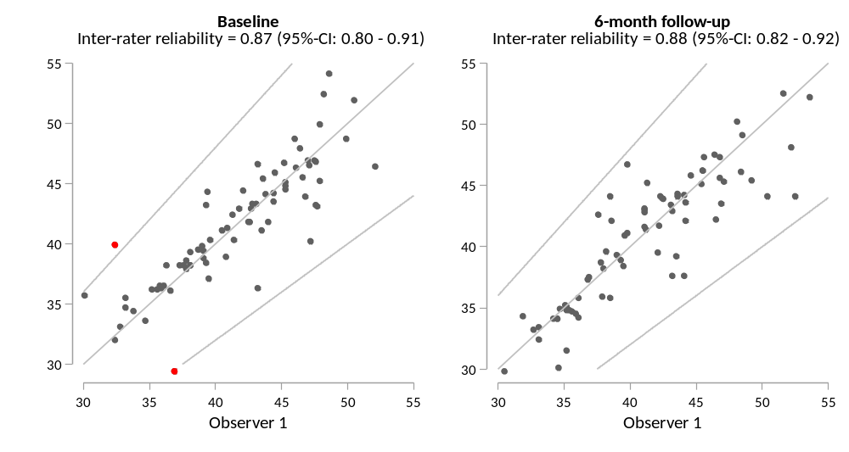

Figure S2. Agreement between duplicate measurements of iron variables, hepcidin and erythropoietin.
Each time, correlations at baseline (left) and 6-month follow-up (right) are shown with the line of identity (y=x) and the range of the 20% deviation of agreement. Correlations outside this range are given in red. The range of intra-class correlations is between 0.97 and 1.00.
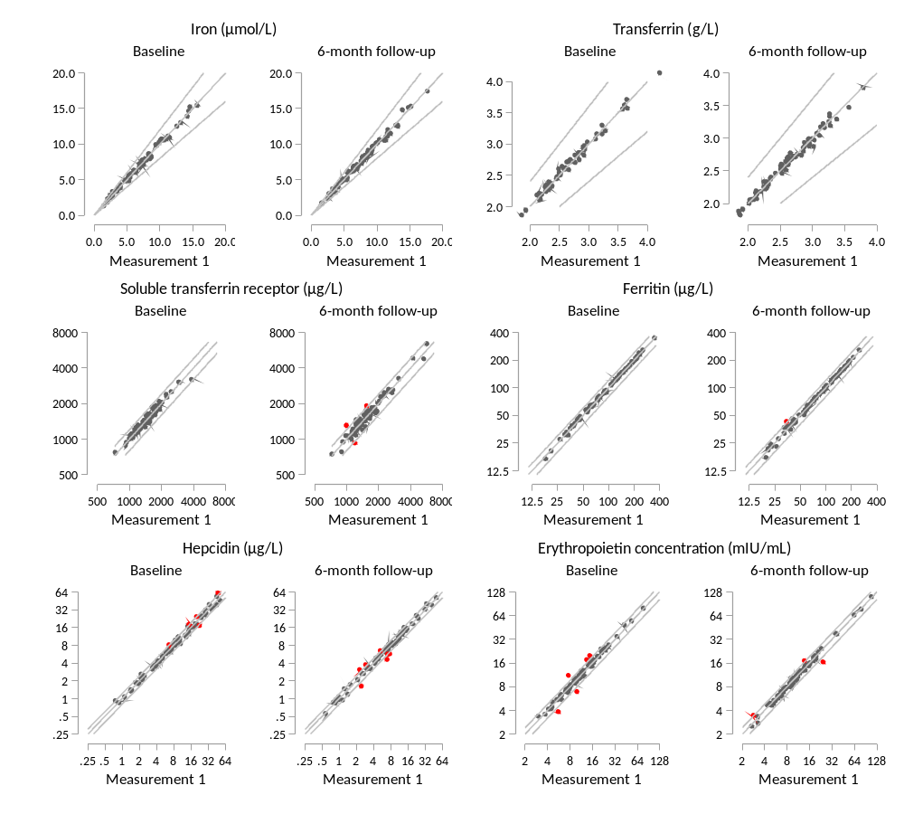

Figure S3. Correlations between concentrations of erythropoietin and the soluble transferrin receptor, hemoglobin, hematocrit and red blood cell count: baseline values (A) and correlations of changes in these variables after 6 months’ treatment by study group (B).
Baseline erythropoietin concentrations correlated directly with soluble transferrin receptor (sTfR) concentrations, and inversely with erythropoietin levels and hemoglobin, red blood cell count and hematocrit. Corresponding, but weaker associations were observed between changes in these variables after 6 months’ treatment. BL, baseline.
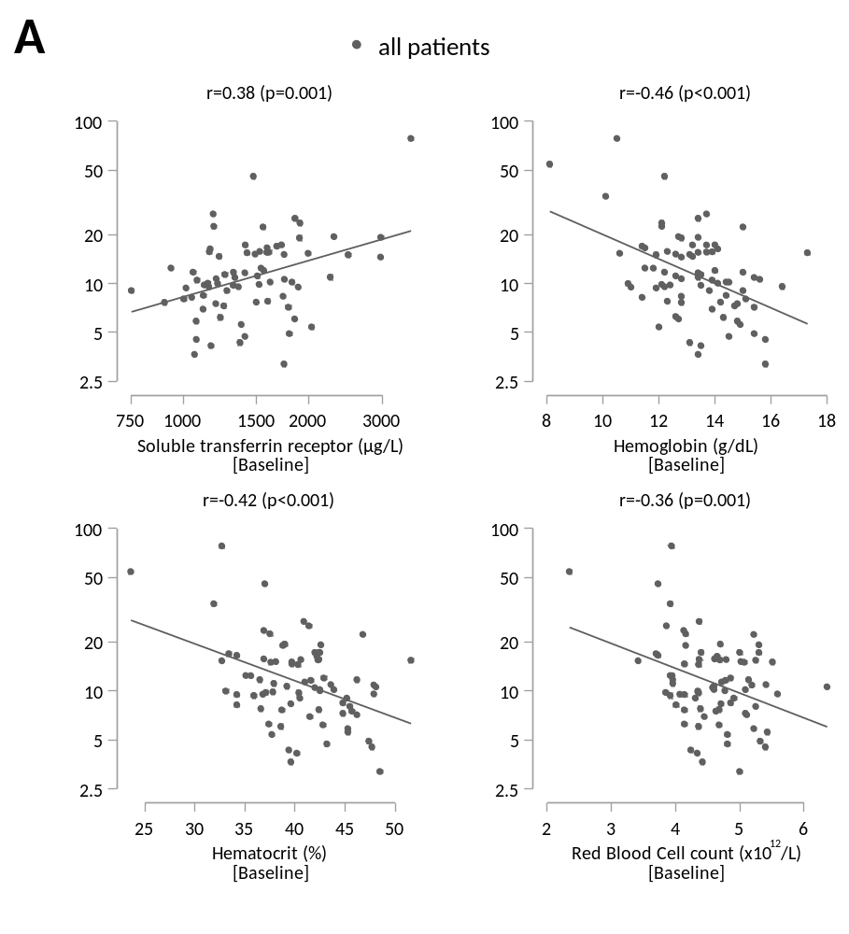
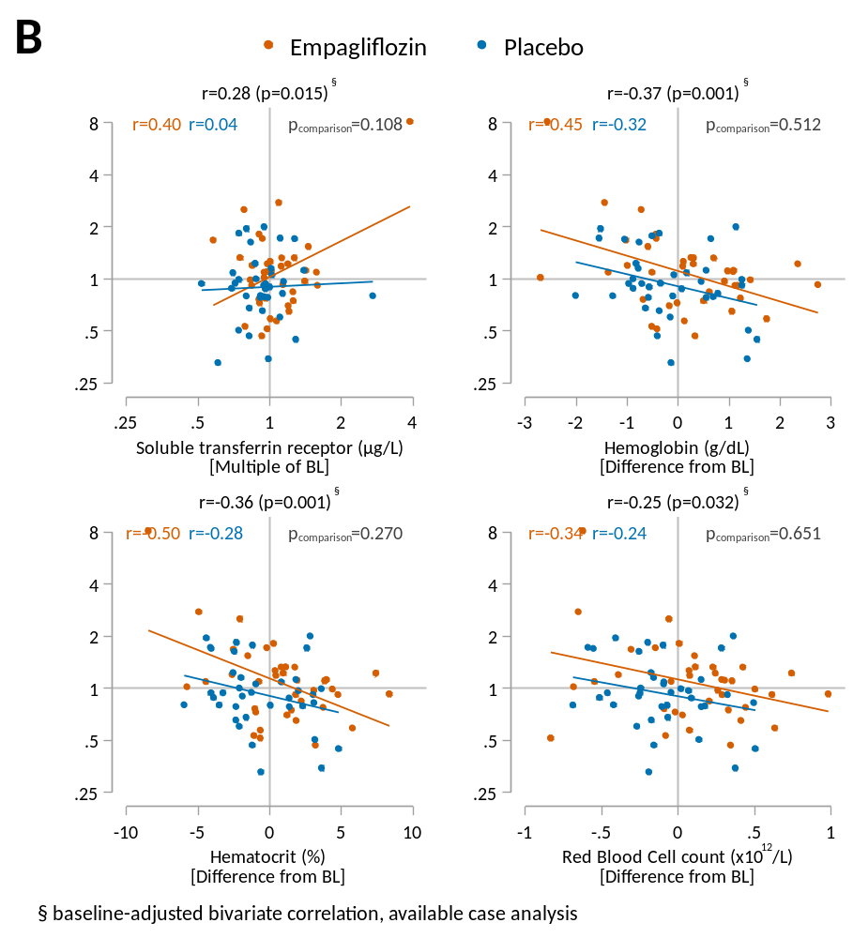

Table S1. Correlations between T2*values and laboratory iron markers, hepcidin and high sensitive C-reactive protein at baseline and between changes in these variables after 6 months’ treatment. In the absence of significant treatment group-specific correlations, all correlations (p-values) are reported across both treatment arms.
Variable | Correlations, r (p-value)
Variable | Baseline values vs. baseline T2* | Change from baseline vs. change in T2* at 6 months | Baseline values vs. change in T2* at 6 months
Iron, µmol/L | –0.02 (0.857) | –0.14 (0.248) | 0.04 (0.735)
Ferritin⁺, µg/L | 0.09 (0.470) | –0.09 (0.473) | 0.11 (0.341)
Transferrin, mg/dL | –0.00 (0.972) | 0.07 (0.535) | –0.11 (0.337)
Transferrin saturation, % | –0.03 (0.796) | –0.13 (0.263) | 0.09 (0.467)
sTfR⁺, ng/mL | 0.09 (0.455) | 0.15 (0.205) | –0.04 (0.752)
Hepcidin⁺, µg/L | 0.01 (0.961) | –0.10 (0.383) | 0.07 (0.563)
hsCRP⁺, mg/dL | 0.04 (0.746) | 0.02 (0.887) | 0.17 (0.181)
⁺These variables were log-transformed for estimation of the correlation coefficient.
hsCRP, high sensitive C-reactive protein; sTfR, soluble transferrin receptor.

