Two Novel coumarin-based fluorescent probes for the detection of Cu²⁺
Canxin Zhang ª Li Huang,ª Lizhen Wang,^{b} Xia Meng,ª Jianhua Zhou,ª Hongdong Duan ^{a,}*
ª School of Chemistry and Chemical Engineering, Qilu University of Technology (Shandong Academy of Sciences), Jinan 250353, PR China
^{b}Biology Institute, Qilu University of Technology (Shandong Academy of Sciences), Jinan 250014, Shandong Province, China
*Corresponding author, E-mail: hdduan67@163.com
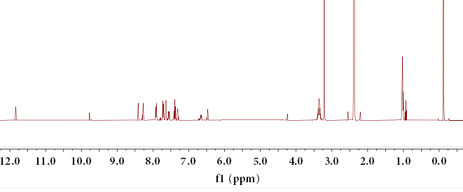
Figure S1. ¹H NMR of probe HQ1
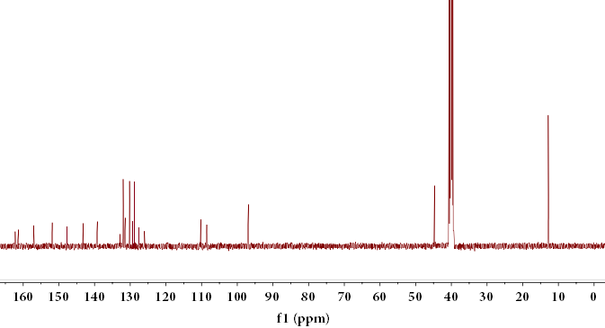
Figure S2 ¹³C NMR of probe HQ1
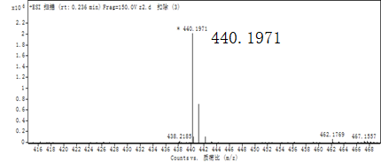
Figure S3. ESI-MS of probe HQ1
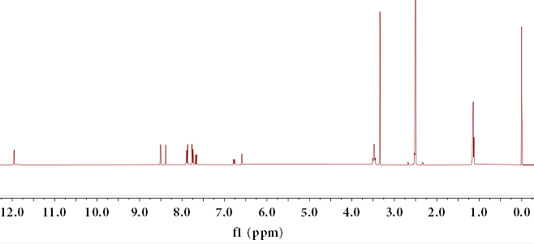
Figure S4. ¹H NMR of probe HQ2
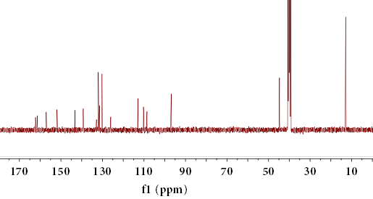
Figure S5. ¹³C NMR of probe HQ2
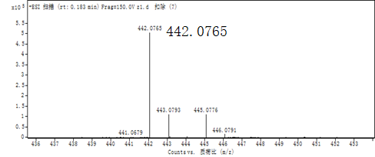
Figure S6. ESI-MS of probe HQ2

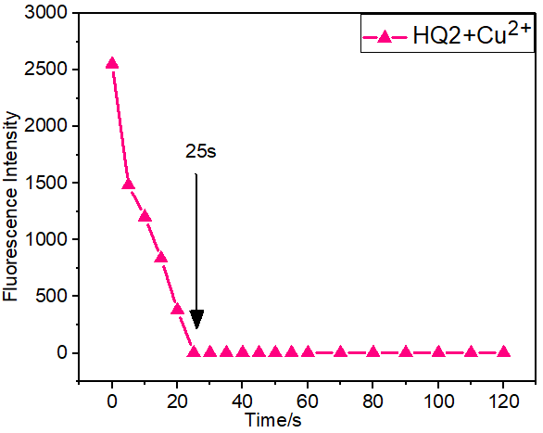
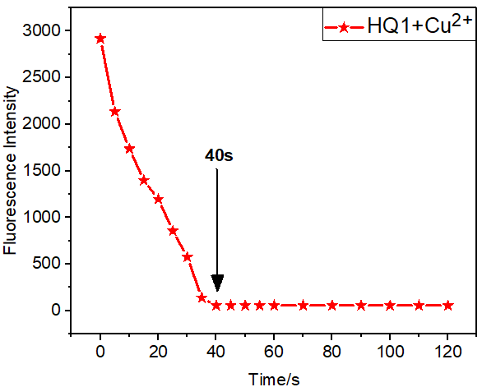
Figure S7 Response time of probe HQ1 and HQ2. DMSO/H₂O solution (1:1, V/V, 10⁻⁵M). Excitation wavelength =450 nm.

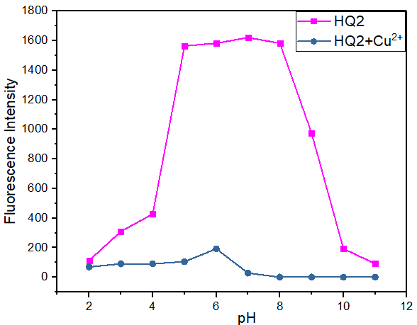
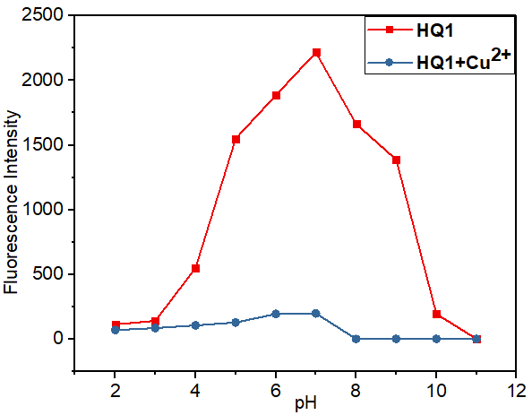
Figure S8. Fluorescence intensity of probe and complex at different pH (2-11), DMSO/H₂O solution (1:1, V/V, 10⁻⁵M). Excitation wavelength =450 nm.

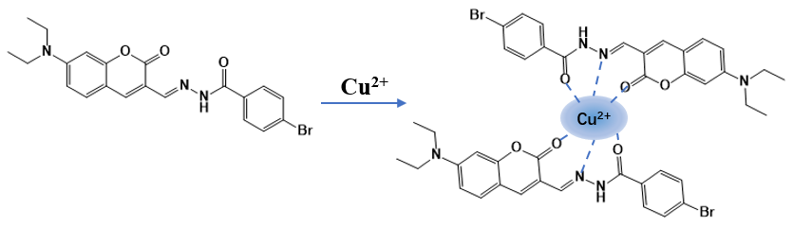
Figure S9. Complexation process diagram of probe HQ2 and Cu²⁺
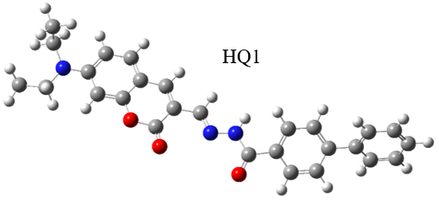
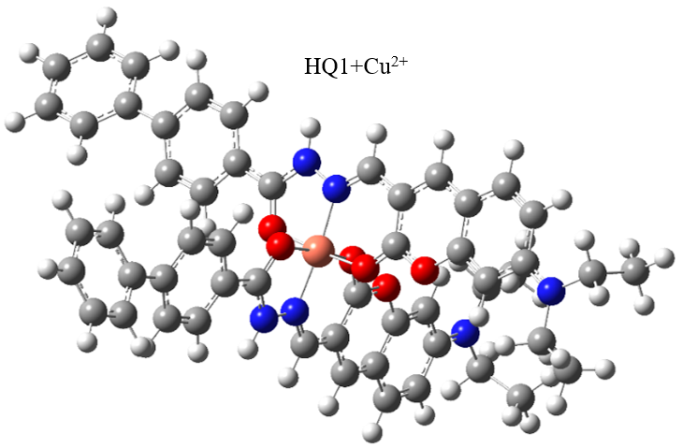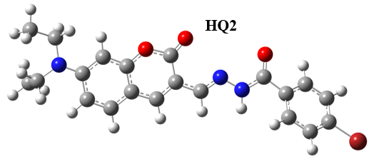
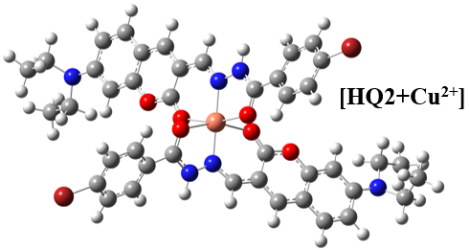
Figure S10. The structure of HQ1, HQ2, [HQ1 + Cu²⁺] and [HQ2 + Cu²⁺].
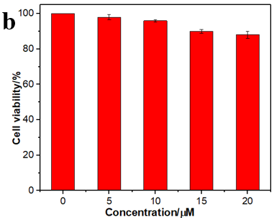
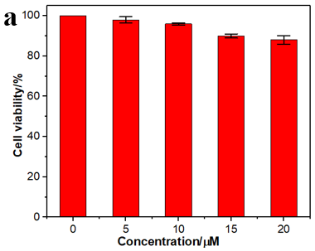
Figure S11. Cellular activity of HQ1 (a) and HQ2 (b) against A549 cells at different concentrations (0-20 μM).

