Supplementary Figure

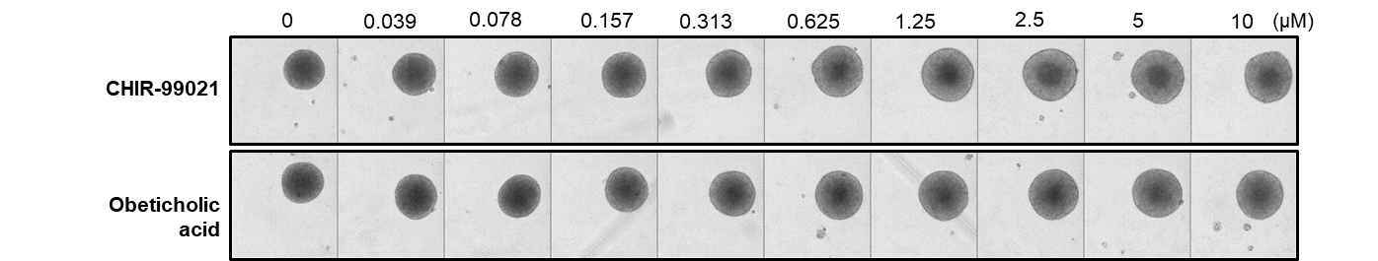

Supplementary Figure 1. The effects of CHIR-99021 and Obeticholic acid in MCHS.

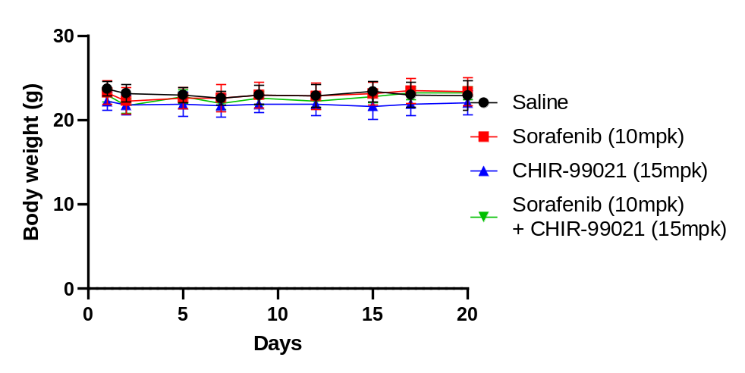
Supplementary Figure 2. The body weight of mouse treated with saline, Sorafenib, CHIR-99021, and Sorafenib and CHIR-99021 combination for 20days.

