Supplementary Information
for
“Ultrafast energy transfer and charge separation dynamics in PSII-dimer from Thermosynechococcus vulcanus”

Daisuke Kosumi, Miki Bando-Uotani, Shunya Kato, Keisuke Kawakami, Koji Yonekura,
Nobuo Kamiya

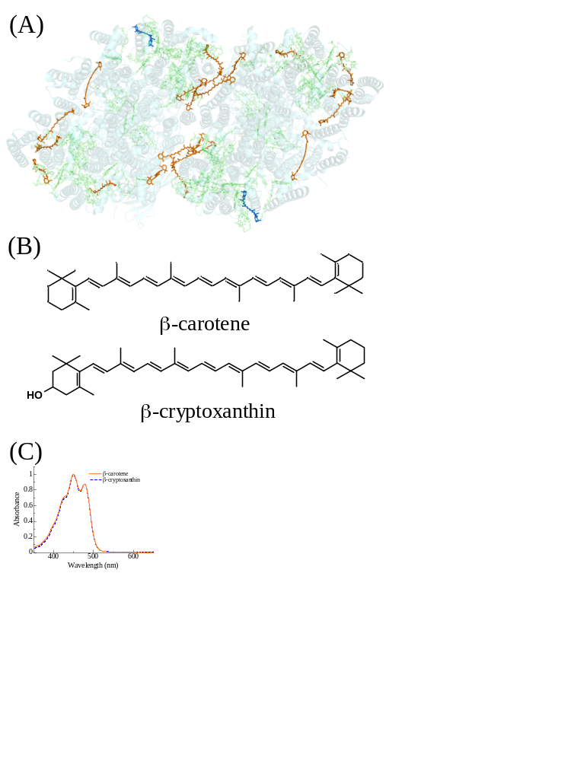
Figure S1: (A) The pigment arrangements of PSII-dimer highlighted in carotenoids (PDB ID: 3WU2). Orange color carotenoids are β-carotene and blue carotenoids denote β-cryptoxanthin. (B) The chemical structures and (C) steady-state absorption spectra in n-hexane of β-carotene and β-cryptoxanthin.

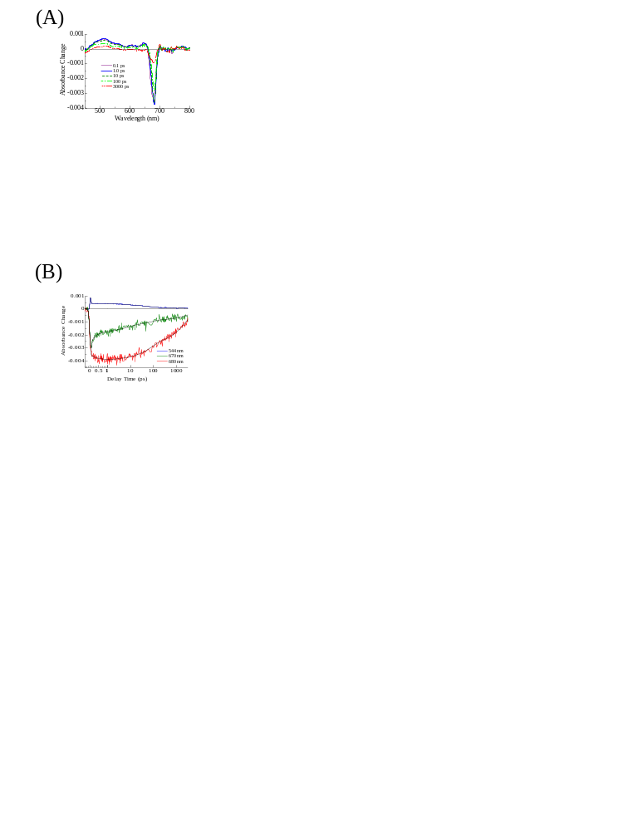
Figure S2: (A) Photo-induced absorption spectra and (B) their kinetic traces of PSII-dimer excited by 670 nm excitation pulse at 296 K.

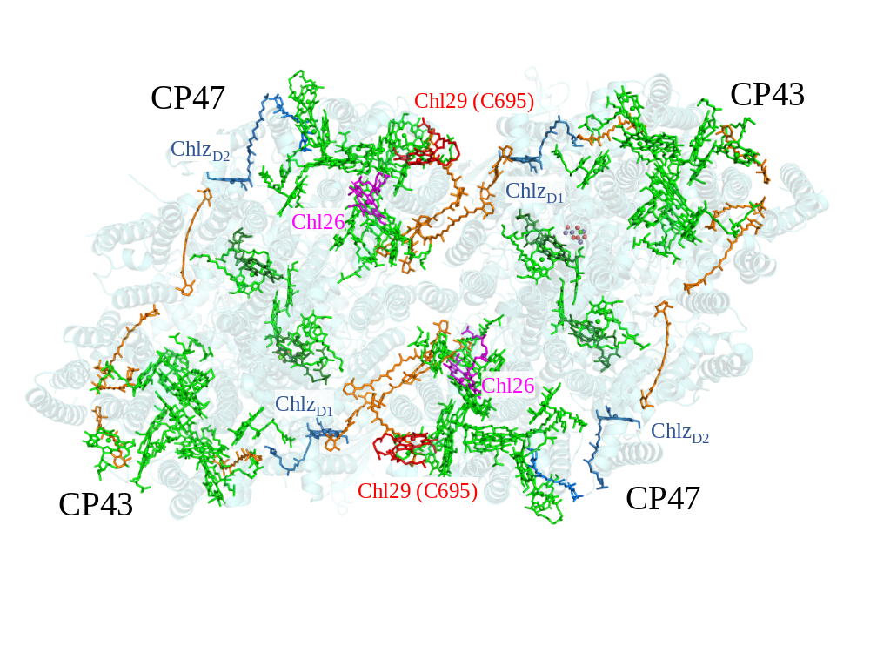
Figure S3: (A) The pigment arrangements of PSII-dimer (PDB ID: 3WU2).

Primary charge separation process in PSII
Here, we discuss the dynamics of Chl_{D1}*, intermediate charge transfer state, and P_{D1}⁺Pheo_{D1}⁻. k₁ and k₂ denote the rise and decay rates of Chl_{D1}, respectively. Electron transfer rates from the intermediate state and P_{D1}⁺Pheo_{D1}⁺ are defined as k₃ and k₄. By solving the rate equations for each state, we obtained the time-dependent population of each state.
$$k_{1}≫k_{2}≫k_{3}≫k_{4}$$
$$N_{{Chl}_{D1}}(t)≈N_{0}\frac{k_{1}}{k_{1}-k_{2}}\left\{exp\left(-k_{2}t\right)-exp\left(-k_{1}t\right)\right\}$$
$N_{Int}(t)≈N_{0}\frac{k_{2}}{k_{2}-k_{3}}\left\{exp\left(-k_{3}t\right)-exp\left(-k_{2}t\right)\right\}$ [S1]
$$N_{{P_{D1}}^{+}{{Pheo}_{D1}}^{-}}(t)≈N_{0}\frac{k_{3}}{k_{3}-k_{4}}\left\{exp\left(-k_{4}t\right)-exp\left(-k_{3}t\right)\right\}$$
N₀ is an initial population immediately after the simultaneous photoexcitation. $N_{{Chl}_{D1}}(t)$, $N_{Int}(t)$, and $N_{{P_{D1}}^{+}{{Pheo}_{D1}}^{-}}(t)$ denote the time-dependent population of each state.

$k_{2}≫k_{1}≫k_{3}≫k_{4}$ $k_{1}$: (0.71 ps)⁻¹, $k_{2}$: (0.1 ps)⁻¹, $k_{3}$: (43.0 ps)⁻¹, $k_{4}$: (20000 ps)⁻¹
In this case, $N_{P_{D1}}(t)$ rises with a time-constant of ($k_{2}$)⁻¹ and decays with ($k_{1}$)⁻¹. Then, $N_{Int}(t)$ rises with (k₁)⁻¹
$$N_{{Chl}_{D1}}(t)≈N_{0}\frac{k_{1}}{k_{2}-k_{1}}\left\{exp\left(-k_{1}t\right)-exp\left(-k_{2}t\right)\right\}$$
$N_{Int}(t)≈N_{0}\frac{k_{2}}{k_{2}-k_{3}}\left\{exp\left(-k_{3}t\right)-exp\left(-k_{1}t\right)\right\}$ [S2]
$$N_{{P_{D1}}^{+}{{Pheo}_{D1}}^{-}}(t)≈N_{0}\frac{k_{3}}{k_{3}-k_{4}}\left\{exp\left(-k_{4}t\right)-exp\left(-k_{3}t\right)\right\}$$
Figure S4(A) shows the time course of each excited state calculated using Eq. [S2]. In this case, the transient signal of Chl_{D1} becomes rather small due to the small coefficient of$\frac{k_{1}}{k_{2}-k_{1}} \left(k_{2}≫k_{1}\right)$. Based on the assumption that the bleaching signal observed at 682 nm in the fourth DADA at 140 K is assignable to Chl_{D1}, the fourth DADS demonstrates the electron transfer originates from P_{D1}⁺Chl_{D1}⁻ to P_{D1}⁺Pheo_{D1}⁻. On the other hand, the primary charge separation of Chl_{D1}* → Chl_{D1}⁺Pheo_{D1}⁻ is unobservable in this model.

$k_{1}≫k_{3}≫k_{2}≫k_{4}$ $k_{1}$: (0.71 ps)⁻¹, $k_{2}$: (43.0 ps)⁻¹, $k_{3}$: (1.0 ps)⁻¹, $k_{4}$: (20000 ps)⁻¹
$$N_{{Chl}_{D1}}(t)≈N_{0}\frac{k_{1}}{k_{1}-k_{2}}\left\{exp\left(-k_{2}t\right)-exp\left(-k_{1}t\right)\right\}$$
$N_{Int}(t)≈N_{0}\frac{k_{2}}{k_{3}-k_{2}}\left\{exp\left(-k_{2}t\right)-exp\left(-k_{3}t\right)\right\}$ [S3]
$$N_{{P_{D1}}^{+}{{Pheo}_{D1}}^{-}}(t)≈N_{0}\frac{k_{3}}{k_{3}-k_{4}}\left\{exp\left(-k_{4}t\right)-exp\left(-k_{2}t\right)\right\}$$
Figure S4(B) shows the time course of each excited state calculated using Eq. [S3]. In this case, the transient signal of the intermediate state becomes small because of the small coefficient of $\frac{k_{2}}{k_{3}-k_{2}} \left(k_{3}≫k_{2}\right)$. Therefore, the primary charge separation of Chl_{D1}* → Chl_{D1}⁺Pheo_{D1}⁻ takes place with 43.0 ps and the electron transfer from P_{D1}⁺Chl_{D1}⁻ to P_{D1}⁺Pheo_{D1}⁻ is not unobservable due to its larger rate in this model.
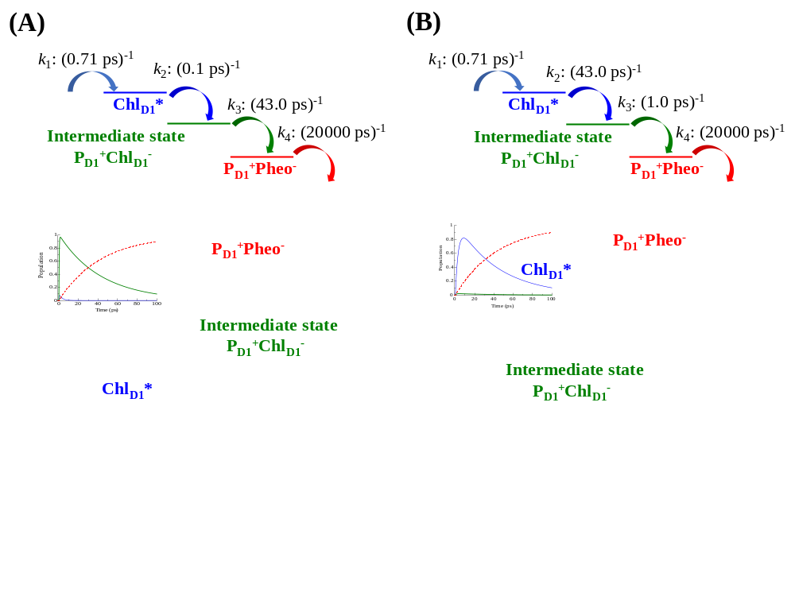
Figure S4: Calculated time-dependent population of each state.

Secondary electron transfer: P_{D1}⁺Pheo_{D1}⁻Q_{A} → P_{D1}⁺Pheo_{D1}Q_{A}⁻
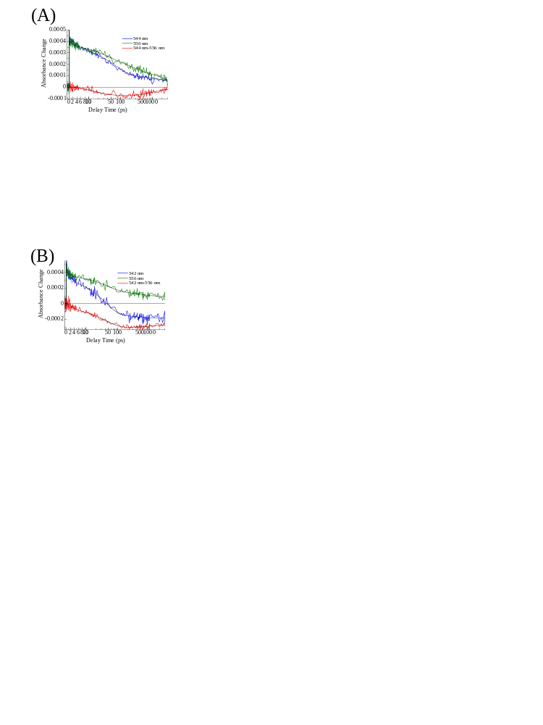
Figure S5: The kinetic traces probed at 542 nm and 556 nm at 140 K (A) and at 544 nm and 556 nm at 296 K (B) excited by the 670 nm pulses. The differences between kinetic traces at 542 and 556 nm (140 K) and between 544 and 556 nm (296 K) are also plotted.
The bleaching signal of Pheo can be detected at 542 nm (140 K) while its kinetic involves other contributions (e.g. transient absorption of Chl a). Thus, we examined the difference of the kinetic traces at 542 nm and 556 nm.
At 140 K, the difference of the kinetic traces
$$ΔΔA_{542}(t)=ΔA_{542}(t)-ΔA_{556}(t)$$
is plotted in Fig.S5(A). At 296 K the difference
$$ΔΔA_{544}(t)=ΔA_{544}(t)-ΔA_{556}(t)$$
is plotted in Fig.S5(B). The obtained difference of the kinetic traces exhibits the pure rise and decay dynamics of Pheo_{D1}. The Pheo_{D1} bleaching rises with one exponential component both at 140 and 296 K. Even though the Pheo_{D1} bleaching signal at 140 K did not decay in the temporal range up to 3 ns, the difference of the kinetic traces at 296 K obviously exhibits the decay of Pheo_{D1}. The decay time-constant was determined to be 650 ps, corresponding to the electron transfer from Pheo_{D1}⁻Q_{A} to Pheo_{D1}Q_{A}⁻.
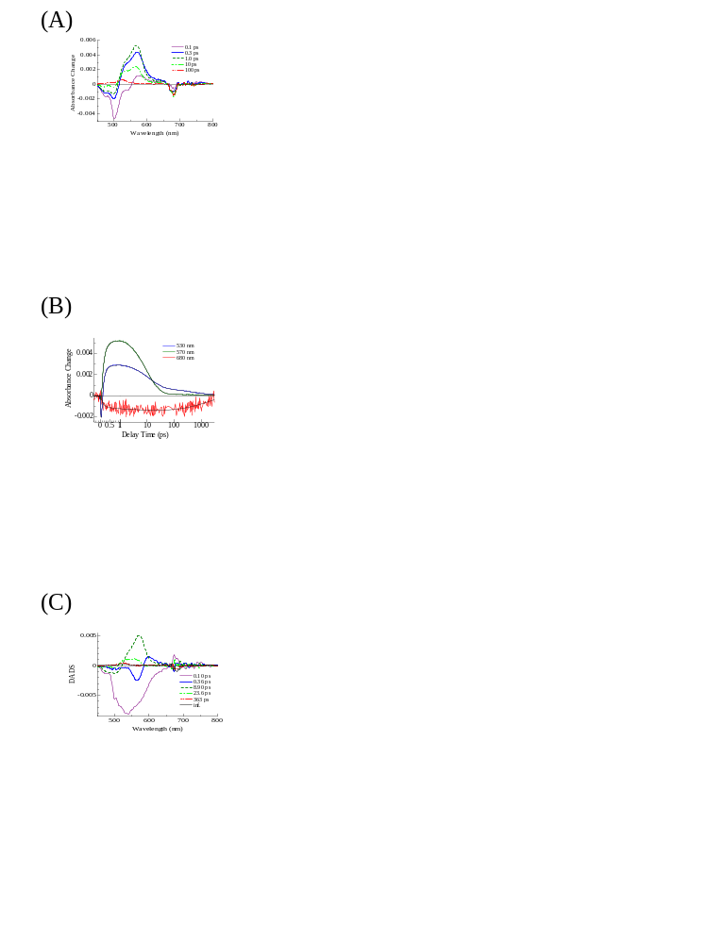
Figure S6: (A) Photo-induced absorption spectra, (B) kinetic traces of absorbance changes, and (C) decay-associated difference spectra of PSII-dimer after excitation to β-Car S₂ at 296 K.

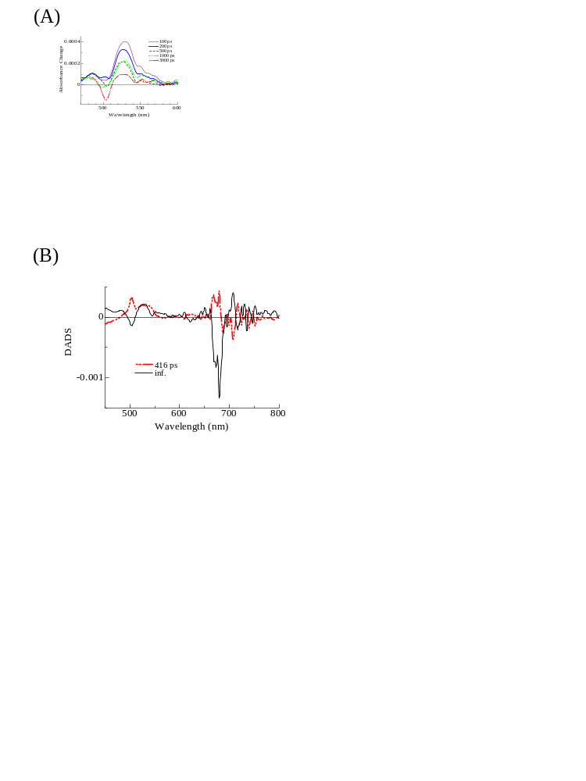
Figure S7: (A) The photo-induced absorption spectra of PSII-dimer at longer delay after excitation to β-Car S₂ at 140 K (B) The fifth (416 ps) and sixth (inf) DADS of PSII dimer after excitation to β-Car S₂ at 140 K.

