SUPPLEMENTARY TABLES
Supplementary Table 1. qRT-PCR reaction mix
Reagent | Volume/Rx. (µL)
Nuclease-free water | 2.16
2x Reaction Mix | 10
Forward primer, 10 μM (AACCCCAGTGGAGAAGTGGA) | 0.4
Reverse primer, 10 μM (TCAGGCTGCCACACCAAA) | 0.8
Fluorogenic probe, 10 μM (6FAM – CGATGTTCCATACTCTGG – MGB NFQ) | 0.2
ROX™ Reference Dye | 0.04
RNaseOUT™ Ribonuclease Inhibitor | 1
SuperScript™ III RT/Platinum™ Taq Mix | 0.4
RNA Template (total RNA) | 5
Final volume | 20
Supplementary Table 2. BinJV RT-PCR reaction mix
Reagent | Volume/Rx. (µL)
2x reaction buffer | 6.25
Forward primer (5uM) | 0.5
Reverse primer (5uM) | 0.5
Reverse transcriptase Platinum Taq polymerase | 0.5
Nuclease-free water | 2.25
RNA | 2.5
Final volume | 12.5
Supplementary Table 3. BinJV qPCR reaction mix
Reagent | Volume/ Rx. (µL) | Final concentration
NFH₂O | 5.2 | -
2x QuantiNova SYBR Green PCR Master Mix | 10 | 1x
Forward Primer | 1.4 | 0.7 µM
Reverse Primer | 1.4 | 0.7 µM
Template (cDNA) | 2 | ≤ 100 ng
Total | 20

Supplementary Table 4. WNV_{KUN} qRT-PCR on randomly collected post-challenge blood samples
No. | Samples ID | Treatment group | CT value | Verdict
1 | 4P-5-01 | Mock vaccinated | NS | Negative
2 | 4P-5-01 | Mock vaccinated | NS | Negative
3 | 4P-5-01 | Mock vaccinated | NS | Negative
4 | 4P-5-02 | Mock vaccinated | NS | Negative
5 | 4P-5-02 | Mock vaccinated | NS | Negative
6 | 4P-5-02 | Mock vaccinated | NS | Negative
7 | 4P-5-03 | Mock vaccinated | 37.26 | Positive
8 | 4P-5-03 | Mock vaccinated | 38.55 | Positive
9 | 4P-5-03 | Mock vaccinated | 39.09 | Positive
10 | 4P-5-04 | Mock vaccinated | NS | Negative
11 | 4P-5-04 | Mock vaccinated | NS | Negative
12 | 4P-5-04 | Mock vaccinated | NS | Negative
13 | 4P-5-05 | Mock vaccinated | NS | Negative
14 | 4P-5-05 | Mock vaccinated | NS | Negative
15 | 4P-5-05 | Mock vaccinated | NS | Negative
16 | 4P-5-06 | Mock vaccinated | NS | Negative
17 | 4P-5-06 | Mock vaccinated | NS | Negative
18 | 4P-5-06 | Mock vaccinated | NS | Negative
19 | 4P-5-07 | Mock vaccinated | NS | Negative
20 | 4P-5-07 | Mock vaccinated | 46.2 | +/-
21 | 4P-5-07 | Mock vaccinated | NS | Negative
22 | 4P-5-08 | Mock vaccinated | 32.68 | Positive
23 | 4P-5-08 | Mock vaccinated | 32.02 | Positive
24 | 4P-5-08 | Mock vaccinated | 32.6 | Positive
25 | 4P-5-09 | Mock vaccinated | 29.64 | Positive
26 | 4P-5-09 | Mock vaccinated | 29.58 | Positive
27 | 4P-5-09 | Mock vaccinated | 29.57 | Positive
28 | 4P-5-10 | Mock vaccinated | 30.69 | Positive
29 | 4P-5-10 | Mock vaccinated | 30.26 | Positive
30 | 4P-5-10 | Mock vaccinated | 31.58 | Positive
31 | 4P-4-01 | Inactivated + Adjuvant | NS | Negative
32 | 4P-4-01 | Inactivated + Adjuvant | NS | Negative
33 | 4P-4-01 | Inactivated + Adjuvant | NS | Negative
34 | 4P-4-02 | Inactivated + Adjuvant | NS | Negative
35 | 4P-4-02 | Inactivated + Adjuvant | NS | Negative
36 | 4P-4-02 | Inactivated + Adjuvant | NS | Negative
37 | 4P-4-03 | Inactivated + Adjuvant | NS | Negative
38 | 4P-4-03 | Inactivated + Adjuvant | NS | Negative
39 | 4P-4-03 | Inactivated + Adjuvant | NS | Negative
40 | 4P-4-04 | Inactivated + Adjuvant | NS | Negative
41 | 4P-4-04 | Inactivated + Adjuvant | NS | Negative
42 | 4P-4-04 | Inactivated + Adjuvant | NS | Negative
43 | 4P-4-05 | Inactivated + Adjuvant | NS | Negative
44 | 4P-4-05 | Inactivated + Adjuvant | NS | Negative
45 | 4P-4-05 | Inactivated + Adjuvant | NS | Negative
46 | 4P-4-06 | Inactivated + Adjuvant | NS | Negative
47 | 4P-4-06 | Inactivated + Adjuvant | NS | Negative
48 | 4P-4-06 | Inactivated + Adjuvant | NS | Negative
49 | 4P-4-07 | Inactivated + Adjuvant | NS | Negative
50 | 4P-4-07 | Inactivated + Adjuvant | NS | Negative
51 | 4P-4-07 | Inactivated + Adjuvant | NS | Negative
52 | 4P-4-08 | Inactivated + Adjuvant | NS | Negative
53 | 4P-4-08 | Inactivated + Adjuvant | NS | Negative
54 | 4P-4-08 | Inactivated + Adjuvant | NS | Negative
55 | 4P-4-09 | Inactivated + Adjuvant | NS | Negative
56 | 4P-4-09 | Inactivated + Adjuvant | NS | Negative
57 | 4P-4-09 | Inactivated + Adjuvant | NS | Negative
58 | 4P-4-10 | Inactivated + Adjuvant | NS | Negative
59 | 4P-4-10 | Inactivated + Adjuvant | NS | Negative
60 | 4P-4-10 | Inactivated + Adjuvant | NS | Negative
61 | 4P-3-01 | Inactivated | NS | Negative
62 | 4P-3-01 | Inactivated | NS | Negative
63 | 4P-3-01 | Inactivated | NS | Negative
64 | 4P-3-02 | Inactivated | NS | Negative
65 | 4P-3-02 | Inactivated | NS | Negative
66 | 4P-3-02 | Inactivated | NS | Negative
67 | 4P-3-03 | Inactivated | NS | Negative
68 | 4P-3-03 | Inactivated | NS | Negative
69 | 4P-3-03 | Inactivated | NS | Negative
70 | 4P-3-04 | Inactivated | NS | Negative
71 | 4P-3-04 | Inactivated | NS | Negative
72 | 4P-3-04 | Inactivated | NS | Negative
73 | 4P-3-05 | Inactivated | NS | Negative
74 | 4P-3-05 | Inactivated | NS | Negative
75 | 4P-3-05 | Inactivated | NS | Negative
76 | 4P-3-06 | Inactivated | NS | Negative
77 | 4P-3-06 | Inactivated | NS | Negative
78 | 4P-3-06 | Inactivated | NS | Negative
79 | 4P-3-07 | Inactivated | NS | Negative
80 | 4P-3-07 | Inactivated | NS | Negative
81 | 4P-3-07 | Inactivated | NS | Negative
82 | 4P-3-08 | Inactivated | NS | Negative
83 | 4P-3-08 | Inactivated | NS | Negative
84 | 4P-3-08 | Inactivated | NS | Negative
85 | 4P-3-09 | Inactivated | NS | Negative
86 | 4P-3-09 | Inactivated | NS | Negative
87 | 4P-3-09 | Inactivated | NS | Negative
88 | 4P-3-10 | Inactivated | NS | Negative
89 | 4P-3-10 | Inactivated | NS | Negative
90 | 4P-3-10 | Inactivated | NS | Negative
91 | 4P-2-01 | Live + Adjuvant | NS | Negative
92 | 4P-2-01 | Live + Adjuvant | NS | Negative
93 | 4P-2-01 | Live + Adjuvant | NS | Negative
94 | 4P-2-02 | Live + Adjuvant | NS | Negative
95 | 4P-2-02 | Live + Adjuvant | NS | Negative
96 | 4P-2-02 | Live + Adjuvant | NS | Negative
97 | 4P-2-03 | Live + Adjuvant | NS | Negative
98 | 4P-2-03 | Live + Adjuvant | NS | Negative
99 | 4P-2-03 | Live + Adjuvant | NS | Negative
100 | 4P-2-04 | Live + Adjuvant | NS | Negative
101 | 4P-2-04 | Live + Adjuvant | NS | Negative
102 | 4P-2-04 | Live + Adjuvant | NS | Negative
103 | 4P-2-05 | Live + Adjuvant | NS | Negative
104 | 4P-2-05 | Live + Adjuvant | NS | Negative
105 | 4P-2-05 | Live + Adjuvant | NS | Negative
106 | 4P-2-06 | Live + Adjuvant | NS | Negative
107 | 4P-2-06 | Live + Adjuvant | NS | Negative
108 | 4P-2-06 | Live + Adjuvant | NS | Negative
109 | 4P-2-07 | Live + Adjuvant | NS | Negative
110 | 4P-2-07 | Live + Adjuvant | NS | Negative
111 | 4P-2-07 | Live + Adjuvant | NS | Negative
112 | 4P-2-08 | Live + Adjuvant | NS | Negative
113 | 4P-2-08 | Live + Adjuvant | NS | Negative
114 | 4P-2-08 | Live + Adjuvant | NS | Negative
115 | 4P-2-09 | Live + Adjuvant | NS | Negative
116 | 4P-2-09 | Live + Adjuvant | NS | Negative
117 | 4P-2-09 | Live + Adjuvant | NS | Negative
118 | 4P-2-10 | Live + Adjuvant | NS | Negative
119 | 4P-2-10 | Live + Adjuvant | NS | Negative
120 | 4P-2-10 | Live + Adjuvant | NS | Negative
121 | 4P-1-01 | Live | NS | Negative
122 | 4P-1-01 | Live | NS | Negative
123 | 4P-1-01 | Live | NS | Negative
124 | 4P-1-02 | Live | NS | Negative
125 | 4P-1-02 | Live | NS | Negative
126 | 4P-1-02 | Live | NS | Negative
127 | 4P-1-03 | Live | NS | Negative
128 | 4P-1-03 | Live | NS | Negative
129 | 4P-1-03 | Live | NS | Negative
130 | 4P-1-04 | Live | NS | Negative
131 | 4P-1-04 | Live | NS | Negative
132 | 4P-1-04 | Live | NS | Negative
133 | 4P-1-05 | Live | NS | Negative
134 | 4P-1-05 | Live | NS | Negative
135 | 4P-1-05 | Live | NS | Negative
136 | 4P-1-06 | Live | NS | Negative
137 | 4P-1-06 | Live | NS | Negative
138 | 4P-1-06 | Live | NS | Negative
139 | 4P-1-07 | Live | NS | Negative
140 | 4P-1-07 | Live | NS | Negative
141 | 4P-1-07 | Live | NS | Negative
142 | 4P-1-08 | Live | NS | Negative
143 | 4P-1-08 | Live | NS | Negative
144 | 4P-1-08 | Live | NS | Negative
145 | 4P-1-09 | Live | NS | Negative
146 | 4P-1-09 | Live | NS | Negative
147 | 4P-1-09 | Live | NS | Negative
148 | 4P-1-10 | Live | NS | Negative
149 | 4P-1-10 | Live | NS | Negative
150 | 4P-1-10 | Live | NS | Negative
200 | KUNV 10^5.8 | Standard | 19.05 | Positive
201 | KUNV 10^4.8 | Standard | 22.71 | Positive
202 | KUNV 10^3.8 | Standard | 26.53 | Positive
203 | KUNV 10^2.8 | Standard | 29.8 | Positive
204 | BinJV/NHUV | Negative Control | NS | Negative
205 | NFH₂O | NTC | NS | Negative
Supplementary Table 5. WNV_{KUN} qRT-PCR on cloacal swabs and pen water samples
No. | Samples ID | Treatment group | Sample type | Ct value | Verdict
1 | CS2-F4 | Mock vaccinated | Cloacal swabs | NS | Negative
2 | CS2-F4 | Mock vaccinated | Cloacal swabs | NS | Negative
3 | CS2-F4 | Mock vaccinated | Cloacal swabs | NS | Negative
4 | CS2-F16 | Mock vaccinated | Cloacal swabs | 49.51 | +/-
5 | CS2-F16 | Mock vaccinated | Cloacal swabs | NS | Negative
6 | CS2-F16 | Mock vaccinated | Cloacal swabs | NS | Negative
7 | CS2-F33 | Mock vaccinated | Cloacal swabs | 31.24 | Positive
8 | CS2-F33 | Mock vaccinated | Cloacal swabs | 31.45 | Positive
9 | CS2-F33 | Mock vaccinated | Cloacal swabs | 31.10 | Positive
10 | CS2-F44 | Mock vaccinated | Cloacal swabs | NS | Negative
11 | CS2-F44 | Mock vaccinated | Cloacal swabs | NS | Negative
12 | CS2-F44 | Mock vaccinated | Cloacal swabs | NS | Negative
13 | CS2-D12 | Mock vaccinated | Cloacal swabs | 34.65 | Positive
14 | CS2-D12 | Mock vaccinated | Cloacal swabs | 35.54 | Positive
15 | CS2-D12 | Mock vaccinated | Cloacal swabs | 31.83 | Positive
16 | CS2-H19 | Mock vaccinated | Cloacal swabs | NS | Negative
17 | CS2-H19 | Mock vaccinated | Cloacal swabs | NS | Negative
18 | CS2-H19 | Mock vaccinated | Cloacal swabs | NS | Negative
19 | CS2-B44 | Mock vaccinated | Cloacal swabs | 32.02 | Positive
20 | CS2-B44 | Mock vaccinated | Cloacal swabs | 32.88 | Positive
21 | CS2-B44 | Mock vaccinated | Cloacal swabs | 31.42 | Positive
22 | CS2-C32 | Mock vaccinated | Cloacal swabs | NS | Negative
23 | CS2-C32 | Mock vaccinated | Cloacal swabs | NS | Negative
24 | CS2-C32 | Mock vaccinated | Cloacal swabs | NS | Negative
25 | CS2-F1 | Inactivated + Adjuvant | Cloacal swabs | NS | Negative
26 | CS2-F1 | Inactivated + Adjuvant | Cloacal swabs | NS | Negative
27 | CS2-F1 | Inactivated + Adjuvant | Cloacal swabs | NS | Negative
28 | CS2-F8 | Inactivated + Adjuvant | Cloacal swabs | NS | Negative
29 | CS2-F8 | Inactivated + Adjuvant | Cloacal swabs | NS | Negative
30 | CS2-F8 | Inactivated + Adjuvant | Cloacal swabs | NS | Negative
31 | CS2-F25 | Inactivated + Adjuvant | Cloacal swabs | NS | Negative
32 | CS2-F25 | Inactivated + Adjuvant | Cloacal swabs | NS | Negative
33 | CS2-F25 | Inactivated + Adjuvant | Cloacal swabs | NS | Negative
34 | CS2-A10 | Inactivated + Adjuvant | Cloacal swabs | NS | Negative
35 | CS2-A10 | Inactivated + Adjuvant | Cloacal swabs | NS | Negative
36 | CS2-A10 | Inactivated + Adjuvant | Cloacal swabs | NS | Negative
37 | CS2-A14 | Inactivated + Adjuvant | Cloacal swabs | NS | Negative
38 | CS2-A14 | Inactivated + Adjuvant | Cloacal swabs | NS | Negative
39 | CS2-A14 | Inactivated + Adjuvant | Cloacal swabs | NS | Negative
40 | CS2-A20 | Inactivated + Adjuvant | Cloacal swabs | NS | Negative
41 | CS2-A20 | Inactivated + Adjuvant | Cloacal swabs | NS | Negative
42 | CS2-A20 | Inactivated + Adjuvant | Cloacal swabs | NS | Negative
43 | CS2-A30 | Inactivated + Adjuvant | Cloacal swabs | NS | Negative
44 | CS2-A30 | Inactivated + Adjuvant | Cloacal swabs | NS | Negative
45 | CS2-A30 | Inactivated + Adjuvant | Cloacal swabs | NS | Negative
46 | CS2-B15 | Inactivated + Adjuvant | Cloacal swabs | NS | Negative
47 | CS2-B15 | Inactivated + Adjuvant | Cloacal swabs | NS | Negative
48 | CS2-B15 | Inactivated + Adjuvant | Cloacal swabs | NS | Negative
49 | CS2-F5 | Inactivated | Cloacal swabs | NS | Negative
50 | CS2-F5 | Inactivated | Cloacal swabs | NS | Negative
51 | CS2-F5 | Inactivated | Cloacal swabs | NS | Negative
52 | CS2-F29 | Inactivated | Cloacal swabs | NS | Negative
53 | CS2-F29 | Inactivated | Cloacal swabs | NS | Negative
54 | CS2-F29 | Inactivated | Cloacal swabs | NS | Negative
55 | CS2-H11 | Inactivated | Cloacal swabs | NS | Negative
56 | CS2-H11 | Inactivated | Cloacal swabs | NS | Negative
57 | CS2-H11 | Inactivated | Cloacal swabs | NS | Negative
58 | CS2-H15 | Inactivated | Cloacal swabs | NS | Negative
59 | CS2-H15 | Inactivated | Cloacal swabs | NS | Negative
60 | CS2-H15 | Inactivated | Cloacal swabs | NS | Negative
61 | CS2-H17 | Inactivated | Cloacal swabs | NS | Negative
62 | CS2-H17 | Inactivated | Cloacal swabs | NS | Negative
63 | CS2-H17 | Inactivated | Cloacal swabs | NS | Negative
64 | CS2-H36 | Inactivated | Cloacal swabs | NS | Negative
65 | CS2-H36 | Inactivated | Cloacal swabs | NS | Negative
66 | CS2-H36 | Inactivated | Cloacal swabs | NS | Negative
67 | KUNV 10^3.8 | Standard | Virus supernatant | 25.31 | Positive
68 | KUNV 10^2.8 | Standard | Virus supernatant | 30.02 | Positive
69 | KUNV 10^1.8 | Standard | Virus supernatant | 32.95 | Positive
70 | KUNV 10^0.8 | Standard | Virus supernatant | 46.23 | Positive
71 | CASV IC 1 | Negative control | CASV supernatant | NS | Negative
72 | NFH₂O | NTC | NFH2O | NS | Negative

Supplementary Table 6. WNV_{KUN} qRT-PCR on pen water samples and FTA cards
No. | Samples ID | Treatment group | Sample type | Type | Ct value | Verdict
1 | H2O_17-09_5 | Mock vaccinated | Pen water | Unknown | NS | Negative
2 | H2O_20-09_1 | Live | Pen water | Unknown | NS | Negative
3 | H2O_20-09_2 | Live + Adjuvant | Pen water | Unknown | NS | Negative
4 | H2O_20-09_3 | Inactivated | Pen water | Unknown | NS | Negative
5 | H2O_20-09_4 | Inactivated + Adjuvant | Pen water | Unknown | NS | Negative
6 | H2O_20-09_5 | Mock vaccinated | Pen water | Unknown | 46.69 | Negative
7 | H2O_23-09_1 | Live | Pen water | Unknown | NS | Negative
8 | H2O_23-09_2 | Live + Adjuvant | Pen water | Unknown | NS | Negative
9 | H2O_23-09_3 | Inactivated | Pen water | Unknown | NS | Negative
10 | H2O_23-09_4 | Inactivated + Adjuvant | Pen water | Unknown | NS | Negative
11 | H2O_23-09_5 | Mock vaccinated | Pen water | Unknown | 46.69 | Negative
12 | FTA_27-07-21 | NA | Pen water | Unknown | NS | Negative
13 | FTA_12-08-21 | NA | Pen water | Unknown | NS | Negative
14 | FTA_26-08-21 | NA | Pen water | Unknown | NS | Negative
15 | FTA_16-09-21 | NA | Pen water | Unknown | NS | Negative
16 | FTA_23-09-21 | NA | Pen water | Unknown | NS | Negative
17 | FTA_06-10-21 | NA | Pen water | Unknown | NS | Negative
18 | KUNV 10^5.8 | Standard | Virus supernatant | Standard | 25.34 | Positive
19 | KUNV 10^4.8 | Standard | Virus supernatant | Standard | 29.43 | Positive
20 | KUNV 10^3.8 | Standard | Virus supernatant | Standard | 33.40 | Positive
21 | KUNV 10^2.8 | standard | Virus supernatant | Standard | 38.02 | Positive
22 | BinJV/NHUV | Negative Control |  |  | NS | Negative
23 | NFH₂O | NTC |  |  | NS | Negative
Supplementary Table 7. WNV_{KUN} NS1 specific blocking-ELISA
SN | Pen # | Six months post-booster | Treatment group | Percentage of inhibition | Verdict
1 | 95 | 5-B44 | BinJV/WNV_{KUNproto} 2μg SC | -2.75 | Negative
2 | 95 | 5-B45 | BinJV/WNV_{KUNproto} 2μg SC | 5.48 | Negative
3 | 95 | 5-B46 | BinJV/WNV_{KUNproto} 2μg SC | 15.85 | Negative
4 | 95 | 5-B47 | BinJV/WNV_{KUNproto} 2μg SC | 24.80 | Negative
5 | 95 | 5-E25 | BinJV/WNV_{KUNproto} 2μg SC | 26.72 | Negative
6 | 95 | 5-E45 | BinJV/WNV_{KUNproto} 2μg SC | -7.48 | Negative
7 | 95 | 5-E46 | BinJV/WNV_{KUNproto} 2μg SC | -7.70 | Negative
8 | 95 | 5-E47 | BinJV/WNV_{KUNproto} 2μg SC | 12.61 | Negative
9 | 94 | 5-C01 | BinJV/WNV_{KUNproto} 2μg SC | 11.50 | Negative
10 | 94 | 5-C02 | BinJV/WNV_{KUNproto} 2μg SC | 26.73 | Negative
11 | 94 | 5-C03 | BinJV/WNV_{KUNproto} 2μg SC | -12.18 | Negative
12 | 94 | 5-C04 | BinJV/WNV_{KUNproto} 2μg SC | -8.17 | Negative
13 | 94 | 5-C05 | BinJV/WNV_{KUNproto} 2μg SC | 4.96 | Negative
14 | 94 | 5-C06 | BinJV/WNV_{KUNproto} 2μg SC | 15.24 | Negative
15 | 94 | 5-C07 | BinJV/WNV_{KUNproto} 2μg SC | 26.78 | Negative
16 | 94 | 5-C08 | BinJV/WNV_{KUNproto} 2μg SC | -18.05 | Negative
17 | 94 | 5-C09 | BinJV/WNV_{KUNproto} 2μg SC | -3.25 | Negative
18 | 94 | 5-C10 | BinJV/WNV_{KUNproto} 2μg SC | 8.44 | Negative
19 | 94 | 5-C11 | BinJV/WNV_{KUNproto} 2μg SC | 23.62 | Negative
20 | 94 | 5-C12 | BinJV/WNV_{KUNproto} 2μg SC | 29.07 | Negative
21 | 94 | 5-E26 | BinJV/WNV_{KUNproto} 2μg SC | -3.18 | Negative
22 | 92 | 5-C13 | BinJV/WNV_{KUNproto} 10μg SC | -3.01 | Negative
23 | 92 | 5-C15 | BinJV/WNV_{KUNproto} 10μg SC | 6.34 | Negative
24 | 92 | 5-C17 | BinJV/WNV_{KUNproto} 10μg SC | 17.30 | Negative
25 | 92 | 5-C18 | BinJV/WNV_{KUNproto} 10μg SC | 26.68 | Negative
26 | 92 | 5-C20 | BinJV/WNV_{KUNproto} 10μg SC | -1.48 | Negative
27 | 92 | 5-C24 | BinJV/WNV_{KUNproto} 10μg SC | 5.74 | Negative
28 | 92 | 5-C25 | BinJV/WNV_{KUNproto} 10μg SC | 17.66 | Negative
29 | 92 | 5-C26 | BinJV/WNV_{KUNproto} 10μg SC | -10.50 | Negative
30 | 91 | 5-C27 | BinJV/WNV_{KUNproto} 10μg SC | -8.06 | Negative
31 | 91 | 5-C28 | BinJV/WNV_{KUNproto} 10μg SC | 1.70 | Negative
32 | 91 | 5-C29 | BinJV/WNV_{KUNproto} 10μg SC | -35.71 | Negative
33 | 91 | 5-C30 | BinJV/WNV_{KUNproto} 10μg SC | -32.95 | Negative
34 | 91 | 5-C32 | BinJV/WNV_{KUNproto} 10μg SC | 11.82 | Negative
35 | 91 | 5-C33 | BinJV/WNV_{KUNproto} 10μg SC | -5.42 | Negative
36 | 91 | 5-C34 | BinJV/WNV_{KUNproto} 10μg SC | 18.06 | Negative
37 | 91 | 5-C35 | BinJV/WNV_{KUNproto} 10μg SC | -25.89 | Negative
38 | 91 | 5-C36 | BinJV/WNV_{KUNproto} 10μg SC | -3.28 | Negative
39 | 91 | 5-C37 | BinJV/WNV_{KUNproto} 10μg SC | -34.29 | Negative
40 | 91 | 5-C38 | BinJV/WNV_{KUNproto} 10μg SC | -3.86 | Negative
41 | 91 | 5-C39 | BinJV/WNV_{KUNproto} 10μg SC | 9.74 | Negative
42 | 91 | 5-C40 | BinJV/WNV_{KUNproto} 10μg SC | -12.62 | Negative
43 | 91 | 5-E32 | BinJV/WNV_{KUNproto} 10μg SC | -22.99 | Negative
44 | 90 | 5-D19 | BinJV/WNV_{KUN2011} 2μg IM | -9.88 | Negative
45 | 90 | 5-D20 | BinJV/WNV_{KUN2011} 2μg IM | -2.28 | Negative
46 | 90 | 5-D21 | BinJV/WNV_{KUN2011} 2μg IM | 9.80 | Negative
47 | 90 | 5-D22 | BinJV/WNV_{KUN2011} 2μg IM | 4.84 | Negative
48 | 90 | 5-D23 | BinJV/WNV_{KUN2011} 2μg IM | -13.54 | Negative
49 | 90 | 5-D24 | BinJV/WNV_{KUN2011} 2μg IM | 9.36 | Negative
50 | 90 | 5-D25 | BinJV/WNV_{KUN2011} 2μg IM | -3.62 | Negative
51 | 90 | 5-D26 | BinJV/WNV_{KUN2011} 2μg IM | 23.77 | Negative
52 | 90 | 5-D27 | BinJV/WNV_{KUN2011} 2μg IM | -5.62 | Negative
53 | 90 | 5-D28 | BinJV/WNV_{KUN2011} 2μg IM | -5.22 | Negative
54 | 90 | 5-D29 | BinJV/WNV_{KUN2011} 2μg IM | 10.39 | Negative
55 | 90 | 5-D30 | BinJV/WNV_{KUN2011} 2μg IM | 6.60 | Negative
56 | 90 | 5-D31 | BinJV/WNV_{KUN2011} 2μg IM | 9.89 | Negative
57 | 90 | 5-D32 | BinJV/WNV_{KUN2011} 2μg IM | 7.21 | Negative
58 | 97 | 5-D33 | BinJV/WNV_{KUNproto} 10μg IM | 1.66 | Negative
59 | 97 | 5-D34 | BinJV/WNV_{KUNproto} 10μg IM | 4.11 | Negative
60 | 97 | 5-D35 | BinJV/WNV_{KUNproto} 10μg IM | 8.94 | Negative
61 | 97 | 5-D36 | BinJV/WNV_{KUNproto} 10μg IM | 9.59 | Negative
62 | 97 | 5-D37 | BinJV/WNV_{KUNproto} 10μg IM | 8.40 | Negative
63 | 97 | 5-D38 | BinJV/WNV_{KUNproto} 10μg IM | -5.50 | Negative
64 | 97 | 5-D39 | BinJV/WNV_{KUNproto} 10μg IM | -11.93 | Negative
65 | 97 | 5-D41 | BinJV/WNV_{KUNproto} 10μg IM | -7.29 | Negative
66 | 97 | 5-D42 | BinJV/WNV_{KUNproto} 10μg IM | -5.31 | Negative
67 | 97 | 5-D43 | BinJV/WNV_{KUNproto} 10μg IM | 10.57 | Negative
68 | 97 | 5-D45 | BinJV/WNV_{KUNproto} 10μg IM | -14.19 | Negative
69 | 96 | 5-D47 | BinJV/WNV_{KUN2011} 10μg IM | -0.49 | Negative
70 | 96 | 5-D48 | BinJV/WNV_{KUN2011} 10μg IM | 6.95 | Negative
71 | 96 | 5-D49 | BinJV/WNV_{KUN2011} 10μg IM | 0.55 | Negative
72 | 96 | 5-D50 | BinJV/WNV_{KUN2011} 10μg IM | 10.70 | Negative
73 | 96 | 5-E01 | BinJV/WNV_{KUN2011} 10μg IM | -17.35 | Negative
74 | 96 | 5-E03 | BinJV/WNV_{KUN2011} 10μg IM | -16.05 | Negative
75 | 96 | 5-E04 | BinJV/WNV_{KUN2011} 10μg IM | -1.06 | Negative
76 | 96 | 5-E05 | BinJV/WNV_{KUN2011} 10μg IM | 5.90 | Negative
77 | 96 | 5-E06 | BinJV/WNV_{KUN2011} 10μg IM | 13.95 | Negative
78 | 96 | 5-E07 | BinJV/WNV_{KUN2011} 10μg IM | 2.44 | Negative
79 | 96 | 5-E08 | BinJV/WNV_{KUN2011} 10μg IM | -27.77 | Negative
80 | 96 | 5-E09 | BinJV/WNV_{KUN2011} 10μg IM | -20.24 | Negative
81 | 96 | 5-E10 | BinJV/WNV_{KUN2011} 10μg IM | -15.52 | Negative
82 | 96 | 5-E29 | BinJV/WNV_{KUN2011} 10μg IM | -5.92 | Negative
83 | 102 | 5-E11 | BinJV/WNV_{KUN2011} 10μg IM | -5.84 | Negative
84 | 102 | 5-E12 | BinJV/WNV_{KUN2011} 10μg IM | -3.37 | Negative
85 | 102 | 5-E13 | BinJV/WNV_{KUN2011} 10μg IM | -7.63 | Negative
86 | 102 | 5-E14 | BinJV/WNV_{KUN2011} 10μg IM | -2.43 | Negative
87 | 102 | 5-E15 | BinJV/WNV_{KUN2011} 10μg IM | 2.08 | Negative
88 | 102 | 5-E17 | BinJV/WNV_{KUN2011} 10μg IM | 4.51 | Negative
89 | 102 | 5-E19 | BinJV/WNV_{KUN2011} 10μg IM | -4.51 | Negative
90 | 102 | 5-E20 | BinJV/WNV_{KUN2011} 10μg IM | -3.60 | Negative
91 | 102 | 5-E21 | BinJV/WNV_{KUN2011} 10μg IM | 8.38 | Negative
92 | 102 | 5-E22 | BinJV/WNV_{KUN2011} 10μg IM | 18.19 | Negative
93 | 102 | 5-E23 | BinJV/WNV_{KUN2011} 10μg IM | 11.82 | Negative
94 | 102 | 5-E28 | BinJV/WNV_{KUN2011} 10μg IM | 2.58 | Negative
95 | 102 | 5-E48 | BinJV/WNV_{KUN2011} 10μg IM | -5.88 | Negative

SUPPLEMENTARY FIGURES
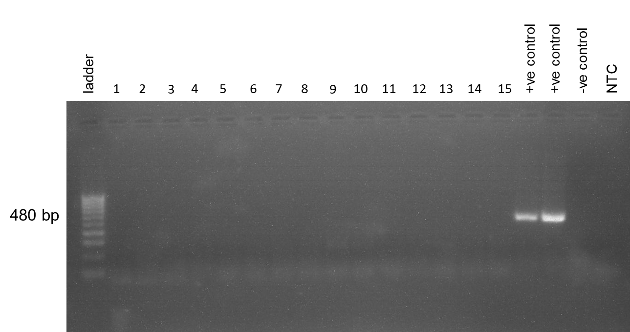
Supplementary Figure 1. BinJV-NS5 specific RT-PCR on crocodile blood samples. Lane 1. ladder, lanes 2-16: blood samples from vaccinated crocodiles, lanes 17-18: positive control, lane 19: negative control, lane 20: no template control.
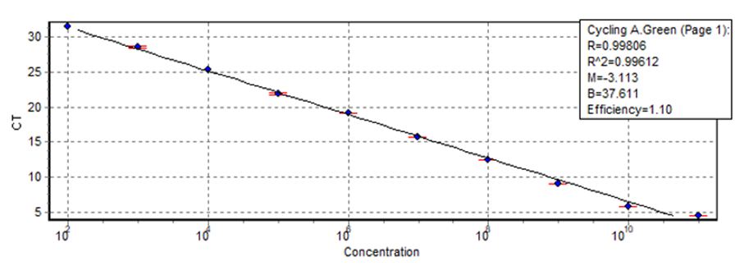
Supplementary Figure 2. Standard curve to determine WNV_{KUN} infectious units equivalents from plasma qRT-PCR CT scores. Ten-fold dilutions of WNV_{KUN} (10-1 to 10-7) were simultaneously assessed for infectious titre by TCID₅₀ assay and levels of viral RNA by Taqman qRT-PCR. An exponential trend line was generated from the derived CT scores and calculated infectious units of the standard dilution series using the Excel Growth Function. Infectious unit equivalents were then predicted for each plasma sample from their derived CT scores. R2 value indicates line of best fit (closest to 1). The limit of detection was 6 - 10 TCID₅₀/mL.
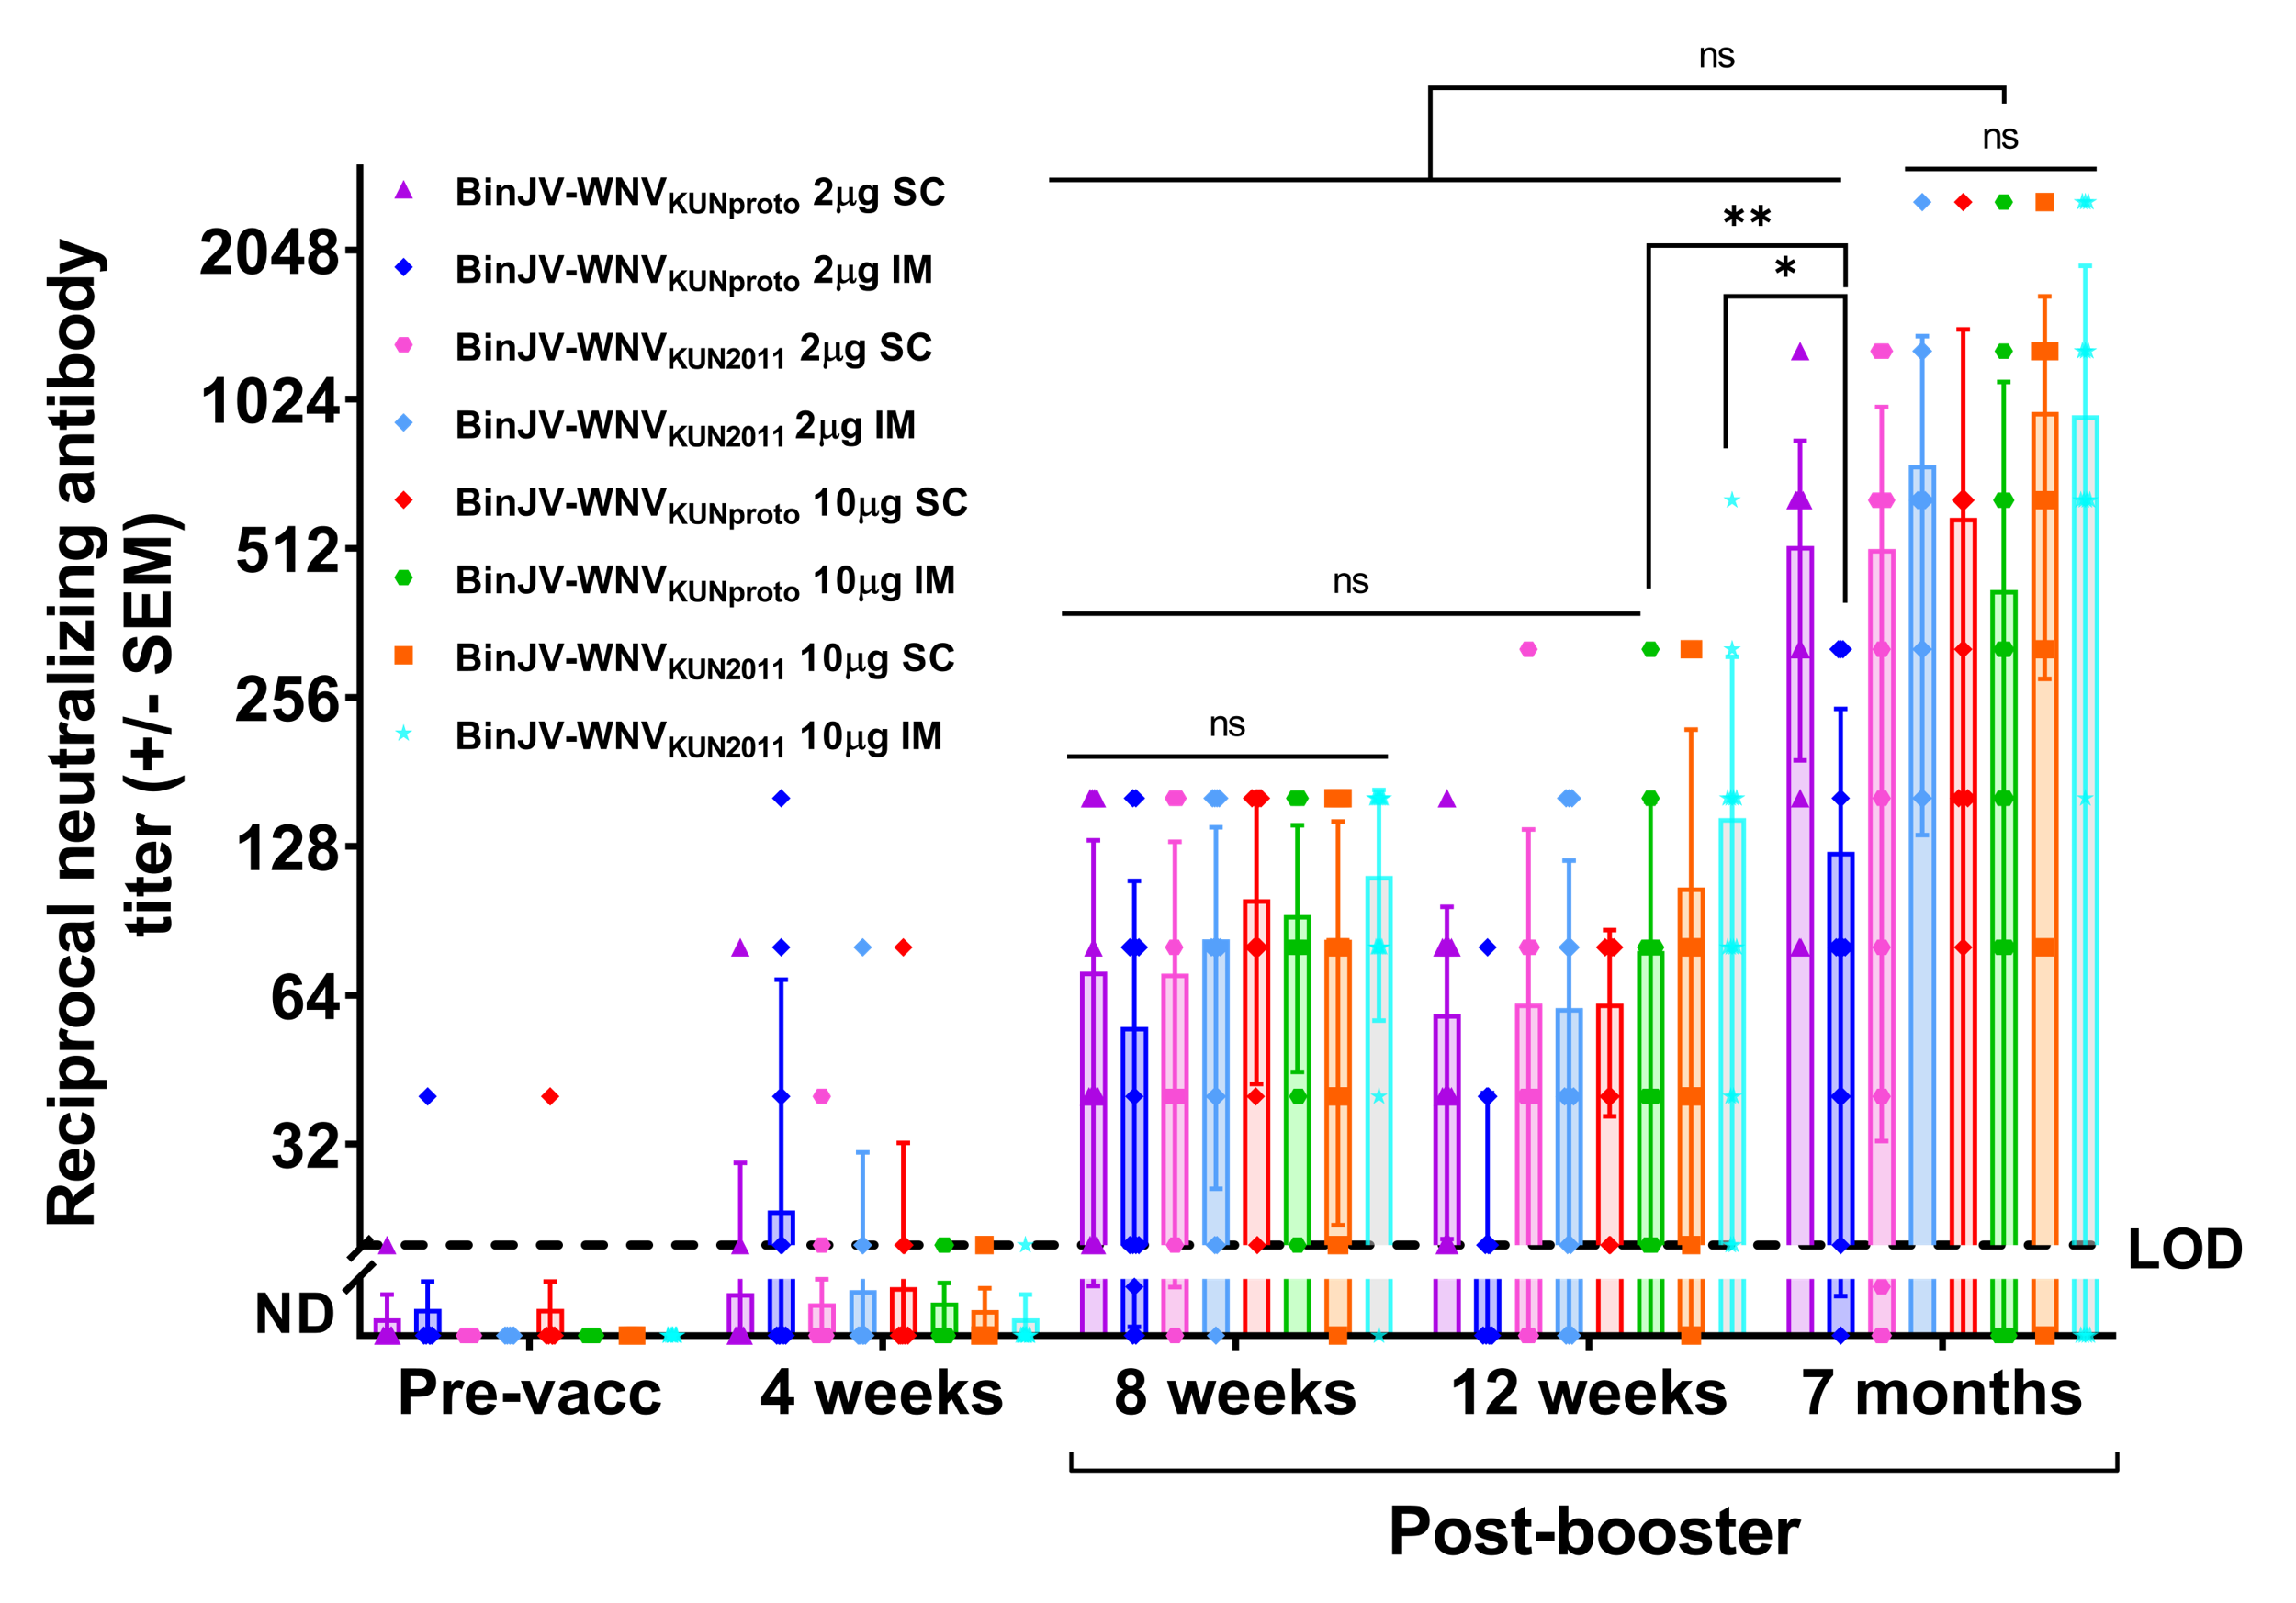
Supplementary Figure 3. Comparison of BinJV/WNV_{KUN2011} and BinJV/WNV_{KUNproto} vaccines vaccine response in vaccinated saltwater crocodiles. The dotted line represents the lower limit of detection (titre of 20) of virus-neutralising antibodies by VNT. The upper limit of detection of the assay was 2560. The data were subjected to two-way ANOVA with a Tukey’s post-test statistical analysis to test differences in virus neutralising antibody titres between treatment groups at various timepoints. Significant statistical difference thresholds are *p ≤ 0.05, **p ≤ 0.01, ***p ≤ 0.001.

Supplementary Table 8. Sero-conversion rate and median neutralising antibody titres induced by BinJV/WNV_{KUNproto}
Timepoint | BinJV/WNV_{KUNproto} 2μg SC |  |  |  | BinJV/WNV_{KUNproto} 10μg SC |  |  |  | BinJV/WNV_{KUNproto} 2μg IM |  |  |  | BinJV/WNV_{KUNproto} 10μg IM
Timepoint | Seroc. rate (%) | Median | UL | LL | Seroc. rate (%) | Median | UL | LL | Seroc. rate (%) | Median | UL | LL | Seroc. rate (%) | Median | UL | LL
day 0 | 0 | <20 | 20 | <20 | 7.1 | <20 | 40 | <20 | 14.2 | <20 | 40 | <20 | 0 | <20 | <20 | <20
4 weeks | 14.2 | <20 | 80 | <20 | 28.6 | <20 | 80 | <20 | 35.7 | <20 | 160 | <20 | 21.4 | <20 | 20 | <20
8 weeks | 100 | 40 | 160 | 20 | 100 | 80 | 160 | 20 | 100 | 30 | 160 | <20 | 100 | 80 | 160 | 20
12 weeks | 100 | 40 | 160 | 20 | 100 | 80 | 80 | 20 | 78.5 | 10 | 80 | <20 | 100 | 60 | 320 | 20
7 months | 100 | 640 | 1280 | 80 | 100 | 240 | 2560 | 80 | 85.7 | 80 | 320 | <20 | 100 | 160 | 2560 | <20
Supplementary Table 9. Sero-conversion rate and median neutralising antibody titres induced by BinJV/WNV_{KUN2011}
Timepoint | BinJV/WNV_{KUN2011} 2μg SC |  |  |  | BinJV/WNV_{KUN2011} 10μg SC |  |  |  | BinJV/WNV_{KUN2011} 2μg IM |  |  |  | BinJV/WNV_{KUN2011} 10μg IM
Timepoint | Seroc. rate (%) | Median | UL | LL | Seroc. rate (%) | Median | UL | LL | Seroc. rate (%) | Median | UL | LL | Seroc. rate (%) | Median | UL | LL
day 0 | 0 | <20 | < 20 | <20 | 0 | <20 | <20 | <20 | 0 | <20 | <20 | <20 | 0 | <20 | <20 | <20
4 weeks | 14.2 | <20 | 40 | <20 | 14.2 | <20 | 20 | <20 | 21.4 | <20 | 80 | <20 | 7.1 | <20 | 20 | <20
8 weeks | 92.8 | 40 | 160 | <20 | 100 | 80 | 160 | <20 | 92.8 | 80 | 160 | <20 | 92.8 | 120 | 160 | <20
12 weeks | 85.7 | 40 | 320 | <20 | 92.8 | 80 | 320 | <20 | 78.6 | 40 | 160 | <20 | 100 | 80 | 640 | 20
7 months | 85.7 | 640 | 1280 | <20 | 100 | 1280 | 2560 | <20 | 100 | 640 | 2560 | 160 | 92.8 | 640 | 2560 | <20

Seroc.: seroconversion
UL: upper limit
LL: lower limit
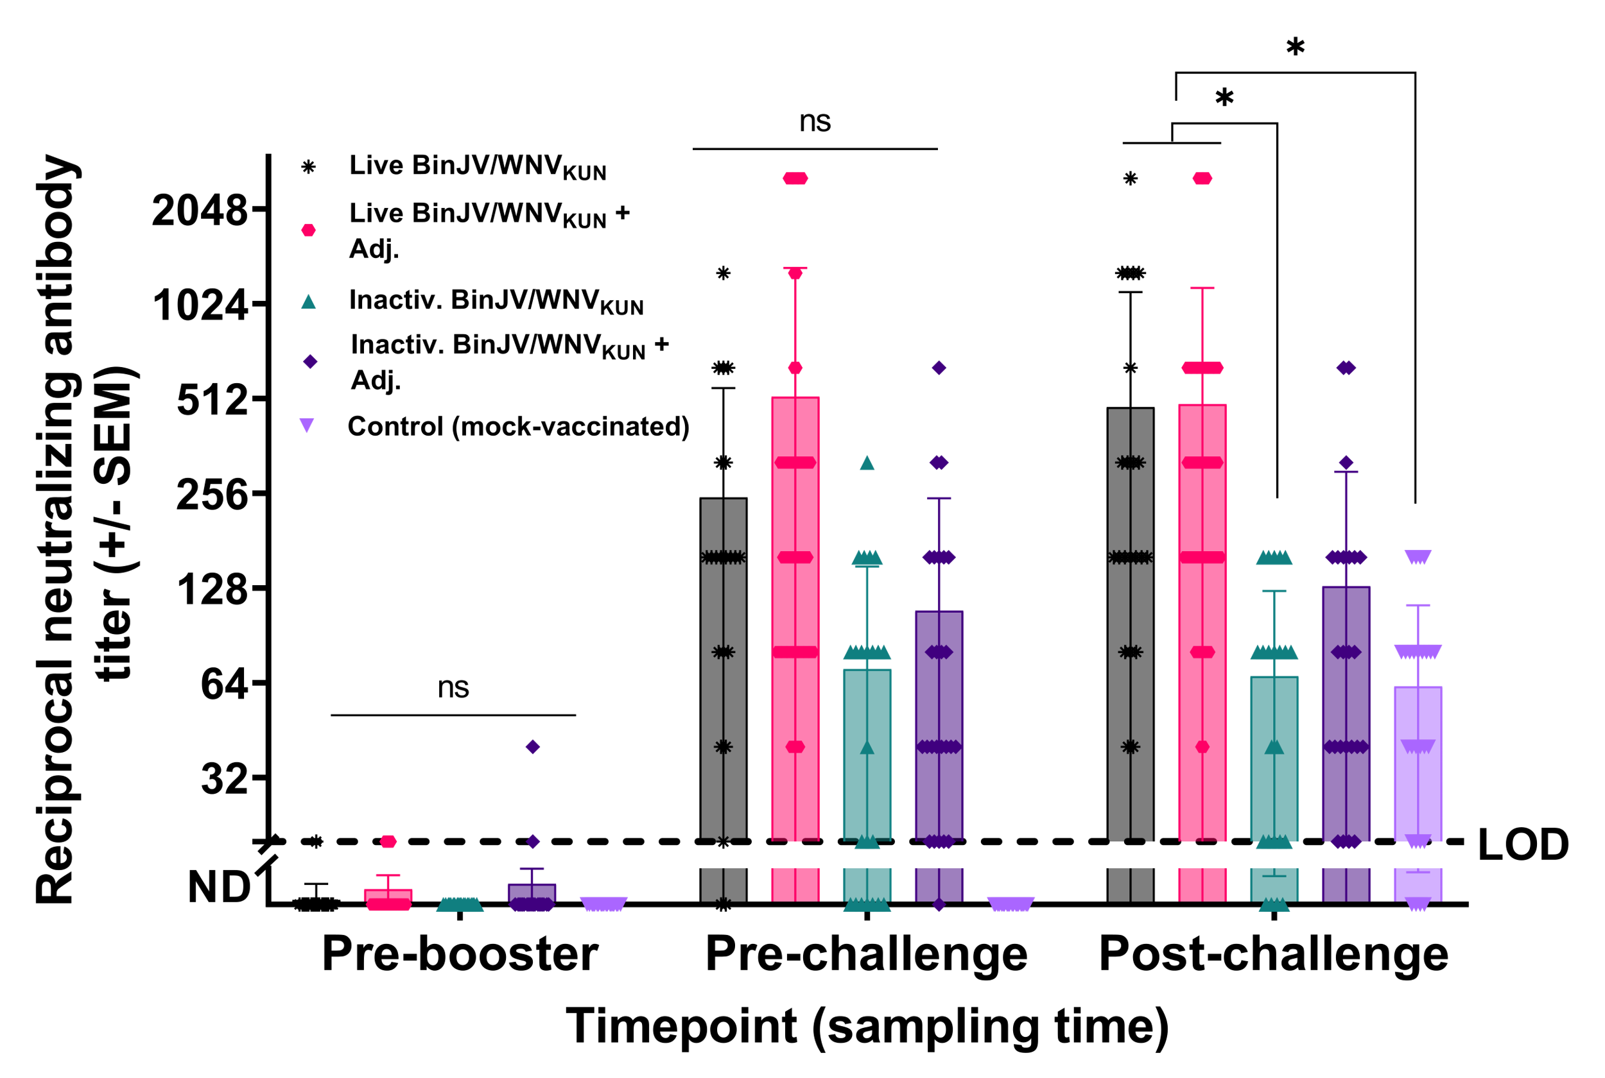
Supplementary Figure 4. Virus neutralisation antibody titres in saltwater crocodiles vaccinated with BinJV/WNV_{KUN} at multiple timepoints. The two-way ANOVA with a Tukey’s post-test statistical analysis to test differences in virus neutralising antibody titres between treatment groups at various timepoints. Significant statistical difference thresholds are *p ≤ 0.05, **p ≤ 0.01, ***p ≤ 0.001. Dotted line represents the limit of detection. The upper limit of detection of the assay was 2560.

