Supplementary data

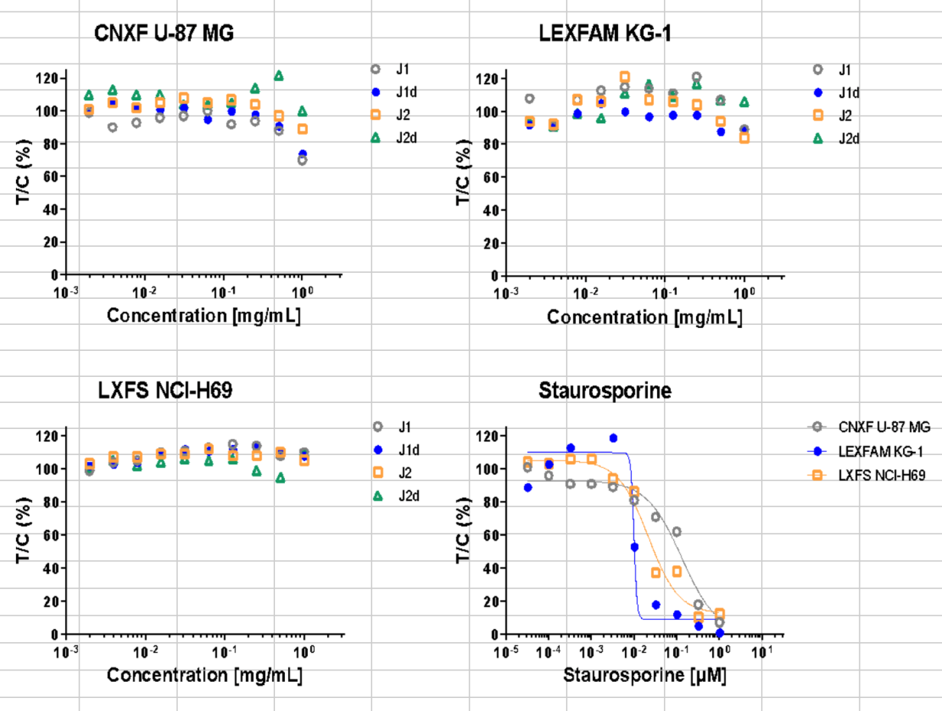
Figure 7. In vitro screening of Peptides J1, J1d, J2 & J2d versus U-87, KG1 & NCI-H69 cell lines.

Table 7.In vitro screening of Peptides J3d, J4d, Ap2d & Ap3d versus Glioblastoma U-87 cell line

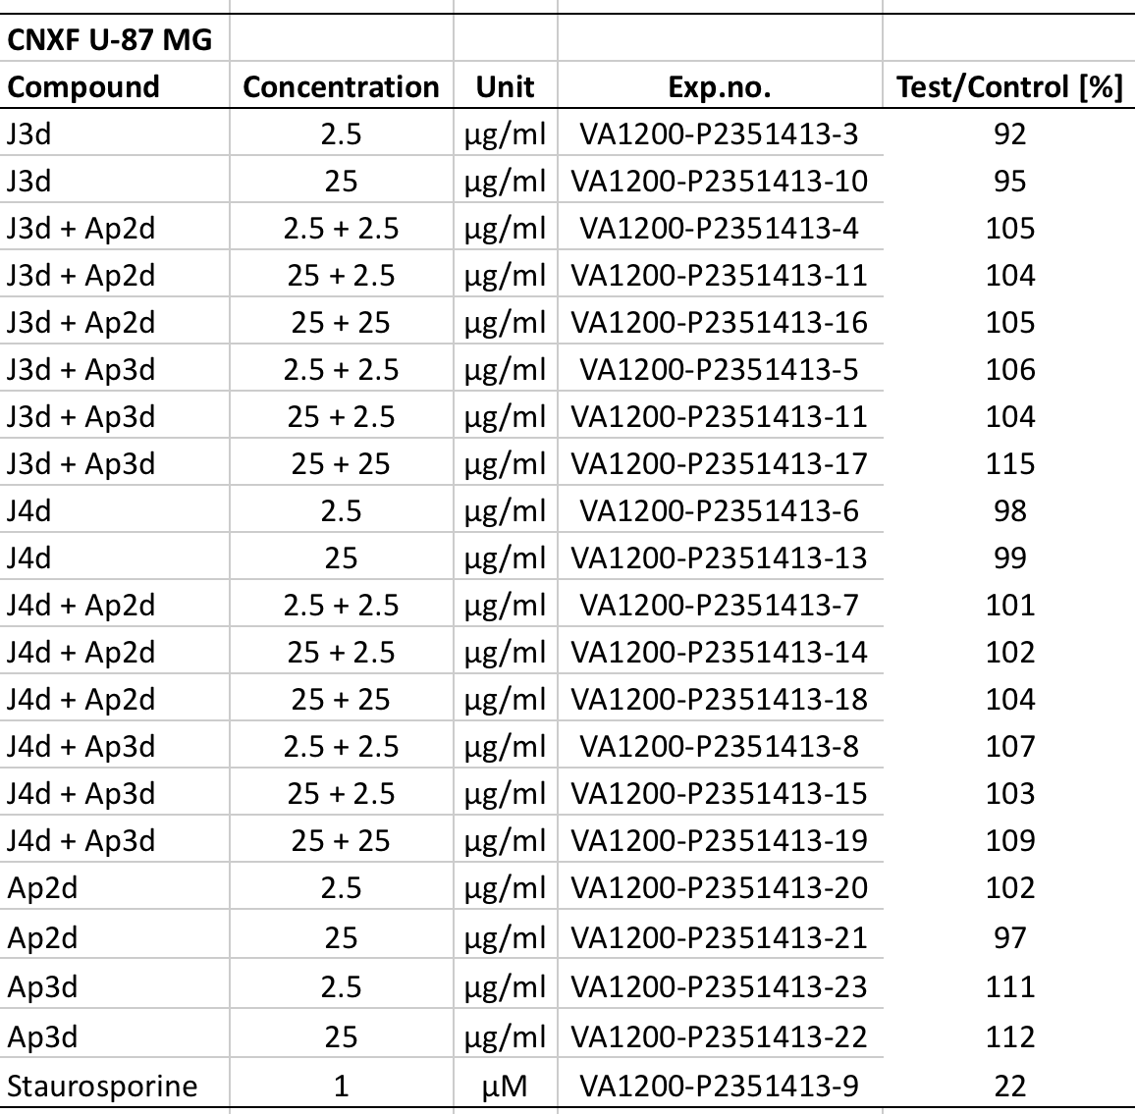
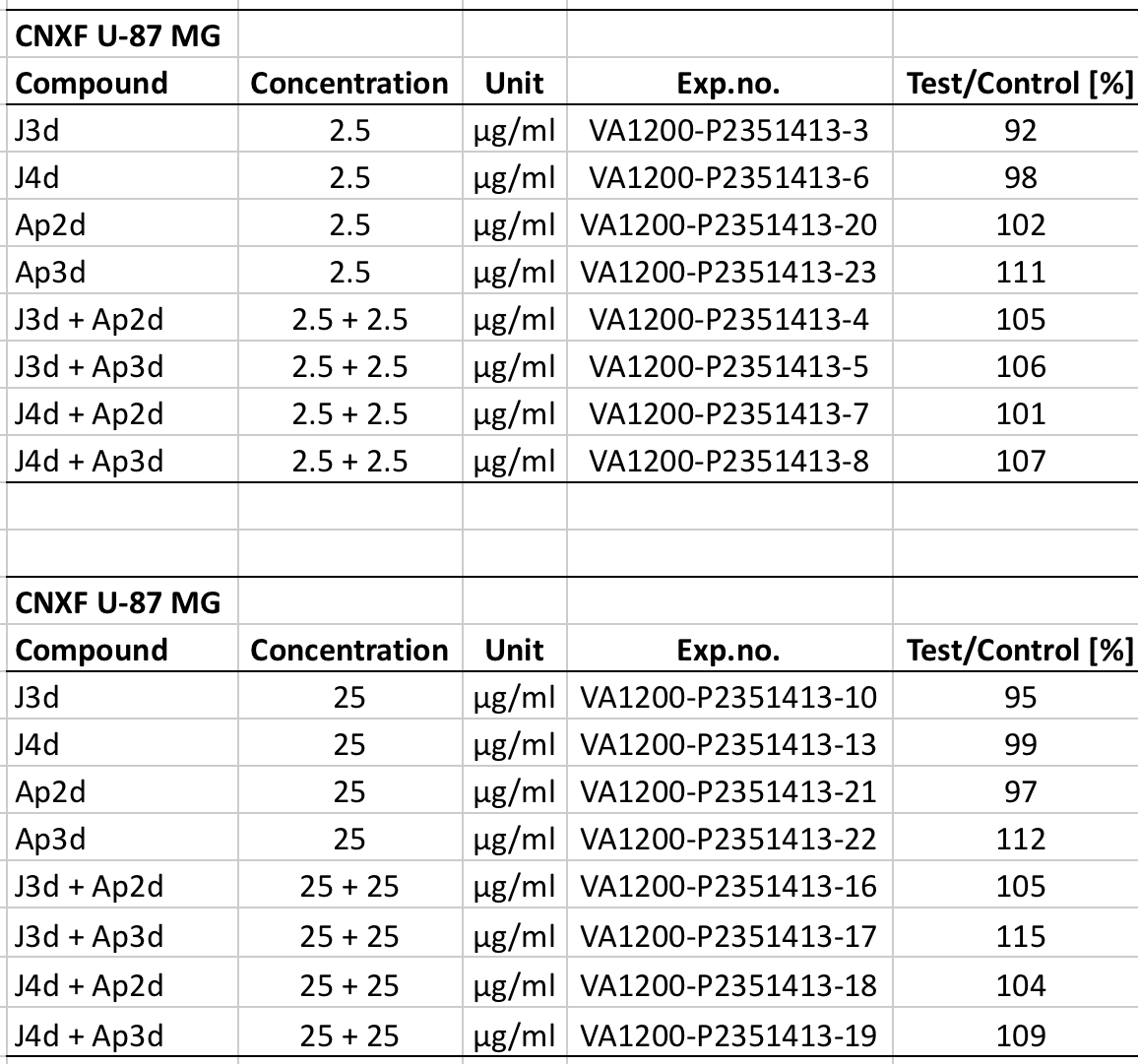

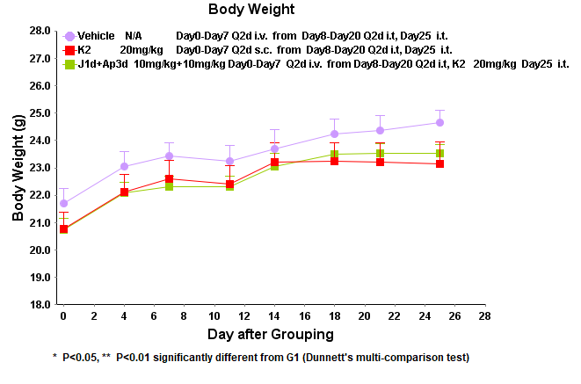

Figure 8. . Body Weight (g) of Mice in Different Groups of U-87 MG Model

Table 8. Body Weight (g) of Mice in Different Groups in Glioblastoma U-87 MG Model

Group |  | Days after inoculation
 |  | 0 | 4 | 7 | 11 | 14 | 18 | 21 | 25
G1 Vehicle Day0-Day7 Q2d i.v; from Day8-Day20 Q2d i.t, Day25 i.t. | Mean | 21.70 | 23.06 | 23.42 | 23.25 | 23.69 | 24.24 | 24.36 | 24.65
 | SEM | 0.56 | 0.52 | 0.50 | 0.57 | 0.72 | 0.55 | 0.55 | 0.47
G2 K2 20mg/kg Day0-Day7 Q2d s.c; from Day8-Day20 Q2d i.t, Day25 i.t. | Mean | 20.78 | 22.11 | 22.59 | 22.41 | 23.22 | 23.23 | 23.20 | 23.16
 | SEM | 0.59 | 0.66 | 0.70 | 0.65 | 0.69 | 0.68 | 0.70 | 0.80
 | P Value | 0.3741 | 0.3740 | 0.4609 | 0.4662 | 0.8212 | 0.3566 | 0.2587 | 0.1228
G3 J1d+Ap3d 10mg/kg +10mg/kg Day0-Day7 Q2d i.v; from Day8-Day20 Q2d i.t, K2 20mg/kg Day25 i.t | Mean | 20.74 | 22.07 | 22.32 | 22.31 | 23.06 | 23.50 | 23.53 | 23.53
 | SEM | 0.41 | 0.40 | 0.39 | 0.39 | 0.47 | 0.42 | 0.38 | 0.33
 | P Value | 0.3460 | 0.3459 | 0.2793 | 0.3857 | 0.7069 | 0.5554 | 0.4479 | 0.2572

Table 9. Tumor volume (mm³) of Mice in Different Groups in Glioblastoma U-87 MG Model
Group |  | Days after inoculation
 |  | 0 | 4 | 7 | 11 | 14 | 18 | 21 | 25
G1 Vehicle Day0-Day7 Q2d i.v; from Day8-Day20, Day25 Q2d i.t. | Mean | 138.26 | 255.49 | 449.92 | 776.70 | 1301.04 | 1741.40 | 2344.19 | 2857.39
 | SEM | 2.93 | 18.21 | 24.37 | 50.89 | 54.65 | 95.92 | 172.25 | 205.99
G2 K2 20mg/kg Day0-Day7 Q2d s.c; from Day8-Day20, Day25 Q2d i.t | Mean | 137.37 | 239.22 | 397.60 | 631.20 | 894.07 | 1282.53 | 1828.74 | 2305.43
 | SEM | 2.96 | 11.60 | 12.58 | 24.40 | 36.70 | 63.12 | 129.71 | 193.24
 | P Value | 0.9668 | 0.6228 | 0.0988 | 0.0195 | 0.0000 | 0.0019 | 0.0395 | 0.0733
G3 J1d+Ap3d 10mg/kg +10mg/kg Day0-Day7 Q2d i.v; from Day8-Day20, K2 20mg/kg Day25 i.t | Mean | 137.75 | 246.18 | 419.63 | 640.18 | 967.33 | 1331.54 | 1979.24 | 2348.61
 | SEM | 2.92 | 10.39 | 15.70 | 28.84 | 60.76 | 92.19 | 120.79 | 119.37
 | P Value | 0.9887 | 0.8502 | 0.4092 | 0.0284 | 0.0003 | 0.0050 | 0.1449 | 0.0892

Table10. Relative tumor volume of Mice in Different Groups for Glioblastoma U-87 MG Model

Group |  | Days after inoculation
 |  | 0 | 4 | 7 | 11 | 14 | 18 | 21 | 25
G1 Vehicle Day0-Day7 Q2d i.v; from Day8-Day20, Day25 Q2d i.t. | Mean | 1.00 | 1.85 | 3.26 | 5.64 | 9.45 | 12.63 | 16.94 | 20.62
 | SEM | 0.00 | 0.13 | 0.18 | 0.40 | 0.46 | 0.72 | 1.15 | 1.30
G2 K2 20mg/kg Day0-Day7 Q2d s.c; from Day8-Day20, Day25 Q2d i.t | Mean | 1.00 | 1.74 | 2.90 | 4.59 | 6.52 | 9.36 | 13.51 | 17.08
 | SEM | 0.00 | 0.07 | 0.09 | 0.14 | 0.27 | 0.49 | 1.08 | 1.67
 | P Value | N/A | 0.6593 | 0.1458 | 0.0309 | 0.0001 | 0.0046 | 0.0727 | 0.1367
G3 J1d+Ap3d 10mg/kg +10mg/kg Day0-Day7 Q2d i.v; from Day8-Day20, K2 20mg/kg Day25 i.t | Mean | 1.00 | 1.80 | 3.06 | 4.67 | 7.03 | 9.72 | 14.44 | 17.13
 | SEM | 0.00 | 0.10 | 0.14 | 0.26 | 0.44 | 0.76 | 1.02 | 1.02
 | P Value | N/A | 0.8934 | 0.4955 | 0.0459 | 0.0007 | 0.0110 | 0.1957 | 0.1271

Table11. Tumor Growth Inhibition in Different Groups in Glioblastoma U-87 MG Model
Day | G2 K2 20mg/kg Day0-Day7 Q2d s.c; from Day8-Day20, Day25 Q2d i.t | G3 J1d+Ap3d 10mg/kg +10mg/kg Day0-Day7 Q2d i.v; from Day8-Day20, K2 20mg/kg Day25 i.t
4 | 5.95% | 2.70%
7 | 11.04% | 6.13%
11 | 18.62% | 17.20%
14 | 31.01% | 25.61%
18 | 25.89% | 23.04%
21 | 20.25% | 14.76%
25 | 17.17% | 16.93%

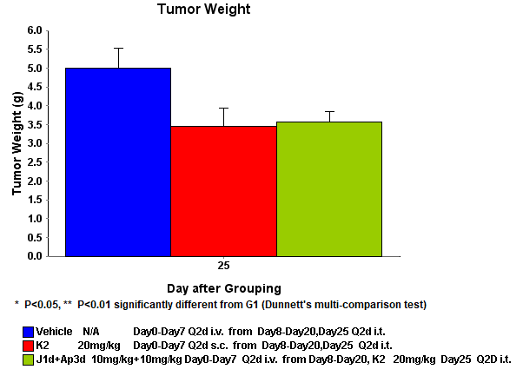
Figure 9. Tumor weight (g) of Mice in Different Groups on Day25 in Glioblastoma U-87 MG Model

Table12. Tumor Weight (g) of Mice in Different Groups on Day25 in Glioblastoma U-87 MG Model
Day | G1 Vehicle Day0-Day7 Q2d i.v; from Day8-Day20, Day25 Q2d i.t. |  | G2 K2 20mg/kg Day0-Day7 Q2d s.c; from Day8-Day20, Day25 Q2d i.t |  |  | G3 J1d+Ap3d 10mg/kg +10mg/kg Day0-Day7 Q2d i.v; from Day8-Day20, K2 20mg/kg Day25 i.t
Day | Mean | SEM | Mean | SEM | P Value | Mean | SEM | P Value
25 | 4.99 | 0.53 | 3.45 | 0.49 | 0.0829 | 3.57 | 0.28 | 0.0518

Table 13. Blood test of Mice in Different Groups on Day25 in Glioblastoma U-87 MG Model
Blood test time(h) | Group NO. |  | WBC | LYM# | MONO# | NEUT# | EO# | BASO#
2 | G1 | Mean | ULoQ* | 11.310 | 57.185 | 489.115 | 12.705 | 0.000
2 | G1 | SEM | N/A | 0.219 | 5.123 | 10.292 | 0.993 | 0.000
2 | G2 | Mean | ULoQ | 1.515 | 3.635 | 107.835 | 0.895 | 2.615
2 | G2 | SEM | N/A | 0.046 | 0.520 | 0.442 | 0.173 | 0.088
2 | G2 | P Value | N/A | 0.001 | 0.018 | 0.001 | 0.014 | 0.002
6 | G1 | Mean | ULoQ | 12.430 | 62.135 | 933.390 | 11.280 | 0.000
6 | G1 | SEM | N/A | 3.267 | 0.626 | 0.000 | 0.948 | 0.000
6 | G2 | Mean | ULoQ | 12.010 | 43.265 | N/A | 7.575 | 0.000
6 | G2 | SEM | N/A | 1.874 | 1.199 | N/A | 1.156 | 0.000
6 | G2 | P Value | N/A | 0.944 | 0.010 | N/A | 0.222 | N/A
24 | G1 | Mean | ULoQ | 11.608 | 50.855 | 682.490 | 10.965 | 0.000
24 | G1 | SEM | N/A | 1.613 | 5.408 | 82.215 | 0.427 | 0.000
24 | G2 | Mean | ULoQ | 7.683 | 28.830 | 406.160 | 4.653 | 2.343
24 | G2 | SEM | N/A | 3.535 | 10.833 | 177.623 | 1.240 | 1.074
24 | G2 | P Value | N/A | 0.397 | 0.159 | 0.434 | 0.006 | 0.086
ULoQ*: upper limits of quantification

Blood test time(h) | Group NO. |  | LYM% | MONO% | NEUT% | EO% | BASO%
2 | G1 | Mean | 1.950 | 10.000 | 85.850 | 2.20 | 0.000
2 | G1 | SEM | 0.106 | 0.636 | 0.318 | 0.212 | 0.000
2 | G2 | Mean | 1.250 | 3.150 | 92.600 | 0.700 | 2.300
2 | G2 | SEM | 0.035 | 0.389 | 0.566 | 0.141 | 0.071
2 | G2 | P Value | 0.047 | 0.023 | 0.018 | 0.053 | 0.002
6 | G1 | Mean | 1.050 | 5.650 | 92.300 | 1.000 | 0.000
6 | G1 | SEM | 0.247 | 0.318 | 0.071 | 0.000 | 0.000
6 | G2 | Mean | 1.000 | 3.800 | 94.600 | 0.600 | 0.000
6 | G2 | SEM | 0.212 | 0.212 | 0.354 | 0.071 | 0.000
6 | G2 | P Value | 0.924 | 0.076 | 0.046 | 0.057 | N/A
24 | G1 | Mean | 1.300 | 5.625 | 91.875 | 1.200 | 0.000
24 | G1 | SEM | 0.308 | 0.691 | 1.120 | 0.150 | 0.000
24 | G2 | Mean | 1.533 | 6.833 | 89.367 | 1.233 | 1.033
24 | G2 | SEM | 0.223 | 0.491 | 1.093 | 0.178 | 0.428
24 | G2 | P Value | 0.647 | 0.310 | 0.243 | 0.908 | 0.065

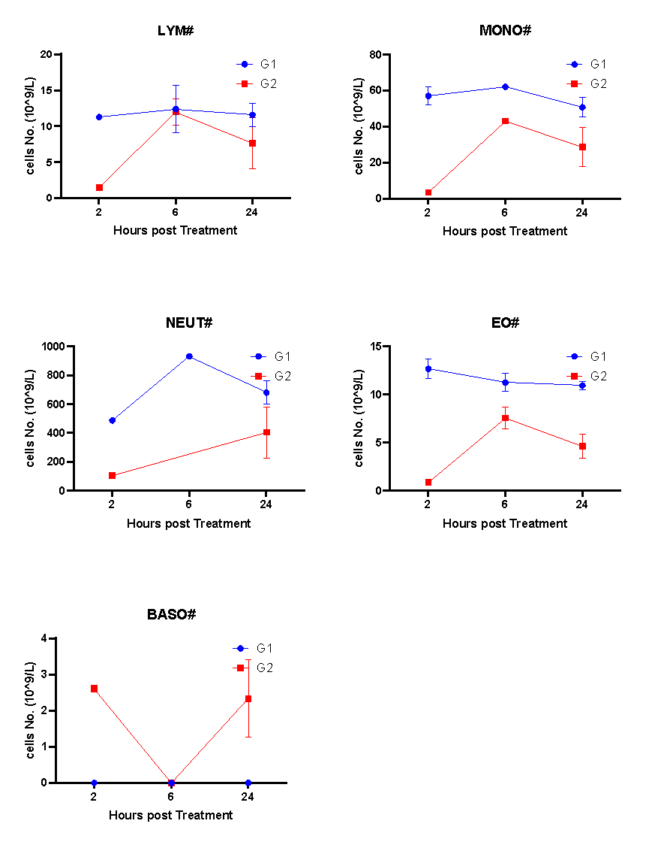
Figure 10. Blood test of Mice in Different Groups on Day25 in Glioblastoma U-87 MG Model

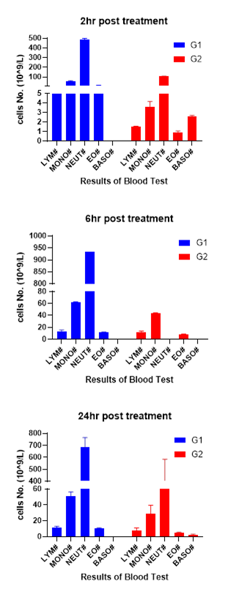
Figure 11. Blood test of Mice in Different Groups on Day25 in Glioblastoma U-87 MG Model

Table 14. Individual and Mean Conc. of K2 in Glioblastoma U-87 MG BALB/c nude Mice Plasma
Animal No. | Time (h) |  | Plasma
Animal No. |  |  | Conc.(ng/mL) | Mean | SD
G2-1 | 0.083 |  | 15.6 | 13.1 | 3.61
G2-2 |  |  | 10.5 | 13.1 | 3.61
G2-5 | 0.25 |  | 12.9 | 12.9 | NA
G2-6 |  |  | BQL | 12.9 | NA
G2-1 | 0.5 |  | 6.59 | 4.69 | 2.69
G2-2 |  |  | 2.79 | 4.69 | 2.69
G2-5 | 1 |  | BQL | BQL | NA
G2-6 |  |  | BQL | BQL | NA
G2-1 | 2 |  | 37.8 | 37.8 | NA
G2-2 |  |  | BQL | 37.8 | NA
G2-3 | 6 |  | BQL | BQL | NA
G2-4 |  |  | BQL | BQL | NA
G2-5 | 24 |  | BQL | BQL | NA
G2-6 |  |  | BQL | BQL | NA
 | Note:
 | 1. NA: Not available.
 | 2. BQL=Below the Low limit of quantifiable (2.0 ng/mL for plasma).

Table 15. Individual and Mean Conc. of K2 in Glioblastoma U-87 MG BALB/c nude Mice Tumor

Group | Time (h) | Animal ID |  | Tumor homogenate Concentration  (ng/mL) |  | Homogenate factor(mL/g) |  | Tumor Concentration (ng/g)
G2 | 2 | G2-1 |  | 193 |  | 4 |  | 772
G2 | 2 | G2-2 |  | 273 |  | 4 |  | 1092
G2 | 2 | Mean |  | 233 |  | NA |  | 932
G2 | 2 | SD |  | 56.6 |  | NA |  | 226
G2 | 6 | G2-3 |  | 91.2 |  | 4 |  | 365
G2 | 6 | G2-4 |  | 162 |  | 4 |  | 648
G2 | 6 | Mean |  | 127 |  | NA |  | 506
G2 | 6 | SD |  | 50.1 |  | NA |  | 200
G2 | 24 | G2-5 |  | 169 |  | 4 |  | 676
G2 | 24 | G2-6 |  | 920 |  | 4 |  | 3680
G2 | 24 | Mean |  | 545 |  | NA |  | 2178
G2 | 24 | SD |  | 531 |  | NA |  | 2124
G3 | 0.083 | G3-3 |  | 156 |  | 4 |  | 624
G3 | 0.083 | G3-4 |  | 40.4 |  | 4 |  | 162
G3 | 0.083 | Mean |  | 98.2 |  | NA |  | 393
G3 | 0.083 | SD |  | 81.7 |  | NA |  | 327
G3 | 0.25 | G3-5 |  | 160 |  | 4 |  | 640
G3 | 0.25 | G3-6 |  | 52.7 |  | 4 |  | 211
G3 | 0.25 | Mean |  | 106 |  | NA |  | 425
G3 | 0.25 | SD |  | 75.9 |  | NA |  | 303
G3 | 0.5 | G3-7 |  | 292 |  | 4 |  | 1168
G3 | 0.5 | G3-8 |  | 21.5 |  | 4 |  | 86.0
G3 | 0.5 | Mean |  | 157 |  | NA |  | 627
G3 | 0.5 | SD |  | 191 |  | NA |  | 765
 | Note:
 | 1. NA: Not available.
 | 2. BQL=Below the Low limit of quantifiable (20.0 ng/g for tumor).

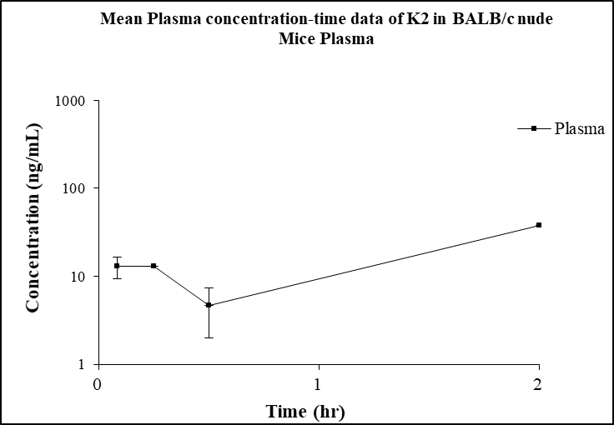
Figure 12. Mean Plasma concentration-time data of K2 in Glioblastoma U-87 MG BALB/c nude Mice Plasma
Table 16. Mean Plasma PK Parameters of K2 in BALB/c nude Mice Plasma
PK parameters (unit) | Plasma
T_{max} (hr) | 2.00
C_{max} (ng/mL) | 37.8
HL_Lambda_z (hr) | NA
AUC_{last} (hr*ng/mL) | 36.8
AUC_{INF}_pred (hr*ng/mL) | NA
CL_pred (mL/hr/kg) | NA
Rsq_adjusted | NA
MRT_{INF_}pred(hr) | NA

Table 17. Individual and Mean Conc. Ratio of Tumor/Plasma of K2 in Glioblastoma U-87 MG BALB/c nude Mice
Animal No. | Time (h) | Tumor/Plasma | Mean | SD
G2-1 | 2 | 20.4 | 20.4 | NA
G2-2 | 2 | NA | 20.4 | NA
G2-3 | 6 | NA | NA | NA
G2-4 | 6 | NA | NA | NA
G2-5 | 24 | NA | NA | NA
G2-6 | 24 | NA | NA | NA

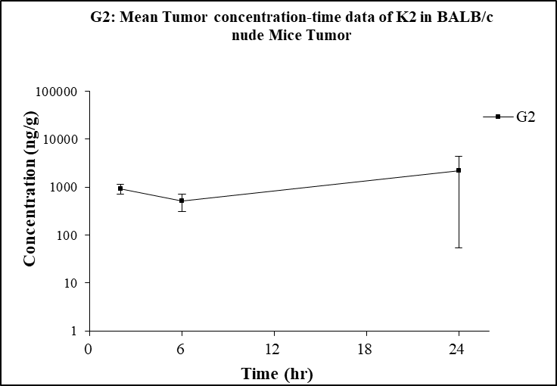

Figure 13. G2: Mean Tumor concentration-time data of K2 in Glioblastoma U-87 MG BALB/c nude Mice Tumor

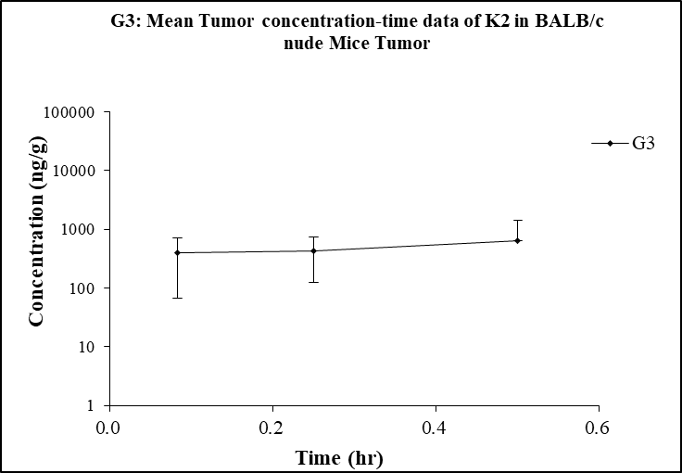

Figure 14. G3: Mean Tumor concentration-time data of K2 in Glioblastoma U-87 MG BALB/c nude Mice Tumor

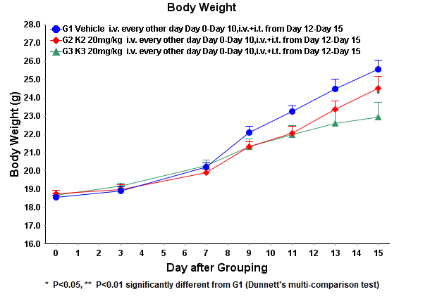
Figure 15. Body Weight (g) of Mice in Different Groups in Leukemia C1498 Syngeneic Model

Table 18. Body Weight (g) of Mice in Different Groups in Leukemia C1498 Syngeneic Model
Group |  | Days after inoculation
 |  | 0 | 3 | 7 | 9 | 11 | 13 | 15
G1 Vehicle i.v. every other day Day0-Day10,i.v.+i.t. from Day12-Day15 | Mean | 18.56 | 18.92 | 20.21 | 22.11 | 23.25 | 24.50 | 25.55
 | SEM | 0.11 | 0.21 | 0.24 | 0.33 | 0.32 | 0.51 | 0.50
G2 K2 20mg/kg i.v. every other day Day0-Day10,i.v.+i.t. from Day12-Day15 | Mean | 18.76 | 18.99 | 19.90 | 21.31 | 22.07 | 23.38 | 24.52
 | SEM | 0.16 | 0.25 | 0.20 | 0.28 | 0.39 | 0.44 | 0.67
 | P Value | 0.398 | 0.958 | 0.519 | 0.200 | 0.101 | 0.360 | 0.461
G3 K3 20mg/kg i.v. every other day Day0-Day10,i.v.+i.t. from Day12-Day15 | Mean | 18.68 | 19.17 | 20.28 | 21.34 | 21.98 | 22.61 | 22.95
 | SEM | 0.09 | 0.16 | 0.33 | 0.41 | 0.51 | 0.72 | 0.78
 | P Value | 0.686 | 0.622 | 0.980 | 0.220 | 0.075 | 0.056 | 0.017

Table 19. Tumor volume (mm³) of Mice in Different Groups in Leukemia C1498 Syngeneic Model

Group |  | Days after inoculation
 |  | 0 | 3 | 7 | 9 | 11 | 13 | 15
G1 Vehicle i.v. every other day Day0-Day10,i.v.+i.t. from Day12-Day15 | Mean | 78.32 | 178.76 | 822.22 | 1419.28 | 2230.20 | 3106.59 | 3920.46
 | SEM | 0.74 | 1.38 | 6.89 | 26.19 | 46.19 | 54.54 | 55.17
G2 K2 20mg/kg i.v. every other day Day0-Day10,i.v.+i.t. from Day12-Day15 | Mean | 78.59 | 170.45 | 696.98 | 1073.05 | 1872.49 | 2431.61 | 3273.96
 | SEM | 0.68 | 3.98 | 8.69 | 26.15 | 77.52 | 87.61 | 94.91
 | P Value | 0.950 | 0.110 | <0.001 | <0.001 | 0.022 | 0.002 | 0.000
G3 K3 20mg/kg i.v. every other day Day0-Day10,i.v.+i.t. from Day12-Day15 | Mean | 78.38 | 173.34 | 698.89 | 1093.57 | 1846.52 | 2436.61 | 3558.21
 | SEM | 0.70 | 2.66 | 17.64 | 49.98 | 130.20 | 169.00 | 117.92
 | P Value | 0.997 | 0.147 | <0.001 | <0.001 | 0.014 | 0.001 | 0.013

Table20. Relative tumor volume of Mice in Different Groups in Leukemia C1498 Syngeneic Model

Group |  | Days after inoculation
 |  | 0 | 3 | 7 | 9 | 11 | 13 | 15
G1 Vehicle i.v. every other day Day0-Day10,i.v.+i.t. from Day12-Day15 | Mean | 1.00 | 2.28 | 10.50 | 18.13 | 28.49 | 39.69 | 50.11
 | SEM | 0.00 | 0.03 | 0.13 | 0.38 | 0.66 | 0.80 | 0.98
G2 K2 20mg/kg i.v. every other day Day0-Day10,i.v.+i.t. from Day12-Day15 | Mean | 1.00 | 2.17 | 8.87 | 13.65 | 23.78 | 31.01 | 41.90
 | SEM | 0.00 | 0.04 | 0.10 | 0.29 | 0.84 | 0.85 | 0.72
 | P Value | - | 0.052 | <0.001 | <0.001 | 0.014 | 0.001 | 0.001
G3 K3 20mg/kg i.v. every other day Day0-Day10,i.v.+i.t. from Day12-Day15 | Mean | 1.00 | 2.21 | 8.91 | 13.94 | 23.53 | 31.04 | 45.31
 | SEM | 0.00 | 0.04 | 0.20 | 0.60 | 1.62 | 2.09 | 1.77
 | P Value | - | 0.270 | <0.001 | <0.001 | 0.009 | 0.001 | 0.025

Table 21. Tumor Growth Inhibition in Different Groups in Leukemia C1498 Syngeneic Model

Day | G2 K2 20mg/kg i.v. every other day Day0-Day10, i.v.+i.t. from Day12-Day15 | G3 K3 20mg/kg i.v. every other day Day0-Day10, i.v.+i.t. from Day12-Day15
Day | TGI% | TGI%
3 | 5.06 | 3.13
7 | 15.55 | 15.14
9 | 24.72 | 23.13
11 | 16.54 | 17.43
13 | 21.88 | 21.79
15 | 16.38 | 9.57

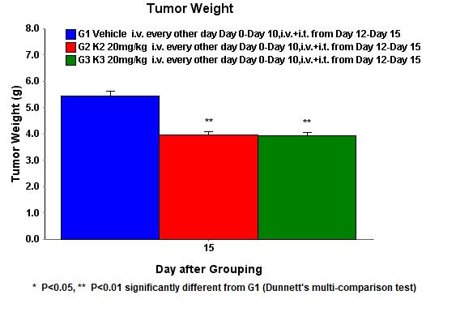
Figure 16. Tumor Weight at the Study Termination in Leukemia C1498 Syngeneic Model

Table 22. Tumor Weight (g) of Mice in Different Groups in Leukemia C1498 Syngeneic Model

Day20 | Mean | SEM | P Value | IR_{TW}%
G1 Vehicle i.v. every other day Day0-Day10,i.v.+i.t. from Day12-Day15 | 5.44 | 0.18 | - | -
G2 K2 20mg/kg i.v. every other day Day0-Day10,i.v.+i.t. from Day12-Day15 | 3.95 | 0.14 | <0.001 | 27.39%
G3 K3 20mg/kg i.v. every other day Day0-Day10,i.v.+i.t. from Day12-Day15 | 3.94 | 0.13 | <0.001 | 27.57%

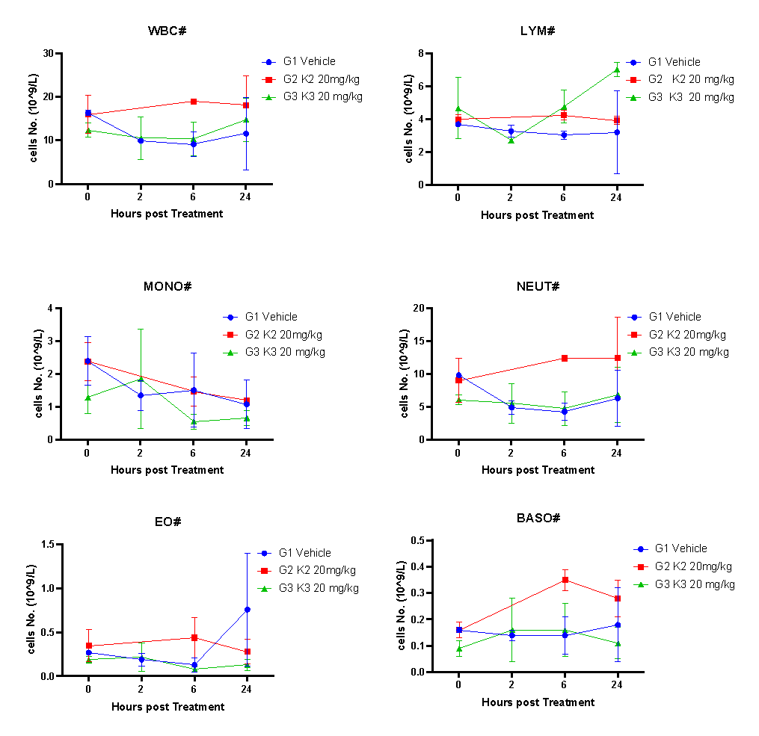
Figure 17. Blood test of Mice in Different Groups on Day15 in Leukemia C1498 Syngeneic Model

Table 23. Blood test of Mice in Different Groups on Day15 in Leukemia C1498 Syngeneic Model

Blood test time(h) | Group NO. |  | WBC | LYM# | MONO# | NEUT# | EO# | BASO#
Pre-dose | G1 | Mean | 16.425 | 3.705 | 2.410 | 9.890 | 0.265 | 0.155
Pre-dose | G1 | SEM | 0.605 | 0.105 | 0.740 | 0.250 | 0.015 | 0.005
Pre-dose | G2 | Mean | 15.975 | 4.020 | 2.385 | 9.065 | 0.345 | 0.160
Pre-dose | G2 | SEM | 4.415 | 0.300 | 0.585 | 3.325 | 0.175 | 0.030
Pre-dose | G2 | P Value | 0.929 | 0.426 | 0.981 | 0.828 | 0.693 | 0.885
Pre-dose | G3 | Mean | 12.425 | 4.700 | 1.300 | 6.150 | 0.185 | 0.090
Pre-dose | G3 | SEM | 1.655 | 1.880 | 0.500 | 0.730 | 0.035 | 0.030
Pre-dose | G3 | P Value | 0.151 | 0.650 | 0.340 | 0.040 | 0.170 | 0.166
2 | G1 | Mean | 9.935 | 3.275 | 1.355 | 4.980 | 0.185 | 0.140
2 | G1 | SEM | 0.115 | 0.355 | 0.445 | 1.000 | 0.065 | 0.020
2 | G3 | Mean | 10.590 | 2.725 | 1.865 | 5.620 | 0.220 | 0.160
2 | G3 | SEM | 4.920 | 0.135 | 1.505 | 3.000 | 0.160 | 0.120
2 | G3 | P Value | 0.906 | 0.285 | 0.776 | 0.858 | 0.858 | 0.885
6 | G1 | Mean | 9.165 | 3.050 | 1.515 | 4.330 | 0.130 | 0.140
6 | G1 | SEM | 2.785 | 0.240 | 1.115 | 1.280 | 0.080 | 0.070
6 | G2 | Mean | 19.010 | 4.265 | 1.480 | 12.475 | 0.440 | 0.350
6 | G2 | SEM | 0.080 | 0.305 | 0.450 | 0.415 | 0.230 | 0.040
6 | G2 | P Value | 0.072 | 0.089 | 0.979 | 0.026 | 0.331 | 0.121
6 | G3 | Mean | 10.385 | 4.790 | 0.555 | 4.810 | 0.075 | 0.155
6 | G3 | SEM | 3.905 | 1.000 | 0.225 | 2.560 | 0.025 | 0.095
6 | G3 | P Value | 0.823 | 0.233 | 0.488 | 0.882 | 0.579 | 0.910
24 | G1 | Mean | 11.615 | 3.220 | 1.085 | 6.370 | 0.760 | 0.180
24 | G1 | SEM | 8.285 | 2.510 | 0.725 | 4.270 | 0.640 | 0.140
24 | G2 | Mean | 18.180 | 3.935 | 1.220 | 12.470 | 0.275 | 0.280
24 | G2 | SEM | 6.760 | 0.255 | 0.030 | 6.270 | 0.135 | 0.070
24 | G2 | P Value | 0.602 | 0.804 | 0.870 | 0.506 | 0.536 | 0.588
24 | G3 | Mean | 14.835 | 7.040 | 0.665 | 6.895 | 0.125 | 0.110
24 | G3 | SEM | 4.975 | 0.440 | 0.215 | 4.205 | 0.055 | 0.060
24 | G3 | P Value | 0.771 | 0.273 | 0.634 | 0.938 | 0.427 | 0.691

Blood test time(h) | Group NO. |  | LYM% | MONO% | NEUT% | EO% | BASO%
Pre-dose | G1 | Mean | 22.600 | 14.500 | 60.350 | 1.600 | 0.950
Pre-dose | G1 | SEM | 0.200 | 4.000 | 3.750 | 0.000 | 0.050
Pre-dose | G2 | Mean | 26.700 | 15.050 | 55.250 | 2.000 | 1.000
Pre-dose | G2 | SEM | 5.500 | 0.450 | 5.550 | 0.500 | 0.100
Pre-dose | G2 | P Value | 0.534 | 0.904 | 0.526 | 0.508 | 0.698
Pre-dose | G3 | Mean | 36.450 | 10.150 | 51.200 | 1.450 | 0.750
Pre-dose | G3 | SEM | 10.250 | 2.750 | 12.700 | 0.050 | 0.350
Pre-dose | G3 | P Value | 0.309 | 0.465 | 0.561 | 0.095 | 0.629
2 | G1 | Mean | 32.950 | 13.750 | 50.000 | 1.900 | 1.400
2 | G1 | SEM | 3.950 | 4.650 | 9.500 | 0.700 | 0.200
2 | G3 | Mean | 32.000 | 14.100 | 50.850 | 1.750 | 1.300
2 | G3 | SEM | 13.500 | 7.600 | 4.750 | 0.650 | 0.500
2 | G3 | P Value | 0.952 | 0.972 | 0.944 | 0.890 | 0.870
6 | G1 | Mean | 35.750 | 14.150 | 47.350 | 1.300 | 1.450
6 | G1 | SEM | 8.250 | 7.850 | 0.450 | 0.500 | 0.350
6 | G2 | Mean | 22.500 | 7.700 | 65.700 | 2.300 | 1.800
6 | G2 | SEM | 1.500 | 2.400 | 1.900 | 1.200 | 0.200
6 | G2 | P Value | 0.255 | 0.514 | 0.011 | 0.522 | 0.477
6 | G3 | Mean | 49.500 | 5.200 | 43.150 | 0.750 | 1.400
6 | G3 | SEM | 9.000 | 0.200 | 8.450 | 0.050 | 0.400
6 | G3 | P Value | 0.377 | 0.372 | 0.669 | 0.388 | 0.934
24 | G1 | Mean | 25.000 | 9.900 | 58.250 | 5.400 | 1.450
24 | G1 | SEM | 3.800 | 0.800 | 4.750 | 1.600 | 0.150
24 | G2 | Mean | 24.500 | 7.700 | 64.750 | 1.450 | 1.600
24 | G2 | SEM | 7.700 | 2.700 | 10.450 | 0.150 | 0.200
24 | G2 | P Value | 0.959 | 0.516 | 0.628 | 0.133 | 0.609
24 | G3 | Mean | 52.350 | 4.500 | 41.700 | 0.800 | 0.650
24 | G3 | SEM | 14.550 | 0.100 | 14.400 | 0.100 | 0.150
24 | G3 | P Value | 0.211 | 0.022 | 0.389 | 0.103 | 0.064

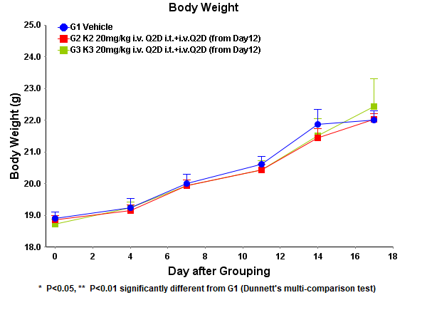
Figure 18. Body Weight (g) of Mice in Different Groups in Lung Carcinoma LLC Syngeneic Model

Table 24. Body Weight (g) of Mice in Different Groups in Lung Carcinoma LLC Syngeneic Model
Days | G1 Vehicle  Day0-Day10 Q2d i.v; from Day12 Q2d i.t + i.v |  | G2 K2 20mg/kg  Day0-Day10 Q2d i.v; from Day12 Q2d i.t + i.v |  |  | G3 K3 20mg/kg  Day0-Day10 Q2d i.v; from Day12 Q2d i.t + i.v
Days | Mean | SEM | Mean | SEM | P Value | Mean | SEM | P Value
0 | 18.91 | 0.19 | 18.85 | 0.15 | 0.955 | 18.72 | 0.16 | 0.632
4 | 19.24 | 0.30 | 19.16 | 0.18 | 0.953 | 19.24 | 0.17 | 1.000
7 | 20.00 | 0.29 | 19.94 | 0.18 | 0.978 | 19.94 | 0.19 | 0.977
11 | 20.61 | 0.26 | 20.43 | 0.18 | 0.837 | 20.44 | 0.30 | 0.841
14 | 21.87 | 0.47 | 21.46 | 0.28 | 0.758 | 21.52 | 0.54 | 0.804
17 | 22.00 | 0.30 | 22.02 | 0.18 | 0.998 | 22.44 | 0.87 | 0.859

Table 25. Tumor volume (mm³) of Mice in Different Groups in Lung Carcinoma LLC Syngeneic Model
Days | G1 Vehicle  Day0-Day10 Q2d i.v; from Day12 Q2d i.t + i.v |  | G2 K2 20mg/kg  Day0-Day10 Q2d i.v; from Day12 Q2d i.t + i.v |  |  | G3 K3 20mg/kg  Day0-Day10 Q2d i.v; from Day12 Q2d i.t + i.v
Days | Mean | SEM | Mean | SEM | P Value | Mean | SEM | P Value
0 | 77.82 | 0.33 | 77.79 | 0.38 | 0.997 | 77.71 | 0.32 | 0.965
4 | 332.32 | 12.43 | 219.36 | 4.17 | <0.001 | 235.43 | 3.38 | <0.001
7 | 771.51 | 13.90 | 482.83 | 11.21 | <0.001 | 506.81 | 4.43 | <0.001
11 | 1104.75 | 7.16 | 955.51 | 9.49 | <0.001 | 1030.36 | 7.74 | <0.001
14 | 2769.16 | 55.43 | 2392.73 | 115.06 | 0.036 | 2577.44 | 127.75 | 0.326
17 | 4835.96 | 78.57 | 4269.96 | 81.90 | 0.074 | 3893.66 | 282.72 | 0.003

Table 26. Relative tumor volume of Mice in Different Groups in Lung Carcinoma LLC Syngeneic Model
Days | G1 Vehicle  Day0-Day10 Q2d i.v; from Day12 Q2d i.t + i.v |  | G2 K2 20mg/kg  Day0-Day10 Q2d i.v; from Day12 Q2d i.t + i.v |  |  | G3 K3 20mg/kg  Day0-Day10 Q2d i.v; from Day12 Q2d i.t + i.v
Days | Mean | SEM | Mean | SEM | P Value | Mean | SEM | P Value
0 | 1.00 | 0.00 | 1.00 | 0.00 | N/A | 1.00 | 0.00 | N/A
4 | 4.27 | 0.16 | 2.82 | 0.06 | <0.001 | 3.03 | 0.05 | <0.001
7 | 9.92 | 0.19 | 6.21 | 0.14 | <0.001 | 6.52 | 0.06 | <0.001
11 | 14.20 | 0.08 | 12.28 | 0.10 | <0.001 | 13.26 | 0.13 | <0.001
14 | 35.58 | 0.67 | 30.80 | 1.54 | 0.046 | 33.20 | 1.72 | 0.371
17 | 62.09 | 0.95 | 54.83 | 1.07 | 0.087 | 50.33 | 3.82 | 0.004

Table 27. Tumor Growth Inhibition in Different Groups in Lung Carcinoma LLC Syngeneic Model
Days | G2 K2 20mg/kg  Day0-Day10 Q2d i.v; from Day12 Q2d i.t + i.v |  | G3 K3 20mg/kg  Day0-Day10 Q2d i.v; from Day12 Q2d i.t + i.v
Days | RTV | TGI | RTV | TGI
4 | 2.82 | 33.96% | 3.03 | 29.04%
7 | 6.21 | 37.40% | 6.52 | 34.27%
11 | 12.28 | 13.52% | 13.26 | 6.62%
14 | 30.80 | 13.43% | 33.20 | 6.69%
17 | 54.83 | 11.69% | 50.33 | 18.94%

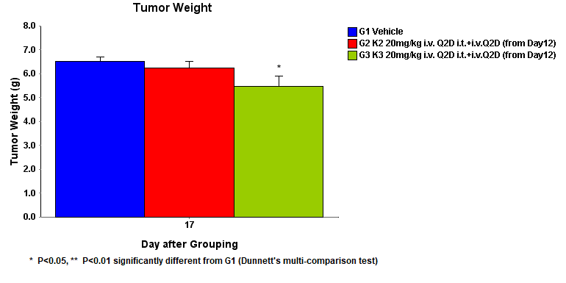
Figure 19. Tumor weight (g) of Mice in Different Groups on Day17 in Lung Carcinoma LLC Syngeneic Model

Table 28. Tumor Weight (g) of Mice in Different Groups on Day17 in Lung Carcinoma LLC Syngeneic Model
Day17 | Mean | SEM | P Value | IR_{TW}%
G1 Vehicle i.v. every other day Day0-Day10,i.v.+i.t. from Day12-Day15 | 6.52 | 0.17 | - | -
G2 K2 20mg/kg i.v. every other day Day0-Day10,i.v.+i.t. from Day12-Day15 | 6.23 | 0.29 | 0.730 | 4.45%
G3 K3 20mg/kg i.v. every other day Day0-Day10,i.v.+i.t. from Day12-Day15 | 5.48 | 0.41 | 0.039 | 15.95%

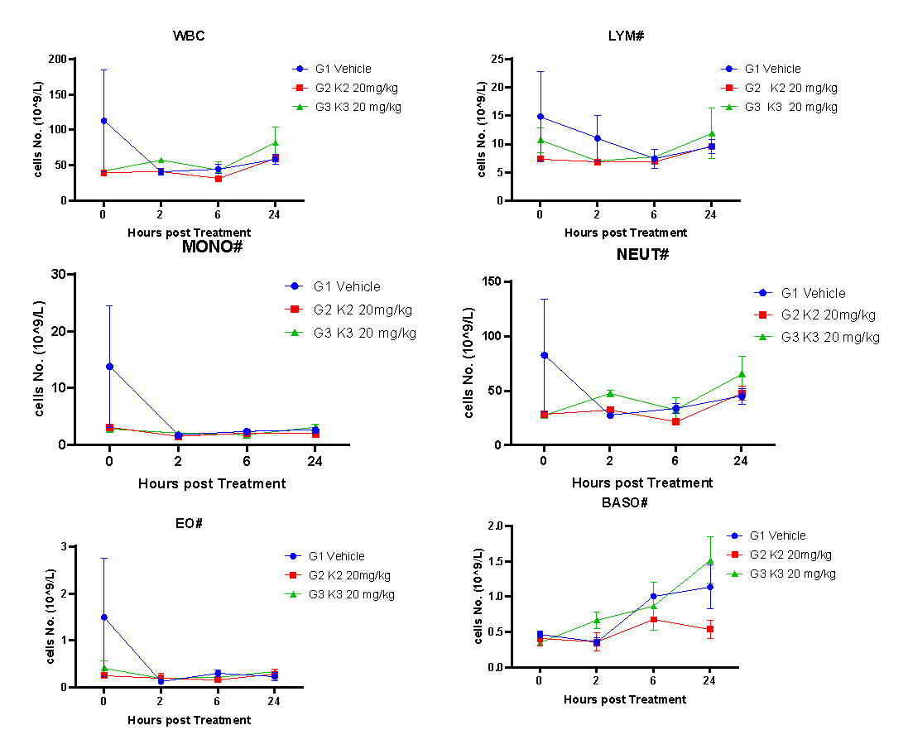
Figure 20. Blood test of Mice in Different Groups on Day17 in Lung Carcinoma LLC Syngeneic Model

Table 29. Blood test of Mice in Different Groups on Day17 in Lung Carcinoma LLC Syngeneic Model

Blood test time(h) | Group NO. |  |  |  | WBC |  | LYM# |  | MONO# |  | NEUT# |  | EO# |  | BASO#
Pre-dose | G1 |  | Mean |  | 113.315 |  | 14.890 |  | 13.815 |  | 82.640 |  | 1.500 |  | 0.470
Pre-dose |  |  | SEM |  | 71.735 |  | 7.880 |  | 10.695 |  | 51.850 |  | 1.260 |  | 0.050
Pre-dose | G2 |  | Mean |  | 39.705 |  | 7.385 |  | 3.100 |  | 28.555 |  | 0.260 |  | 0.405
Pre-dose |  |  | SEM |  | 0.215 |  | 0.275 |  | 0.240 |  | 0.695 |  | 0.060 |  | 0.095
Pre-dose |  |  | P Value |  | 0.413 |  | 0.442 |  | 0.422 |  | 0.406 |  | 0.429 |  | 0.606
Pre-dose | G3 |  | Mean |  | 42.330 |  | 10.770 |  | 2.840 |  | 27.950 |  | 0.420 |  | 0.350
Pre-dose |  |  | SEM |  | 1.080 |  | 2.200 |  | 0.480 |  | 1.740 |  | 0.150 |  | 0.010
Pre-dose |  |  | P Value |  | 0.427 |  | 0.665 |  | 0.413 |  | 0.402 |  | 0.484 |  | 0.143
2 | G1 |  | Mean |  | 40.860 |  | 11.055 |  | 1.715 |  | 27.605 |  | 0.130 |  | 0.355
2 |  |  | SEM |  | 4.720 |  | 3.975 |  | 0.055 |  | 0.845 |  | 0.010 |  | 0.055
2 | G2 |  | Mean |  | 41.760 |  | 6.885 |  | 1.510 |  | 32.800 |  | 0.210 |  | 0.355
2 |  |  | SEM |  | 0.790 |  | 0.365 |  | 0.190 |  | 0.840 |  | 0.100 |  | 0.125
2 |  |  | P Value |  | 0.868 |  | 0.406 |  | 0.409 |  | 0.049 |  | 0.509 |  | 1.000
2 | G3 |  | Mean |  | 57.650 |  | 7.080 |  | 2.010 |  | 47.690 |  | 0.200 |  | 0.670
2 |  |  | SEM |  | 3.000 |  | 0.420 |  | 0.290 |  | 2.990 |  | 0.020 |  | 0.120
2 |  |  | P Value |  | 0.095 |  | 0.425 |  | 0.423 |  | 0.023 |  | 0.089 |  | 0.140
6 | G1 |  | Mean |  | 45.095 |  | 7.440 |  | 2.345 |  | 34.000 |  | 0.305 |  | 1.005
6 |  |  | SEM |  | 6.225 |  | 1.650 |  | 0.245 |  | 4.730 |  | 0.065 |  | 0.025
6 | G2 |  | Mean |  | 31.600 |  | 6.900 |  | 2.120 |  | 21.730 |  | 0.170 |  | 0.680
6 | G3 |  | Mean |  | 43.245 |  | 7.735 |  | 1.820 |  | 32.590 |  | 0.230 |  | 0.870
6 |  |  | SEM |  | 11.655 |  | 0.295 |  | 0.710 |  | 10.860 |  | 0.040 |  | 0.340
6 |  |  | P Value |  | 0.901 |  | 0.877 |  | 0.557 |  | 0.916 |  | 0.429 |  | 0.730
24 | G1 |  | Mean |  | 58.690 |  | 9.620 |  | 2.595 |  | 45.100 |  | 0.240 |  | 1.135
24 |  |  | SEM |  | 6.660 |  | 1.280 |  | 0.325 |  | 7.220 |  | 0.090 |  | 0.305
24 | G2 |  | Mean |  | 60.370 |  | 9.635 |  | 2.000 |  | 47.915 |  | 0.285 |  | 0.535
24 |  |  | SEM |  | 5.420 |  | 1.225 |  | 0.100 |  | 6.775 |  | 0.105 |  | 0.125
24 |  |  | P Value |  | 0.863 |  | 0.994 |  | 0.222 |  | 0.803 |  | 0.776 |  | 0.210
24 | G3 |  | Mean |  | 82.425 |  | 11.930 |  | 3.105 |  | 65.540 |  | 0.335 |  | 1.515
24 |  |  | SEM |  | 21.345 |  | 4.410 |  | 0.615 |  | 15.960 |  | 0.035 |  | 0.325
24 |  |  | P Value |  | 0.400 |  | 0.665 |  | 0.540 |  | 0.364 |  | 0.429 |  | 0.484
Blood test time(h) |  | Group NO. |  |  |  | LYM% |  | MONO% |  | NEUT% |  | EO% |  | BASO%
Pre-dose |  | G1 |  | Mean |  | 14.600 |  | 10.400 |  | 73.400 |  | 1.000 |  | 0.600
 |  |  |  | SEM |  | 2.200 |  | 2.900 |  | 0.700 |  | 0.400 |  | 0.400
 |  | G2 |  | Mean |  | 18.600 |  | 7.850 |  | 71.950 |  | 0.650 |  | 0.950
 |  |  |  | SEM |  | 0.800 |  | 0.650 |  | 1.350 |  | 0.150 |  | 0.250
 |  |  |  | P Value |  | 0.230 |  | 0.481 |  | 0.441 |  | 0.499 |  | 0.535
 |  | G3 |  | Mean |  | 25.350 |  | 6.750 |  | 66.200 |  | 0.950 |  | 0.750
 |  |  |  | SEM |  | 4.550 |  | 0.950 |  | 5.800 |  | 0.350 |  | 0.050
 |  |  |  | P Value |  | 0.167 |  | 0.354 |  | 0.343 |  | 0.934 |  | 0.746
2 |  | G1 |  | Mean |  | 26.300 |  | 4.250 |  | 68.300 |  | 0.300 |  | 0.850
 |  |  |  | SEM |  | 6.700 |  | 0.650 |  | 5.800 |  | 0.000 |  | 0.250
 |  | G2 |  | Mean |  | 16.550 |  | 3.600 |  | 78.600 |  | 0.450 |  | 0.800
 |  |  |  | SEM |  | 0.550 |  | 0.500 |  | 0.500 |  | 0.250 |  | 0.300
 |  |  |  | P Value |  | 0.284 |  | 0.511 |  | 0.219 |  | 0.609 |  | 0.910
 |  | G3 |  | Mean |  | 12.400 |  | 3.450 |  | 82.700 |  | 0.300 |  | 1.150
 |  |  |  | SEM |  | 1.400 |  | 0.350 |  | 0.900 |  | 0.000 |  | 0.150
 |  |  |  | P Value |  | 0.179 |  | 0.392 |  | 0.134 |  | - |  | 0.412
6 |  | G1 |  | Mean |  | 16.350 |  | 5.350 |  | 75.400 |  | 0.650 |  | 2.250
 |  |  |  | SEM |  | 1.450 |  | 1.350 |  | 0.100 |  | 0.050 |  | 0.250
 |  | G2 |  | Mean |  | 21.900 |  | 6.700 |  | 68.800 |  | 0.500 |  | 2.100
 |  | G3 |  | Mean |  | 19.500 |  | 4.050 |  | 74.000 |  | 0.550 |  | 1.900
 |  |  |  | SEM |  | 6.000 |  | 0.550 |  | 5.200 |  | 0.050 |  | 0.300
 |  |  |  | P Value |  | 0.661 |  | 0.467 |  | 0.813 |  | 0.293 |  | 0.465
24 |  | G1 |  | Mean |  | 16.900 |  | 4.400 |  | 76.450 |  | 0.400 |  | 1.850
 |  |  |  | SEM |  | 4.100 |  | 0.000 |  | 3.650 |  | 0.100 |  | 0.350
 |  | G2 |  | Mean |  | 16.300 |  | 3.300 |  | 79.050 |  | 0.450 |  | 0.900
 |  |  |  | SEM |  | 3.500 |  | 0.100 |  | 4.150 |  | 0.250 |  | 0.300
 |  |  |  | P Value |  | 0.922 |  | 0.008 |  | 0.684 |  | 0.870 |  | 0.175
 |  | G3 |  | Mean |  | 14.050 |  | 3.850 |  | 79.900 |  | 0.400 |  | 1.800
 |  |  |  | SEM |  | 1.750 |  | 0.250 |  | 1.300 |  | 0.100 |  | 0.100
 |  |  |  | P Value |  | 0.588 |  | 0.159 |  | 0.467 |  | 1.000

