Additional file 1
Table 1 List of Health Extension Program (HEP) primary health care services(25), grouped in service packages. These services are expected to be delivered at the health posts.
Maternal and new-born
ANC
- ANC visits
- ANC rapid testing
Delivery
- Normal labor management
- Active management 3rd stage
- Emergency OB
- Pre-referral for complications
PNC
- PNC home visits
- Maternal sepsis
- Mastitis
- Postpartum hemorrhage
- Pre-referral PPH
Surveillance
- Mortality surveillance
- ID fistula and prolapse
- Promote cervical cancer ID and treat
New-born and Child Health
- Newborn care
- Chlorhexidine
- Kangaroo care
- Refer congenital anomalies
- ICCM childhood illness
- IMNCI
- Well child check & growth monitoring
- Treat severe malnutrition
- Treat moderate malnutrition
- Deworming & Vitamin A
- Pediatric palliative
- Pharyngitis, tonsillitis, sinusitis
- Scabies
- Prevention and identification of child abuse
- Pediatric social services
EPI
- Promotion of immunization
- Routine immunization
- SIAs
- RI adverse effects
- Outbreak detection & response
- Mobilization & promotion of EPI
- VPD surveillance
Adolescent and Young Adult Health and Family Planning
- FP counseling
- Provision of contraceptives
- Provision of implants and IUCD
- Removal of implants and IUCD
- Psycho-social counseling
- Abortion care & referral
- Post-abortion follow-up
- Education on menstruation
- Treatment of menstrual problems
- Promote self-breast exam
- HPV vaccination
- Education on health & wellbeing
- Adolescent SRH
- Provision of adolescent-friendly contraceptives
- Education about GBV
- Community dialogue about GBV
- Pregnancy test for GBV
- HIV test for GBV
- Emergency GBV response
- Medical treatment for GBV
- Psycho-social support for GBV
- Advocacy against HTP
- Prevention of teen pregnancy
- Folic acid
- SRH counseling for men
Nutrition
- Promote breast feeding
- Nutritional screening during pregnancy
- Monthly monitoring
- MUAC and oedema screening
- Treat malnourished mothers
- Anemia
- Promote nutrition for MNC
- Education re nutrition
- Calcium supplementation
- Nutrition for HIV-positive women
- Promote iodized salt & fortified food
- Nutrition outreach
- Promote gender equity & empowerment
- Nutritional disaster response
- Multisectoral nutrition intervention
- Breast feeding technique
- Acute malnutrition
- Counsel complementary feeding
- Timely complementary feeding
- Promote BF until 24 months
- Promote BF during child illness
- Educate on complementary foods
- Nutrition education for children
- Nutrition in schools
- Food diversification
- School-based de-worming
- School nutrition clubs
- School gardening programs
- School nutrition demonstrations
Major Communicable Diseases
HIV/AIDS and STI
- STI management
- STI prevention for sex workers
- Risk reduction
- HIV self-testing
- HIV voluntary counseling & testing
- HIV provider-initiated counseling & testing
- HIV linkages
- Post-exposure prophylaxis
- ART refilling/adherence
Malaria
- Vector control
- RDT & treat uncomplicated cases
- Treat & refer severe cases
- Malaria surveillance
- Risk reduction
- Outbreak detection & response
TB and Leprosy
- Screening for TB & leprosy
- Treatment (DOT)
- HIV prevention for TB patients
Non-communicable Diseases (NCDs)
Lifestyle
- Promote protection from tobacco smoke
- Hazardous alcohol use awareness campaigns
- Community-level physical activity
Cancers
- Awareness on risk factors
- Screening for common cancers
- Breast cancer education
- Clinical breast exams
- Palliative care for cancer
Hypertension
- Lifestyle counseling
- Hypertension screening
- Hypertension routine care
Diabetes
- Lifestyle counseling
- Screening for type 2 diabetes
- Diabetes routine care
Asthma and COPD
- Smoking cessation
- Prevention of risk factors
- Diagnosis & treat mild asthma
- Diagnosis & refer severe asthma
Mental, neurological, and substance use disorders
- Generate community awareness
- Identify & link to care
- Workplace stress reduction
- School-based mental health programs
- Identify & assess drug use
- Safer storage of pesticides
- Emergency poisoning response
Ophthalmic Problems
- Awareness & screening for cataracts
- Awareness of eyeglasses
- School screenings for vision impairment
- Opportunistic screenings for vision impairment
- Awareness & screening for glaucoma
- Common eye infection treatment
First Aid
- Basic first aid
- Advanced first aid
Other Outpatient Services
NTDs
Surveillance for NTDs
Lymphatic filariasis
- LF screening & referral
- LF MDA
- LLINs and IRS
- LF behavior change
Onchocerciasis
- Onchocerciasis MDA
- Onchocerciasis behavior change
Trachoma
- Trachoma behavior change
- Promote water and sanitation
- Dx & treat trachoma
- Trachomatous trichiasis surgery
- Trachoma MDA
- Promote face washing
Schistosomiasis
- Schistosomiasis behavior change
- Snail control
- Schistosomiasis MDA
Soil Transmitted Helminths (STH)
- STH behavior change
- STH MDA
- STH dx & treat in pregnancy
Scabies
- Scabies behavior change
- Scabies MDA
- Diagnosis & treat scabies
Guinea-worm Elimination
- GW vector control
- Diagnosis and refer GW
- GW behavior change
- GW surveillance
Podoconiosis Elimination
- Podo behavior change
- Identify & refer infectious lymphedema
Hygiene and Environmental Health
Health Education and Promotion

Table 2 Probability distribution specifications for stochastic parameters. Random sampling occurs for the listed model parameters based on the chosen probability distribution. Mean and delta values for each model parameter are sourced from reported data. Values for p and q are chosen to reflect the desired range of values to sample from.
Model parameter | Distribution | Inputs for probability distribution
Fertility rates | Uniform | mean,  p = 0.12 | min = mean – mean*p  max = mean + mean*p
Mortality rates | Uniform | mean,  p = 0.12 | min = mean – mean*p  max = mean + mean*p
Incidence rates | Uniform | mean,  p = 0.1 | min = mean – mean*p  max = mean + mean*p
Annual delta fertility rates | Truncated normal | delta,  p = 0.135,  q = 1.35 | mean = delta  std dev = p  a = mean – p*q  b = mean + p*q
Annual delta mortality rates | Truncated normal | delta,  p = 0.22,  q = 1.6 | mean = delta  std dev = p  a = mean – p*q  b = mean + p*q
Annual delta incidence rates | Truncated normal | delta,  p = 0.1,  q = 2 | mean = delta  std dev = p  a = mean – p*q  b = mean + p*q
Minutes per contact | Lognormal | Mean =1,  p = 0.1 | meanlog = log(mean) $-\frac{1}{2}log⁡[{\left(\frac{p}{mean}\right)}^{2}+1]$  sdlog = $\sqrt[2]{log⁡[{\left(\frac{p}{mean}\right)}^{2}+1] }$

Table 3 Seasonality Curves. Each column of the table represents one seasonality curve, reflecting the relative frequency of observing the condition in each month of the year. The sum across all months of the year for each curve is 1.
Month | Malnutrition (21) | TB (23) | Births (19) | Malaria (22) | Diarrhea (20)
Jan | 0.16 | 0.08 | 0.08 | 0.07 | 0.10
Feb | 0.07 | 0.09 | 0.09 | 0.06 | 0.11
Mar | 0.02 | 0.09 | 0.08 | 0.06 | 0.13
Apr | 0.02 | 0.09 | 0.08 | 0.06 | 0.12
May | 0.03 | 0.09 | 0.11 | 0.06 | 0.10
June | 0.03 | 0.09 | 0.09 | 0.08 | 0.07
July | 0.04 | 0.08 | 0.08 | 0.09 | 0.06
Aug | 0.07 | 0.08 | 0.10 | 0.07 | 0.06
Sept | 0.11 | 0.08 | 0.09 | 0.09 | 0.06
Oct | 0.15 | 0.08 | 0.09 | 0.13 | 0.06
Nov | 0.15 | 0.08 | 0.07 | 0.13 | 0.07
Dec | 0.15 | 0.08 | 0.05 | 0.09 | 0.08

Table 4 Seasonality Offsets. Seasonality curves are applied to relevant clinical tasks based on the listed offset values for each contact. An offset value specifies the number of months a seasonality curve needs to shift to match the timing of the contact with the health system to receive service: 0 for as is, a positive value for shifting forward, and a negative value for shifting backward.
Clinical Task | Seasonality Curve | Number of Contacts | Offset value for each contact
ANC visits | Births | 4 | -7, -5, -3, -1
ANC rapid testing | Births | 1 | -4
Normal labor management | Births | 1 | 0
Emergency OB | Births | 1 | 0
Active management 3rd stage | Births | 1 | 0
Newborn care | Births | 2 | 0, 1
Postnatal care | Births | 2 | 1, 2
Maternal sepsis | Births | 1 | 1
RI 1st year | Births | 4 | 4, 6, 9, 12
RI 2nd year | Births | 1 | 15
Well child check & growth monitoring | Births | 3 | 6, 8, 10
Treat malnourished mothers | Malnutrition | 2 | 0, 3
Treat severe malnutrition | Malnutrition | 4 | 0, 1, 2, 3
Treat moderate malnutrition | Malnutrition | 2 | 0, 1
Uncomplicated malaria in adults | Malaria | 1 | 0
Uncomplicated malaria in children | Malaria | 1 | 0
Testing non-malaria cases | Malaria | 1 | 0
Severe malaria in adults | Malaria | 1 | 0
Severe malaria in children | Malaria | 1 | 0
Testing | TB | 1 | 0
Follow-up and linkage for positives | TB | 1 | 0
Diarrhea | Diarrhea | 1 | 0

Table 5 Data sources for metrics used as model input. The metrics are chosen to best capture the expected healthcare needs of relevant population for each service category. The most recent and the most localized data are used depending on data availability and quality.
Service category | Primary source | Metrics | Recency | Coverage | Concerns
Family planning | DHS | Demand for family planning, provision of contraceptives, FP consult switch | 2016 | All regions | Demand changes with population transitions
Nutrition | DHS, meta-analyses | Incidence of moderate and severe malnutrition and anemia in children and adults | 2019, 2016 | All regions | Malnutrition is influence by seasonality and disasters
Pregnancy | National survey, meta-analyses | Incidence of emergency OB, maternal sepsis, and postpartum hemorrhage | 2009-2021 | Some regions | Different region at different time
Sick child care | DHS, meta-analyses | Incidence for pneumonia, diarrhea, parasites, and fever excluding diarrhea and ARI | 2009-2019 | All regions | Only for leading causes of morbidity and mortality; poor data availability for children above five
NCDs | National survey, meta-analyses | Prevalence for hypertension, diabetes, cancer, asthma, and ophthalmic disease | 2009-2019 | Some regions | Different region at different time; lack of up-to-date data
Malaria | WDI, Global Health Data Exchange, meta-analyses | Incidence for complicated and uncomplicated malaria in children and adults | 2020 | National, some regions | Regional data quality varies
NTDs | Surveillance surveys | Prevalence of scabies, LF, trachoma, etc. | 2015-2019 | Some regions | Data availability accompanies outbreaks
Tuberculosis | WDI, Global Health Data Exchange, meta-analyses | Incidence of TB | 2020 | National, some regions | Regional data quality varies
HIV | WDI, Global Health Data Exchange, meta-analyses | Incidence and prevalence of HIV | 2020 | National, some regions | Regional data quality varies
Sexual health | DHS | Incidence of STI, sexual violence and physical violence | 2016 | All regions | Metrics are coarse and susceptible to underreporting
First aid | DHS | Incidence of injury | 2016 | All regions | Underreporting
Mental health | National health survey, meta-analyses | Prevalence of depression | 2003 | National | Lack of up-to-date data, underreporting, large variations depending on metrics definition.

Figure 1 Population composition in 2020 based on age group classifications, by region. Population between the age of 0 and 100 are assigned into following groups: infants (i.e., age under 1), under 5 (i.e., age of 1 to 4), 5-14, 15-24, 25-34, 35-44, 45-54, 55-64, 65-100.
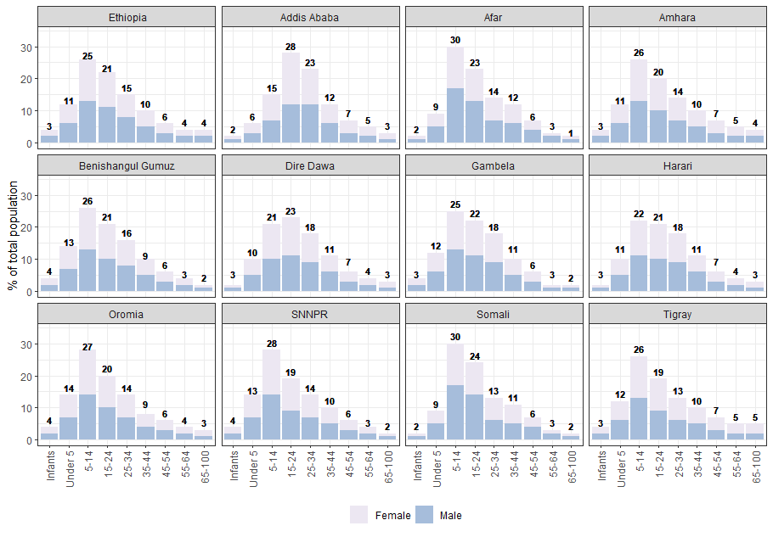

Figure 2 Month of the year profile for clinical workload, by region, 2022 and 2035. Values are the ratio of predicted clinical workload for the month to average predicted monthly workload of the year, calculated as mean ratios from 100 simulation trials.
