Supporting Information

A Novel Water-Soluble Photosensitizer for Photodynamic Inactivation of Gram-Positive Bacteria
Zihuayuan Yang, Ying Qiao, Junying Li, Fu-Gen Wu, Fengming Lin*

State Key Laboratory of Bioelectronics, School of Biological Science and Medical Engineering, Southeast University, Nanjing 210096, China
E-mail addresses: linfengming@seu.edu.cn (F. M. Lin.).

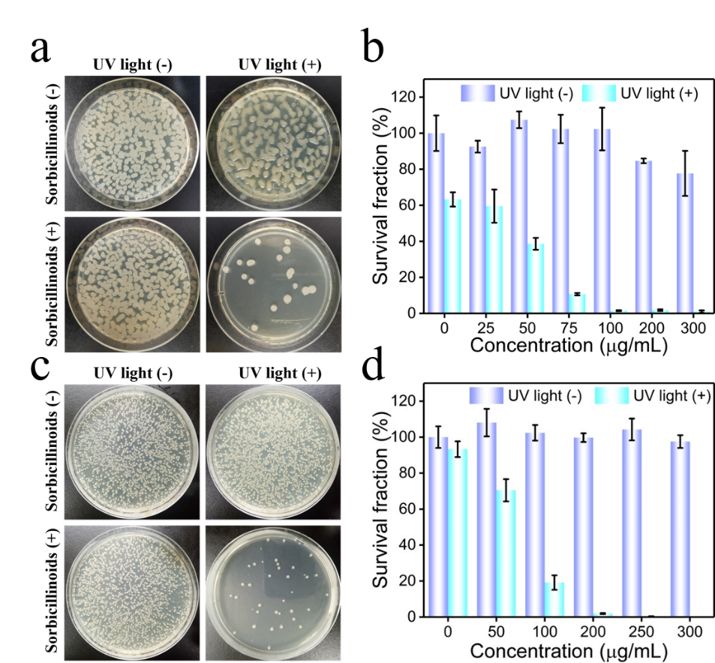
Figure S1. Evaluation of the APDT ability of sorbicillinoids against B. subtilis (a) and M. luteus (b) under (no) UV light irradiation.
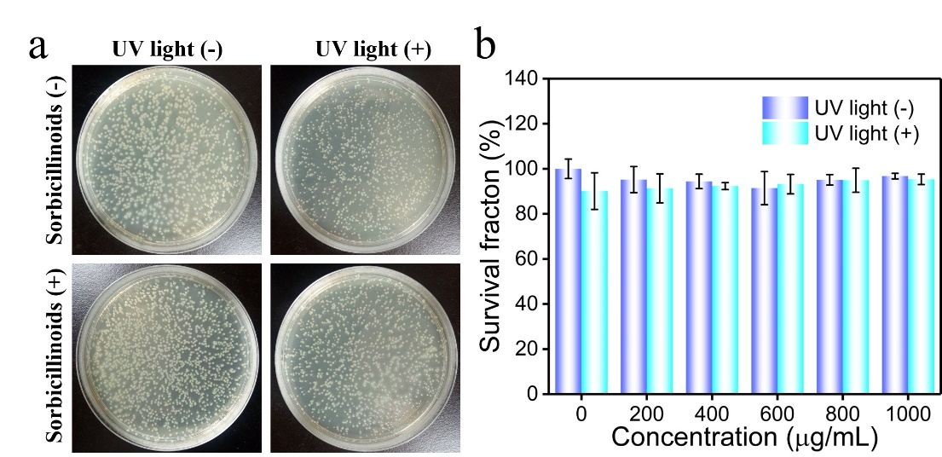
Figure S2. Evaluation of the APDT ability of sorbicillinoids against P. vulgaris under (no) UV light irradiation.
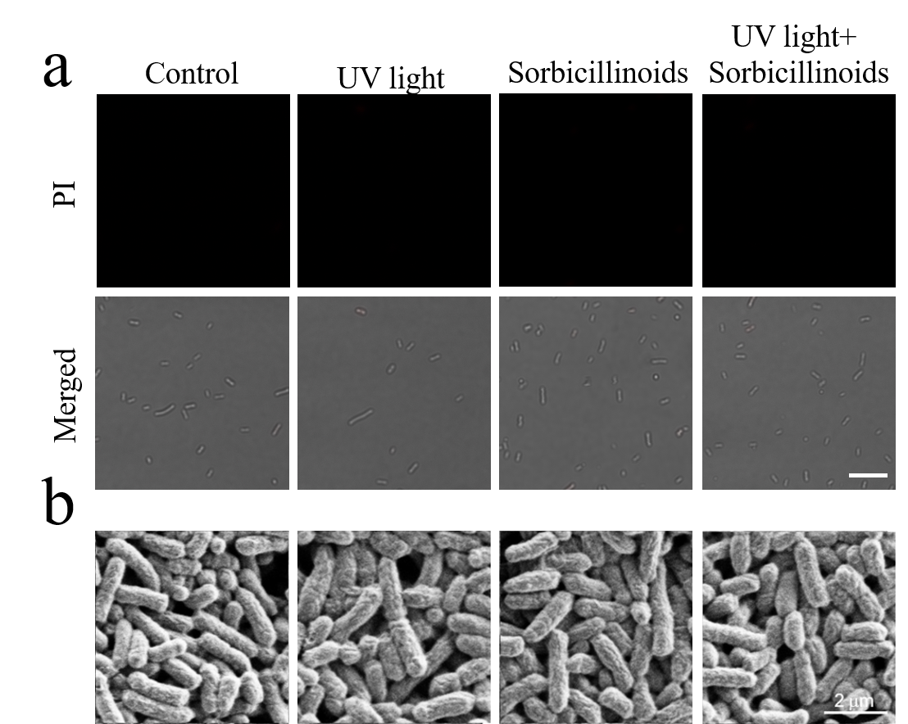
Figure S3. a) Confocal fluorescence images of E. coli that was incubated with PI after different treatments as indicated in the figure. Bacteria with damaged cell membrane would be stained by PI, showing red fluorescence. (scale bar = 10 μm). b) the corresponding SEM images were also taken.

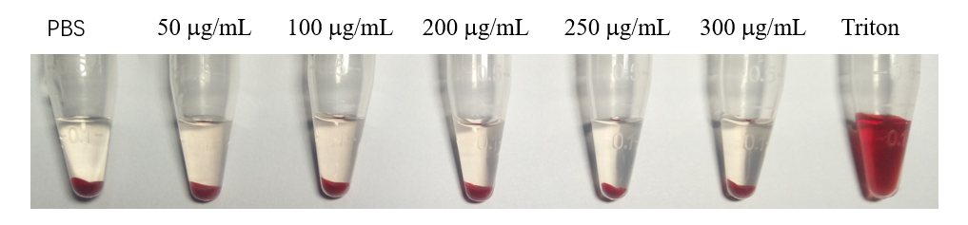
Figure S4. The photos of hemolysis behavior of RBCs after incubation with various concentrations of sorbicillinoids.

