SUPPLEMENTARY INFORMATION

Endophytic fungus from Handroanthus impetiginosus immobilized on electrospun nanofibrous membrane for bioremoval of bisphenol A

João Carlos Silva Conceiçãoª, Augusto D. Alvarega^{b}, Luiza A. Mercante^{c}, Daniel S. Correa^{b,*}, Eliane Oliveira Silva^{a,*}

ªDepartament of Organic Chemistry, Institute of Chemistry, Federal University of Bahia, Salvador, 40170-115, Brazil

^{b}Nanotechnology National Laboratory for Agriculture (LNNA), Embrapa Instrumentation, São Carlos, 13560-970, Brazil

^{c}Institute of Chemistry, Federal University of Bahia, Salvador, 40170-115, Brazil

*Corresponding authors:
D.S. Correa
E-mail address: daniel.correa@embrapa.br
ORCID number: 0000-0002-5592-0627

E.O. Silva
E-mail address: elianeos@ufba.br
ORCID number: 0000-0001-9121-0481

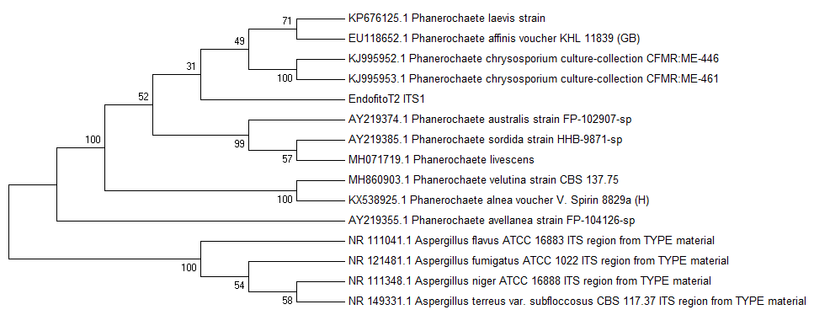

Figure S1. Neighbor-Joining phylogenetic tree of endophytic fungi selected based on their ITS1-5.8S-ITS2 rDNA sequences. The optimal tree with the sum of branch length = 0.41458023 is shown. The percentage of replicate trees in which the associated taxa clustered together in the bootstrap test (1000 replicates) are shown next to the branches. The “Endofito T2 ITS1” was identified as Phanerochaete sp. H2.

