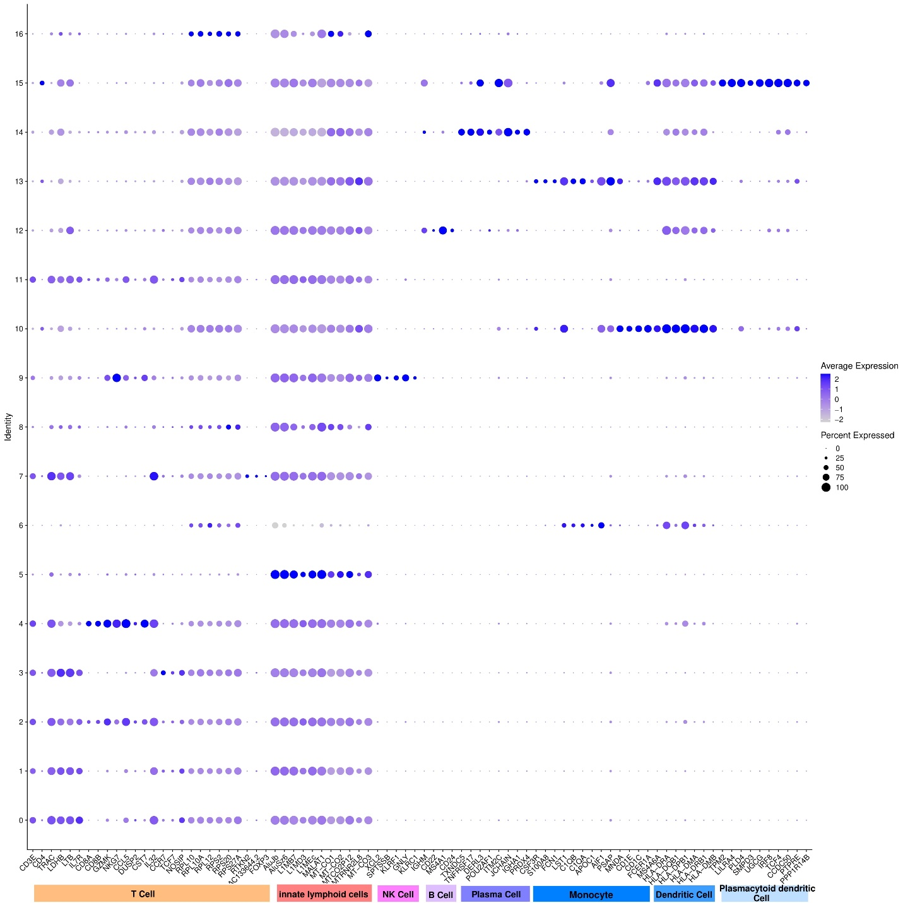
Fig S1. marker gene expression in the MS population.

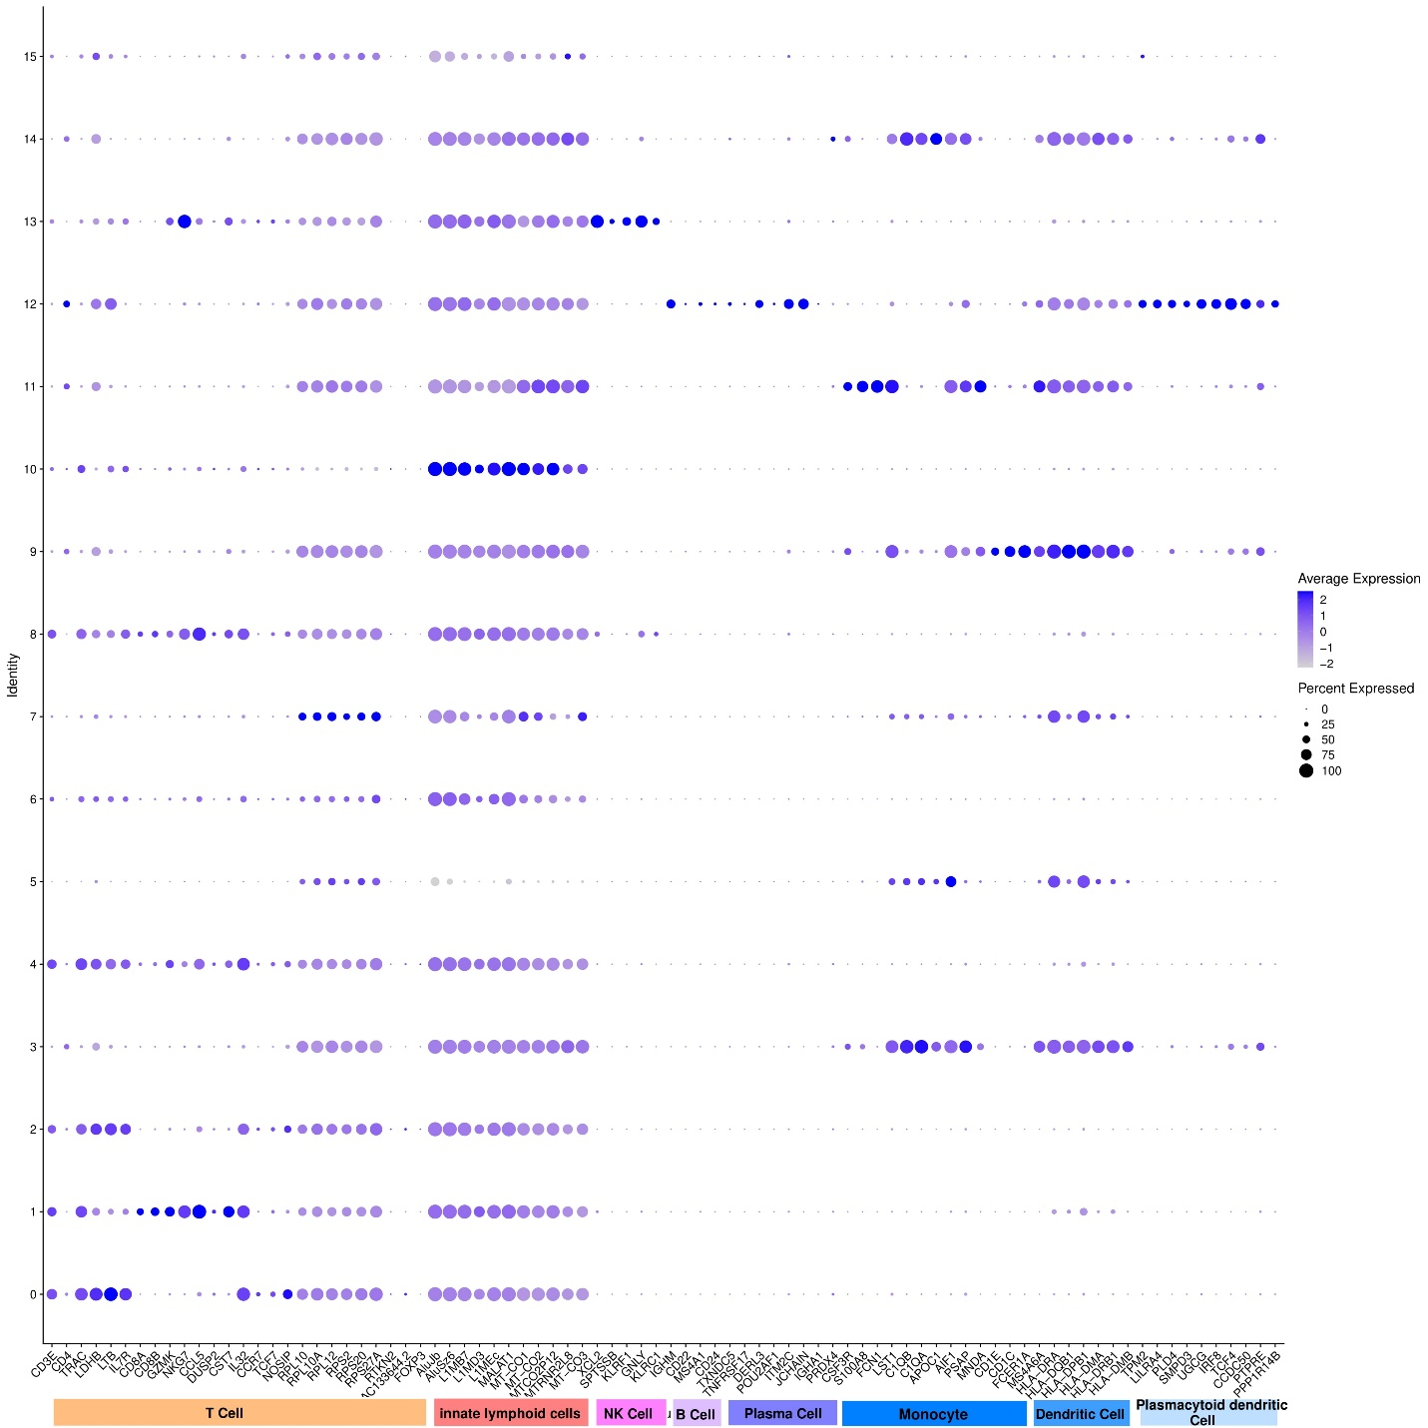
Fig S2. marker gene expressions in the IIH population.

