Supplementary Figures for

Ictogenesis Proceeds Through Discrete Phases in Hippocampal CA1 Seizures
John-Sebastian Mueller^{1*}, Fabio Cesar Tescarollo^{1*}, Trong Huynh^{1,2}, Daniel Brenner¹, Daniel Valdivia¹, Kanyin Olagbegi¹, Sahana Sangappa¹, Spencer C. Chen^{1†}, Hai Sun^{1†}
*†These authors contributed equally to this work.

Author affiliations:
1 Department of Neurosurgery, Robert Wood Johnson Medical School, New Brunswick, NJ, 08854, USA
2 Department of Surgery, Rutgers New Jersey Medical School, Newark, NJ, 07103, USA

Correspondence to: Hai Sun
Robert Wood Johnson Medical School, Rutgers University, 10 Plum Street, 5th floor, New Brunswick, NJ 08901, USA
hs925@rwjms.rutgers.edu
Running title: Discrete Phases of Ictogenesis

Supplementary Tables
Supplementary Table 1 Mice and overview of experiments performed
 | Mouse details |  |  |  | Frequency detailsª
Mouse ID | Sex | Age^{b} | Implant | Length^{c} | 5Hz  ^{Rec.} ^{Seizures} |  | 10Hz  ^{Rec.} ^{Seizures} |  | 20Hz  ^{Rec.} ^{Seizures}
OP126 | F | 83 | Mono | 54 | 2 | 0 | 13 (1) | 18 | 1 (1) | 6
OP133 | F | 116 | Bipolar | 34 | 0 | 0 | 3 | 7 | 2 | 12
OP134 | F | 116 | Bipolar | 55 | 3 | 0 | 9 (1) | 11 | 4 (1) | 31
OP137 | M | 108 | Bipolar | 55 | 3 | 0 | 11 | 11 | 2 (3) | 5
OP138 | M | 108 | Bipolar | 154 | 5 | 0 | 27 (2) | 42 | 5 (2) | 26
OP141 | F | 141 | Mono | 121 | 2 | 0 | 18 (2) | 47 | 1 (1) | 8
OP142 | F | 141 | Mono | 127 | 2 | 0 | 19 (3) | 52 | 2 | 22
OP159 | M | 129 | Mono | 121 | 2 | 2 | 20 (2) | 55 | 2 | 20
Totals
n = 8 |  |  |  |  | 19 | 2 | 120 (11) | 243 | 19 (8) | 130

ªThe number in parentheses refers to total number of excluded recordings.
^{b}Age of mouse in days at the time of surgery
^{c}Number of days that recordings were performed
F = Female; M = Male; Mono = monopolar electrode implant.

Supplementary Figures
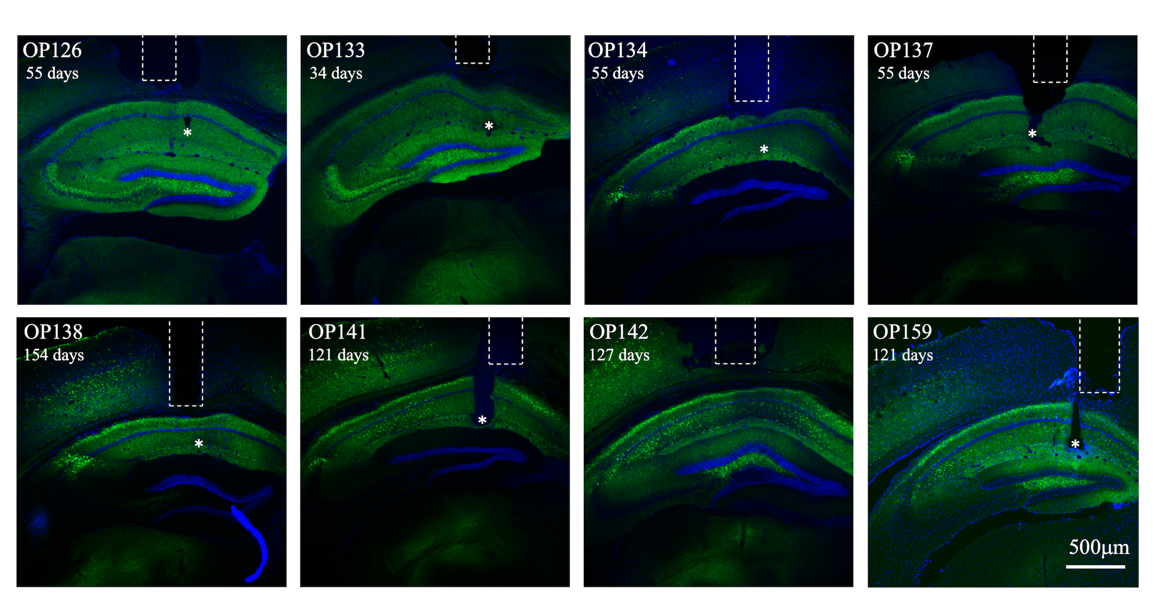
Supplementary Figure 1 ChR2-EYFP location, and optic fiber and electrode location placement. Coronal brain section from the hippocampus of individual mice. Mouse ID and the number of days between viral vector injection and transcardial perfusion is identified in top left of each image (reference Supplementary Table 1). ChR2-EYFP injected in the dorsal CA1 of the hippocampus showed ubiquitous ChR2 expression in the oriens, radiatum and lacunosum moleculare layers of area CA1 of all mice. The dashed boxes indicate the optic fiber position for each mouse, situated above the oriens layer of CA1 for all animals, and specifically in the transition between the lateral parietal cortex and corpus callosum. The white asterisk identifies the positioning of the tip of the implanted electrode, which could be detected in the transition between the radiatum and lacunosum moleculare layer of hippocampal area CA1 in almost all animals. The exception was OP142’s electrode that could not be located; however, since the electrode extends 400μm past the tip of the fiber, it is likely located in a similar location. Scale Bar: 500μm.

Supplementary Figure 2 Averaged spectrograms of optogenetic-induced seizures. (A) Spectrograms averaged by seizure type for seizures induced by 10Hz stimulation. To align the seizures, the time-axis of the spectrogram was re-scaled for each seizure, so the following segments were equal length: pre-stimulus, stimulus onset to paroxysmal, paroxysmal to stimulus offset, and post-stimulus segments – demarcated by "Stim Start”, “Paroxysmal”, and “Stim End” markers. At the paroxysmal point, there is a clear, stepwise broadband increase in spectral power in conjunction with a step-decrease in the power contribution of the fundamental and harmonics of the stimulation frequency (10 or 20Hz). (B) As in A, averaged spectrograms by seizure type induced by 20Hz stimulation. (C) The relative contribution to total power (0-200Hz) from the 10Hz fundamental and harmonics during 10Hz stimulation induced seizures. (D) The power of the 10Hz fundamental and harmonics of the seizures in C. (E) The power of the non-harmonic spectral components of the seizures in C. This is the remainder after subtracting harmonic power D from the total power (0-200Hz). (F-H) Same as C-E respectively, for 20Hz stimulation induced seizures. (I) Average power spectrum of the 10Hz seizures (during stimulation) shown as change in the power pre- and post- the paroxysmal point. Original spectrums contain prominent reduction at the frequency of the stimulation harmonics (dashed lines), which was interpolated out to obtain a smooth estimate of the power spectrum (solid lines). (J) As in I, average power spectrum of the 20Hz seizures. Shaded area in C-J represents 95% confidence interval of the mean across seizures.

Supplementary Figure 3 Construction of a pulsogram. (A) EEG response to optogenetic pulses, where the timing and duration of the light delivered (cyan box) and -5 to 60ms snippet of response centered on each stimulus pulse (orange dotted box) was extracted to construct the pulsogram. In this representative EEG, stimulus frequency was 10Hz with the standard pulse width of 5ms. (B) Three-dimensional representation of the pulsogram, which was constructed by aligning each snippet by the time of pulse delivery in chronological order of pulse delivery. (C) Pulsogram coloring applied to pulse-aligned EEG snippets from B. (D) Two-dimensional view of pulse-aligned EEG snippets (pulsogram) from C, where the y-axis is pulse time (milliseconds), and the x-axis is duration of the stimulation train (seconds). (E) As in D, but the pulsogram has been extended to include 10s of stimulation.

Supplementary Figure 4 Detailed determination of the secondary discharge and comparison of seizure power. The secondary discharge is highlighted as a stepwise increase in the response power 20-50ms from each stimulation pulse. (A) Averaged event-aligned power pulsograms (from Fig. 5C) for 10Hz stimulations. Pulsograms were aligned to epochs start, the divergent point, and the paroxysmal point. From top to bottom, averaged power pulsograms are displayed for naïve seizures, then break-long, and end with break-short seizures. Seizures of the same type were first averaged within each mouse, and then averaged across all mice (n=8) for plotting. (B) Average power changes for all 10Hz seizures. As in A, seizures were grouped according to classification, average Δpower within each mouse was calculated, and then averaged across mice and plotted, where gray lines represent Δpower of individual mice. (C) Time-dependent plot of EEG power for early pulse response (0-20ms) in green compared to changes in power of the late pulse response (20-50ms) in pink. As in A, the x-axis was compressed to align with seizure events. As in 5C, power was normalized to the average power during the core activity phase. As in A, average power was first calculated within mice and then the average and s.e.m. across mice was plotted. (D-F) Same as A-C, for 20Hz seizures.

Supplementary Figure 5 Detailed comparisons of dynamic time warping analysis by stimulation frequency. (A) Relative percentage of trajectory used up in the time-warping of one response (y-axis) compared to a reference response (x-axis). Plots are split by reference response type and stimulation frequency. Only response trajectories from the same recording were analyzed. The comparison response type in each plot is color coded. Diagonal line indicates identically matched response. Shaded area indicates 95% confidence interval about the mean. (B) Swarm plots illustrating the % warped trajectory in A at 80% of the reference trajectory (horizontal dashed line). Each dot represents data from one trajectory pair. Circle markers indicate the mean calculated in the z-transformed space of the % values. Significant differences between 10Hz and 20Hz stimulations are marked *P<0.05, **P<0.01, and ***P<0.0001; Student’s t-test with Bonferroni multiple comparison adjustment. (C) Swarm plots illustrating the dynamic time warped separation distance results of the same trajectory pairings in A. Separation distance was normalized so that average distance to the response from the first epoch of the recording (naïve seizure) was 1.0 (horizontal dashed line). Circle markers indicate the mean calculated in the log-transformed space of the distance values. Significant differences between 10Hz and 20Hz stimulations are marked as in B; Student’s t-test with Bonferroni multiple comparison adjustment. Error bars in B and C indicates 95% confidence intervals.

Supplementary Figure 6 Schematic for angular segmentation process and representative application to pulsogram. (A) To perform angular segmentation, each pulse response (vertical strip of pulsogram) was considered as a point in n-dimensional space representing the EEG response. As the stimulus progressed, the response moved along these points in this n-dimensional space. Vector turning angle, θ, of this traversal was calculated. (B) Pulsograms were constructed from EEG responses from 3 epochs of an example experiment. Vertical lines designated example strips represented in A (for illustration only, see Methods for actual algorithm). (C) Smoothed pulsograms are depicted after initial pre-processing to smooth both the x- and y-dimensions of the pulsogram as well as to diminish any spurious spikes (see Methods). Dashed vertical lines mark the final segmentation boundaries from the process. (D) Plots of the turning angles determined by A. Troughs of the turning angles, shown as cyan circles, were identified to best line up with visually identifiable phase boundaries in the pulsogram shown in C. Several heuristics were adopted to disregard troughs from the same spatial cluster or minor deviations from the main trajectory of change (see Methods). The final segment boundaries are marked with dashed vertical lines.

Supplementary Figure 7 Detailed comparisons of trajectory complexity by stimulation frequency. (A) Swarm plots illustrating the relative distributions of trajectory complexity for each response type estimated. From top to bottom, complexity is calculated by PCA (same as Fig. 6F), angular segmentation (as used in Fig. 6E), and the number of vertices in from the Douglas-Peucker simplified trajectory (used to cross-verify previous two). Each dot represents data from one epoch. Data is grouped by response type. Within each response type, the left and right swarms correspond to 10Hz and 20Hz stimulations, respectively. As in Fig. 6D and E, frequency did not have a significant effect on the number of PCs [P_{Hz}= 0.1552, two-factor ANOVA of log(#PCs) against seizure type and stimulus frequency] or for number of segments [P_{Hz}= 0.8554, two-factor ANOVA of log(#segments) against seizure type and stimulus frequency]. With the Ramer-Douglas-Peucker algorithm, increased frequency decreased the number of vertices required to represent the trajectory [P_{Hz}<0.0001, P_{Sz}<0.0001, two-factor ANOVA of log(#vertices) against seizure type and stimulus frequency]. (B) Bar graph plots of ANOVA estimated means and 95% confidence interval of data from A, with 10Hz and 20Hz stimulations pooled. Naïve seizures were the most complex (P<0.0001 against all other response types), and there was no significance between break-short and break-long seizures (P=0.5591). All statistical tests were performed by the described ANOVA with Tukey-Kramer corrections for multiple comparisons. *P<0.05, **P<0.0001, ns = non-significant.

