Plant managements but not fertilization mediate soil carbon emission and microbial community composition in subtropical Eucalyptus plantations

Appendix S1: Supplementary Tables and Figures
Table S1 Soil microclimate and physicochemical properties under different treatments. Notes: Values are means ± SE (n=3). Different lowercase letters indicate significantly different (P < 0.05) between different treatments in the same plantations. Different uppercase letters indicate significantly different (P < 0.05) in plantations of different ages. Abbreviations: (1) 2, 6: 2 and 6-year-old plantation; CK: control; Fer: fertilization; Tre: tree root trenching; UR: understory removal; UR+Fer+Tre: the combination between understory removal, tree root trenching, and fertilization. (2) ST: soil temperature; SM: soil water contents; SOC: soil organic carbon; NO₃⁻-N: nitrate nitrogen; NH₄⁺-N: ammonium nitrogen; TN: total nitrogen; AP: available phosphorus; TP: total phosphorus; TK: total kalium.
Properties |  | Treatments
 |  | CK | Fer | Tre | Tre+Fer | UR | UR+Fer | UR+Tre | UR+Tre+Fer
ST (℃) | 2 | 15.43±0.53(Aa) | 15.98±0.40(Aa) | 15.84±0.30(Aa) | 14.79±1.20(Aa) | 14.19±0.99(Aa) | 14.42±1.05(Aa) | 16.03±0.64(Aa) | 16.16±0.92(Aa)
ST (℃) | 6 | 12.54±0.79(Ba) | 12.42±0.33(Ba) | 12.05±0.02(Ba) | 12.13±0.12(Ba) | 12.40±0.31(Ba) | 12.72±0.51(Ba) | 12.63±0.79(Ba) | 12.62±0.59(Ba)
SM (%) | 2 | 24.72±1.19(Aab) | 22.06±0.43(Ab) | 23.54±0.79(Aab) | 22.92±0.51(Aab) | 25.09±0.67(Aab) | 24.72±0.64(Aab) | 22.71±0.12(Aab) | 25.94±0.26(Aa)
SM (%) | 6 | 21.95±0.41(Ab) | 22.74±0.65(Aab) | 27.72±0.19(Aa) | 25.11±1.25(Aab) | 21.53±1.14(Ab) | 25.04±1.55(Aab) | 27.50±0.47(Aa) | 21.31±1.58(Ab)
pH | 2 | 4.58±0.10(Ba) | 4.54±0.01(Ba) | 4.65±0.08(Ba) | 4.64±0.09(Ba) | 4.64±0.06(Ba) | 4.66±0.05(Ba) | 4.61±0.06(Ba) | 4.52±0.06(Ba)
pH | 6 | 4.77±0.06(Aa) | 4.86±0.02(Aa) | 4.63±0.11(Aa) | 4.85±0.01(Aa) | 4.80±0.05(Aa) | 4.67±0.05(Aa) | 4.83±0.04(Aa) | 4.59±0.02(Aa)
SOC (g·kg⁻¹) | 2 | 17.65±0.96(Aab) | 17.28±0.04(Aab) | 19.82±0.91(Aa) | 18.40±0.48(Aab) | 17.87±1.16(Aab) | 19.75±0.48(Aab) | 16.45±0.35(Ab) | 18.36±0.28(Aab)
SOC (g·kg⁻¹) | 6 | 12.92±0.26(Bb) | 16.21±0.96(Ba) | 14.86±0.37(Bab) | 13.13±0.13(Bab) | 16.22±0.59(Ba) | 12.85±0.22(Bb) | 13.51±1.12(Bab) | 13.43±0.42(Bab)
NO₃⁻-N (mg·kg⁻¹) | 2 | 4.63±2.01(Aa) | 6.39±0.10(Aa) | 6.11±1.80(Aa) | 6.25±1.17(Aa) | 3.62±0.69(Aa) | 6.45±1.01(Aa) | 4.12±2.00(Aa) | 4.01±1.92(Aa)
NO₃⁻-N (mg·kg⁻¹) | 6 | 3.34±0.89(Aa) | 6.58±0.36(Aa) | 3.90±1.75(Aa) | 2.72±0.89(Aa) | 3.93±0.90(Aa) | 2.75±1.38(Aa) | 2.91±1.55(Aa) | 2.82±1.69(Aa)
NH₄⁺-N (mg·kg⁻¹) | 2 | 7.57±1.02(Ba) | 6.87±1.34(Ba) | 6.10±0.44(Ba) | 7.00±1.01(Ba) | 7.02±1.49(Ba) | 7.87±1.91(Ba) | 7.86±0.70(Ba) | 8.18±1.60(Ba)
NH₄⁺-N (mg·kg⁻¹) | 6 | 6.49±0.55(Aa) | 7.62±1.06(Aa) | 10.78±0.43(Aa) | 9.29±2.13(Aa) | 10.46±0.39(Aa) | 9.70±0.22(Aa) | 8.43±1.53(Aa) | 10.64±0.42(Aa)
TN (g·kg⁻¹) | 2 | 1.28±0.08(Aa) | 1.36±0.20(Aa) | 1.42±0.07(Aa) | 1.27±0.05(Aa) | 1.24±0.12(Aa) | 1.37±0.08(Aa) | 1.16±0.06(Aa) | 1.28±0.06(Aa)
TN (g·kg⁻¹) | 6 | 1.01±0.07(Ba) | 1.18±0.14(Ba) | 1.25±0.22(Ba) | 1.11±0.20(Ba) | 1.11±0.07(Ba) | 1.04±0.08(Ba) | 0.94±0.12(Ba) | 0.93±0.04(Ba)
AP (g·kg⁻¹) | 2 | 0.26±0.04(Bb) | 0.37±0.12(Bb) | 0.39±0.04(Bb) | 0.77±0.01(Bab) | 0.77±0.29(Bab) | 0.76±0.06(Bab) | 0.39±0.08(Bb) | 1.05±0.08(Ba)
AP (g·kg⁻¹) | 6 | 1.73±0.62(Aa) | 1.06±0.32(Aa) | 1.97±0.39(Aa) | 0.81±0.16(Aa) | 0.86±0.52(Aa) | 0.65±0.47(Aa) | 2.09±0.14(Aa) | 1.07±0.35(Aa)
TP (g·kg⁻¹) | 2 | 0.44±0.04(Aa) | 0.52±0.08(Aa) | 0.47±0.04(Aa) | 0.44±0.03(Aa) | 0.44±0.04(Aa) | 0.49±0.05(Aa) | 0.45±0.03(Aa) | 0.43±0.06(Aa)
TP (g·kg⁻¹) | 6 | 0.11±0.01(Ba) | 0.24±0.09(Ba) | 0.08±0.01(Ba) | 0.14±0.04(Ba) | 0.13±0.02(Ba) | 0.10±0.02(Ba) | 0.08±0.00(Ba) | 0.09±0.02(Ba)
TK (g·kg⁻¹) | 2 | 5.42±0.50(Ba) | 5.83±0.45(Ba) | 5.33±0.11(Ba) | 5.20±0.01(Ba) | 6.08±0.47(Ba) | 5.35±0.20(Ba) | 5.52±0.49(Ba) | 5.19±0.51(Ba)
TK (g·kg⁻¹) | 6 | 12.71±2.76(Aa) | 14.12±1.51(Aa) | 12.40±2.03(Aa) | 14.92±2.31(Aa) | 12.23±1.87(Aa) | 12.33±2.46(Aa) | 12.33±2.35(Aa) | 10.51±2.09(Aa)

Table S2 The variation of soil respiration rate on different treatments. Notes: Values are means ± SE (n=3). CK: control; UR: understory removal; Tre: tree root trenching; Fer: fertilization; UR+Fer+Tre: the combination between understory removal, tree root trenching, and fertilization.
Treatments | 2-year-old |  |  | 6-year-old |  |  | Both plantation
 | Mean value | variation |  | Mean value | variation |  | Mean value | variation
CK | 3.20(±0.16) | / |  | 3.39(±0.20) | / |  | 3.30(±0.13) | /
Fer | 2.66(±0.14) | 16.87% |  | 3.32(±0.19) | 2.08% |  | 2.99(±0.12) | 9.40%
Tre | 1.56(±0.09) | 51.37% |  | 2.33(±0.15) | 31.37% |  | 1.94(±0.09) | 41.27%
Tre+Fer | 1.78(±0.10) | 44.46% |  | 2.09(±0.14) | 38.36% |  | 1.93(±0.09) | 41.38%
UR | 1.90(±0.10) | 40.70% |  | 2.20(±0.14) | 35.10% |  | 2.05(±0.09) | 37.87%
UR+Fer | 2.23(±0.12) | 30.48% |  | 2.45(±0.16) | 27.64% |  | 2.34(±0.10) | 29.05%
UR+Tre | 1.22(±0.10) | 61.83% |  | 1.84 (±0.13) | 45.69% |  | 1.53(±0.08) | 53.68%
UR+Tre+Fer | 1.45(±0.08) | 54.75% |  | 1.74 (±0.13) | 48.79% |  | 1.59(±0.08) | 51.74%

Table S3 Effects (P values) of plantation age and treatment on soil microbial diversity. Notes: Age: plantation age; UR: understory removal; Tre: tree root trenching; Fer: fertilization; UR×Tre×Fer: the combination between understory removal, tree root trenching, and fertilization. Significance was set at P < 0.05.
Source | Bacterial |  |  |  |  | Fungal
Source | Shannon |  | Chao1 |  |  | Shannon |  | Chao1
Source | F | P | F | P |  | F | P | F | P
Age | 62.615 | <0.001 | 81.812 | <0.001 |  | 0.356 | 0.554 | 14.181 | <0.001
UR | 0.790 | 0.380 | 4.770 | 0.035 |  | 0.233 | 0.632 | 0.958 | 0.333
Tre | 0.448 | 0.507 | 0.536 | 0.469 |  | 3.780 | 0.059 | 6.790 | 0.013
Fer | 0.775 | 0.384 | 0.027 | 0.871 |  | 1.734 | 0.195 | 0.927 | 0.342
UR×Tre | 0.036 | 0.851 | 0.001 | 0.977 |  | 1.021 | 0.318 | 0.668 | 0.419
UR×Fer | 0.036 | 0.851 | 0.000 | 0.986 |  | 0.862 | 0.359 | 0.313 | 0.578
Tre×Fer | 0.011 | 0.917 | 0.560 | 0.459 |  | 3.468 | 0.070 | 4.539 | 0.039
UR×Tre×Fer | 1.135 | 0.293 | 0.448 | 0.507 |  | 1.362 | 0.250 | 3.299 | 0.076

Figures
Figure S1 Response of different plantation ages and control treatments on soil respiration rate and temperature sensitivity (Q₁₀) values. The linear equation, R², and Q₁₀ values are shown in the figure. a, b, c) are 2-year-old plantation and d,e, f) are 6-year-old plantation.
Figure S2 The soil microbial group under different plantation ages and treatments. CK: control; Fer: fertilization; Tre: tree root trenching; UR: understory removal; UR+Fer+Tre: the combination between understory removal, tree root trenching, and fertilization. a, b) Bacterial of 2- and 6-year-old plantation; c, d) Fungal of 2- and 6-year-old plantation.
Figure S3 Relative abundance of phylum under different plantations ages and treatments. CK: control; Fer: fertilization; Tre: tree root trenching; UR: understory removal; UR+Fer+Tre: the combination between understory removal, tree root trenching, and fertilization. a, b) Bacterial of 2- and 6-year-old plantation; c, d) Fungal of 2- and 6-year-old plantation.
Figure S4 The redundancy analysis between main microbial groups and physicochemical factors at the phylum level. ST: soil temperature; SM: Soil water contents; SOC: soil organic carbon; NO3-N: nitrate nitrogen; NH4-N: ammonium nitrogen; TN: total nitrogen; AP: available phosphorus; TP: total phosphorus; TK: total kalium. a) Bacterial; b) fungal.
Figure S5 The redundancy analysis between main microbial groups and physical and chemical factors at the phylum level. ST: soil temperature; SM: Soil water contents; SOC: soil organic carbon; NO3-N: nitrate nitrogen; NH4-N: ammonium nitrogen; TN: total nitrogen; AP: available phosphorus; TP: total phosphorus; TK: total kalium. a, b) Bacterial of 2- and 6-year-old plantation; c, d) Fungal of 2- and 6-year-old plantation.

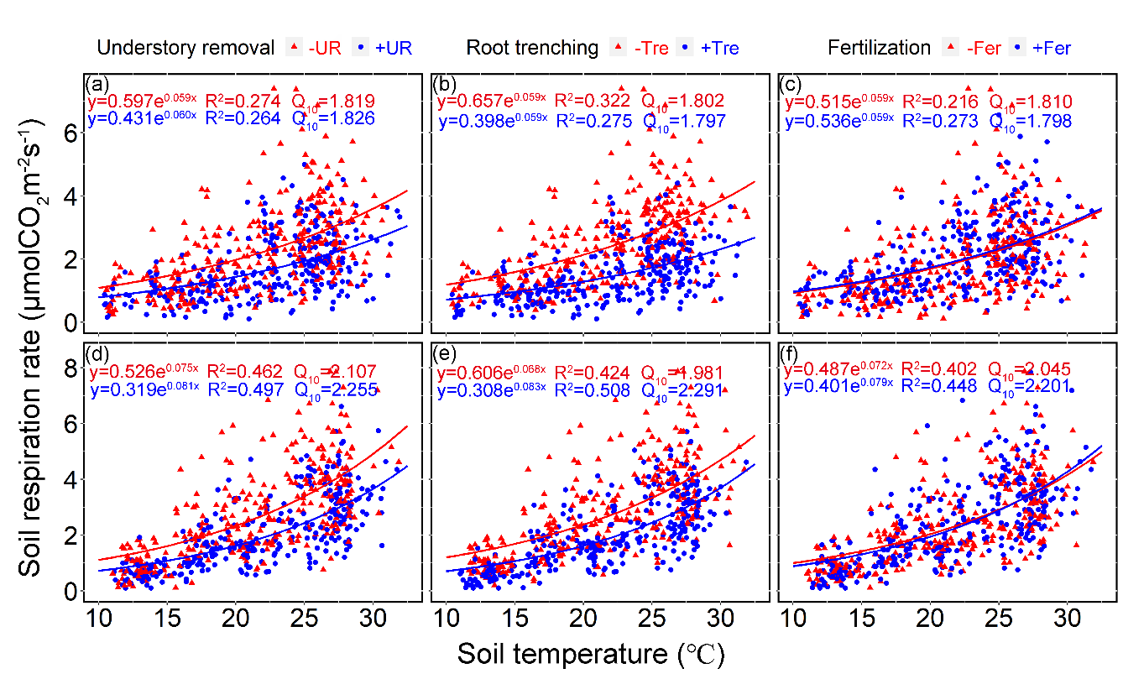
Figure S1

Figure S2

Figure S3

Figure S4

Figure S5

