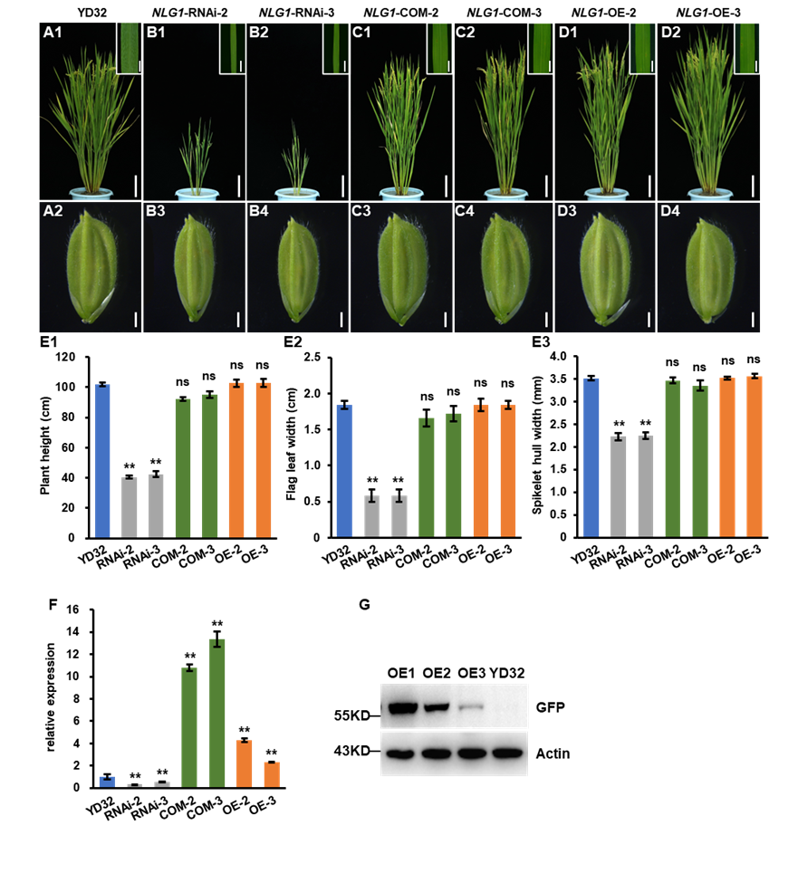
Fig. S2. Morphological comparison among YD32, RNAi, COM and OE transgenic lines at heading stage. A-D Morphological comparison of plant architecture, flag leaf and spikelet of YD32 (A1-A2), RNAi (NLG1-RNA interference) (B1-B4), COM (NLG1-complementation) (C1-C4), OE (NLG1-overexpression) (D1-D4). E1-E2 Plant height (E1), flag leaf width (E2) and spikelet hull width (E3) of YD32, RNAi, COM and OE lines. Data represent means ± SD (n = 5). F Expression analysis of NLG1 in the flag leaves of the YD32, RNAi, COM and OE lines using RT-qPCR. Data represent means ± SD (n = 3). G Immunoblot showing the quantities of NLG1-GFP fusion protein in flag leaves from three independent OE lines. Actin showing approximately equal loading of total proteins. **Significant difference at p < 0.01 compared with YD32 by Student’s t-test, and ns means no significance. Scale bars: 10cm in A1, B1, B2, C1, C2, D1, D2; 1mm in flag leaf, 1mm in A2, B3, B4, C3, C4, D3, D4.

