NLG1, a novel mitochondrial membrane protein, control leaf and grain development in rice
Yi Wen^{1,2+}, Kaixiong Wu²⁺, Bingze Chai²⁺, Peng Hu², Yiqing Tan², Yueying Wang², Hao Wu², Junge Wang², Li Zhu², Guangheng Zhang², Zhenyu Gao², Deyong Ren², Dali Zeng², Lan Shen², Guojun Dong², Qiang Zhang², Qing Li², Qian Qian^{1,2,3,4*}, Jiang Hu^{2*}
¹Rice Research Institute, Shenyang Agricultural University, Shenyang, China
²State Key Laboratory of Rice Biology, China National Rice Research Institute, Hangzhou, China
³Hainan Yazhou Bay Seed Laboratory, Sanya 572024, Hainan, China
⁴National Nanfan Research Institute (Sanya), Chinese Academy of Agricultural Sciences, Sanya 572024, China

*Corresponding author: qianqian188@hotmail.com (Q.Q); hujiang588@163.com (J.H)
⁺These authors have contributed equally to this work and share first authorship

Supplementary Information
Fig. S1. Dynamic characteristics of seedling of YD32 and nlg1. A-D Representative images of YD32 (up) and nlg1 (down) at at different stage, 10 Days (A), 20 Days (B), 30 Days (C), 35 Days (D), Scale bars: 2cm. E-F Leaf blade width (E) and plant height (F) of the YD32 and nlg1 during 10 days-35 days growth stage. Data represent means ± SD (n = 5).
Fig. S2. Morphological comparison among YD32, RNAi, COM and OE transgenic lines at heading stage. A-D Morphological comparison of plant architecture, flag leaf and spikelet of YD32 (A1-A2), RNAi (NLG1-RNA interference) (B1-B4), COM (NLG1-complementation) (C1-C4), OE (NLG1-overexpression) (D1-D4). E1-E2 Plant height (E1), flag leaf width (E2) and spikelet hull width (E3) of YD32, RNAi, COM and OE lines. Data represent means ± SD (n = 5). F Expression analysis of NLG1 in the flag leaves of the YD32, RNAi, COM and OE lines using RT-qPCR. Data represent means ± SD (n = 3). G Immunoblot showing the quantities of NLG1-GFP fusion protein in flag leaves from three independent OE lines. Actin showing approximately equal loading of total proteins. **Significant difference at p < 0.01 compared with YD32 by Student’s t-test, and ns means no significance. Scale bars: 10cm in A1, B1, B2, C1, C2, D1, D2; 1mm in flag leaf, 1mm in A2, B3, B4, C3, C4, D3, D4.
Fig. S3. Histological analysis of the flag leaf of YD32 and nlg1, RNAi, COM and OE transgenic lines. A Parrafin transverse section of the flag leaf of YD32, nlg1, RNAi, COM and OE. Red arrows point out the large vascular bundles (LVs). B-C Comparisons of the number of the large vascular bundles (LVs) B, the small vascular bundles (SVs) C. Data represent means ± SD (n = 10). **Significant difference at p < 0.01 compared with YD32 by Student’s t-test, and ns means no significance. Scale bars: 500μm in A.
Fig. S4. Alignment of amino acid sequence NLG1. Alignment of amino acid sequence NLG1. A Alignment of amino acid sequence of NLG1 with other 6 representative species in plants. Mitochondrial transmembrane region and TIM21 domain were indicated by blue line and red line, respectively. Oryza sativa Japonica Group [GenBank accession number: NP_001173354.1, NLG1], Arabidopsis thaliana [GenBank accession number: NP_001031562.1], Zea mays [GenBank accession number: NP_001131979.1], Sorghum bicolor [GenBank accession number: XP_002465542.1], Nicotiana attenuata [GenBank accession number: XP_019252274.1], Dendrobium catenatum [GenBank accession number: XP_020704802.1], Hordeum vulgare subsp. Vulgare [GenBank accession number: XP_044965486.1].
Fig. S5. Treatment with mitochondrial electron transport inhibitors. Treatment with mitochondrial electron transport inhibitors. A Phenotypes of the YD32 and nlg1 mutant after treatment with 1 μM antimycin A and 0.2 μM oligomycin for 3 days. B-C The survival rate of the YD32 and nlg1 mutant after treatment with 1 μM antimycin A and 0.2 μM oligomycin, respectively. Data represent means ± SD (n = 6). **Significant difference at p < 0.01 compared with YD32 by Student’s t-test. Scale bars: 5cm in A.
Table S1. List of genes in the 42.1 kb target region.
Table S2. Primers used in this study.
Table S3. DEGs from RNA-seq compared between with W7, nlg1.

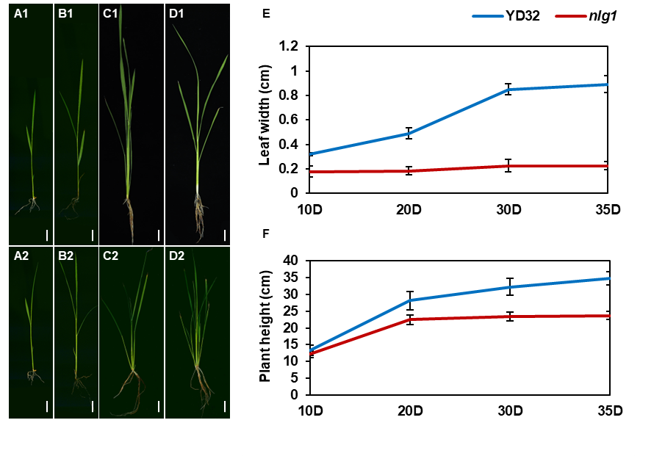
Fig. S1. Dynamic characteristics of seedling of YD32 and nlg1. A-D Representative images of YD32 (up) and nlg1 (down) at different stage, 10 Days (A), 20 Days (B), 30 Days (C), 35 Days (D), Scale bars: 2cm. E-F Leaf blade width (E) and plant height (F) of the YD32 and nlg1 during 10 days-35 days growth stage. Data represent means ± SD (n = 5).

