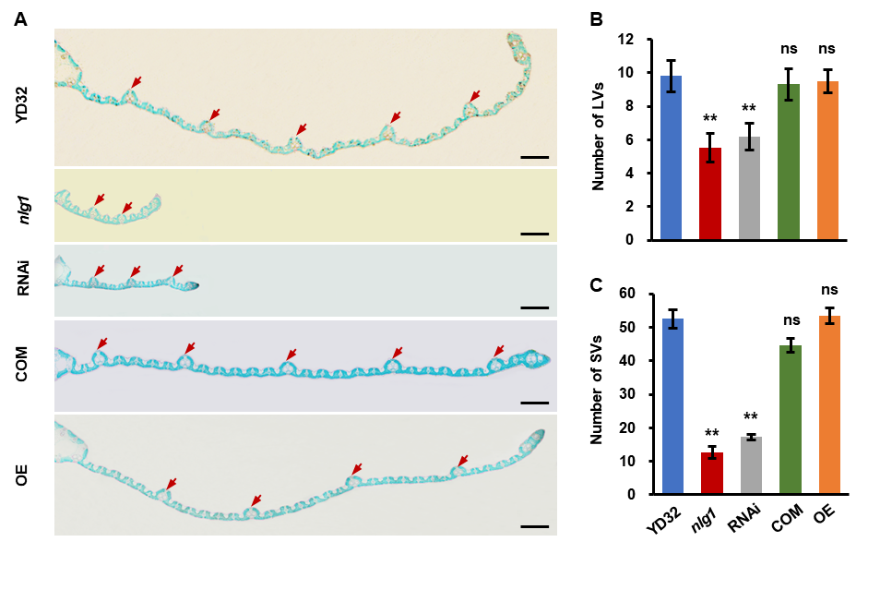
Fig. S3. Histological analysis of the flag leaf of YD32 and nlg1, RNAi, COM and OE transgenic lines. A Parrafin transverse section of the flag leaf of YD32, nlg1, RNAi, COM and OE. Red arrows point out the large vascular bundles (LVs). B-C Comparisons of the number of the large vascular bundles (LVs) B the small vascular bundles (SVs) C. Data represent means ± SD (n = 10). **Significant difference at p < 0.01 compared with YD32 by Student’s t-test, and ns means no significance. Scale bars: 500μm in A.

