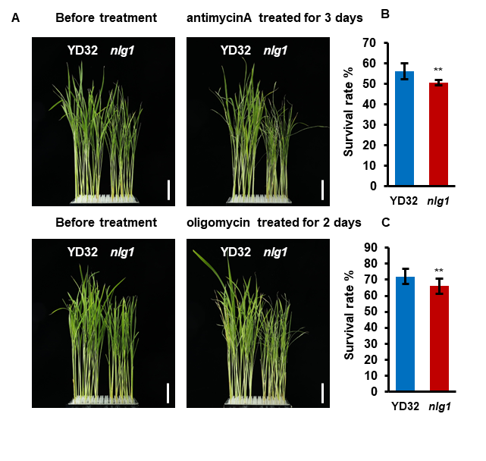

Fig. S5. Treatment with mitochondrial electron transport inhibitors. A Phenotypes of the YD32 and nlg1 mutant after treatment with 1 μM antimycin A and 0.2 μM oligomycin for 3 days. B-C The survival rate of the YD32 and nlg1 mutant after treatment with 1 μM antimycin A and 0.2 μM oligomycin, respectively. Data represent means ± SD (n = 6). **Significant difference at p < 0.01 compared with YD32 by Student’s t-test. Scale bars: 5cm in A.

