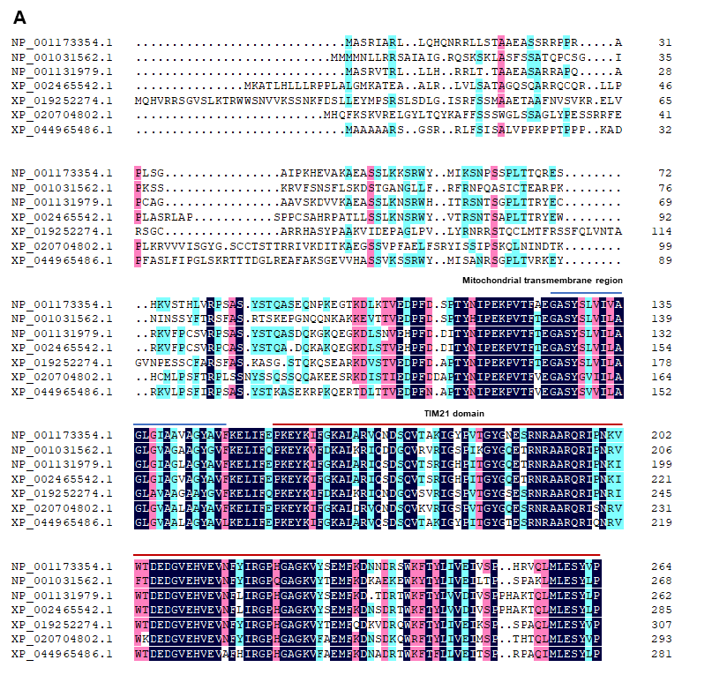
Fig. S4. Alignment of amino acid sequence NLG1. A Alignment of amino acid sequence of NLG1 with other 6 representative species in plants. Mitochondrial transmembrane region and TIM21 domain were indicated by blue line and red line, respectively. Oryza sativa Japonica Group [GenBank accession number: NP_001173354.1, NLG1], Arabidopsis thaliana [GenBank accession number: NP_001031562.1], Zea mays [GenBank accession number: NP_001131979.1], Sorghum bicolor [GenBank accession number: XP_002465542.1], Nicotiana attenuata [GenBank accession number: XP_019252274.1], Dendrobium catenatum [GenBank accession number: XP_020704802.1], Hordeum vulgare subsp. Vulgare [GenBank accession number: XP_044965486.1].

