

Extended Data for

Reconfigurable Geometrical Phase Spatial Light Modulator Using Short-Pitch Ferroelectric Liquid Crystals

Zhi-bo Sun, Zheng-nan Yuan, Vigneshwaran Swaminathan, Valerii Vashchenko, Olena Vashchenko, Alex Yuk Lung Cheung, Lei Lu, Hoi-sing Kwok and Abhishek. K. Srivastava*

State Key Laboratory of Advanced Displays and Optoelectronics Technologies, and Center for Display Research, Department of Electronics and Computer Engineering, Hong Kong University of Science and Technology, Clear Water Bay Road, Kowloon, Hong Kong

Corresponding Author: Abhishek. K. Srivastava (eeabhishek@ust.hk) Phone Number: (852) 3469 2485

Contact Information:
Zhi-bo Sun (zsunak@connect.ust.hk); Zheng-nan Yuan (zyuanae@connect.ust.hk); Vigneshwaran Swaminathan (eeswaminav@ust.hk); Valerii Vashchenko (eevvv@ust.hk); Olena Vashchenko (eeevv@ust.hk); Alex Yuk Lung Cheung (eealexcheung@ust.hk); Lei Lu (lulei@pku.edu.cn); Hoi-sing. Kwok (eekwok@ust.hk)

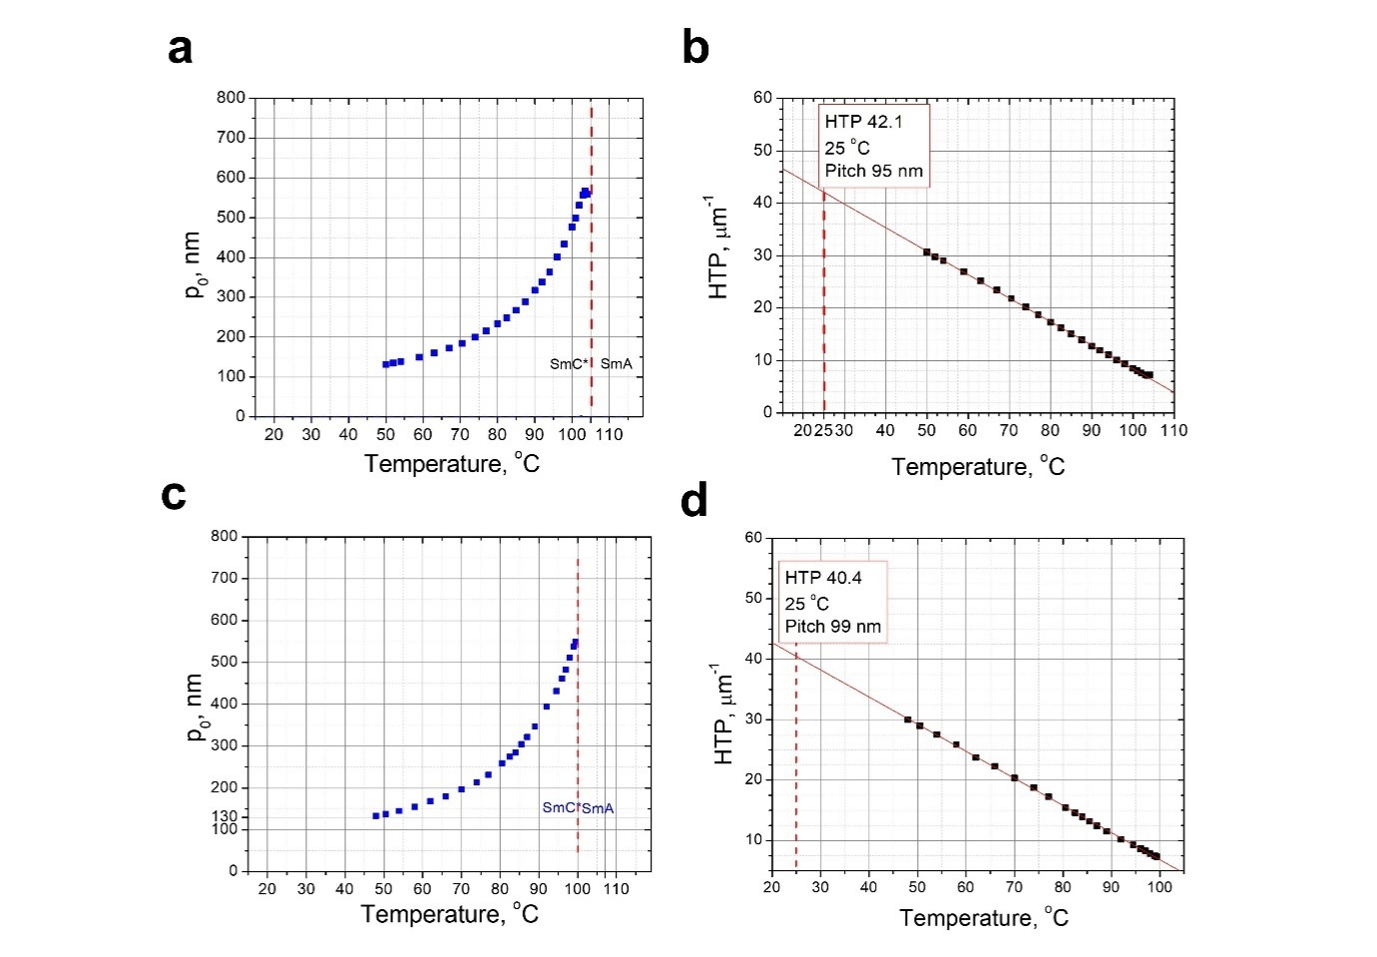
Extended Data Figure 1. Temperature dependency of helix pitch and HTP. a.The temperature dependence of helix pitch and b. HTP for for the 25 mol.% mixture of DFT-TFA-6 in BPP-73 host. c. The temperature dependence of helix pitch and d. HTP for the 25 mol.% mixture of PDN-TFA-6 in BPP-73 host.

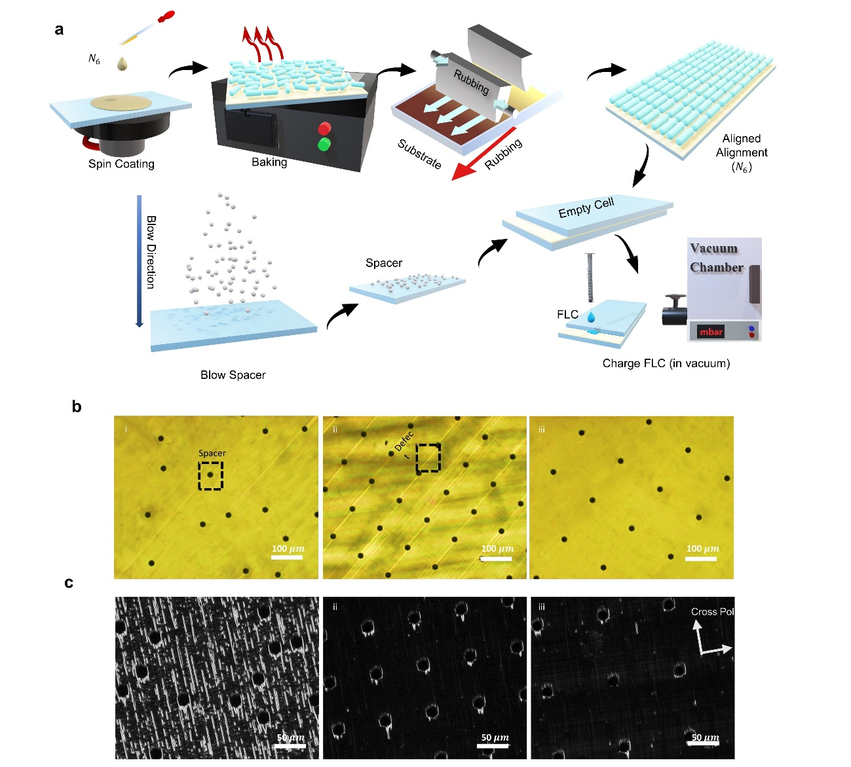
Extended Data Figure 2 Fabrication process and alignment optimization of defect-free planar-aligned DHFLC a. Fabrication process of DHFLC. POM of planar-aligned DHFLC with spacer configuration in i). random order. ii). periodic order with 100 μm spacer gap. ii). periodic with 150 μm.at c. Bright state. and b. Dark state.

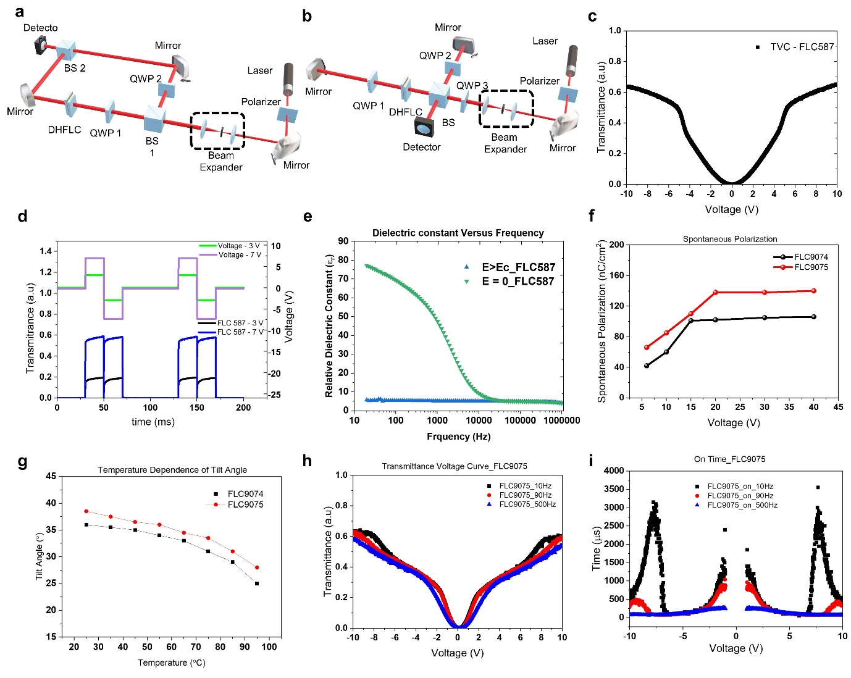
Extended Data Figure 3 Electric-optical (EO) performance of FLC. a The measurement setup based on the Mach-Zehnder Michelson interferometer. b The measurement setup is based on the Michelson interferometer. c. Transmittance versus voltage (TVC) of DHFLC. d. Driving signal and corresponding waveform at $3 V$ and $7 V$.e. Capacitance versus frequency of FLC587. The different bias voltage is applied for the blue and green dot lines. Gold Stone mode is below 10 kHz. f. Temperature dependence of spontaneous polarization. g. Temperature dependence of tilt angle. h. TVC, and i. Response Time of FLC9074 and FLC 9075.

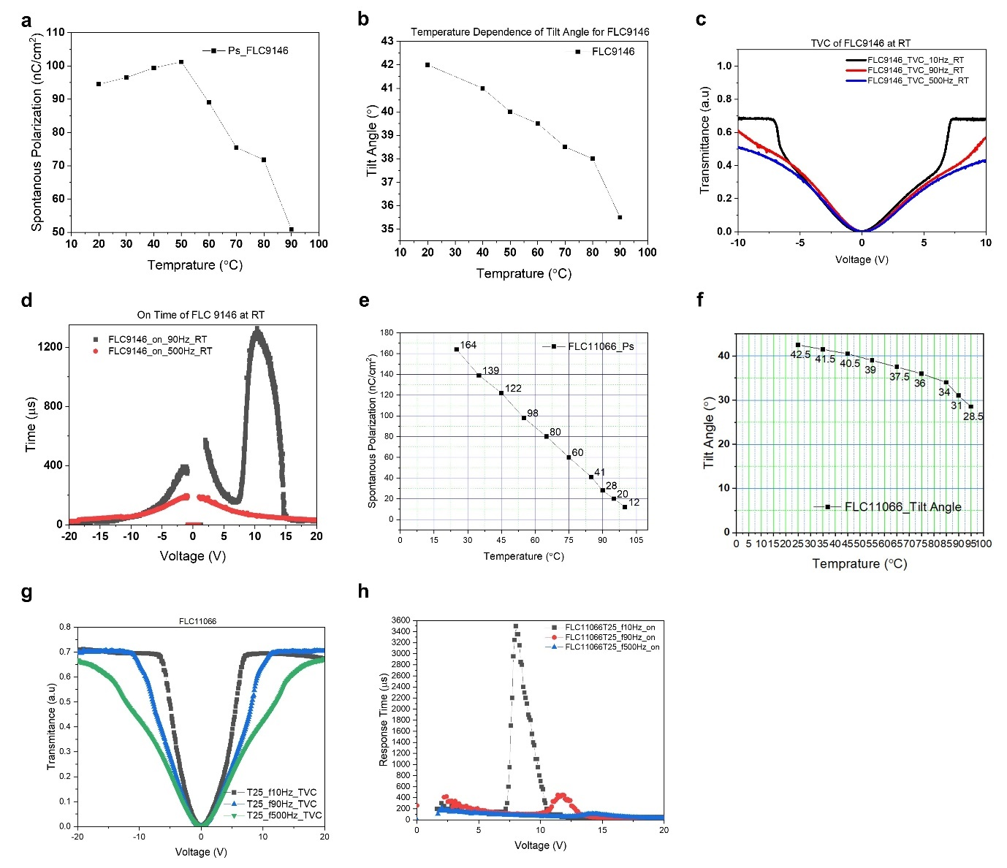
Extended Data Figure 4 EO performance of FLC. a. Temperature dependence of spontaneous polarization. b. temperature dependence of tilt angle. c Transmittance versus voltage. and d Response time versus voltage of FLC 9146. e. temperature dependence of spontaneous polarization. f. temperature dependence of tilt angle. g Transmittance versus voltage. h. the response time versus voltage of FLC 11066.

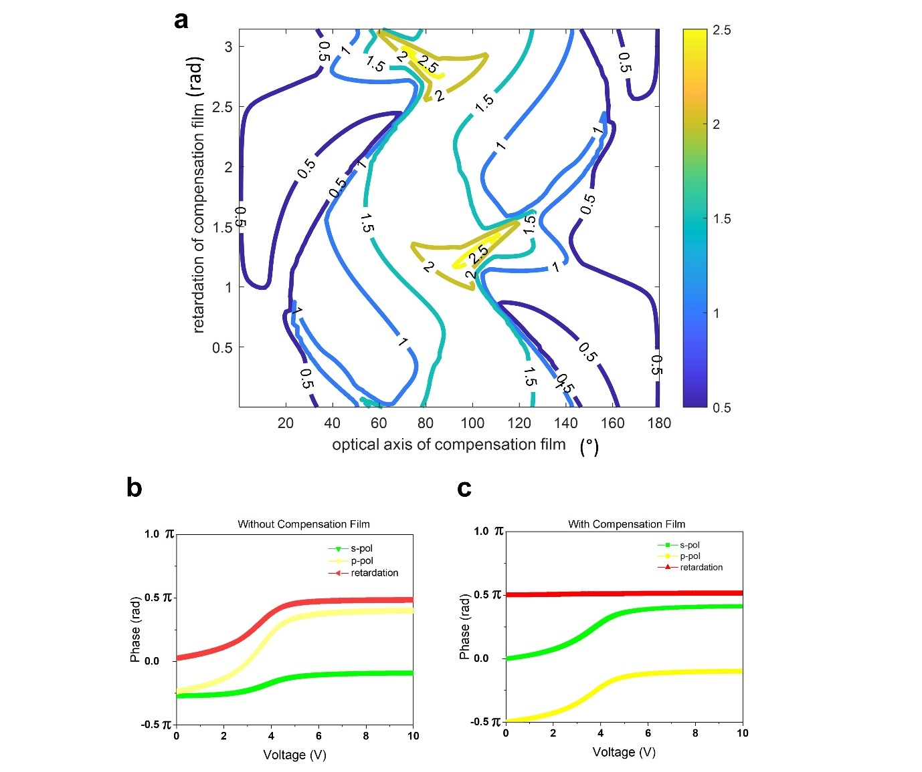
Extended Data Figure 5 Compensation film design. a Contour map of the parameters of the compensation film; b the phase and retardation of the DHFLC without compensation film; c the phase and retardation of the DHFLC with compensation film

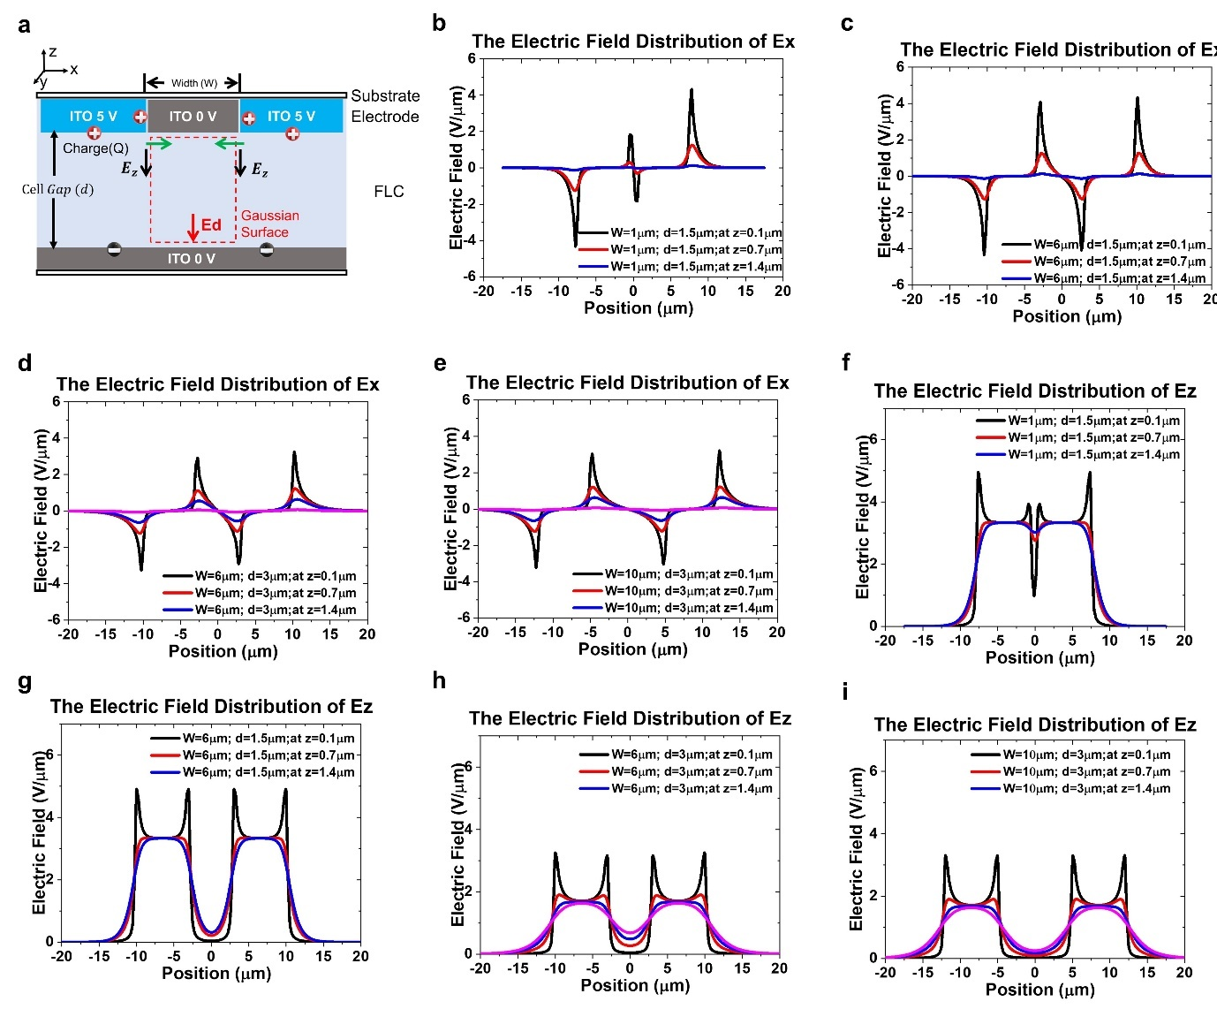
Extended Data Figure 6. Study of Fringe Field Effect on FLCs Based on Proposed Dynamic Model. a. Study of FFE on FLCs Based on Proposed Dynamic Model. The simulation results of electric field (Ex) distribution for b. ITO gap (W)=1 μm; Cell gap (d)=1.5 μm c. W = 6 μm; d = 1.5 μm; d W = 6 μm; d = 3 μm;e. W = 10 μm; d = 3 μm along different positions on z-axis. The simulation results of electric field (Ez) distribution for. f ITO gap (W) = 1 μm; Cell gap (d)1.5 μm. g. W = 6 μm; d = 1.5 μm; h. W = 6 μm; d=3 μm; i. W = 10 μm; d = 3 μm along different positions on z-axis.

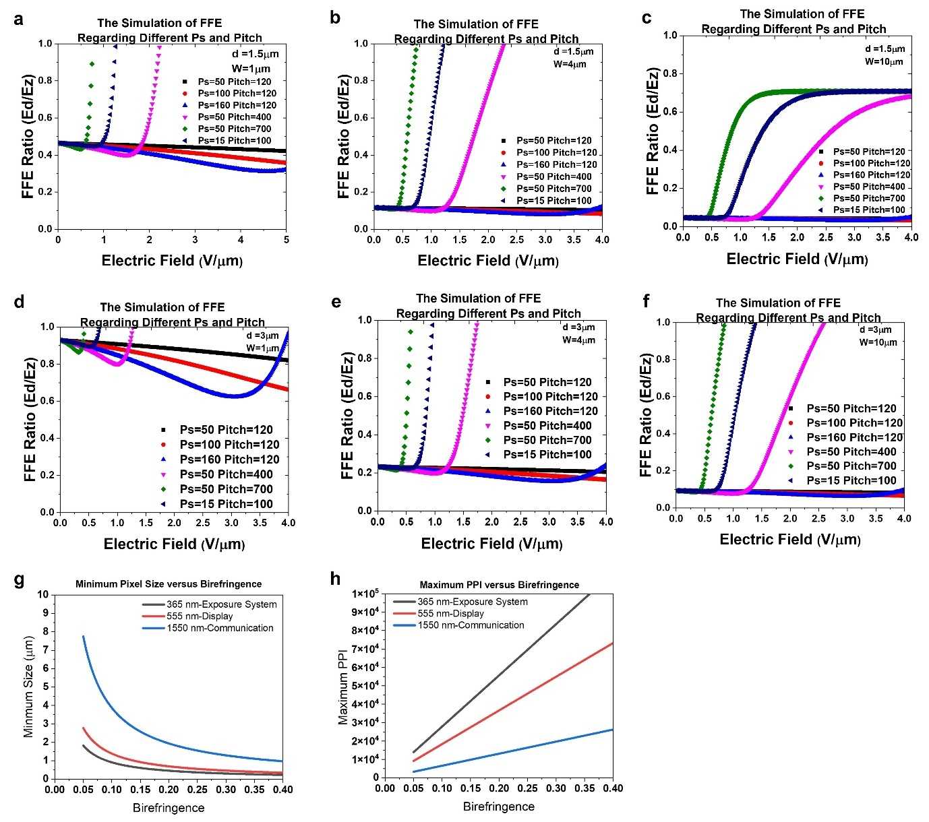
Extended Data Figure 7 The comparison of FFE ratio and applied voltage with different material parameters. The simulation of PPI estimation regarding the different applications. The FFE at a. $d=1.5 μm,W=1 μm$. b. $d=1.5 μm,W=4 μm$. c. $d=1.5 μm,W=10 μm$. d. $d=3 μm,W=1 μm$. e. $d=3 μm,W=4 μm$. f. $d=3 μm,W=10 μm$. g. The birefringence versus minimum pixel size for various applications in a different wavelength. h. The birefringence versus maximum for various applications in a different wavelength.

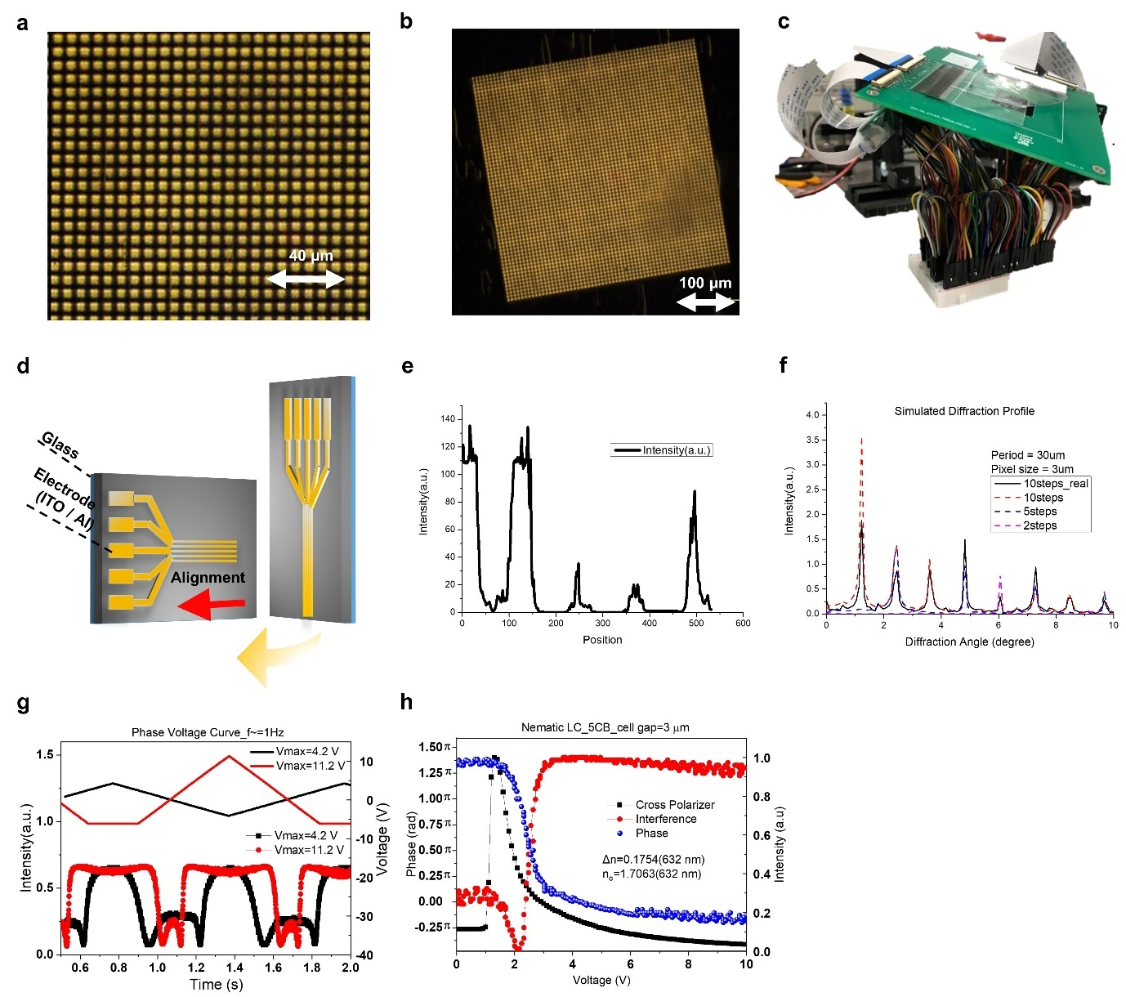
Extended Data Figure 8. Passively addressed phase SLM using DHFLC with 3 $μm$ pixel size and measurement results. a POM image of the SLM, the scale is 40 μm; b POM image of the SLM, the scale is 100 μm; c picture of the prototype; d the schematic structure of the SLM; e the experimental diffraction profile of the SLM with 2D blazed grating; f the simulated of results of the SLM with 2D blazed grating in e. g. The waveform recorded when driven in triangle wave; h. The transmittance and phase versus voltage of the 5CB LC cell were measured under a cross polarizer and interferometer. The reference cell is filled by 5CB and aligned by rubbed PI in an anti-parallel state.

