Supplementary Material 1a – Changes in clinician-rated questionnaires in responders (blue) and non-responders (red)
MADRS: Montgomery-Asberg Depression Rating Scale; CGI: Clinical Global Impression

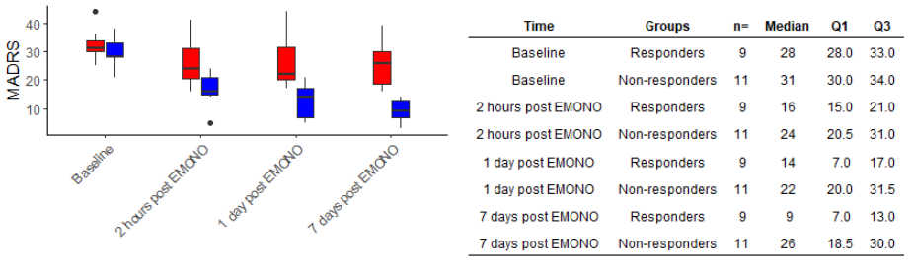

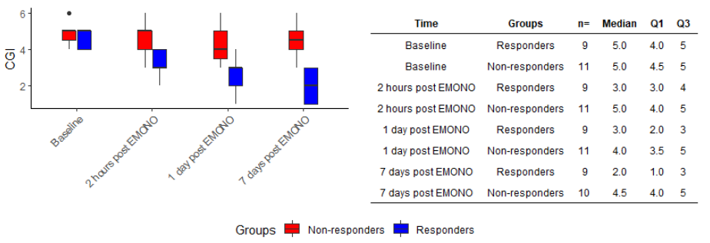

Supplementary Material 1b – Changes in self-rated questionnaires in responders (blue) and non-responders (red)
QIDS-SR: Quick Inventory of Depressive Symptomatology; STAI: The State-Trait Anxiety Inventory ; VAS: Visual Analogue Scale

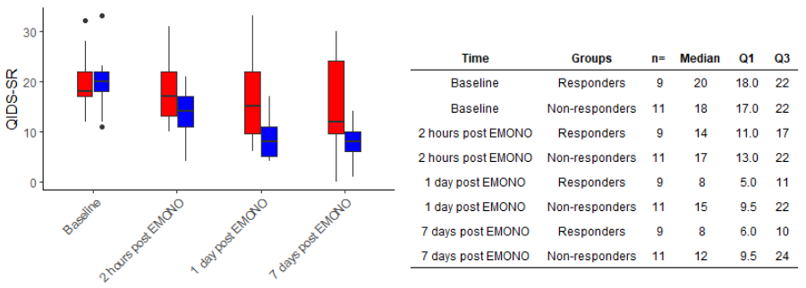
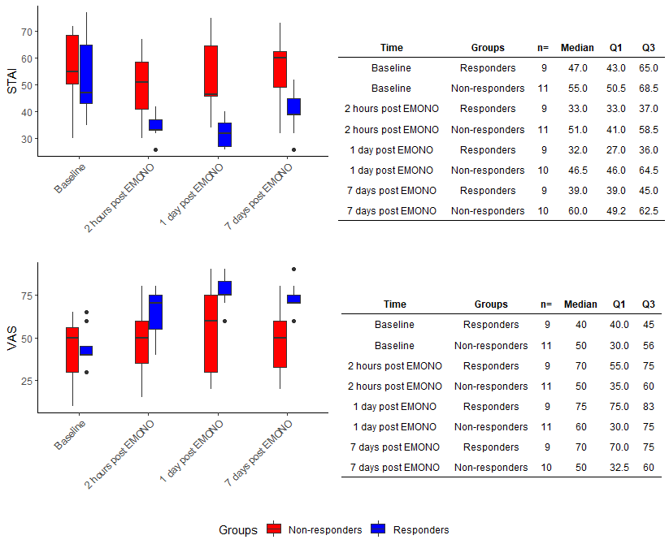

Supplementary Material 1c – Changes in suicidal ideations, manic symptoms, dissociative symptoms and psychotic symptoms in responders and non-responders

 |  | Responders (n=9) |  |  |  | Non-responders  (n=11) |  |  |  | Controls (n=10)
 |  | Median | Q1 | Q3 |  | Median | Q1 | Q3 |  | Median | Q1 | Q3
Baseline | SSI | 1 | 1 | 3 |  | 1 | 0 | 3 |  | 0 | 0 | 0
 | YMRS | 0 | 0 | 2 |  | 2 | 0.5 | 3.5 |  | 0 | 0 | 0
 | CADSS | 2 | 1 | 5 |  | 3 | 1.5 | 5 |  | 0 | 0 | 0
2h post treatment | SSI | 0 | 0 | 1 |  | 0 | 0 | 1.5 |  | 0 | 0 | 0
 | YMRS | 0 | 0 | 1 |  | 0 | 0 | 0.5 |  | 0 | 0 | 0
 | CADSS | 5 | 1 | 11 |  | 1.5 | 0 | 2 |  | 0 | 0 | 0
 | BPRS | 0 | 0 | 2 |  | 0 | 0 | 0 |  | 0 | 0 | 0
Day 1 | SSI | 0 | 0 | 0 |  | 0 | 0 | 2.5 |  | 0 | 0 | 0
 | YMRS | 0 | 0 | 0 |  | 0 | 0 | 1.5 |  | 0 | 0 | 0
 | CADSS | 0 | 0 | 1 |  | 1 | 1 | 2 |  | 0 | 0 | 0
 | BPRS | 0 | 0 | 0 |  | 0 | 0 | 0 |  | 0 | 0 | 0
Day 7 | SSI | 0 | 0 | 0 |  | 0 | 0 | 3 |  | - | - | -
 | YMRS | 0 | 0 | 0 |  | 0 | 0 | 0 |  | - | - | -
 | CADSS | 0 | 0 | 1 |  | 2 | 0.5 | 3 |  | - | - | -
 | BPRS | 0 | 0 | 0 |  | 0 | 0 | 0 |  | - | - | -
Q1: first quartile
Q2: third quartile
SSI: Scale of Suicide Ideation
YMRS: Young Mania Rating Scale
CADSS: Clinician-Administered Dissociative States Scale
BPRS: Brief Psychiatric Rating Scale

