Supplementary Information

Loci Associated with Postpartum Depression: A Genome-Wide Association Study

Xue Li M.D, Nagahide Takahashi Ph.D, Akira Narita Ph.D, Yukako Nakamura Ph.D, Mika Sakurai-Yageta Ph.D, Keiko Murakami Ph.D, Mami Ishikuro Ph.D, Taku Obara Ph.D, Masahiro Kikuya Ph.D, Fumihiko Ueno Ph.D, Hirohito Metoki Ph.D, Hisashi Ohseto M.D, Ippei Takahashi MS.c, Tomohiro Nakamura Ph.D, Noriko Warita M.W, Tomoka Shoji MS.c, Zhiqian Yu Ph.D, Chiaki Ono Ph.D, Natsuko Kobayashi Ph.D, Saya Kikuchi Ph.D, Fuji Nagami Ph.D, Soichi Ogishima Ph.D , Junichi Sugawara Ph.D, Tetsuro Hoshiai Ph.D , Masatoshi Saito Ph.D, Nobuo Fuse Ph.D, Kengo Kinoshita Ph.D, Masayuki Yamamoto Ph.D, Nobuo Yaegashi Ph.D, Norio Ozaki Ph.D, Gen Tamiya Ph.D, Shinichi Kuriyama Ph.D, Hiroaki Tomita Ph.D

Table S1: The top 46 significant pathways from the pathway analyses
Gene Set | Description | Ratio | P Value
hsa04730 | Long-term depression | 2.1348 | 1.02E-05
hsa00410 | beta-Alanine metabolism | 1.9947 | 4.50E-03
hsa04970 | Salivary secretion | 1.9631 | 3.32E-06
hsa05412 | Arrhythmogenic right ventricular cardiomyopathy (ARVC) | 1.9631 | 3.13E-05
hsa04912 | GnRH signaling pathway | 1.8997 | 8.87E-06
hsa04664 | Fc epsilon RI signaling pathway | 1.8837 | 1.78E-04
hsa04012 | ErbB signaling pathway | 1.8707 | 3.69E-05
hsa01521 | EGFR tyrosine kinase inhibitor resistance | 1.845 | 1.07E-04
hsa04916 | Melanogenesis | 1.8367 | 1.47E-05
hsa04724 | Glutamatergic synapse | 1.821 | 6.12E-06
hsa04750 | Inflammatory mediator regulation of TRP channels | 1.7846 | 5.15E-05
hsa04921 | Oxytocin signaling pathway | 1.7726 | 7.98E-07
hsa04911 | Insulin secretion | 1.7668 | 2.32E-04
hsa05226 | Gastric cancer | 1.749 | 2.03E-06
hsa04514 | Cell adhesion molecules (CAMs) | 1.7484 | 3.06E-06
hsa05231 | Choline metabolism in cancer | 1.74 | 1.22E-04
hsa04974 | Protein digestion and absorption | 1.7177 | 3.58E-04
hsa04540 | Gap junction | 1.7065 | 4.98E-04
hsa04925 | Aldosterone synthesis and secretion | 1.7024 | 3.03E-04
hsa04310 | Wnt signaling pathway | 1.6942 | 1.14E-05
hsa05214 | Glioma | 1.6797 | 2.39E-03
hsa04390 | Hippo signaling pathway | 1.6635 | 1.53E-05
hsa04261 | Adrenergic signaling in cardiomyocytes | 1.6563 | 3.43E-05
hsa04725 | Cholinergic synapse | 1.6563 | 2.47E-04
hsa05205 | Proteoglycans in cancer | 1.6481 | 1.35E-06
hsa04270 | Vascular smooth muscle contraction | 1.6427 | 1.88E-04
hsa05225 | Hepatocellular carcinoma | 1.6301 | 1.65E-05
hsa04015 | Rap1 signaling pathway | 1.6295 | 1.91E-06
hsa04360 | Axon guidance | 1.6153 | 1.69E-05
hsa04934 | Cushing syndrome | 1.6062 | 6.74E-05
hsa04072 | Phospholipase D signaling pathway | 1.6034 | 1.10E-04
hsa04022 | cGMP-PKG signaling pathway | 1.5988 | 5.06E-05
hsa04926 | Relaxin signaling pathway | 1.5969 | 2.95E-04
hsa04020 | Calcium signaling pathway | 1.593 | 2.11E-05
hsa05224 | Breast cancer | 1.5624 | 2.69E-04
hsa04727 | GABAergic synapse | 1.556 | 4.70E-03
hsa05410 | Hypertrophic cardiomyopathy (HCM) | 1.5433 | 6.98E-03
hsa04211 | Longevity regulating pathway | 1.5385 | 5.68E-03
hsa04150 | mTOR signaling pathway | 1.5211 | 5.62E-04
hsa04510 | Focal adhesion | 1.5093 | 1.12E-04
hsa04530 | Tight junction | 1.5069 | 3.65E-04
hsa04010 | MAPK signaling pathway | 1.4523 | 2.51E-05
hsa04014 | Ras signaling pathway | 1.4279 | 3.68E-04
hsa04810 | Regulation of actin cytoskeleton | 1.4101 | 9.92E-04
hsa05200 | Pathways in cancer | 1.3435 | 1.13E-05
hsa04080 | Neuroactive ligand-receptor interaction | 1.2756 | 8.16E-03
*FDR <0.05

Table S2: Previous GWAS studies
Author(s) | Year | Sample size | Genome-wide significant loci | Overlaps with the present study | Disease
Glessner [1] | 2010 | 1,693 cases, 4,506 controls | SLIT3, CCDC99, DOCK2 | DOCK2 | MDD
Sullivan [2] | 2013 | 9,240 cases, 9,519 controls | No SNPs | / | MDD
N Davies [3] | 2014 | 50 monozygotic twin pairs | CADPS1, PTPRM, ZBTB20 | PTPRM | MDD
CONVERGE Consortium [4] | 2015 | 5,303 cases, 5,337 controls | SIRT1 and LHPP gene loci (Chr 10) | / | MDD
Chen [5] | 2017 | 56,569 SNPs, SCZ119, BD253, MDD177 | DOCK2, CDH6, CDH9, CDH10, CDH12 | DOCK2 | SCZ, BD, MDD
Howard [6] | 2019 | 246,363 cases, 561,190 controls | 87 associated variants | / | Depression
Hüls [7] | 2020 | 608 participants | YOD1, UGT8, FNDC3B, SLIT2 | UGT8 | MDD
Giannakopoulou [8] | 2021 | 15,771 cases, 178,777 controls | rs4656484  rs10240457 | / | Depression
Thalamuthu [9] | 2022 | 3,510 cases, 6,057 controls | 48 SNPs | / | MDD
Qi [10] | 2022 | 503,325 participants | DAB1, ROBO2, CACNA1C, GRK5 | DAB1 | BD, depression
Lee [11] | 2010 | 1,000 cases, 1,000 controls | No SNPs | / | BD
Reif [12] | 2011 | 600 ADHD, 420 controls | DIRAS2 | DIRAS2 | BD, ADHD
Ikeda [13] | 2017 | 2,964 cases, 61,887 controls | 11q12.2, FADS1/2/3 | / | BD
Li [14] | 2021 | 1,822 cases, 4,650 controls | TMEM108, VRK2, RHEBL1 | / | BD
Mullins [15] | 2021 | 41,917 cases, 371,549 controls | 64 associated genomic loci | DOCK2 | BD
This table summarizes previous studies, including the first author, year of publication, sample size, results, and diseases, based on GWAS analysis.

Supplementary Figures

Figure S1: Manhattan plot of the association study from TMM-V2 with PCA and age
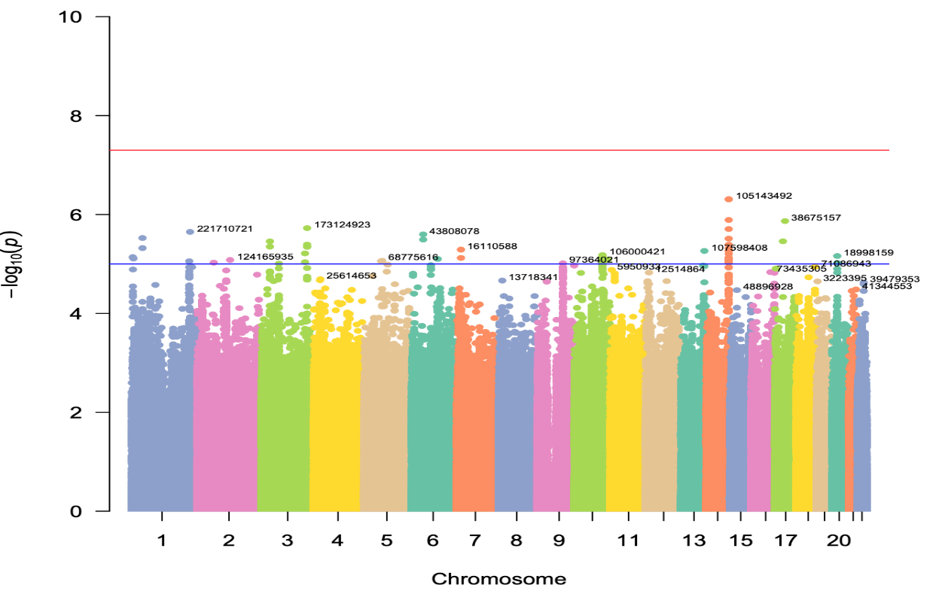

Figure S2: Manhattan plot of the association study from TMM-NEO with PCA and age
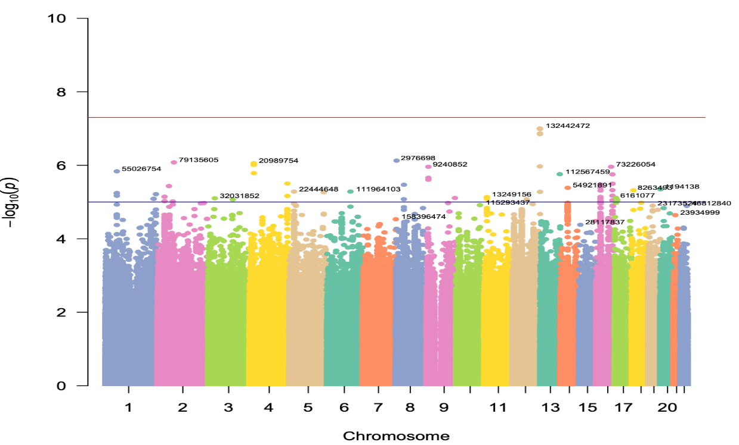

Figure S3: Manhattan plot of the association study from NGO-NEO with PCA and age
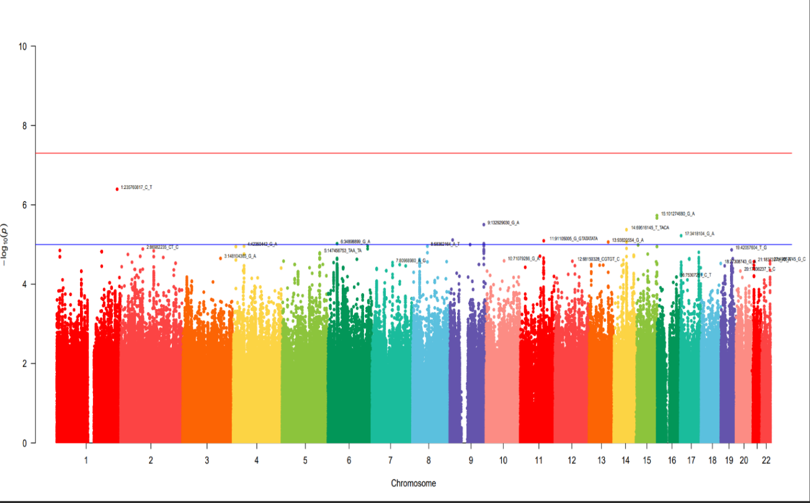

Figure S4: Manhattan plot of the meta-analysis of participants in TMM-V2, TMM-NEO, and NGO-NEO with PCA and age
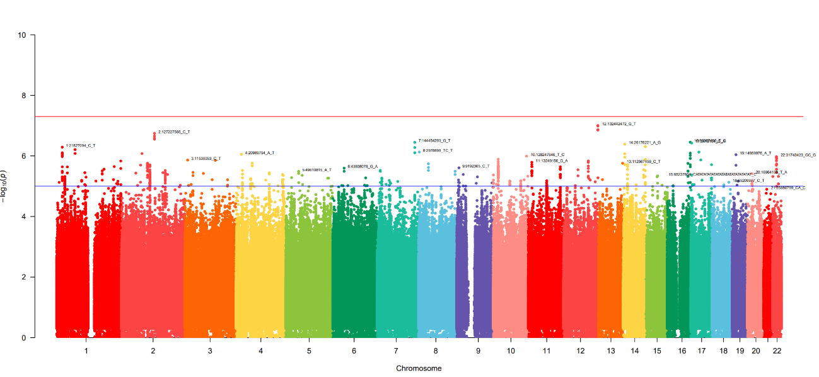
Figure S5: Manhattan plot of the meta-analysis of participants in TMM-V2, TMM-NEO, and NGO-NEO with PCA and age based on fastGWA and REGENIE
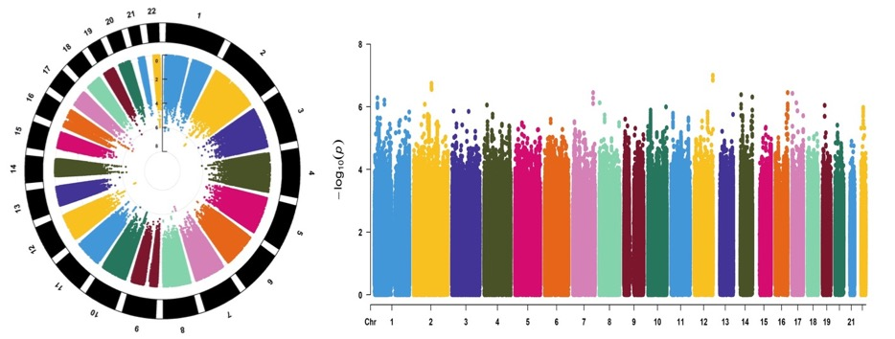

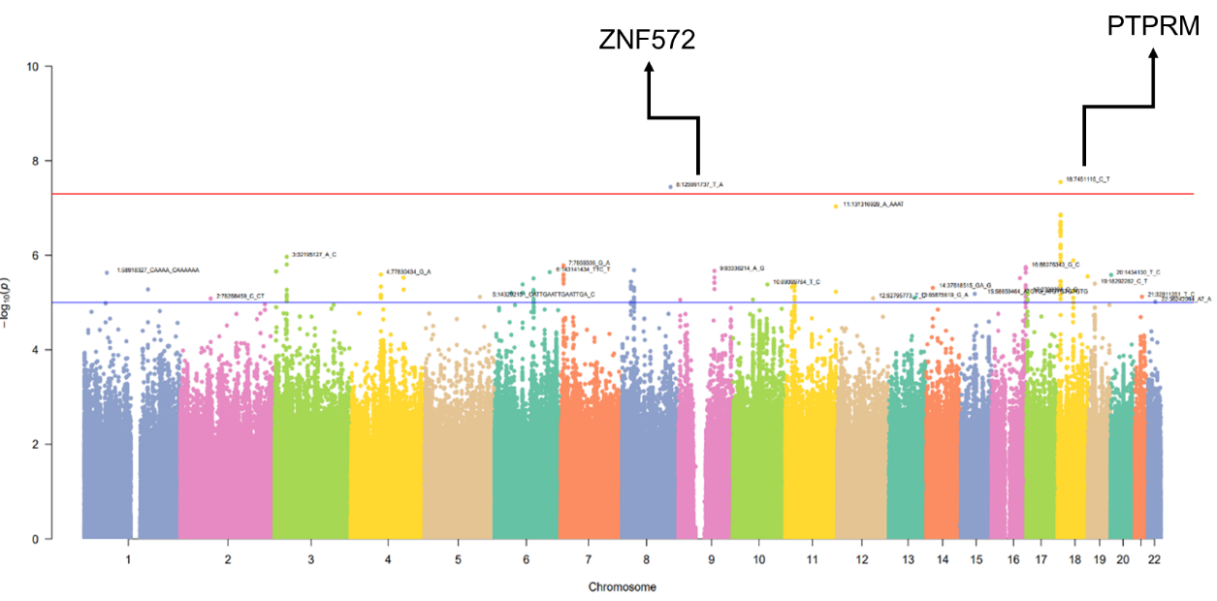
Figure S6: Manhattan plot of the association study from TMM-V2 considering factors related to PPD

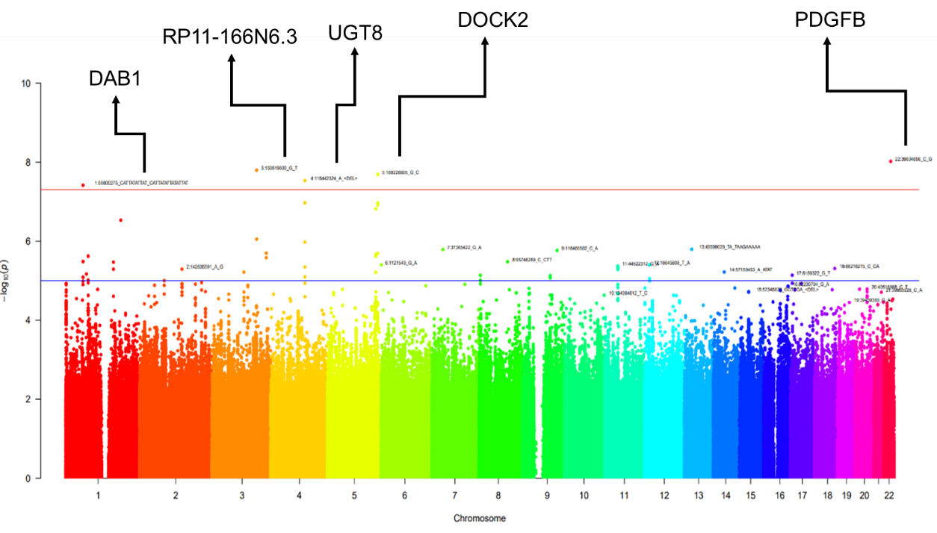
Figure S7: Manhattan plot of the association study from TMM-NEO considering factors related to PPD

Figure S8: Manhattan plot of the association study from NGO-NEO considering factors related to PPD
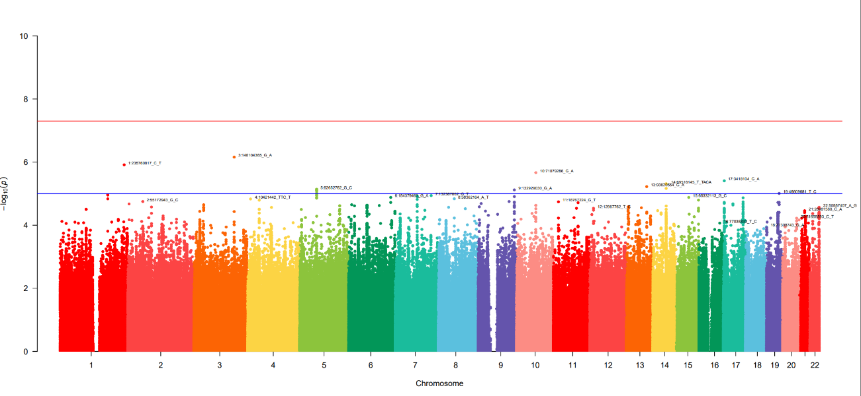

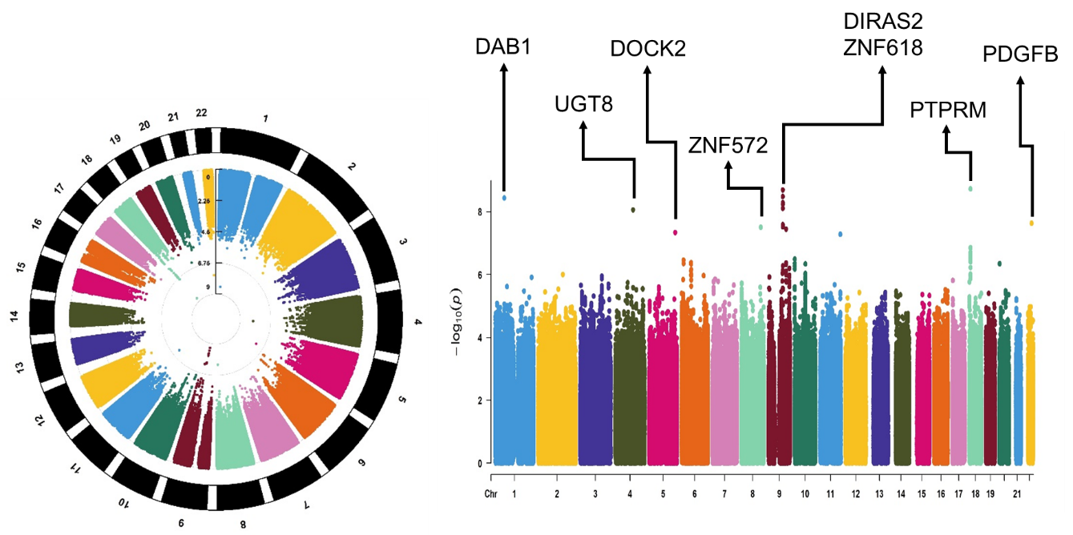
Figure S9: Manhattan plot of the meta-analysis of participants in TMM-V2, TMM-NEO, and NGO-NEO considering factors related to PPD

Figure S10: Manhattan plot of the meta-analysis of participants in TMM-V2, TMM-NEO, and NGO-NEO considering factors related to PPD based on fastGWA and REGENIE

Figure S11: Manhattan plot of the association study from TMM-V2 considering important factors related to PPD
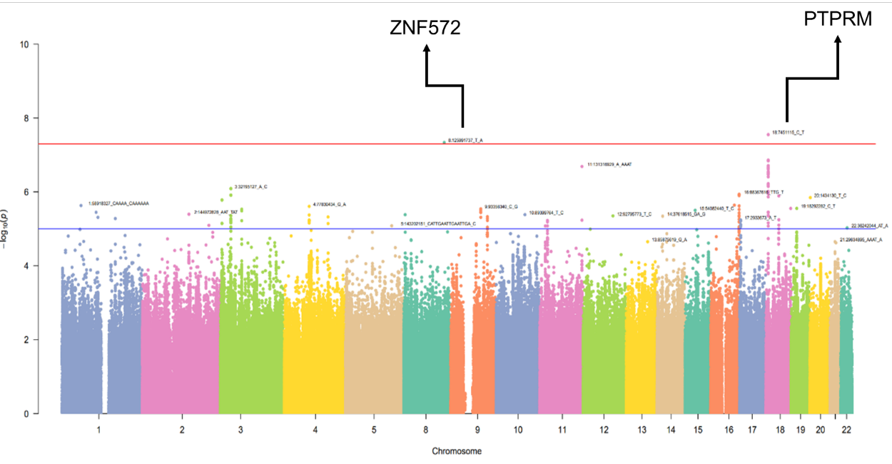

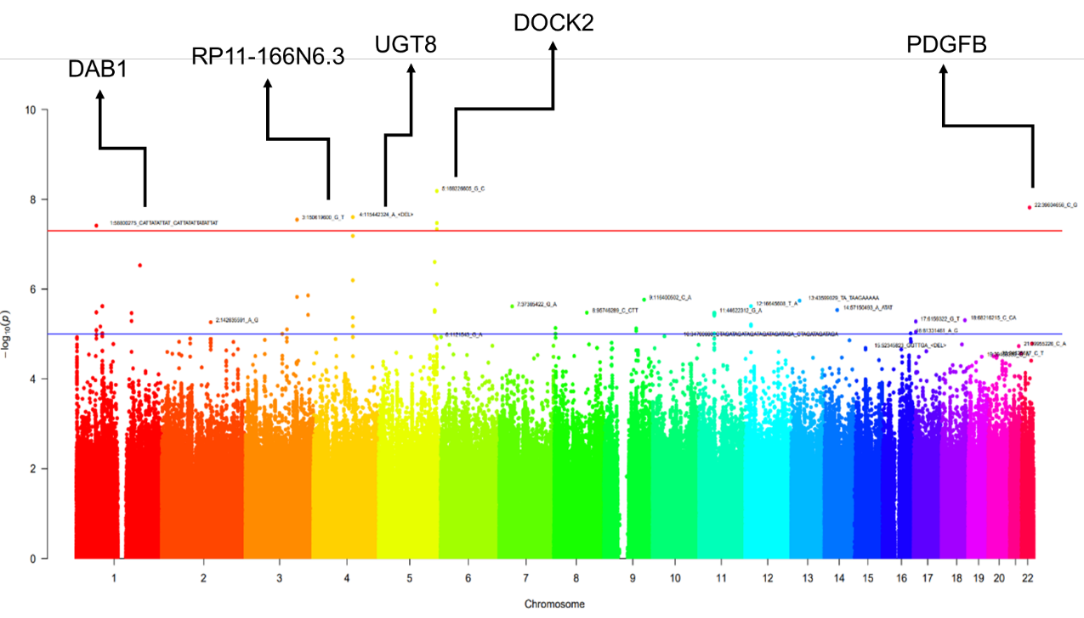
Figure S12: Manhattan plot of the association study from TMM-NEO considering important factors related to PPD

Figure S13: Manhattan plot of the association study from NGO-NEO considering important factor related to PPD
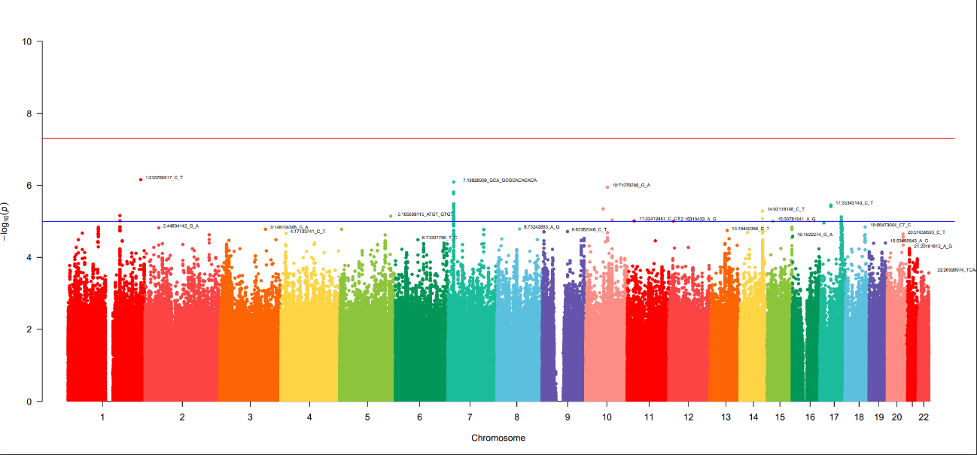

Figure S14: Manhattan plot of the meta-analysis of participants in TMM-V2, TMM-NEO, and NGO-NEO considering important factors related to PPD
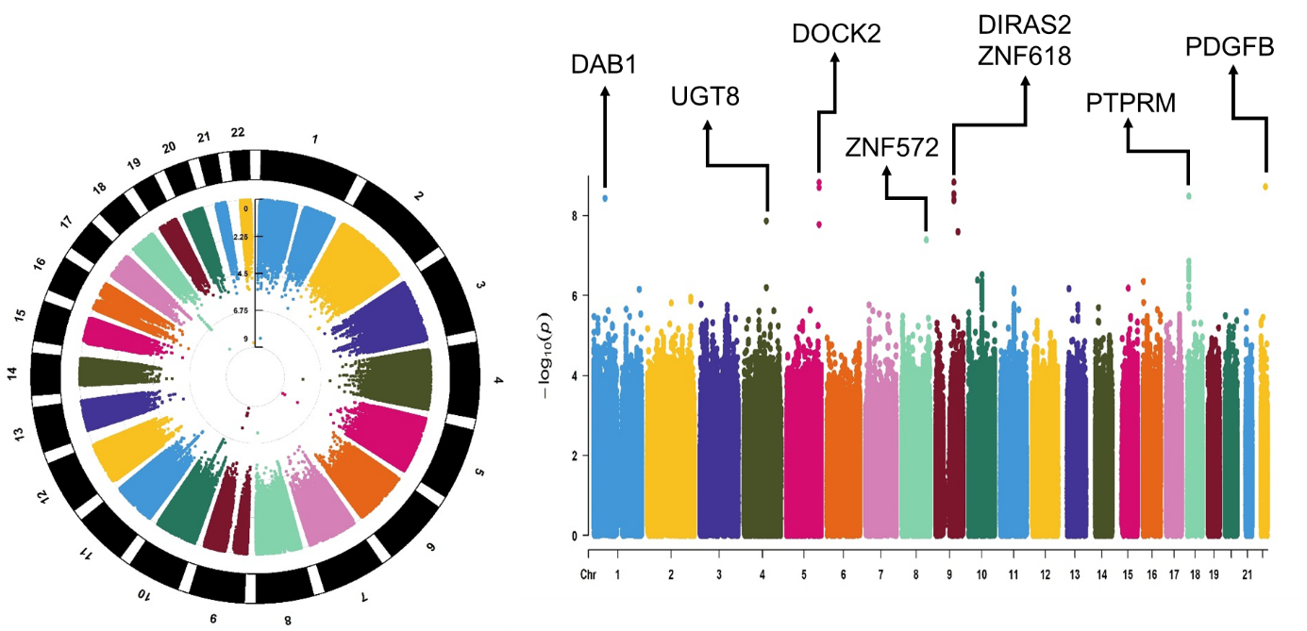

Figure S15: Manhattan plot of the meta-analysis of participants in TMM-V2, TMM-NEO, and NGO-NEO considering important factors related to PPD based on fastGWA and REGENIE

Figure S16: Regional association plot for rs377546683
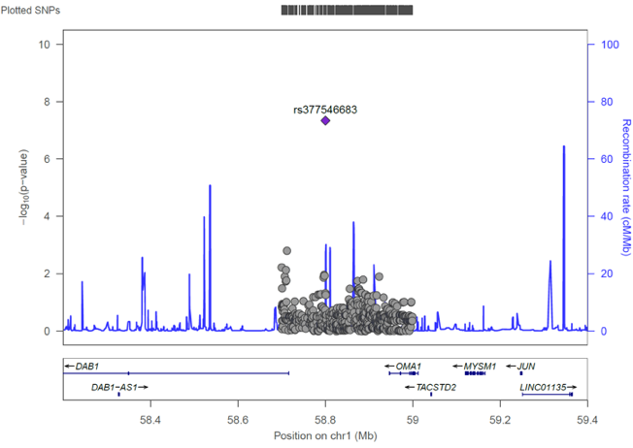

Figure S17: Regional association plot for rs11940752
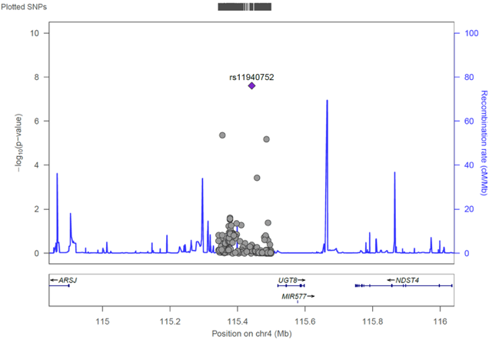

Figure S18: Regional association plot for rs141172317
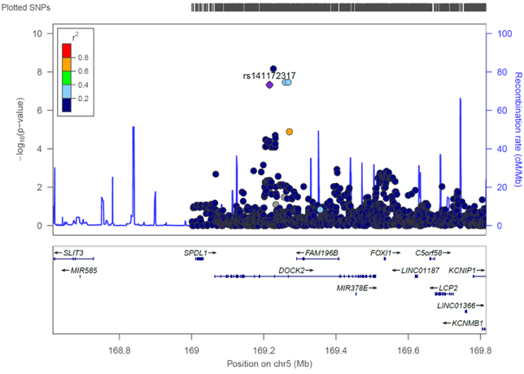

Figure S19: Regional association plot for rs117928019
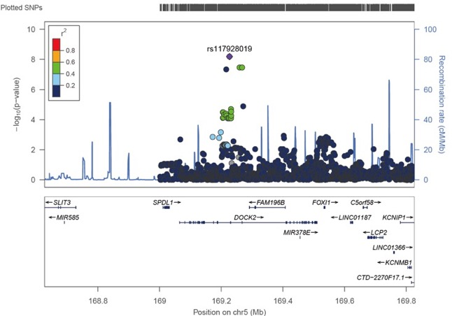

Figure S20: Regional association plot for rs76631412
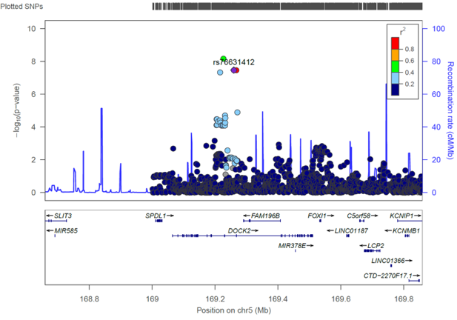

Figure S21: Regional association plot for rs188907279
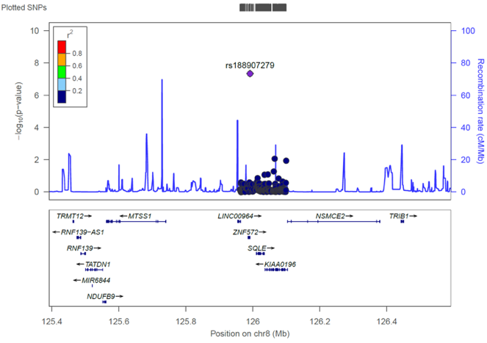

Figure S22: Regional association plot for rs504378
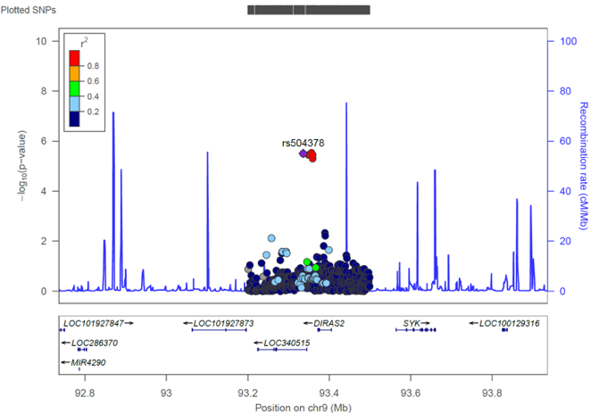

Figure S23: Regional association plot for rs690150
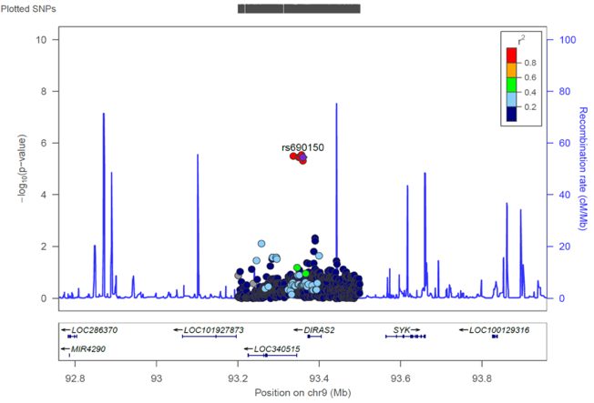

Figure S24: Regional association plot for rs491868
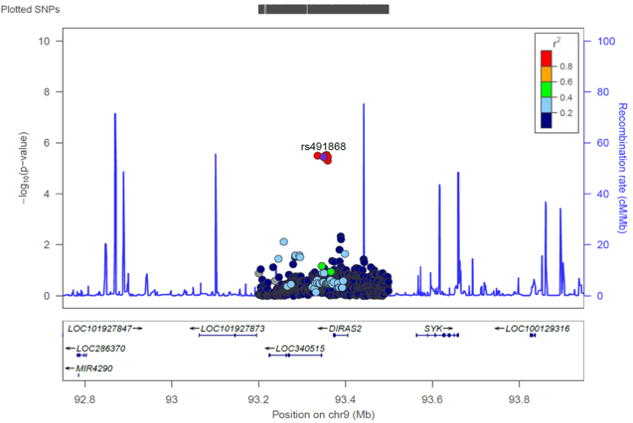

Figure S25: Regional association plot for rs689917
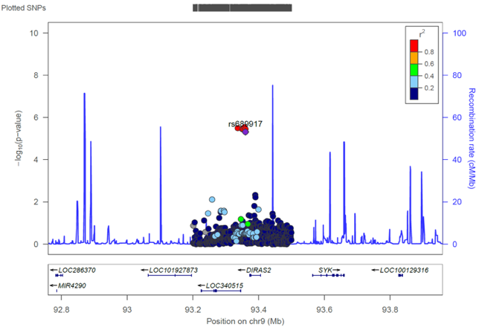

Figure S26: Regional association plot for rs474978
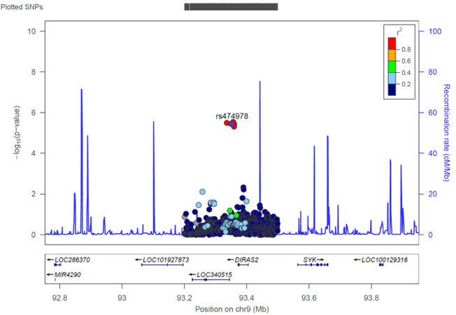

Figure S27: Regional association plot for rs690118
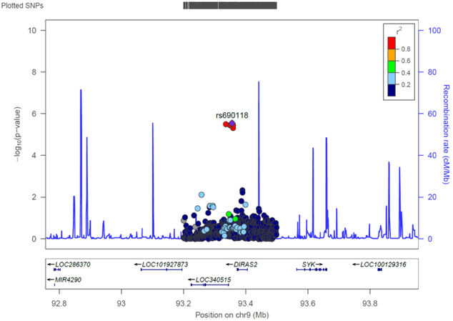

Figure S28: Regional association plot for rs690253
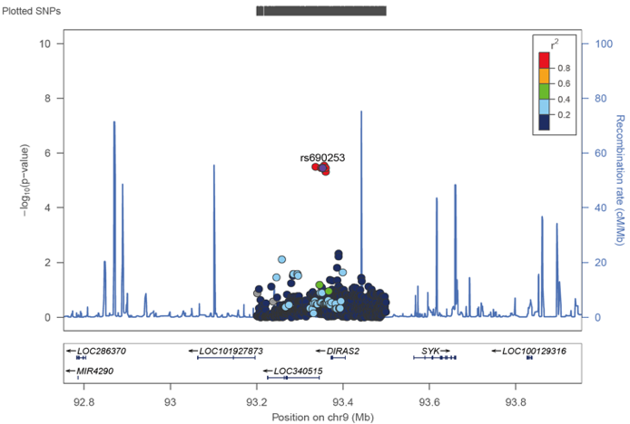

Figure S29: Regional association plot for rs1435984417
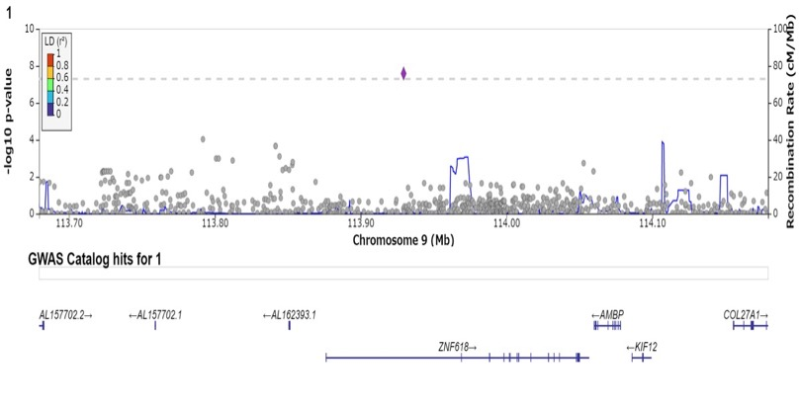

Figure S30: Regional association plot for rs57705782
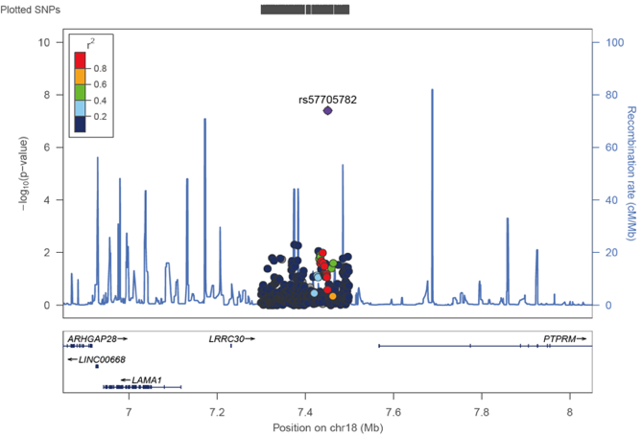

Figure S31: Regional association plot for rs185293917
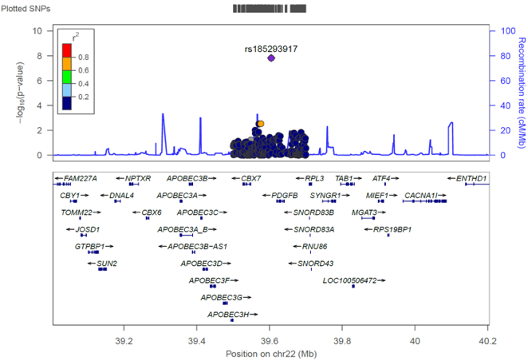

References for supplementary data
1. Glessner JT, Wang K, Sleiman PM, et al. Duplication of the SLIT3 locus on 5q35.1 predisposes to major depressive disorder. PloS one 2010; 5(12): e15463.
2. Ripke S, Wray NR, Lewis CM, et al. A mega-analysis of genome-wide association studies for major depressive disorder. Molecular psychiatry 2013; 18(4): 497-511.
3. Davies MN, Krause L, Bell JT, et al. Hypermethylation in the ZBTB20 gene is associated with major depressive disorder. Genome biology 2014; 15(4): R56.
4. Sparse whole-genome sequencing identifies two loci for major depressive disorder. Nature 2015; 523(7562): 588-91.
5. Chen X, Long F, Cai B, Chen X, Chen G. A novel relationship for schizophrenia, bipolar and major depressive disorder Part 5: a hint from chromosome 5 high density association screen. American journal of translational research 2017; 9(5): 2473-91.
6. Howard DM, Adams MJ, Clarke TK, et al. Genome-wide meta-analysis of depression identifies 102 independent variants and highlights the importance of the prefrontal brain regions. Nature neuroscience 2019; 22(3): 343-52.
7. Hüls A, Robins C, Conneely KN, et al. Association between DNA methylation levels in brain tissue and late-life depression in community-based participants. Translational psychiatry 2020; 10(1): 262.
8. Giannakopoulou O, Lin K, Meng X, et al. The Genetic Architecture of Depression in Individuals of East Asian Ancestry: A Genome-Wide Association Study. JAMA psychiatry 2021; 78(11): 1258-69.
9. Thalamuthu A, Mills NT, Berger K, et al. Genome-wide interaction study with major depression identifies novel variants associated with cognitive function. Molecular psychiatry 2022; 27(2): 1111-9.
10. Qi X, Jia Y, Pan C, et al. Index of multiple deprivation contributed to common psychiatric disorders: A systematic review and comprehensive analysis. Neuroscience and biobehavioral reviews 2022; 140: 104806.
11. Lee MT, Chen CH, Lee CS, et al. Genome-wide association study of bipolar I disorder in the Han Chinese population. Molecular psychiatry 2011; 16(5): 548-56.
12. Reif A, Nguyen TT, Weissflog L, et al. DIRAS2 is associated with adult ADHD, related traits, and co-morbid disorders. Neuropsychopharmacology : official publication of the American College of Neuropsychopharmacology 2011; 36(11): 2318-27.
13. Ikeda M, Takahashi A, Kamatani Y, et al. A genome-wide association study identifies two novel susceptibility loci and trans population polygenicity associated with bipolar disorder. Molecular psychiatry 2018; 23(3): 639-47.
14. Li HJ, Zhang C, Hui L, et al. Novel Risk Loci Associated With Genetic Risk for Bipolar Disorder Among Han Chinese Individuals: A Genome-Wide Association Study and Meta-analysis. JAMA psychiatry 2021; 78(3): 320-30.
15. Mullins N, Forstner AJ, O'Connell KS, et al. Genome-wide association study of more than 40,000 bipolar disorder cases provides new insights into the underlying biology. Nature genetics 2021; 53(6): 817-29.

