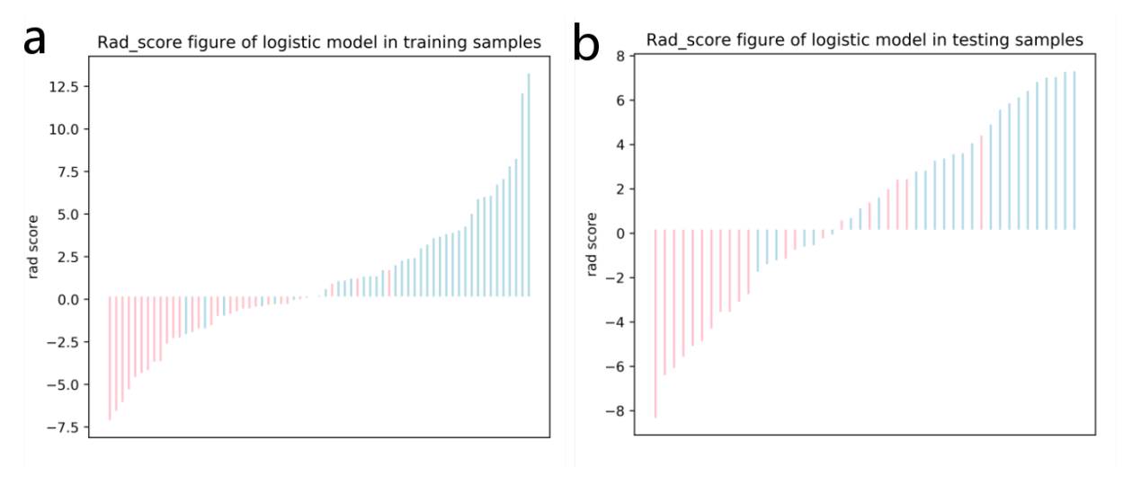

Figure S1. The Rad-score for each patient in the training (a) testing (b) sets.

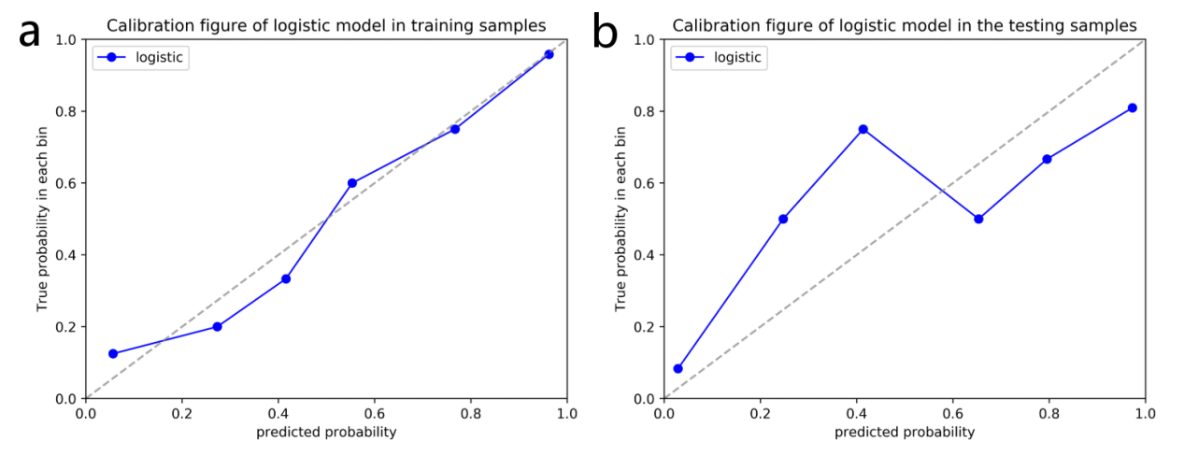

Figure S2. Radiomics nomogram calibration curves for the training (a) and testing (b) sets. The calibration curves show a good fit for the nomogram. The 45° straight lines indicated a perfect match between the true (Y-axis) and predicted (X-axis) probabilities. The closer the distance between the two curves, the better accuracy.

