Fig. S1
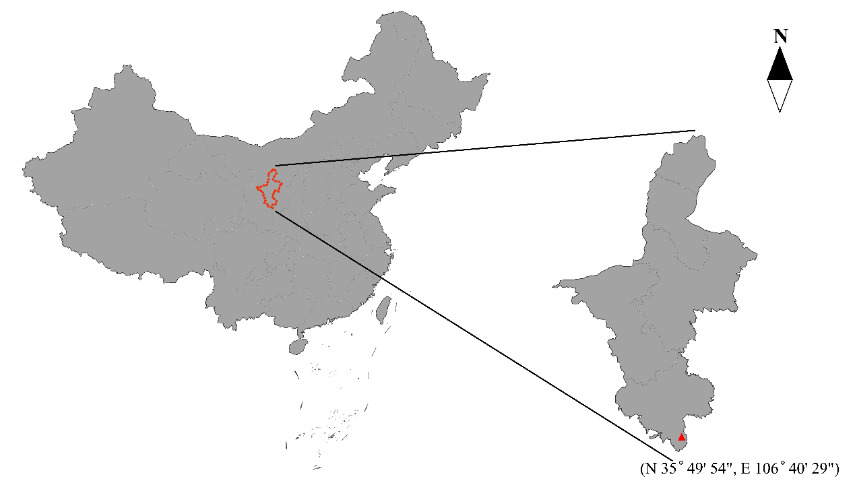
Fig. S1 The map of the location where the experiment was conducted

Fig. S2
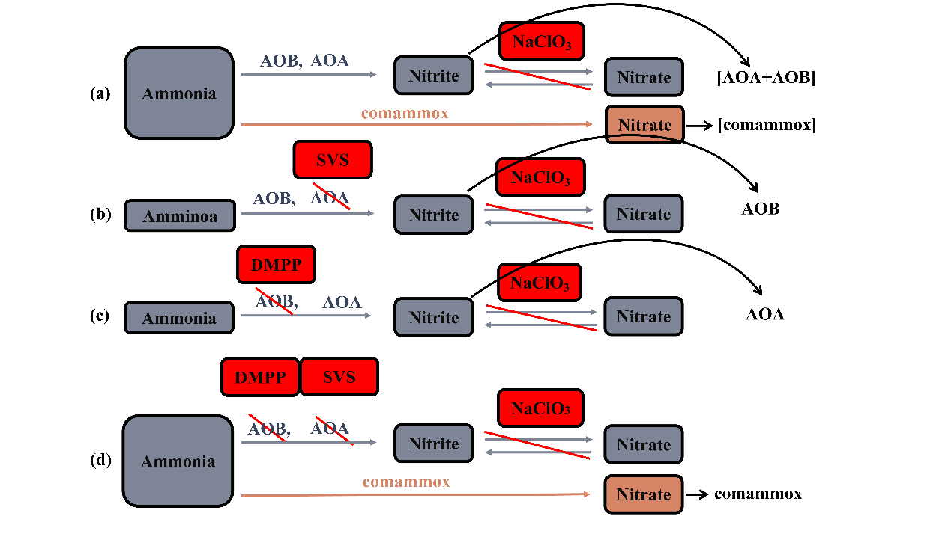
Fig. S2 Schematic diagram of determination of single nitrification potential of AOA, AOB or comammox, respectively.

Fig. S3

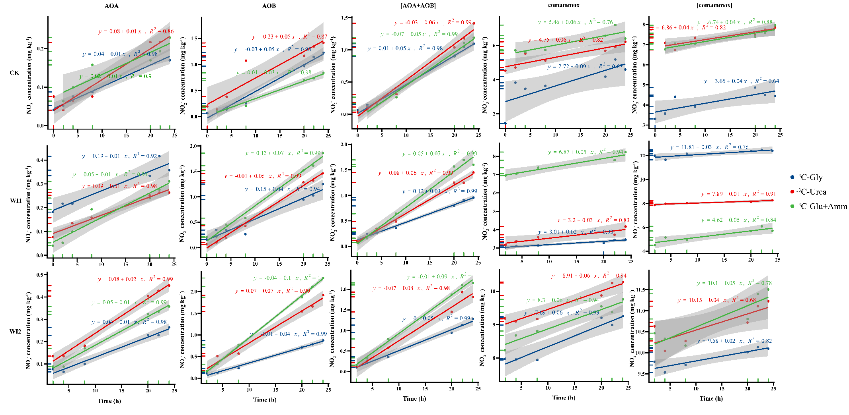
Fig. S3 Linear regression of NO₂⁻ or NO₃⁻ in samples tock at 2, 4, 8, 20, 22, and 24 based on sampling time.

Fig. S4
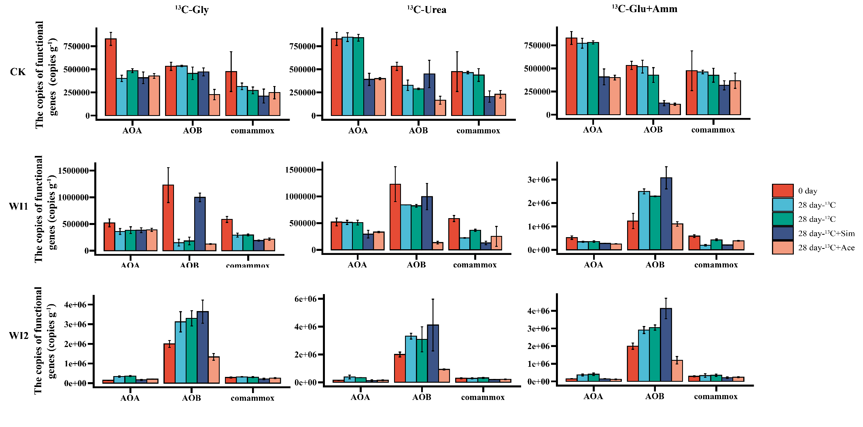
Fig. S4 Changes in the abundance of AOA, AOB and comammox for each treatment at the beginning and end of the incubation.

Table S1 Batch experiments of ¹³C and ¹²C label
Treatments | Levels of additive
¹³C-Gly | ¹³C Glycine (100 mg C kg⁻¹ and 50 mg N kg⁻¹)
¹³C-Gly+Ace | ¹³C Glycine (100 mg C kg⁻¹ and 50 mg N kg⁻¹) + Acetylene (1% v/v)
¹³C-Gly+Sim | ¹³C Glycine (100 mg C kg⁻¹ and 50 mg N kg⁻¹) + Simvastatin (12.5 mg g⁻¹)
¹³C-Urea | ¹³C Urea (100 mg C kg⁻¹ and 200 mg N kg⁻¹)
¹³C-Urea+Ace | ¹³C Urea (100 mg C kg⁻¹ and 200 mg N kg⁻¹) + Acetylene (1% v/v)
¹³C-Urea+Sim | ¹³C Urea (100 mg C kg⁻¹ and 200 mg N kg⁻¹) + Simvastatin (12.5 mg g⁻¹)
¹³C-Glu+Amm | ¹³C Glucose (100 mg C kg⁻¹) + NH₄Cl (50 mg N kg⁻¹)
¹³C-Glu+Amm+Ace | ¹³C Glucose (100 mg C kg⁻¹) + NH₄Cl (50 mg N kg⁻¹) + Acetylene (1% v/v)
¹³C-Glu+Amm+Sim | ¹³C Glucose (100 mg C kg⁻¹) + NH₄Cl (50 mg N kg⁻¹) + Simvastatin (12.5 mg g⁻¹)
¹²C-Gly | ¹²C Glycine (100 mg C kg⁻¹ and 50 mg N kg⁻¹)
¹²C-Gly+Ace | ¹²C Glycine (100 mg C kg⁻¹ and 50 mg N kg⁻¹) + Acetylene (1% v/v)
¹²C-Gly+Sim | ¹²C Glycine (100 mg C kg⁻¹ and 50 mg N kg⁻¹) + Simvastatin (12.5 mg g⁻¹)
¹²C-Urea | ¹²C Urea (100 mg C kg⁻¹ and 200 mg N kg⁻¹)
¹²C-Urea+Ace | ¹²C Urea (100 mg C kg⁻¹ and 200 mg N kg⁻¹) + Acetylene (1% v/v)
¹²C-Urea+Sim | ¹²C Urea (100 mg C kg⁻¹ and 200 mg N kg⁻¹) + Simvastatin (12.5 mg g⁻¹)
¹²C-Glu+Amm | ¹²C Glucose (100 mg C kg⁻¹) + NH₄Cl (50 mg N kg⁻¹)
¹²C-Glu+Amm+Ace | ¹²C Glucose (100 mg C kg⁻¹) + NH₄Cl (50 mg N kg⁻¹) + Acetylene (1% v/v)
¹²C-Glu+Amm+Sim | ¹²C Glucose (100 mg C kg⁻¹) + NH₄Cl (50 mg N kg⁻¹) + Simvastatin (12.5 mg g⁻¹)

Table S2 Percentage of ¹³C labeled for AOA, AOB, and comammox
Soil | Treatments | AOA (%) | AOB (%) | comammox (%)
CK | ¹³C-Gly | 14.4 | 0 | 20.1
CK | ¹³C-Gly+Sim | 0 | 54.1 | 12.5
CK | ¹³C-Gly+Ace | 0 | 0 | 8.8
CK | ¹³C-Urea | 41.1 | 0 | 88
CK | ¹³C-Urea+Sim | 0 | 75.5 | 0
CK | ¹³C-Urea+Ace | 0 | 0 | 7.2
CK | ¹³C-Glu+Amm | 70.6 | 0 | 0
CK | ¹³C-Glu+Amm+Sim | 27.9 | 0 | 0
CK | ¹³C-Glu+Amm +Ace | 0 | 0 | 0
WI1 | ¹³C-Gly | 75.5 | 11.9 | 42.1
WI1 | ¹³C-Gly+Sim | 44.9 | 13 | 29.7
WI1 | ¹³C-Gly+Ace | 9.34 | 0 | 0
WI1 | ¹³C-Urea | 55.6 | 65.4 | 5.26
WI1 | ¹³C-Urea+Sim | 0 | 84.2 | 0
WI1 | ¹³C-Urea+Ace | 0 | 0 | 8.54
WI1 | ¹³C-Glu+Amm | 48.9 | 0 | 7.8
WI1 | ¹³C-Glu+Amm+Sim | 0 | 0 | 0
WI1 | ¹³C-Glu+Amm +Ace | 38.1 | 0 | 6.2
WI2 | ¹³C-Gly | 10.6 | 0 | 28.9
WI2 | ¹³C-Gly+Sim | 0 | 3.1 | 0
WI2 | ¹³C-Gly+Ace | 20.5 | 0 | 32.3
WI2 | ¹³C-Urea | 0 | 61.4 | 0
WI2 | ¹³C-Urea+Sim | 0 | 86.9 | 0
WI2 | ¹³C-Urea+Ace | 80.3 | 0 | 64.2
WI2 | ¹³C-Glu+Amm | 54.2 | 0 | 50.1
WI2 | ¹³C-Glu+Amm+Sim | 0 | 0 | 0
WI2 | ¹³C-Glu+Amm +Ace | 0 | 0 | 0

