Supplementary Material
Using nafamostat mesilate anticoagulation for continuous renal replacement therapy in high bleeding risk patients: a systematic review and meta-analysis

CONTENTS
1. Appendix A. PRISMA 2020 checklist
2. Appendix B. Search strategy of databases
3. Appendix C. Data Extraction Form
4. Appendix D. Characteristics of studies included in the meta-analysis.
5. Appendix E. Characteristics of NM-CRRT
4. Appendix F. The criteria of high bleeding risk and outcomes.
5. Appendix G. Baseline data of the enrolled patients
6. Appendix H. The modified version of the Newcastle-Ottawa Scale for assessing the quality of studies in meta-analyses
7. Appendix I. Methodological quality of the included observational studies based on Newcastle-Ottawa Scale
8. Appendix J. Risk of bias graph for the included studies based on Cochrane Risk of Bias methodology

Appendix A: PRISMA 2020 checklist
Section and Topic | Item # | Checklist item | Location where item is reported
TITLE
Title | 1 | Identify the report as a systematic review. | Page 1
ABSTRACT
Abstract | 2 | See the PRISMA 2020 for Abstracts checklist. | Page 1-2
INTRODUCTION
Rationale | 3 | Describe the rationale for the review in the context of existing knowledge. | Page 2-3
Objectives | 4 | Provide an explicit statement of the objective(s) or question(s) the review addresses. | Page 3
METHODS
Eligibility criteria | 5 | Specify the inclusion and exclusion criteria for the review and how studies were grouped for the syntheses. | Page 4
Information sources | 6 | Specify all databases, registers, websites, organisations, reference lists and other sources searched or consulted to identify studies. Specify the date when each source was last searched or consulted. | Page 3-4
Search strategy | 7 | Present the full search strategies for all databases, registers and websites, including any filters and limits used. | Page 4
Selection process | 8 | Specify the methods used to decide whether a study met the inclusion criteria of the review, including how many reviewers screened each record and each report retrieved, whether they worked independently, and if applicable, details of automation tools used in the process. | Page 4-5
Data collection process | 9 | Specify the methods used to collect data from reports, including how many reviewers collected data from each report, whether they worked independently, any processes for obtaining or confirming data from study investigators, and if applicable, details of automation tools used in the process. | Page 4-5
Data items | 10a | List and define all outcomes for which data were sought. Specify whether all results that were compatible with each outcome domain in each study were sought (e.g. for all measures, time points, analyses), and if not, the methods used to decide which results to collect. | Page 5
Data items | 10b | List and define all other variables for which data were sought (e.g. participant and intervention characteristics, funding sources). Describe any assumptions made about any missing or unclear information. | Page 5
Study risk of bias assessment | 11 | Specify the methods used to assess risk of bias in the included studies, including details of the tool(s) used, how many reviewers assessed each study and whether they worked independently, and if applicable, details of automation tools used in the process. | Page 5
Effect measures | 12 | Specify for each outcome the effect measure(s) (e.g. risk ratio, mean difference) used in the synthesis or presentation of results. | Page 5-6
Synthesis methods | 13a | Describe the processes used to decide which studies were eligible for each synthesis (e.g. tabulating the study intervention characteristics and comparing against the planned groups for each synthesis (item #5)). | Page 5-6
Synthesis methods | 13b | Describe any methods required to prepare the data for presentation or synthesis, such as handling of missing summary statistics, or data conversions. | Page 5-6
Synthesis methods | 13c | Describe any methods used to tabulate or visually display results of individual studies and syntheses. | Page5- 6
Synthesis methods | 13d | Describe any methods used to synthesize results and provide a rationale for the choice(s). If meta-analysis was performed, describe the model(s), method(s) to identify the presence and extent of statistical heterogeneity, and software package(s) used. | Page 5-6
Synthesis methods | 13e | Describe any methods used to explore possible causes of heterogeneity among study results (e.g. subgroup analysis, meta-regression). | Page 5-6
Synthesis methods | 13f | Describe any sensitivity analyses conducted to assess robustness of the synthesized results. | Page 5-6
Reporting bias assessment | 14 | Describe any methods used to assess risk of bias due to missing results in a synthesis (arising from reporting biases). | Page 5-6
Certainty assessment | 15 | Describe any methods used to assess certainty (or confidence) in the body of evidence for an outcome. | Page 5-6
RESULTS
Study selection | 16a | Describe the results of the search and selection process, from the number of records identified in the search to the number of studies included in the review, ideally using a flow diagram. | Page 6-7
Study selection | 16b | Cite studies that might appear to meet the inclusion criteria, but which were excluded, and explain why they were excluded. | Page 6-
Study characteristics | 17 | Cite each included study and present its characteristics. | Page 6-7
Risk of bias in studies | 18 | Present assessments of risk of bias for each included study. | Page 7
Results of individual studies | 19 | For all outcomes, present, for each study: (a) summary statistics for each group (where appropriate) and (b) an effect estimate and its precision (e.g. confidence/credible interval), ideally using structured tables or plots. | Page 7-9
Results of syntheses | 20a | For each synthesis, briefly summarise the characteristics and risk of bias among contributing studies. | Page 7-9
Results of syntheses | 20b | Present results of all statistical syntheses conducted. If meta-analysis was done, present for each the summary estimate and its precision (e.g. confidence/credible interval) and measures of statistical heterogeneity. If comparing groups, describe the direction of the effect. | Page 7-9
Results of syntheses | 20c | Present results of all investigations of possible causes of heterogeneity among study results. | Page 7-9
Results of syntheses | 20d | Present results of all sensitivity analyses conducted to assess the robustness of the synthesized results. | Page 7-9
Reporting biases | 21 | Present assessments of risk of bias due to missing results (arising from reporting biases) for each synthesis assessed. | Page 7-9
Certainty of evidence | 22 | Present assessments of certainty (or confidence) in the body of evidence for each outcome assessed. | Page 7-9
DISCUSSION
Discussion | 23a | Provide a general interpretation of the results in the context of other evidence. | Page 9-10
Discussion | 23b | Discuss any limitations of the evidence included in the review. | Page 11-12
Discussion | 23c | Discuss any limitations of the review processes used. | Page 11-12
Discussion | 23d | Discuss implications of the results for practice, policy, and future research. | Page 12
OTHER INFORMATION
Registration and protocol | 24a | Provide registration information for the review, including register name and registration number, or state that the review was not registered. | Page 14
Registration and protocol | 24b | Indicate where the review protocol can be accessed, or state that a protocol was not prepared. | Page 13
Registration and protocol | 24c | Describe and explain any amendments to information provided at registration or in the protocol. | Page 13
Support | 25 | Describe sources of financial or non-financial support for the review, and the role of the funders or sponsors in the review. | Page 13
Competing interests | 26 | Declare any competing interests of review authors. | Page 13
Availability of data, code and other materials | 27 | Report which of the following are publicly available and where they can be found: template data collection forms; data extracted from included studies; data used for all analyses; analytic code; any other materials used in the review. | Page 13

Appendix B: Search strategy of databases
PubMed
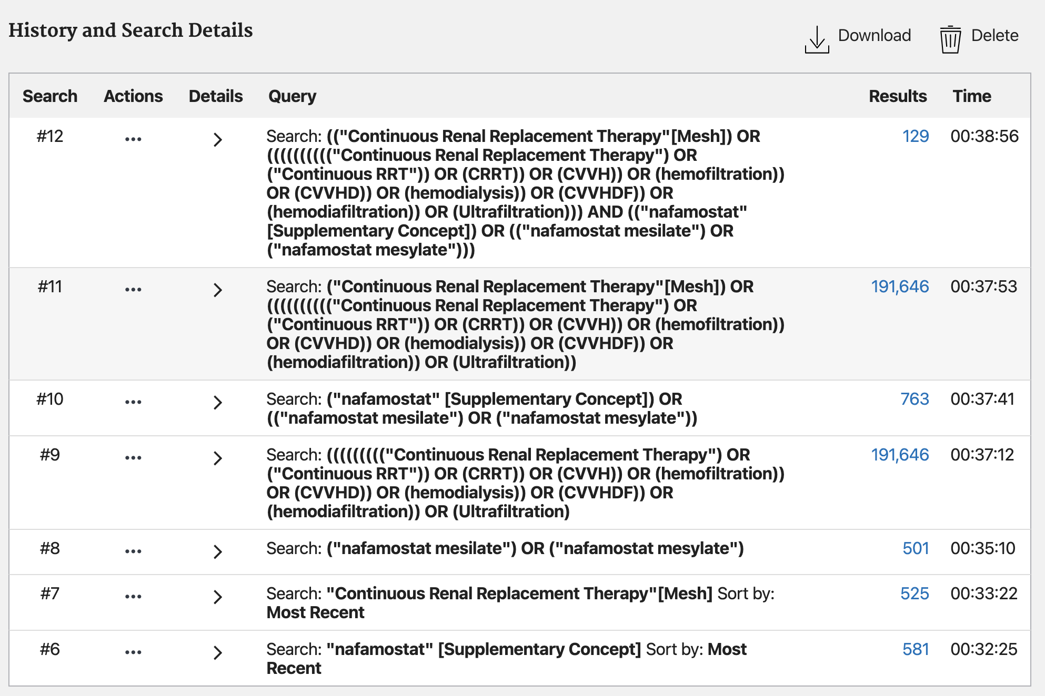

EMBASE
Search | Query | Results
#1 | 'nafamstat mesilate'/exp | 19455
#2 | 'continuous renal replacement therapy'/exp | 3212657
#3 | 'nafamostat mesylate'/exp OR 'nafamostat mesylate' OR 'nafamostat mesilate'/exp OR 'nafamostat mesilate' | 3087
#4 | 'continuous renal replacement therapy'/exp OR 'continuous renal replacement therapy' OR 'ultrafiltration'/exp OR ultrafiltration OR 'scuf'/exp OR 'scuf' OR 'continuous rrt' OR 'crrt'/exp OR 'crrt' OR 'cvvh'/exp OR 'cvvh' OR 'hemofiltration'/exp OR hemofiltration OR 'cvvhd'/exp OR 'cvvhd' OR 'hemodialysis'/exp OR hemodialysis OR 'cvvhdf'/exp OR cvvhdf OR 'hemodiafiltration'/exp OR hemodiafiltration | 214369
#5 | #1 OR #3 | 1569
#6 | #2 OR #4 | 214369
#7 | #5 AND #6 | 303

CINAHL
Search | Query | Results
S1 | TX nafamstat mesilate OR TX nafamostat mesylate | 52

J-STAGE
Search | Query | Results
#1 | ("nafamostat mesylate" OR "nafamostat mesilate") AND ("Continuous Renal Replacement Therapy" OR CRRT) | 52

KoreaMed
Search | Query | Results
#1 | (("nafamostat mesylate"[ALL])) OR ("nafamostat  mesilate"[ALL]) | 20

Cochrane
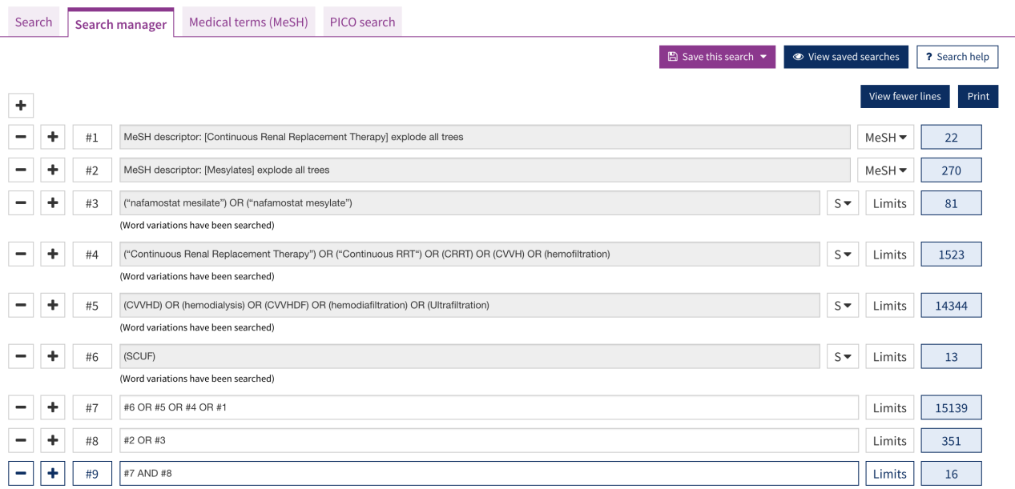

Web of Science
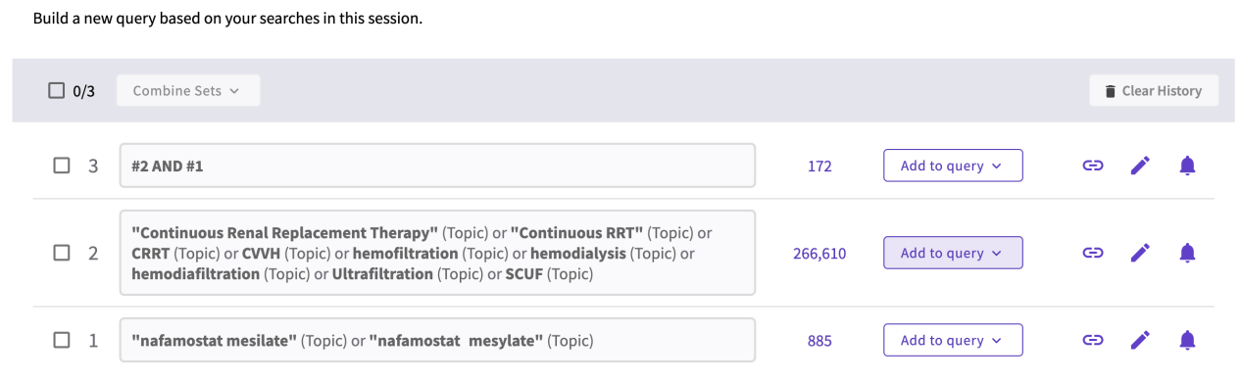

Appendix C: Study Selection and Data Extraction Form
Study Selection and Data Extraction Form
Name of author extracting data: Date form completed:
Party1: General study information
Items | Data | Notes
Title
Study ID
Authors
Journal
Year
Country
COI

Party 2: Study Selection
Items | Choose | Notes
Types of participants:  Were the participants with increased bleeding risk and underwent CRRT? | Yes  Unclear  No
Interventions:  Was the conventional anticoagulant strategy compared with NM? | Yes  Unclear  No
Conclusion:
Do not proceed if any of the previous answers are ‘No’.
Included
Excluded and listed in excluded table
More information needed before inclusion decision (specify)

Party 3: Study details
Inclusion/Exclusion Criteria:

 | Intervention | Control
Number of Participants
Type of Participants
Age, mean (SD)
Median (IQR)
Male n (%)
Female n (%)
Setting
NM Intervention (How to do? How long?)

Control (How to do? How long?)

Follow up

outcomes

Abbreviations: NM, nafamostat mesilate; CRRT, continuous renal replacement therapy;
Appendix D: Characteristics of studies included in the meta-analysis.
Source  (year/country) | Design | Setting | No. of centers | Inclusion | Exclusion | Intervention/control | End-points
Baek et al.  (2012/Kore)^{[24]} | ROS | ICU | 1 | High risk of bleeding; CRRT more than 48 hours | Received less than 48h of CRRT;  began CRRT before the study; received standard heparin anticoagulation. | NM/NA | Filter lifespan;  bleeding complication; mortality
Choi et al.  (2015/Korea)^{[25]} | RCT | ICU | 1 | Adult; required CRRT; high bleeding risk | Pregnant or possibly pregnant women; allergic to NM or were hypercoagulable | NM/NA | Filter lifespan;  bleeding complication; frequency of transfusions; mortality;  total duration of CRRT
Hwang et al. (2013/Korea)^{[26]} | ROS | ICU | 1 | Treated with CRRT；with obvious or suspicious bleeding | Patients died within the first filter use; ingested paraquat | NM/NA | Filter lifespan; coagulation parameters; bleeding complication;  mortality
Kim et al. (2011/Korea)^{[27]} | RCT | ICU | 1 | Patients high bleeding risk | Blood flow cannot reach 230 mL/min or higher | NM/NA | Bleeding complication
Lee ST et al. (2014/Korea)^{[28]} | ROS | ICU | 1 | Pediatric patients (≤18 years old); at least 24 hours of venovenous CRRT | NR | NM/NA | Filter lifespan;  bleeding events;  survival rate;  total duration of CRRT
Lee YK et al. ( 2014/Korea)^{[29]} | RCT | ICU | 1 | Patients requiring CRRT with hemorrhagic tendency | Patients who were pregnant (or possibly pregnant); breast feeding; allergic to nafamostat mesilate | NM/NA | Mortality;  filter lifespan;  transfusion;  bleeding complication
Park et al. (2009/Korea)^{[30]} | RCT | ICU | 1 | Patients with high bleeding risk | NR | NM/NA | Filter lifespan;  anticoagulation effects;  CVVH duration;  bleeding complication
Abbreviations: NM, nafamostat mesilate; CRRT, continuous renal replacement therapy; NA, anticoagulation-free; CVVH, continuous venovenous hemofiltration; NR, not reported; ROS, retrospective observational study; ICU, intensive care unit

Appendix E: Characteristics of NM-CRRT
Study | Type of CRRT | CRRT machine | NM maintenance doses | Filter | Blood flow (ml/min) | Replacement/Dialysate fluid | Replacement/Dialysate fluid flow (ml/h) | Pre-/post-filter dilution | Vascular access | Catheter size(Fr)
Baek 2012^{[24]} | CVVHDF | Prisma or Prismaflex (Gambro) | 5-20mg/h | Polyacrylonite hollow-fiber hemofilter (M-100,  Gambro) | 120-150 | Bicarbonate buffered | 1000-2000 | Pre-filter | IJV, FV, SV | 11.5-12.5
Choi 2015^{[25]} | CVVHDF | multiFiltrate | 10-30mg/h | Polysulfone membrane hemofilter (Ultraflux AV 600S) | 150-200 | NR | NR | NR | NR | NR
Hwang 2013^{[26]} | CVVHDF | Prisma or Prismaflex (Gambro) | 10-30mg/h | AN69/HF1000 | 100-150 | Bicarbonate buffered | 1000/1000 | Pre-filter | FV, IJV | 11.5
Kim 2011^{[27]} | CVVH | NR | 12.5 mg/h | PMMA filter (Toray B3 1.3A) | 230-300 | NR | NR | NR | AV fistula; AV graft; Catheter | NR
Lee ST 2014^{[28]} | CVVHDF | Prisma or Prismaflex (Gambro) | 0.125–0.5 mg/kg/h | ST 60/ST 100 | 3-5/kg/ | bicarbonate buffered | 2000 | NA | IJV, FV | 8-11
Lee YK 2014^{[29]} | CVVHDF | Prisma or Prismaflex (Gambro) | 10–30 mg/h | NR | 130-200 | Bicarbonate buffered | NR | Pre-filter | FV, IJV | NR
Park 2009^{[30]} | CVVH | prisma (Gambro) | 12.5 mg/h | HF 1000 | 230–300 | NR | 2000 | NR | NR | NR
Abbreviations: NM, nafamostat mesilate; CRRT, continuous renal replacement therapy; CVVH, continuous venovenous hemofiltration; NR, not reported; CVVHDF, continuous veno-venous hemodiafiltration; FV, femoral vein; IJV, internal jugular vein; SV, subclavian vein

Appendix F: The criteria of high bleeding risk and outcomes
Study | High bleeding risk | Filter failure
Baek 2012^{[24]} | - The presence of spontaneous bleeding (i.e., surgical drain blood loss or gastrointestinal hemorrhage);  - Major surgery within 7 days before CRRT;  - Brain hemorrhage, or operation within 14 days before CRRT;  - Coagulopathy (a prolonged prothrombin time international normalized ratio > 2, a prolonged activated partial thromboplastin time > 60 s, or a platelet count less than 50,000/mm) | NR
Choi 2015^{[25]} | - Active bleeding such as gastrointestinal bleeding and intracranial hemorrhage;  2. Activated partial thromboplastin time > 60 seconds, prothrombin time–international normalized ratio > 2.0, thrombocytopenia (< 100,000/μL);  3. Surgery within 48 hours before CRRT | Filter clotting, persistent transmembrane pressure >200 mm Hg, malfunction of vascular access, dysfunction of extracorporeal circuits, change in CRRT schedule, and cessation of CRRT owing to other causes.
Hwang 2013^{[26]} | Obvious or suspicious bleeding | NR
Kim 2011^{[27]} | - Postoperatively, active bleeding such as gastrointestinal bleeding, intracranial bleeding, hemoptysis, and hematuria;  - Severe thrombocytopenia (platelet count below 50,000/mm 3) | NR
Lee ST 2014^{[28]} | - The presence of a prolonged prothrombin time i national normalized ratio (PT INR) > 2, activated partial thromboplastin time (aPTT) > 60 seconds, platelet counts < 50,000/mm3 , activated clotting time (ACT) ≥ 200 seconds,;  - Major surgery within seven days before CRRT;  - Brain hemorrhage or an operation within 14 days before CRRT | NR
Lee YK 2014^{[29]} | - Platelet count < 100,000/µL;  - Activated partial thromboplastin time> 60 seconds;  - Prothrombin time-international normalized ratio> 2.0;  - Active hemorrhage;  - Surgery within the past 48 hours;  - Cerebral hemorrhage within the past 3 months or history of a major cerebral bleeding;  - Septic shock or disseminated intravascular coagulation | Filter clot, ultrafiltrate loss <150 mL/hr within 3 hours, persistent transmembrane pressure higher than 200 mmHg, or an extracorporeal circuit abnormality due to another apparatus
Park 2009^{[30]} | - In the case of surgery within 48 hours or bleeding  - if heparin cannot be used as an anticoagulant due to cerebral hemorrhage, gastrointestinal bleeding, etc.  - INR> 60, APTT< 60sec, platelet counts < 50,000/mm3 | NR
Abbreviations: CRRT, continuous renal replacement therapy; NR, not reported; ACT, activated clotting time; APTT, activated partial thromboplastin time; PT, prothrombin time; INR, international normalized ratio

Appendix G: Baseline data of the enrolled patients
study | Sample size | Age（T/C, year) | Male/Female | Severity | Creatinine (mg/dl) | BUN (mg/dl) | Platelet  (×10³ /mm³ ) | aPTT (s)
Baek 2012^{[24]} | 243 | NM: 59.3 ± 15.9 NA: 55.5 ± 12.7 | NM: 40/22 NA: 114/67 | NR | NR | NR | NR | NR
Choi 2015^{[25]} | 55 | NM: 63.6 ± 11.5 NA: 58.6 ± 18.0 | NM: 21/10 NA: 15/9 | APACHE II  NM: 23.5 ± 6.2 NA:25.9 ± 8.4 | NM: 4.2 ± 1.9 NA: 3.9 ± 1.3 | NM:77.4 ± 36.9  NA: 73.6 ± 37.7 | NM: 115.5 ± 75.9  NA: 77.7 ± 65.6 | NM: 52.5 ± 39.3  NA: 46.3 ± 28.2
Hwang 2013^{[26]} | 156 | NM: 65.2 ± 11.0 NA: 66.3 ± 15.0 | NM: 16/9  NA: 77/54 | APACHEII  NM : 25.6 ± 7.1 NA:24.9 ± 6.1 | NM: 4.2 ± 2.9 NA: 4.3 ± 3.4 | NM: 70.8 ± 52.4 NA: 68.1 ± 68.1 | NM: 136.9 ± 108.4  NA: 136.9 ± 108.4 | NM: 54.9 ± 25.3 NA: 54.9 ± 25.3
Kim 2011^{[27]} | 35 | NM: 58.8 ± 14.60 NA: 57.1 ± 16.80 | NM: 8/9  NA: 10/8 | NR | NR | NR | NM: 224.4 ± 136.2 NA:187.3 ± 66.2 | NM: 30.1 ± 5.7 NA: 30.0 ± 4.8
Lee ST 2014^{[28]} | 34 | NM: 6.9 ± 5.6  NA: 9.2 ± 6.4 | NM: 9/6  NA: 12/7 | NR | NR | NR | NM: 43.2 ± 23.4  NA: 36.7 ± 21.6 | NM: 50.8 ± 23.5 NA: 73.9 ± 74.7
Lee YK 2014^{[29]} | 73 | NM: 52.97 ± 13.94 NA: 57.54 ± 13.04 | NM: 24/12 NA: 20/17 | APACHE II NM:26.72 ± 5.26 NA:26.84 ± 6.00 | NR | NM: 64.09 ± 25.64 NA: 61.71 ±30.16 | NM: 57.44 ± 40.05 NA: 90.92 ± 97.39 | NR
Park 2009^{[30]} | 43 | NM: 61.25 ± 18.23 NA: 59.00 ± 10.29 | NM: 12/8  NA: 11/12 | APACHE II  NM: 17.35 ± 5.13 NA: 15.52 ± 3.96 | NR | NM: 43.96 ± 24.76 NA: 51.39 ± 25.18 | NM:152.25 ±117.99  NA: 158.83 ± 98.81 | NM:58.19 ± 32.95 NA:50.59 ± 26.05
Abbreviations: NR, not reported; aPTT, activated partial thromboplastin time; BUN, blood urine nitrogen; NM, nafamostat mesilate; NA, anticoagulation-free; APACHE II, acute physiology and chronic health evaluation

Appendix H: The modified version of the Newcastle-Ottawa Scale for assessing the quality of studies in meta-analyses
Quality-assessed Items | Sub-items |  | Criteria and scores
Subjects selection | Selection 1 | Representativeness of the patients at high risk of bleeding included in the studies | a | truly representative of the general characteristics of patients at high risk of bleeding (1 star)
Subjects selection | Selection 1 |  | b | somewhat representative of the general characteristics of patients at high risk of bleeding (1 star)
Subjects selection | Selection 1 |  | c | no description of the derivation of the cohort (0 star)
Subjects selection | Selection 2 | Selection of the non exposed cohort | a | drawn from the same setting as the exposed cohort (1 star)
Subjects selection | Selection 2 | Selection of the non exposed cohort | b | drawn from a different source (1 star)
Subjects selection | Selection 2 | Selection of the non exposed cohort | c | no description of the derivation of the non exposed cohort (0 star)
Subjects selection | Selection 3 | Ascertainment of high risk of bleeding | a | rigorous diagnostic criteria (e.g. laboratory test record and clinical manifestation) (1 star)
Subjects selection | Selection 3 | Ascertainment of high risk of bleeding | b | deducing from the underlying diseases and conditions (1 star)
Subjects selection | Selection 3 | Ascertainment of high risk of bleeding | c | no description (0 star)
Subjects selection | Selection 4 | Demonstration that endpoint events were not presented at start of study | a | yes (1 star)
Subjects selection | Selection 4 |  | b | no (0 star)
Comparability | Comparability of cohorts on the basis of the design or analysis |  | a | study controls for risk factors of bleeding (1 star)
Comparability |  |  | b | study controls for any additional factor (1 star)
Comparability |  |  | c | none (0 star)
Outcome | Outcome 1 | Assessment of outcome | a | independent blind assessment (1 star)
Outcome | Outcome 1 | Assessment of outcome | b | non-independent blind assessment (1 star)
Outcome | Outcome 1 | Assessment of outcome | c | no description (0 star)
Outcome | Outcome 2 | Was observation long enough for endpoint events to occur | a | yes (1 star)
Outcome | Outcome 2 | Was observation long enough for endpoint events to occur | b | no (0 star)
Outcome | Outcome 3 | Completeness of the observation period | a | complete observation - all subjects accounted for (1 star)
Outcome | Outcome 3 | Completeness of the observation period | b | subjects lost to follow up unlikely to introduce bias-small number lost < 10%, or description provided of those lost (1 star)
Outcome | Outcome 3 | Completeness of the observation period | c | loss ratio > 25% and no description of those lost (0 star)
Outcome | Outcome 3 | Completeness of the observation period | d | no statement (0 star)
Note: A study can be awarded a maximum of 1 star for each numbered item within the Selection and Outcome categories. A maximum of 2 stars can be given for Comparability.

Appendix I: Methodological quality of the included observational studies
Author (Year) | Selection 1 | Selection 2 | Selection 3 | Selection 4 | Comparability | Outcome 1 | Outcome 2 | Outcome 3 | Total stars
Baek et al. (2012)^{[24]} | a | a | a | b | a | c | a | a | 6
Hwang et al. (2013)^{[26]} | a | a | b | b | a | c | a | a | 6
Lee ST et al. (2014)^{[28]} | b | a | a | b | a | c | a | a | 6

Appendix J. Risk of bias graph for the included studies based on Cochrane Risk of Bias methodology.

