Fig.S1 Hasegawa et al.
A
CB PLB
M HFt S Beads S Beads
kDa

250
150

100

75

50

37

25

20

15
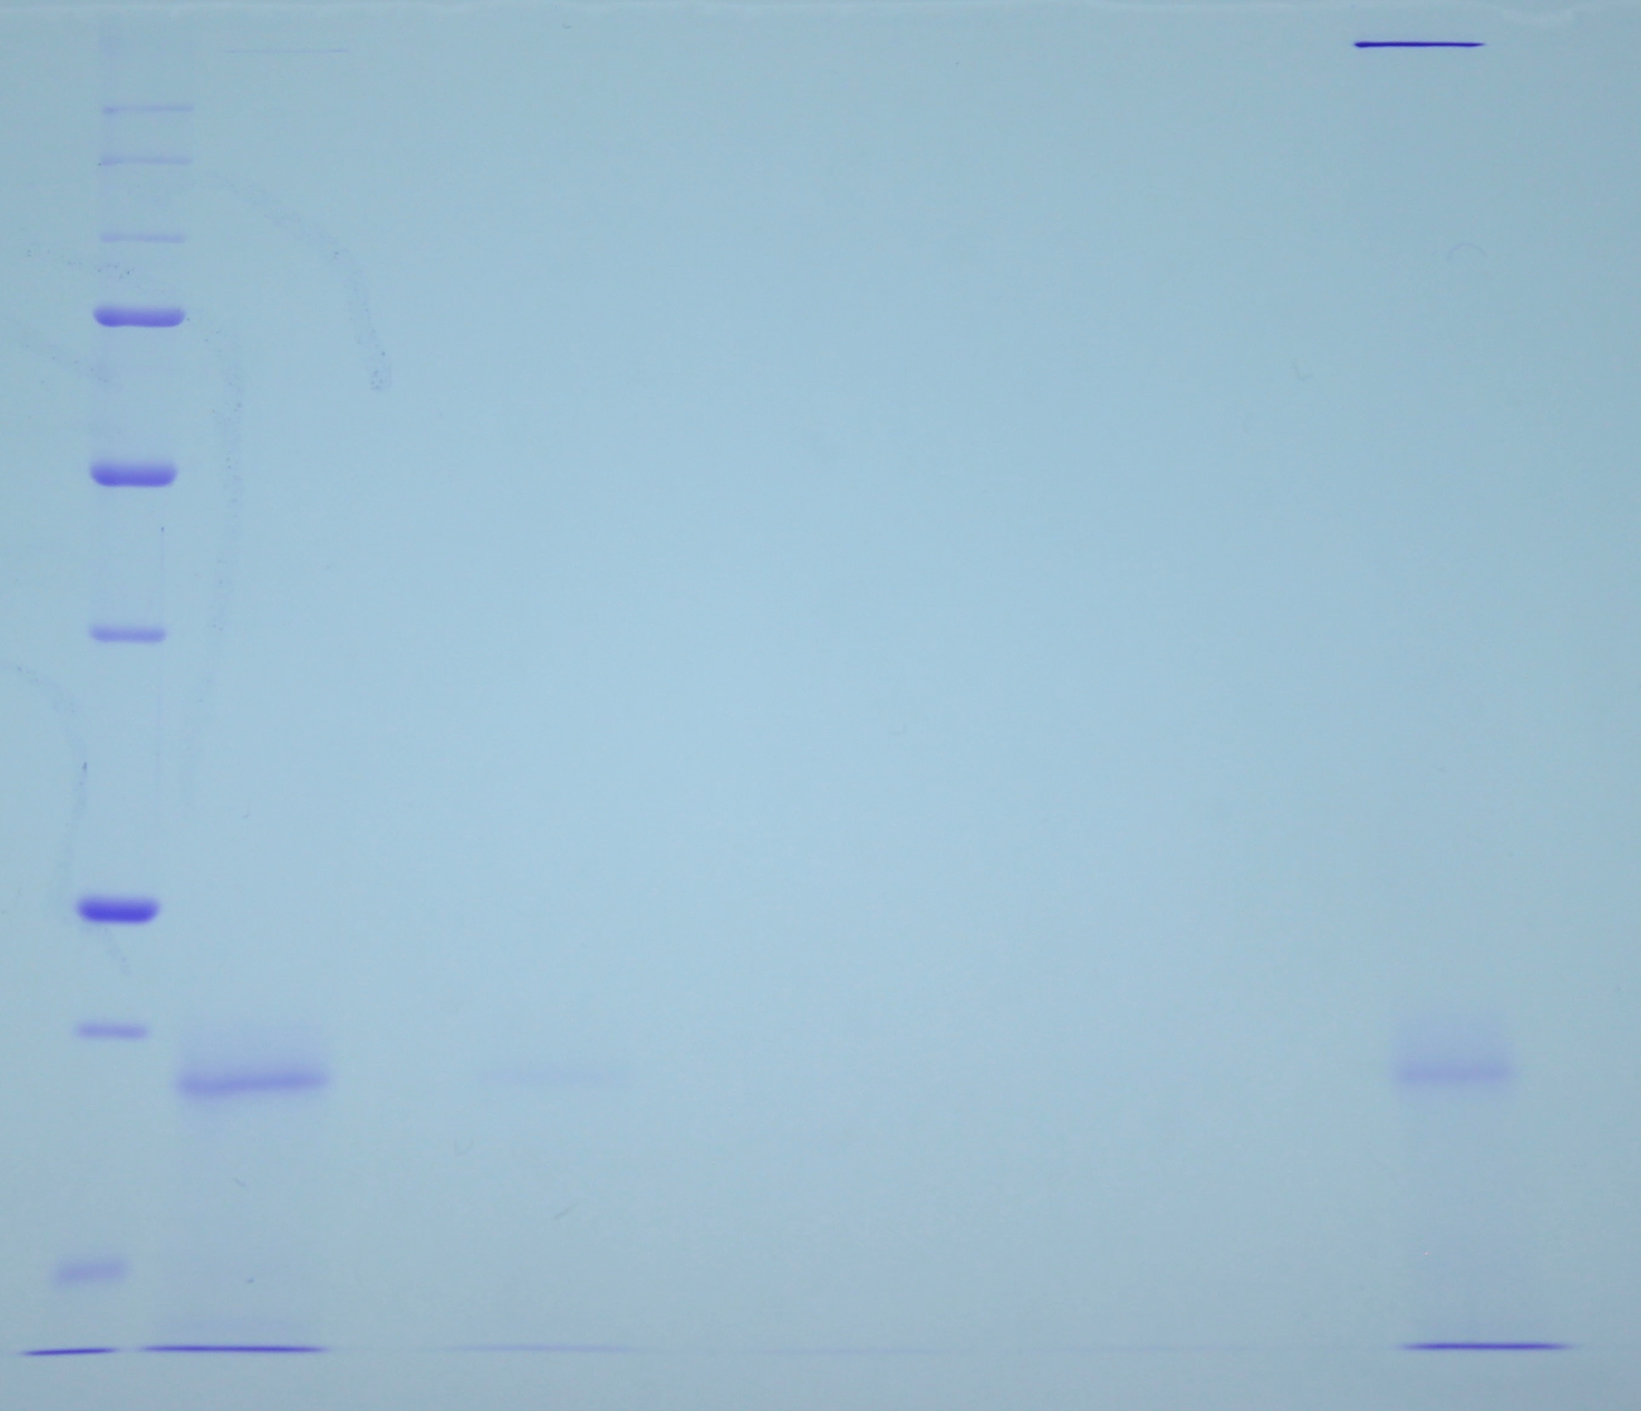

B
kDa

250
150

100

75

50

37

25

20

15

Apo- CB PLB CasB
M HFt S Beads S Beads S Beads
