Supplementary Figures
Supplementary Figure 1
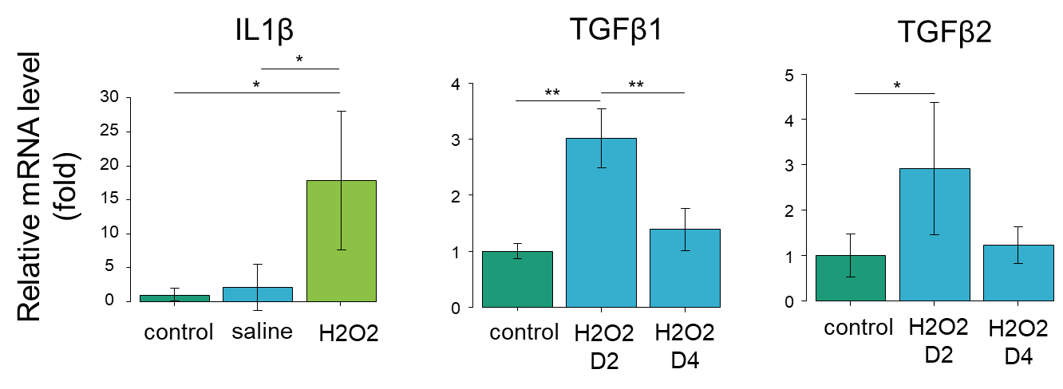
Supplementary Figure 1. mRNA expressions of TGF-β are elevated in H₂O₂-induced mice.
Effect of intravesical infusion of H₂O₂ on the mRNA expression levels of inflammatory cytokines. The mRNA expression levels of IL1β and TGF-β1,2 in control, saline, H₂O₂ groups (respectively n=3) were measured by real-time RT-qPCR. Each mRNA level was normalized to the β-actin mRNA level and expressed relative to the control (fold). Results are represented as means ± sd. *P < 0.05, **P < 0.01.

Supplementary Figure 2
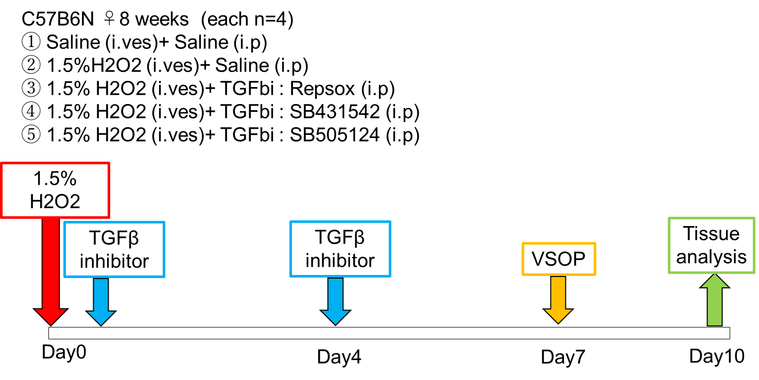
Supplementary Figure 2. Experimental scheme is shown.
The mice at the age of 8 weeks were anesthetized with isoflurane. 1.5% H₂O₂ were intravesically infused into the bladder for 30 minutes. Thirty min after H₂O₂ emission, TGF-β inhibitors (either SB431542, SB505124, or Repsox at 1.2 mM, 100μl/mouse) were intraperitoneally injected. On day 4, an injection of TGF-β inhibitors were repeated. Urination was recorded on day 7 by VSOP. Mice were sacrificed and bladder was removed on day 10.

Supplementary Figure 3
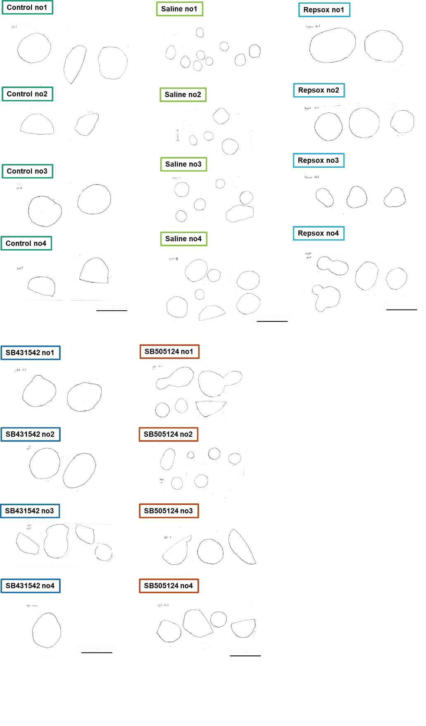
Supplementary Figure 3. The stain sizes of the H₂O₂ group were smaller than that of the control and the TGF-β inhibitors (SB431542, SB505124 and Repsox) group.
Scale bar = 50mm.
Supplementary Figure 4
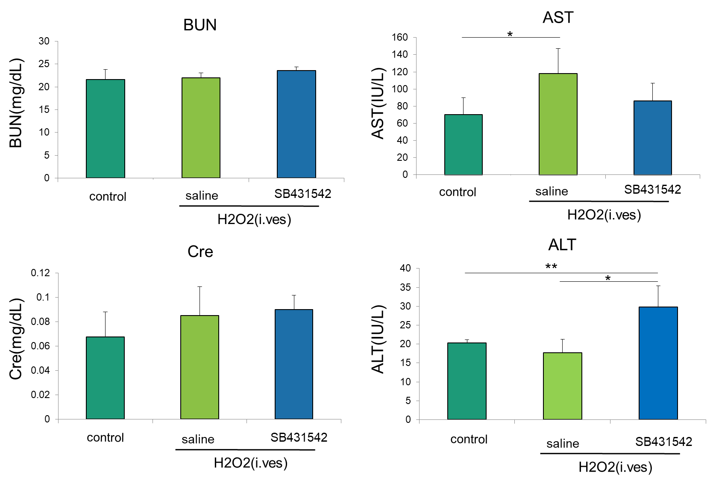
Supplementary Figure 4. Biological toxicity in liver and kidney is not confirmed.
Blood samples were collected for the assessment of liver and renal toxicity. sham, H₂O₂: intravesical H₂O₂ injection+ intraperitoneal saline injection, SB431542: intravesical H₂O₂ injection+ intraperitoneal SB431542 injection, respectively n=4. Results are represented as means ± sd. *P<0.05. AST, aspartate aminotransferase; ALT, alanine aminotransferase; BUN, blood urea nitrogen; Cre, creatinine.

Supplementary Figure 5
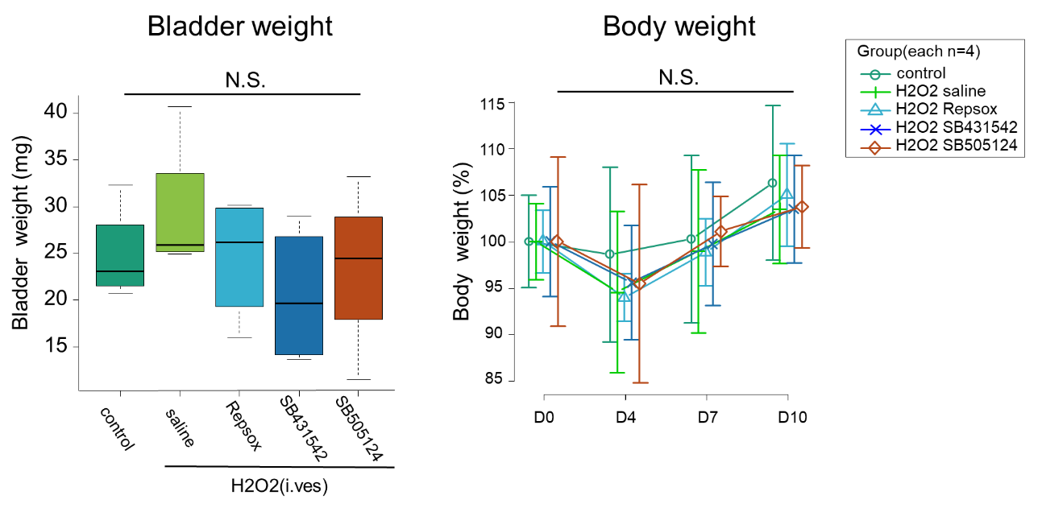
Supplementary Figure 5. Body weight and bladder weight
Bladder weight (mg) on post-instillation day 10. sham, H₂O₂: intravesical H₂O₂ injection+ intraperitoneal saline injection, inhibitors(Repsox, SB431542, and SB505124): intravesical H₂O₂ injection+ intraperitoneal inhibitors injection, respectively n=4. Chronological changes in whole body weight(g) on baseline, H₂O₂ pre-instillation day 0 and post-instillation day 4, 7. Results are represented as means ± sd. N.S.: no significant difference.

Supplementary Figure 6
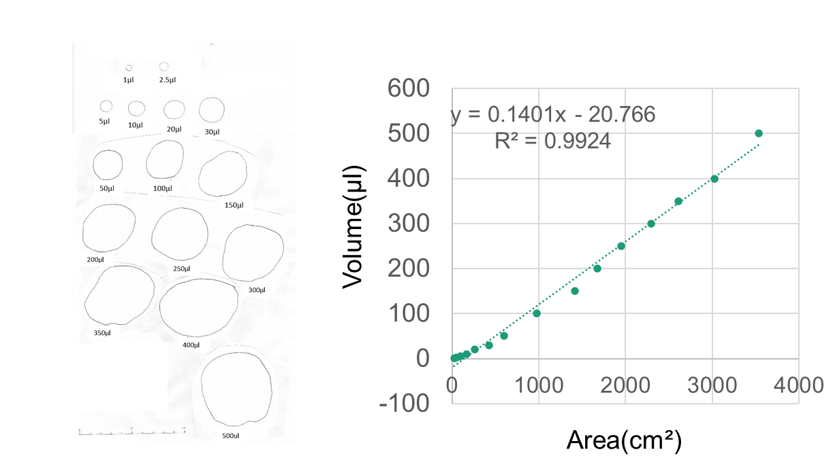
Supplementary Figure 6. Method of Voided Stain On Paper (VSOP) is shown.
The surface area is made by fluid drops of known volume (1 μL, 2.5μL, 5 μL, 10 μL, 20 μL, 50 μL, 100 μL, 150 μL, 200 μL, 250 μL, 300 μL, 350 μL, 400 μL, 500 μL). Linear correlation between liquid volume and stained area on the filter paper (r2= 0.9924, y = 0.1401x - 20.766).

