Supplementary
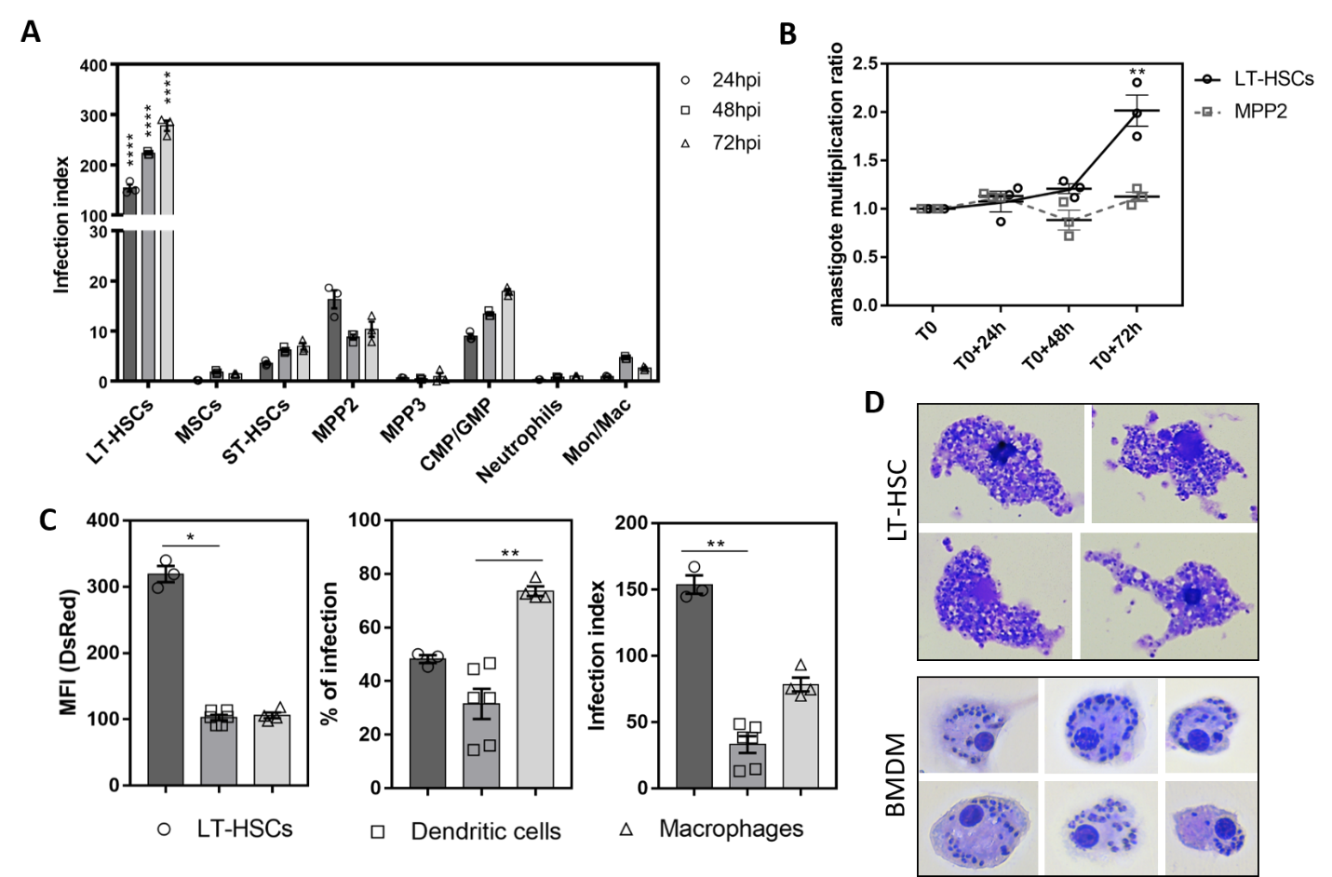
Figure S1. LT-HSCs are most susceptible to VL infection ex vivo. (A) Ex vivo Ldl82 WT^{PpyRE9/DsRed} infection of lineage depleted BM collected from BALB/c mice: infection index representing DsRed MFI × % of infection. (B) Evolution over time of the intracellular parasite burden (amastigote multiplication ratio) in two BM cell subsets: LT-HSCs and MPP2s. (C) Comparison of MFI, % infection and infection index between BM-derived dendritic cells and macrophages and LT-HSCs, (D) Giemsa staining of Lld82 WT^{PpyRE9/DsRed} infected BM-derived macrophages and sorted LT-HSC. (A-D) Days post-infection (dpi), median fluorescence intensity (MFI), mesenchymal stem cell (MSC), long-term hematopoietic stem cell (LT-HSC), short-term hematopoietic stem cell (ST-HSC), multipotent progenitor (MPP), common myeloid progenitor (CMP), granulocyte-monocyte progenitor (GMP), monocyte/macrophage (Mon/Mac). Results are shown as mean ± SEM and are based on at least three independent repeats (3 ≤ n ≤ 6). Statistical significance was found with two-tailed tests, i.e. 2way ANOVA in (A), Kruskal-Wallis in (C), and multiple t test in (D). *p<0.05, **p<0.01, ****p<0.0001.

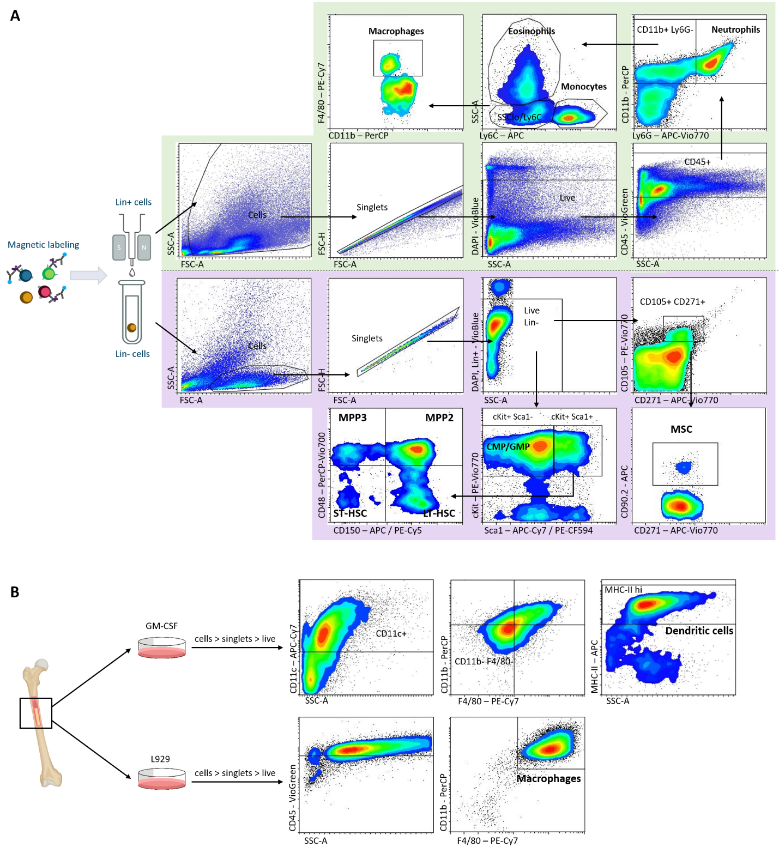Figure S2. Flow cytometry gating strategy. (A) BM cells were separated into lineage positive (Lin+) and negative (Lin-) cells using negative magnetic sorting. For both fractions, a cell gate was selected in a SSC-A versus FSC-A plot, followed by a gating on singlets in a FSC-H versus FSC-A plot. Lin+ live (DAPI-) CD45⁺ cells were further characterized as neutrophils (CD11b+ Ly-6G+), monocytes (Ly-6Chi) and macrophages (SSClow, Ly-6C-, F4/80+). Lin- live (DAPI-) cells were either plotted as cKit versus Sca1 or as CD105 versus CD271 to allow identification of hematopoietic stem cells or mesenchymal stem cells, respectively. cKit+Sca1+ cells were further characterized as LT-HSCs (CD48- CD150+), ST-HSCs (CD48- CD150-), MPP2 (CD48+ CD150+), and MPP3 (CD48+ CD150-). cKit+Sca1- cells were identified as CMP/GMP. CD105+CD271+ cells were further characterized as MSCs (CD90.2+). (B) BM cells were differentiated into dendritic cells or macrophages using GM-CSF or L929, respectively. For both subsets, a cell gate was selected in a SSC-A versus FSC-A plot, followed by gating on singlets in a FSC-H versus FSC-A plot and a live (DAPI-) selection as in (A). CD45⁺ cells were further characterized as macrophages (CD11b+ F4/80+), and CD11c+ cells as dendritic cells (CD11b- F4/80- MHC-II^{hi}).

Table S1. Characteristic cell surface markers for the identification of BM cells with flow cytometry. Abbreviations: long-term (LT) and short-term (ST) hematopoietic stem cell (HSC), multipotent progenitor (MPP), common myeloid progenitor (CMP), granulocyte monocyte progenitor (GMP).
Cell Type | Flow cytometry markers
MSC | Lin- CD105+ CD271+ CD90.2+
LT-HSC | Lin- Sca+ cKit+ CD150+ CD48-
ST-HSC | Lin- Sca+ cKit+ CD150- CD48-
MPP | Lin- Sca+ cKit+ CD150- CD48+
CMP / GMP | Lin- Sca- cKit+ CD34+
Monocytes | CD45+ CD11b+ Ly6C^{Hi} Ly6G- F4/80^{Low}
Macrophages | CD45+ CD11b+ Ly6C^{Low} Ly6G- F4/80+
Neutrophils | CD45+ CD11b+ Ly6C+ Ly6G+ F4/80-
Dendritic cells | CD11c+ CD11b- F4/80- MHC-II^{Hi}

Table S2. Cell markers to differentiate BM cells by flow cytometry using MACSQuant® Analyzer 10. Abbreviations: long-term (LT) and short-term (ST) hematopoietic stem cell (HSC), multipotent progenitor (MPP), common myeloid progenitor (CMP), granulocyte monocyte progenitor (GMP).
Cell surface marker | Fluorophore | Clone N° | Manufacturer
LT-HSC, ST-HSC, MPP2, MPP3, CMP, GMP
cKit | PE-Vio770 | REA791 | Miltenyi Biotec
CD150 | APC | REA299 | Miltenyi Biotec
CD48 | PerCP-Vio700 | HM48-1 | Miltenyi Biotec
CD34 | FITC | REA383 | Miltenyi Biotec
Ter119 | VioBlue | Ter-119 | Miltenyi Biotec
Gr-1 | VioBlue | REA810 | Miltenyi Biotec
CD11b | VioBlue | REA592 | Miltenyi Biotec
TCR-β | VioBlue | REA318 | Miltenyi Biotec
B220 | VioBlue | REA755 | Miltenyi Biotec
CD335 | VioBlue | REA815 | Miltenyi Biotec
Sca-1 | APC-Cy7 | D7 | BD Biosciences
Monocytes, macrophages, neutrophils, eosinophils
Ly6C | APC | AL-21 | BD Biosciences
Ly6G | APC-Vio770 | REA526 | Miltenyi Biotec
CD11b | PerCP | M1/70 | BioLegend®
F4/80 | PE-Cy7 | BM8 | BioLegend®
CD45 | VioGreen | REA737 | Miltenyi Biotec
Mesenchymal stem cells
CD105 | PE-Vio770 | REA1058 | Miltenyi Biotec
CD271 | APC-Vio770 | REA648 | Miltenyi Biotec
CD34 | FITC | REA383 | Miltenyi Biotec
Ter119 | VioBlue | Ter-119 | Miltenyi Biotec
Gr-1 | VioBlue | REA810 | Miltenyi Biotec
CD11b | VioBlue | REA592 | Miltenyi Biotec
TCR-β | VioBlue | REA318 | Miltenyi Biotec
B220 | VioBlue | REA755 | Miltenyi Biotec
CD335 | VioBlue | REA815 | Miltenyi Biotec
Dendritic cells
CD11b | PerCP | M1/70 | BioLegend®
F4/80 | PE-Cy7 | BM8 | BioLegend®
CD11c | APC-Cy7 | REA791 | Miltenyi Biotec
MHC-II | APC | M5/114.15.2 | Miltenyi Biotec
Cell markers to differentiate BM cells by flow cytometry using FACSMelodyTM.
Cell surface marker | Fluorophore | Clone N° | Manufacturer
LT-HSC, ST-HSC, MPP2, MPP3, CMP, GMP
cKit | PE-Vio770 | REA791 | Miltenyi Biotec
CD150 | PE-Cy5 | TC15-12F12.2 | BioLegend®
CD48 | PerCP-Vio700 | HM48-1 | Miltenyi Biotec
CD34 | FITC | REA383 | Miltenyi Biotec
Ter119 | VioBlue | Ter-119 | Miltenyi Biotec
Gr-1 | VioBlue | REA810 | Miltenyi Biotec
CD11b | VioBlue | REA592 | Miltenyi Biotec
TCR-β | VioBlue | REA318 | Miltenyi Biotec
B220 | VioBlue | REA755 | Miltenyi Biotec
CD335 | VioBlue | REA815 | Miltenyi Biotec
Sca-1 | PE-CF594 | D7 | BD Bioscience

