Supplementary Material

Biochar supported nanoscale zero-valent iron for the kinetics removal and mechanism of decabromodiphenyl ethane in the sediment

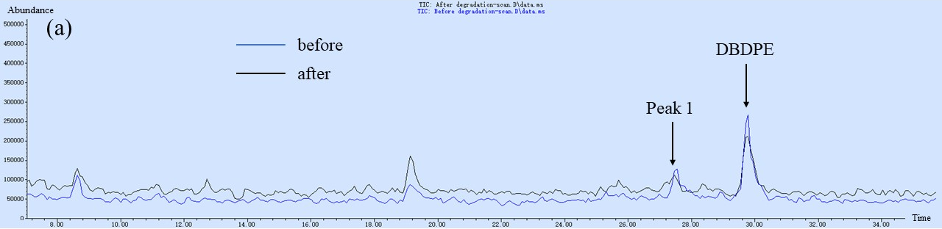
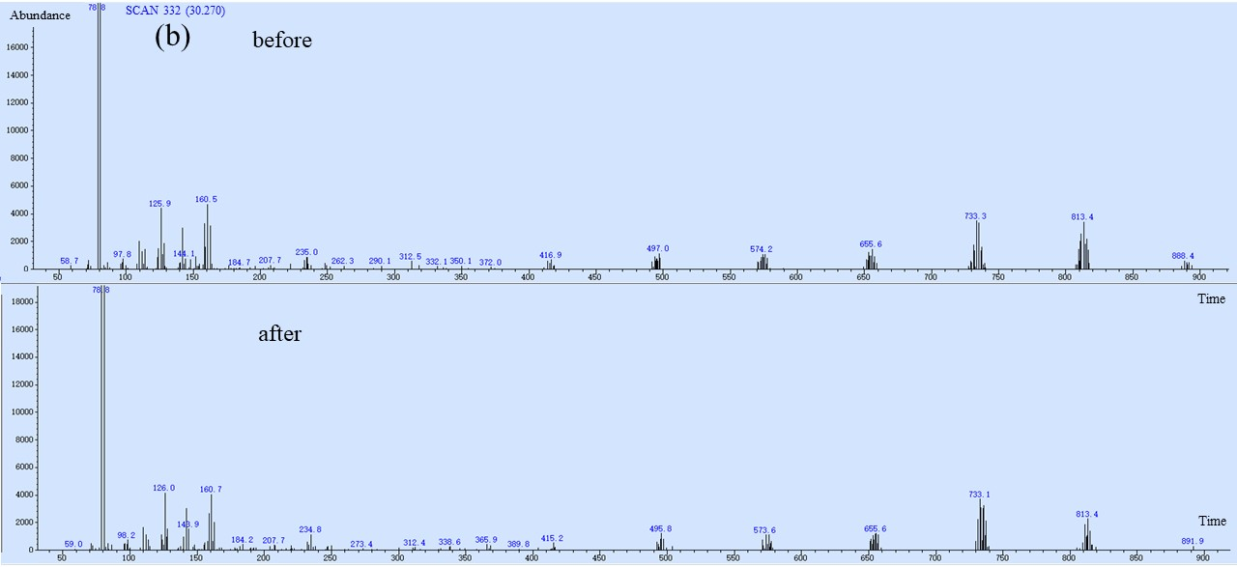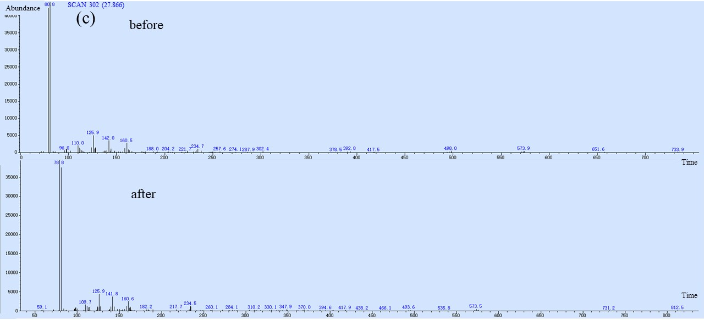
Fig.S1 TIC (a) and ion chromatogram (b, c) before and after the degradation of DBDPE.

