Supplementary figure

Figure S1: Flow chart of study participants.
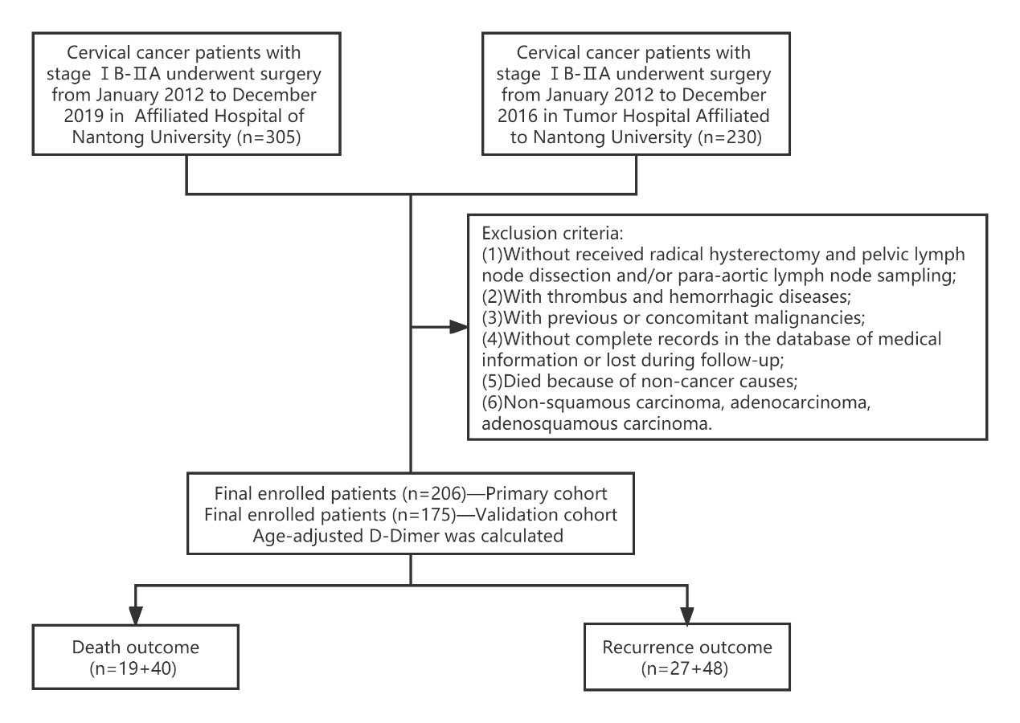

Table S1
Scoring details.
 | Score
FBG<5.45mmol/L and Age-adjusted D-Dimer<0.184mg/L FEU | 0
FBG≥5.45mmol/L or Age-adjusted D-Dimer≥0.184mg/L FEU | 1
FBG≥5.45mmol/L and Age-adjusted D-Dimer≥0.184mg/L FEU | 2

Table S2
Univariate Cox regression analyses of overall survival and progression-free survival in stage IB-IIA patients undergoing radical hysterectomy.
Variable | Primary cohort |  |  |  | Validation cohort
Variable | Overall survival |  | Progression-free survival |  | Overall survival |  | Progression-free survival
Variable | HR (95%CI) | P-value | HR (95%CI) | P-value | HR (95%CI) | P-value | HR (95%CI) | P-value
Age | 1.043(0.998,1.089) | 0.059 | 1.028(0.991,1.067) | 0.143 | 1.006(0.975,1.038) | 0.710 | 0.991(0.963,1.020) | 0.540
FIGO stage |  | 0.032 |  | 0.023 |  | 0.027 |  | 0.039
IB | 1.00 |  | 1.00 |  | 1.00 |  | 1.00
IIA | 2.701(1.089,6.696) |  | 2.424(1.129,5.203) |  | 2.017(1.084,3.754) |  | 1.821(1.032,3.214)
Histological type |  | 0.356 |  | 0.160 |  | 0.647 |  | 0.561
SCC | 1.00 |  | 1.00 |  | 1.00 |  | 1.00
Non SCC | 0.386(0.052,2.900) |  | 0.239(0.032,1.762) |  | 0.804(0.315,2.051) |  | 0.776(0.330,1.825)
Grade |  | 0.042 |  | 0.082 |  | 0.077 |  | 0.227
Good or moderate | 1.00 |  | 1.00 |  | 1.00 |  | 1.00
Poor | 2.634(1.037,6.689) |  | 2.104(0.909,4.866) |  | 1.938(0.932,4.032) |  | 1.517(0.771,2.984)
Tumor size |  | <0.001 |  | <0.001 |  | <0.001 |  | 0.001
≤4 cm | 1.00 |  | 1.00 |  | 1.00 |  | 1.00
>4 cm | 6.411(2.528,16.258) |  | 4.338(1.968,9.563) |  | 5.540(2.131,14.401) |  | 3.391(1.613,7.128)
Preoperative chemoradiotherapy |  | 0.890 |  | 0.598 |  | 0.201 |  | 0.032
No | 1.00 |  | 1.00 |  | 1.00 |  | 1.00
Yes | 1.092(0.316,3.775) |  | 0.723(0.217,2.410) |  | 1.555(0.790,3.061) |  | 2.049(1.066,3.941)
Surgical procedure |  | 0.664 |  | 0.957 |  | 0.699 |  | 0.461
MIS | 1.00 |  | 1.00 |  | 1.00 |  | 1.00
Open surgery | 1.230(0.483,3.131) |  | 0.978(0.435,2.196) |  | 0.885(0.476,1.645) |  | 0.808(0.459,1.424)
Intraoperative bleeding (ml) | 1.001(0.998,1.004) | 0.535 | 1.001(0.998,1.003) | 0.583 | 1.000(0.999,1.001) | 0.474 | 1.000(0.999,1.001) | 0.922
LVSI |  | 0.070 |  | 0.075 |  | 0.004 |  | 0.029
No | 1.00 |  | 1.00 |  | 1.00 |  | 1.00
Yes | 2.524(0.926,6.880) |  | 2.168(0.924,5.090) |  | 2.503(1.344,4.691) |  | 1.894 (1.066,3.365)
DSI |  | 0.009 |  | 0.005 |  | 0.022 |  | 0.150
<1/2 | 1.00 |  | 1.00 |  | 1.00 |  | 1.00
≥1/2 | 4.356 (1.443,13.148) |  | 3.443(1.454,8.154) |  | 2.198(1.118,4.324) |  | 1.537(0.856,2.757)
Nerve invasion |  | 0.076 |  | 0.240 |  | 0.351 |  | 0.636
No | 1.00 |  | 1.00 |  | 1.00 |  | 1.00
Yes | 3.836(0.870,16.912) |  | 2.387(0.559,10.192) |  | 1.635(0.582,4.595) |  | 1.281(0.460,3.565)
Postoperative chemoradiotherapy |  | 0.075 |  | 0.694 |  | 0.358 |  | 0.479
No | 1.00 |  | 1.00 |  | 1.00 |  | 1.00
Yes | 0.367(0.122,1.105) |  | 0.855(0.391,1.868) |  | 0.335(0.046,2.444) |  | 0.379(0.052,2.759)
Score
0 | 1.00 |  | 1.00 |  | 1.00 |  | 1.00
1 | 7.988(0.999,63.867) | 0.050 | 2.479(0.788,7.793) | 0.120 | 1.838(0.205,16.445) | 0.586 | 1.284(0.331,4.706) | 0.744
2 | 27.122(3.218,228.607) | 0.002 | 8.174(2.465,27.108) | <0.001 | 22.768(3.115,166.389) | 0.002 | 7.611(2.343,24.726) | <0.001
FIGO, International Federation of Gynecology and Obstetrics; SCC, squamous cell carcinoma; LVSI, lymphovascular space invasion; DSI, deep stromal invasion.

