Incipient carbonate melting drives metal and sulfur mobilization in the mantle

Isra S. Ezad et al.*

*Corresponding author: isra.ezad@mq.edu.au

This PDF file includes:

- Supplementary Table 1. Starting material compositions used in high-pressure experiments.
- Supplementary Table 2. Experimental run conditions and results.
- Supplementary Table 3. Compositions of run products from experiment M21-107 – peridotite sample.
- Supplementary Table 4. Compositions of run products from experiment M21-107 – pyroxenite sample.
- Supplementary Table 3. PGE concentrations within carbonate melts.
- Supplementary Table 6. Sulfide and metal compositions of sulfides within TEM lamella.
- Supplementary Table 7. Compositions of PGE inclusions within TEM - sulfide blebs.
- Supplementary Figure 1. Compositions of carbonate melts in this study compared to natural carbonatites and other high-pressure experiments.
- Supplementary Figure 2. Quantitative spectra of high Fe sulfide in Figure 4e.
- Supplementary Figure 3. Quantitative spectra of high Ni sulfde in Figure 4f.
- Supplementary Figure 4. Quantitative spectra of PGE inclusion in Figure 4.
- Supplementary Figure 5. S-XANES spectra for M21-107 peridotite carbonate melt.
- Supplementary Figure 6. S-XANES spectra for M21-107 pyroxenite carbonate melt.
- Supplementary Figure 7. High magnification scanning electron micrograph of M21-107 peridotite quenched carbonate melt structure.
References for supplementary materials only (78 – 83).

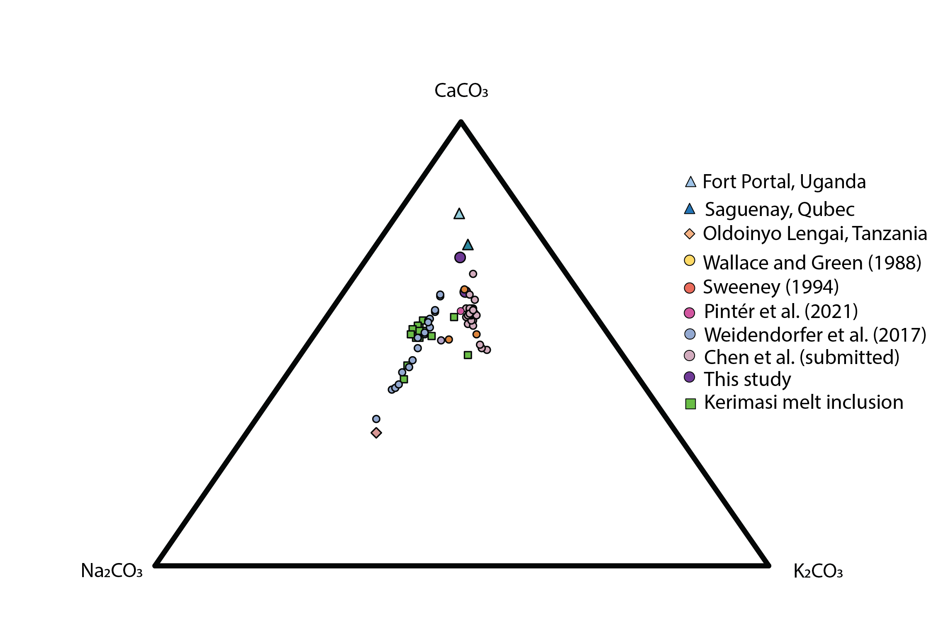

Fig. S1. Carbonate melt compositions plotted on the CaCO3-Na₂CO₃-K₂CO₃ ternary system. Compositions of melts from natural carbonatites in triangle and diamond symbols, melt inclusions in squares and high-pressure experimental melts in circles. Compositions for Fort Portal (78), Saguenay (79), Oldoinoyo Lengai (80), Kerimasi melt inclusions (81).

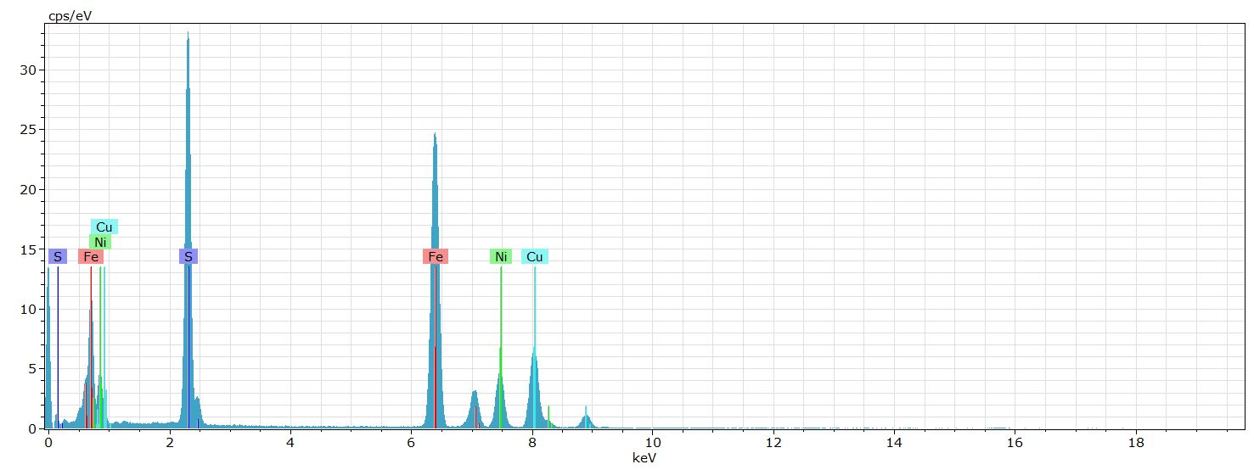
Supplementary Figure 2. Quantitative spectra of high Fe sulfide in Figure 4e.

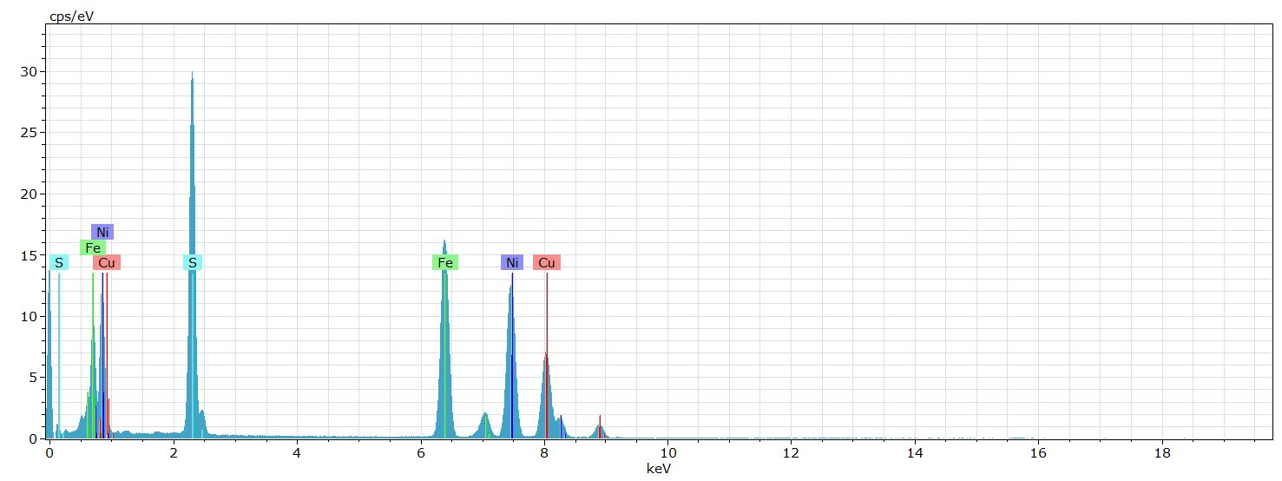

Supplementary Figure 3. Quantitative spectra of high Ni sulfde in Figure 4f.

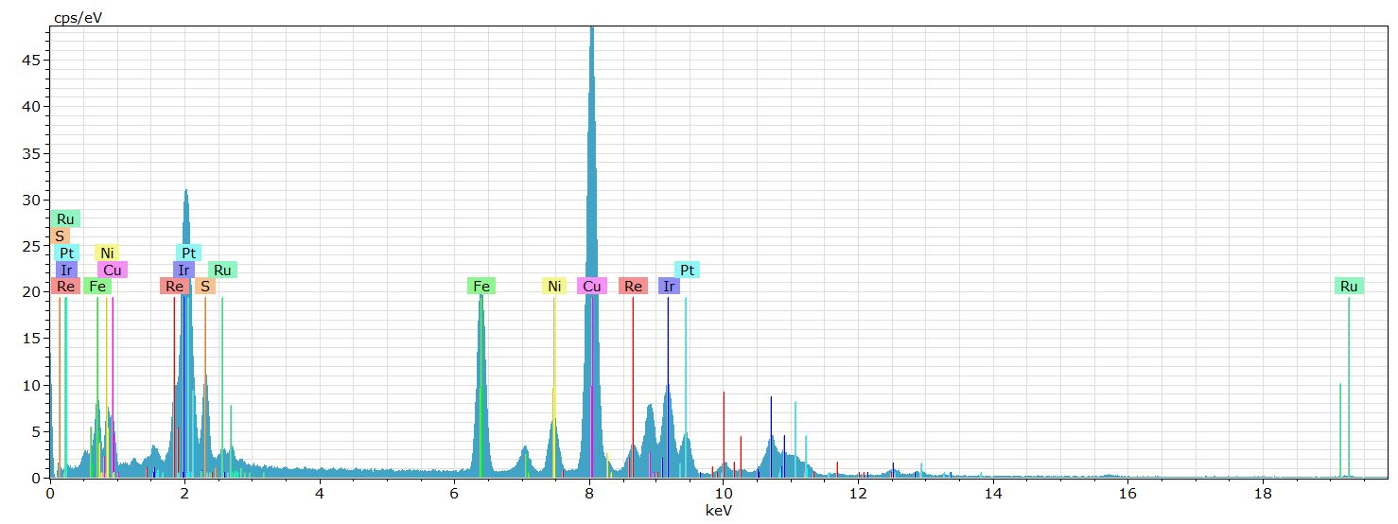
Supplementary Figure 4. Quantitative spectra of PGE inclusion in Figure 4.

Supplementary Figure 5. S-XANES spectra for M21-107 peridotite carbonate melt.

Supplementary Figure 6. S-XANES spectra for M21-107 pyroxenite carbonate melt.

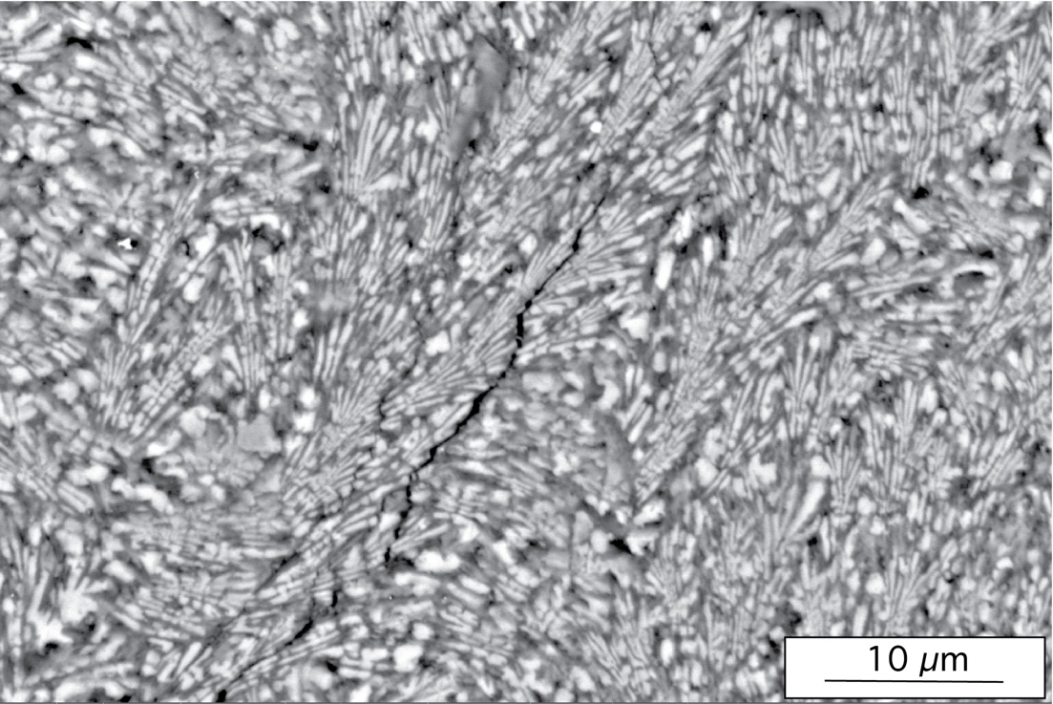

Supplementary Figure 7. High-magnification scanning electron micrograph of quenched peridotite carbonatite, for M21-107.

 | Lake Nyos | Uganda Pyrx
SiO₂ | 43.2 | 36.6
TiO₂ | 0.1 | 9.5
Al₂O₃ | 1.7 | 9.8
Cr₂O₃ | 0.3 | -
FeO_{TOT} | 8.8 | 14.2
MnO | 0.1 | 0.1
NiO | 0.3 | -
MgO | 43.3 | 12.3
CaO | 1.4 | 8.3
Na₂O | 0.1 | 0.4
K₂O | - | 6.3
BaO | - | 0.4
Sum | 99.3 | 97.5
CO2* | 2.5 | 3
H2O* | 1 | 1.5
PGE* | 0.05 | 0.08
S* | 0.5 | 0.8

Supplementary table 1. Starting material compositions, determined by whole rock XRF. Compositions in wt%. * Refers to concentrations of elements which were added to the starting material.

Run | Temperature | Duration | Phases perdiotite mix | Phases pyroxenite mix
MO21-107 | 1050 | 24 | Olv, Sp, Opx, Cpx, Ch, Carb-m | Olv, Sp, Phl, Cpx, Ilm, Carb - m
MO21-109 | 975 | 24 | Olv, Sp, Opx, Cpx, Carb-m | Olv, Sp, Phl, Cpx, Ilm, Carb - m
A22-001 | 950 | 24 | Olv, Sp, Opx, Cpx, Carb-m | Olv, Sp, Phl, Cpx, Ilm, Carb - m
MO22-004 | 900 | 24 | Olv, Sp, Opx, Cpx, Carb-m | Phl, Cpx, Ilm, Carb-m
M22-007 | 850 | 24 | Olv, Sp, Opx, Cpx, Carb-m | Phl, Cpx, Ilm, Carb-m
A22-030 | 830 | 24 | Olv, Sp, Opx, Cpx, Carb-m | Phl, Cpx, Ilm, Carb-m
Supplementary Table 2. Experimental run conditions and results, all experiments were conducted at 2.5 GPa

 | Melt | Olivine | Spinel | Clinohumite | Clinopyroxene | Orthopyroxene
n | 10 | 5 | 5 | 5 | 5 | 5
SiO2 | 1.91 (0.47) | 40.3 (0.40) |  | 34.43 (0.98) | 52.53 (0.36) | 55.35 (0.22)
TiO2 |  |  |  | 0.29 (0.01) | 0.23 (0.05)
Al2O3 | 0.42 (0.07) |  | 51.71 (0.27) |  | 5.66 (0.06) | 3.57 (0.03)
CrO3 |  |  | 13.23 (0.11) |  | 0.71 (0.02) | 0.36 (0.02)
FeO | 0.22 (0.07) | 9.29 (0.57) | 11.04 (0.09) | 1.62 (0.8) | 3.65 (0.06) | 6.22 (0.02)
MnO |  | 0.15 (0.05) |  |  | 0.1 (0.01)
MgO | 18.54 (2.6) | 48.35 (0.32) | 19.84 (0.07) | 57.62 (0.42) | 16.44 (0.36) | 33.06 (0.16)
CaO | 42.61 (1.66) | 0.09 (0.03) |  | 0.25 (0.98) | 18.66 (0.04) | 0.55 (0.01)
NiO |  | 0.48 (0.23) | 0.34 (0.08)
Na2O | 0.24 (0.03) |  |  |  | 1.82 (0.02)
K2O
P2O5 | 0.18 (0.01)
ZrO2 | 0.24 (0.03)
SO3 | 0.12 (0.01)
F | 12.05 (1.7) |  |  | 4.83 (1.95)
Total | 76.53 | 98.66 | 96.16 | 99.04 | 99.8 | 99.21
Supplementary Table 3. Composition of run products in M21-107 - peridotite, determined by Quant - EDS spectroscopy. Values in paratheses are 1 standard deviation.
Compositions in wt%

 | Melt | Phlogopite | Calcium Titanite | Clinopyroxene | Olivine
n | 10 | 5 | 5 | 5 | 3
SiO2 | 2.25 (0.12) | 39.95 (1.30) | 0.16 (0.8) | 50.66 (0.31) | 37.79 (3.24)
TiO2 | 0.47 (0.07) | 0.66 (0.45) | 58.02 (1.85) | 1.68 (0.16) | 0.70 (0.36)
Al2O3 | 0.71 (0.09) | 16.36 (2.08) | 0.45 (0.28) | 2.86 (0.07)
FeO | 0.29 (0.02) | 6.9 (1.41) | 1.06 (0.34) | 8.8 (0.48) | 8.60 (1.45)
MnO |  |  |  |  | 0.14 (0.07)
MgO | 22.4 (2.03) | 22.64 (1.62) |  | 12.38 (0.53) | 50.77 (1.61)
CaO | 31.64 (2.98) |  | 40.02 (0.59) | 22.54 (0.08) | 0.93 (0.25)
NiO
Na2O | 0.54 (0.07) |  |  | 0.99 (0.02)
K2O | 1.38 (0.28) | 10.82 (0.48) |  | 0.13 (0.21)
P2O5 | 0.62 (0.15)
ZrO2 | 0.14 (0.036)
SO3 | 0.21 (0.03)
BaO |  | 0.79 (0.31)
F | 14.51 (2.80) | 0.94 (0.38)
Total | 75.16 | 99.24 | 99.71 | 100.04 | 98.94
Supplementary Table 4. Composition of run products in M21-107 – pyroxenite, determined by Quant- EDS spectroscopy. Compositions in wt%, values in paratheses are 1 standard deviation.

 | Peridotite | Pyroxenite
Rh | 84.8 (0.18) | 18 (1.42)
Ru | 24.8 (0.23) | 173 (43)
Pd | 135.2 (5.04) | 43.3 (6.22)
Ag | 0.23 (0.03) | 0.25 (0.05)
Re | 76.6 (0.03) | 109 (48.7)
Os | 0.25 (0.01) | b.d.l
Ir | 80.11 (0.02) | 54.1 (9.9)
Pt | 254 (63.5) | 251 (40.2)
Au | 0.92 (0.05) | 0.18 (0.04)
Supplementary Table 5. PGE concentrations within carbonated melts, determined by LA-ICP-MS. Concentrations reported in ppm, values in paratheses are 2 σ errors.

 | Perd. Left sulfide bleb | Perd right sulfide bleb | Pyrx sulfide
S | 35 | 30 | 20
Fe | 54 | 36 | 10
Ni | 12 | 35 | -
Rh | - | - | 70
Re | - | - | -
Supplementary Table 6. Sulfide and metal compositions in wt% for M21-107, determined by Quant TEM-EDS

 | Peridotite PGE inclusion [wt.%] | Inner pyroxenite PGE inclusion [wt. %] | Outer pyroxenite PGE inclusion [wt. %]
Rhenium | 17 | 15
Iridium | 54
Platinum | 25
Ruthenium | 4
Rhodium | 0 | 70 | 80
Iron | 0 | 15 | 20
Sum | 100 | 100 | 100

Supplementary Table 7. Compositions of PGE inclusions within sulfide blebs. Peridotite PGE composition determined for left peridotite bleb (Figure 4) and left pyroxenite bleb (Figure 5). Compositions were determined by Quant TEM-EDS and given in wt %.

