Online Resource 4 Rarefaction curves for the asymptotic metazoan parasite species richness of Syacium gunteri (Sg) and Syacium papillosum (Sp) from Coatzacoalcos, Veracruz - Tamaulipas (VT), Northwestern Yucatan shelf - Coatzacoalcos, Veracruz (NYV) and the Yucatan shelf (YS)
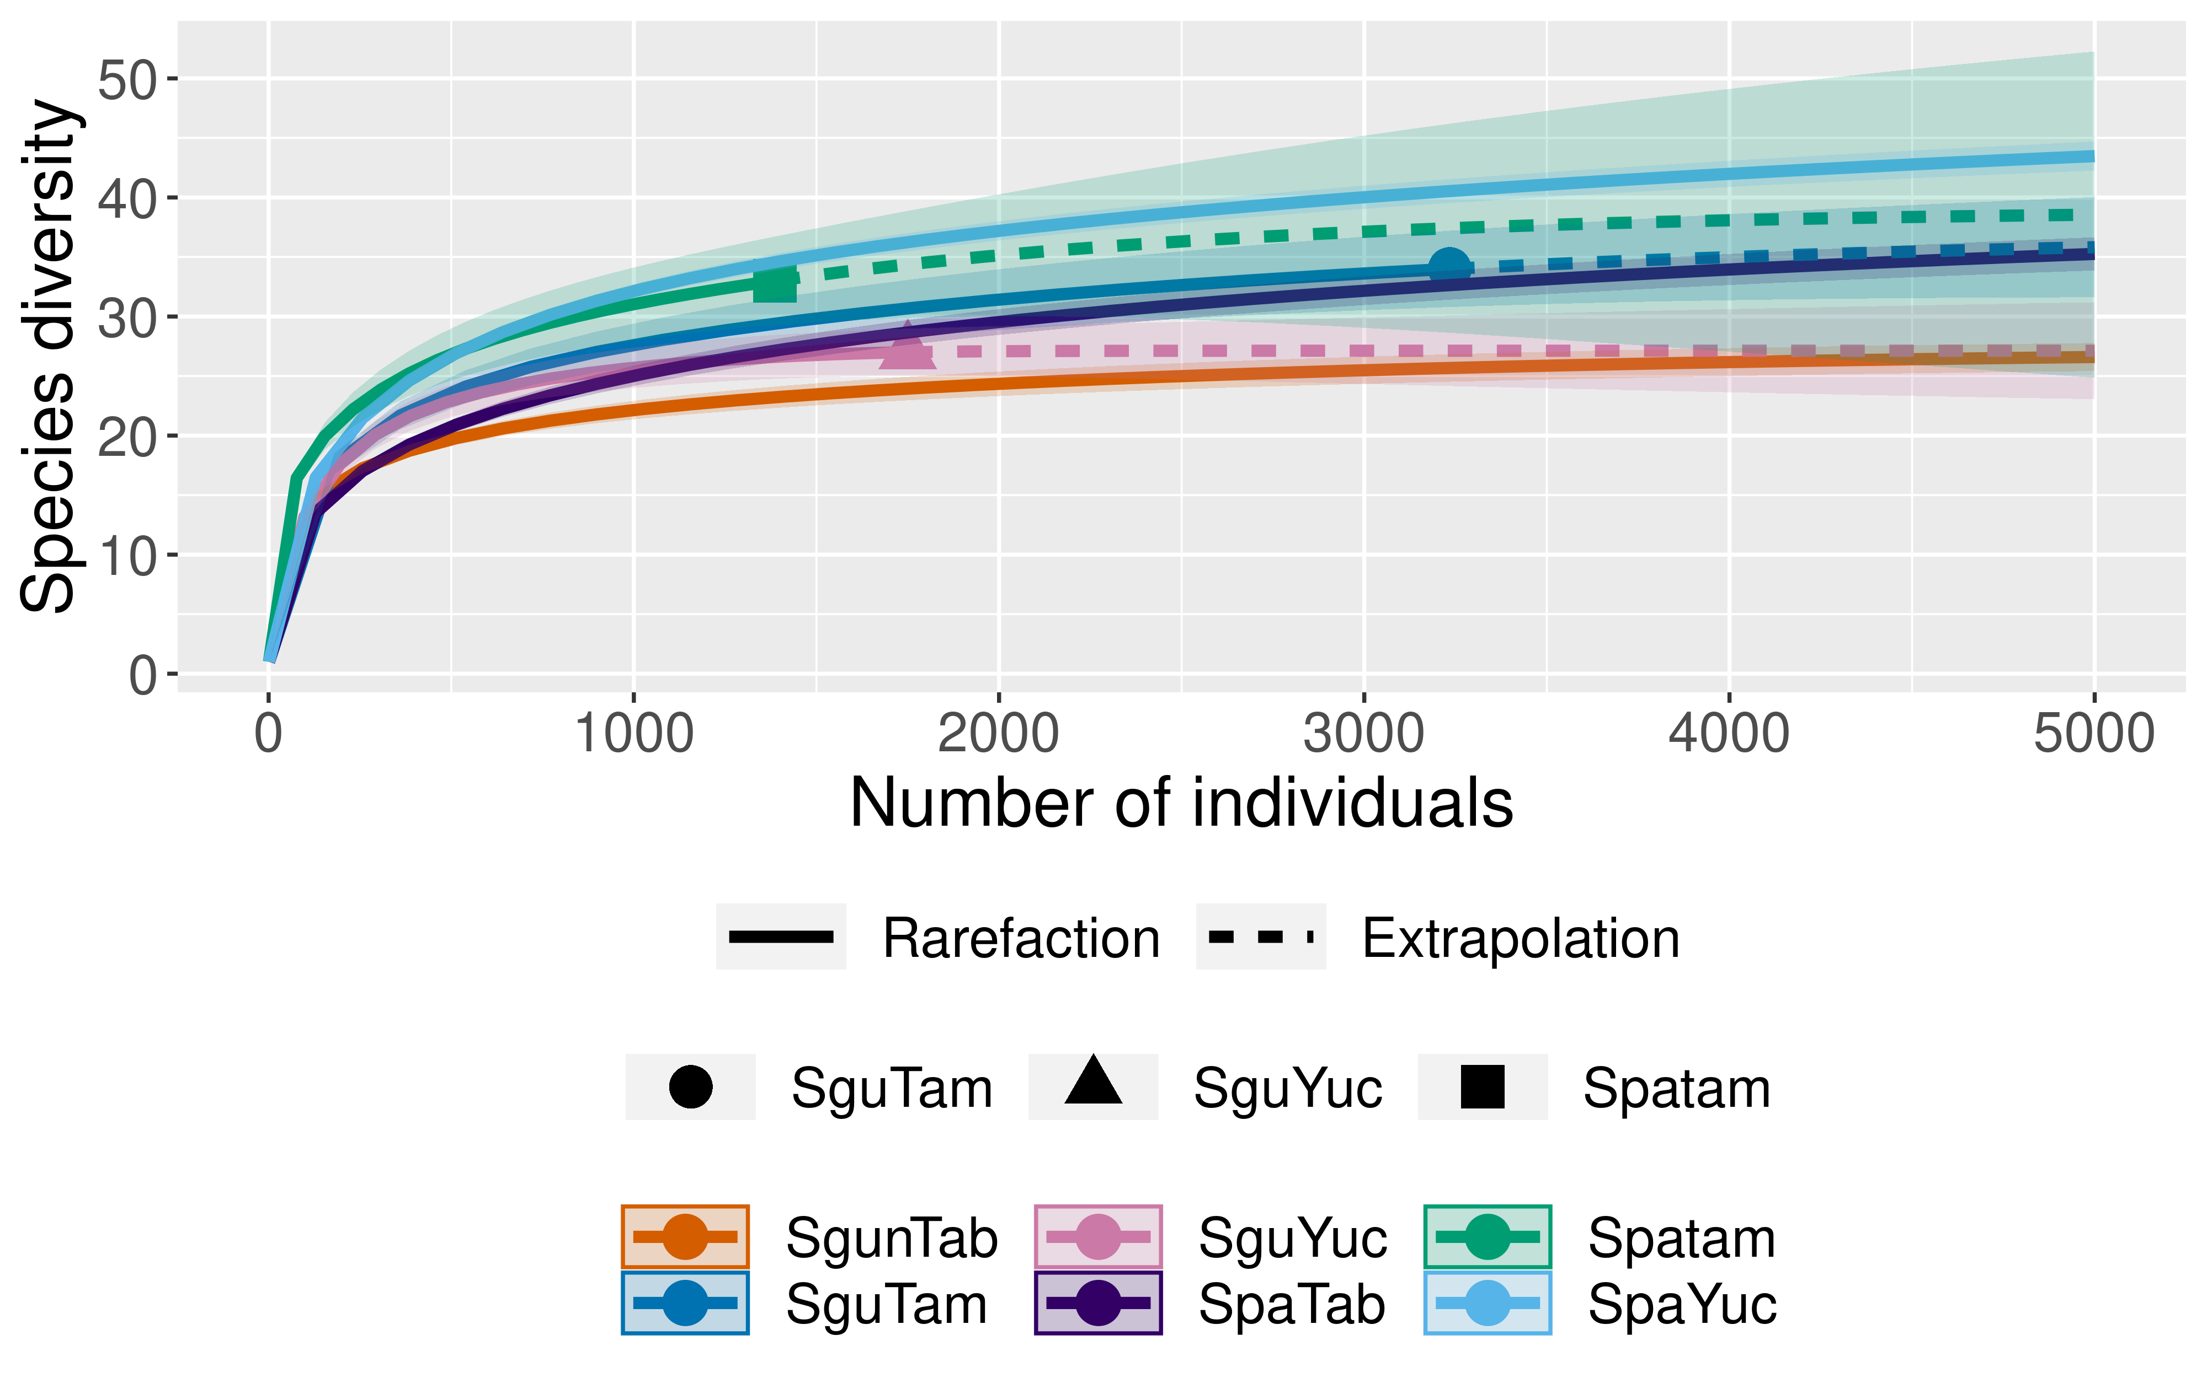
SgTV
SgYS
SpTV
SgNYV
SgTV
SgYS
SpNYV
SpTV
SpYS

