Supplementary Digital Content

Supplementary Box 1: Methods for determination of hepatic tissue adenosine triphosphate and glycogen.

Hepatic tissue adenosine triphosphate (ATP) content was determined using the ATP Bioluminescent Kit (FLAA Sigma-Aldrich) according to the manufacturer’s instructions. Frozen core biopsies were homogenised and sonificated on ice in 100uL of SONOP Buffer (0.372g EDTA in 130ml dH₂O, adjusted to pH 10.9 with NaOH with ethanol) and centrifuged at 13000g to remove particulates. ATP concentration was calculated using luminosity according to the standards in the manufacturer’s instructions. This was corrected for protein concentration which was determined using the BCA Protein Assay Kit (ThermoFisher Scientific) and results expressed as μmol/g protein.
Hepatic tissue glycogen was determined using the Glycogen Assay Kit (MAK016, Sigma-Aldrich) according to the manufacturer’s instructions. Frozen core biopsies were homogenised and sonificated on ice in 100μl H₂O before being centrifuged at 13000g to remove particulates. The glycogen concentration was measured according to the manufacturer’s instructions and the results were expressed as μg/μg of tissue.

Supplementary Table 1: Graft characteristics, donor liver function tests and donation details

CIT: cold ischaemia time, WCRS: withdrawal of cardiorespiratory support, WIT: warm ischaemia time

Liver number | Bilirubin (μmol/L) | AST (U/L) | ALT (U/L) | ALP (U/L) | GGT (U/L) | INR | Time to death (WCRS to cessation of circulation) (minutes) | CIT (minutes) | WIT (systolic blood pressure <50 to cold flush) (minutes)
1 | 3 | 63 | 63 | 42 | 32 | 1.1 | N/A | 238 | N/A
2 | 4 | 56 | 43 | 70 | 150 | 1.1 | 19 | 305 | 20
3 | 9 | 19 | 21 | 71 | 65 | 1.4 | 31 | 449 | 29
4 | 6 | 40 | 50 | 70 | 68 | 1 | 21 | 456 | 22
5 | 7 | 110 | 30 | 88 | 38 | 1.4 | N/A | 187 | N/A
6 | 152 | 95 | 241 | 246 | 333 | 2.1 | N/A | 430 | N/A
7 | 9 | 146 | 187 | 82 | 51 | 1.1 | 36 | 284 | 19
8 | 6 | 53 | 25 | 228 | 308 | 1 | 19 | 272 | 29
9 | 11 | 51 | 46 | 68 | 108 | 1.5 | 17 | 274 | 14
10 | 29 | 49 | 51 | 117 | 79 | 2 | N/A | 397 | N/A

Supplementary Table 2: Perfusion details after long-term normothermic perfusion of partial human livers

ERG: extended right graft, LLSG: left lateral segment graft

Liver number | Whole Liver weight (g) | Graft type | Weight after split (g) | Weight at end (g) | Maximum viability* (hours) | Graft survival (hours)
1 | 1862 | LLSG | 437 | 438 | 22 | 159
1 | 1862 | ERG | 1501 | 1445 | 21 | 39
2 | 2188 | LLSG | 626 | 595 | 171 | 209
2 | 2188 | ERG | 1514 | 1440 | 210 | 228
3 | 2407 | LLSG | 575 | 477 | 87.5 | 107
3 | 2407 | ERG | 1771 | 1470 | 262 | 288
4 | 1279 | LLSG | 238 | 252 | 88.5 | 108
4 | 1279 | ERG | 846 | 895 | 139.5 | 167
5 | 1615 | LLSG | 227 | 353 | 125 | 181
5 | 1615 | ERG | 1210 | 1302 | 125 | 163
6 | 1500 | LLSG | 279 | 362 | 82 | 96
6 | 1500 | ERG | 1113 | 1413 | 66 | 79
7 | 1343 | LLSG | 241 | 313 | 90 | 114
7 | 1343 | ERG | 845 | 902 | 115 | 123
8 | 3633 | LLSG | 726 | 738 | 105.5 | 150.5
8 | 3633 | ERG | 2455 | 2439 | 160.5 | 177.5
9 | 2497 | LLSG | 418 | 623 | 165.5 | 327.5
9 | 2497 | ERG | 1522 | 1719 | 295.5 | 327.5
10 | 1461 | LLSG | 292 | 457 | 201.5 | 257.5
10 | 1461 | ERG | 959 | 1172 | 190.5 | 222.5

*Viability according to the criteria proposed by the VITTAL clinical trial (≤2.5mmol/L, and two or more of: bile production, pH≥7.30, glucose metabolism, hepatic arterial flow ≥150ml/minute and portal vein flow ≥500ml/minute, or homogeneous perfusion).²

Supplementary Figure 1: Additional biochemical and functional evidence of long-term graft function of human split livers. Typically, bilirubin (A), and GGT (B) levels in the perfusate remained low during perfusion but gradually increased during perfusion towards the point of graft failure. Urea (C), albumin (D), total protein (E) and ALP (F) levels remained steady during perfusion. Perfusate levels of ALT peaked in the first 48-72 hours after whole liver reperfusion before plateauing then decreasing during long-term perfusion (G). ALP: alkaline phosphatase, ALT: alanine amino-transferase, GGT: Gamma-glutamyl transferase

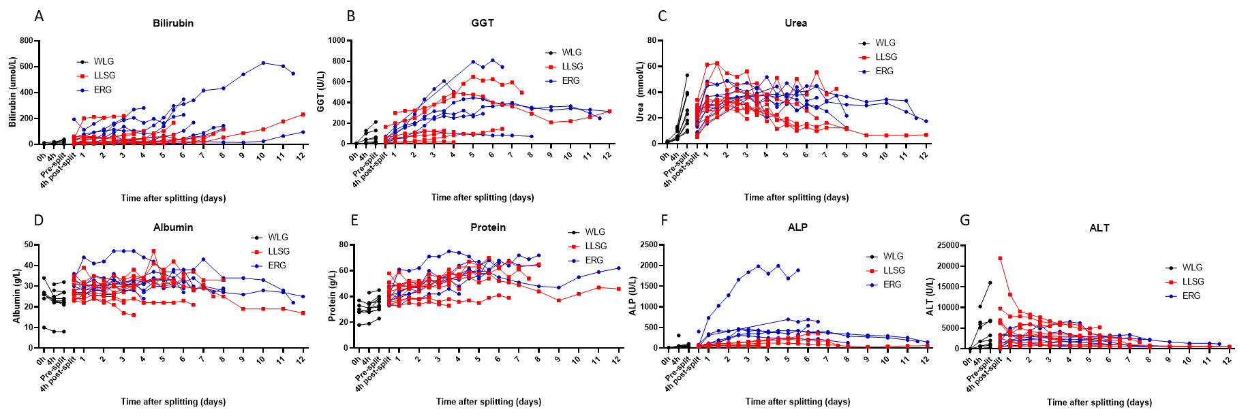

Supplementary Figure 2. Additional factors related to long-term survival of human split livers. Perfusate bilirubin (A), GGT (B), urea (C), total protein (D), albumin (E), ALP (F), and ALT (G) did not demonstrate significant differences between grafts that survived >7 days or ≤7 days. ALP: alkaline phosphatase, ALT: alanine amino-transferase, GGT: Gamma-glutamyl transferase
