Supplementary data for

Acetylcholinesterase inhibition studies of alkaloid components from Crinum asiaticum var. sinicum plants: In vitro assessments by molecular docking and molecular dynamics simulations

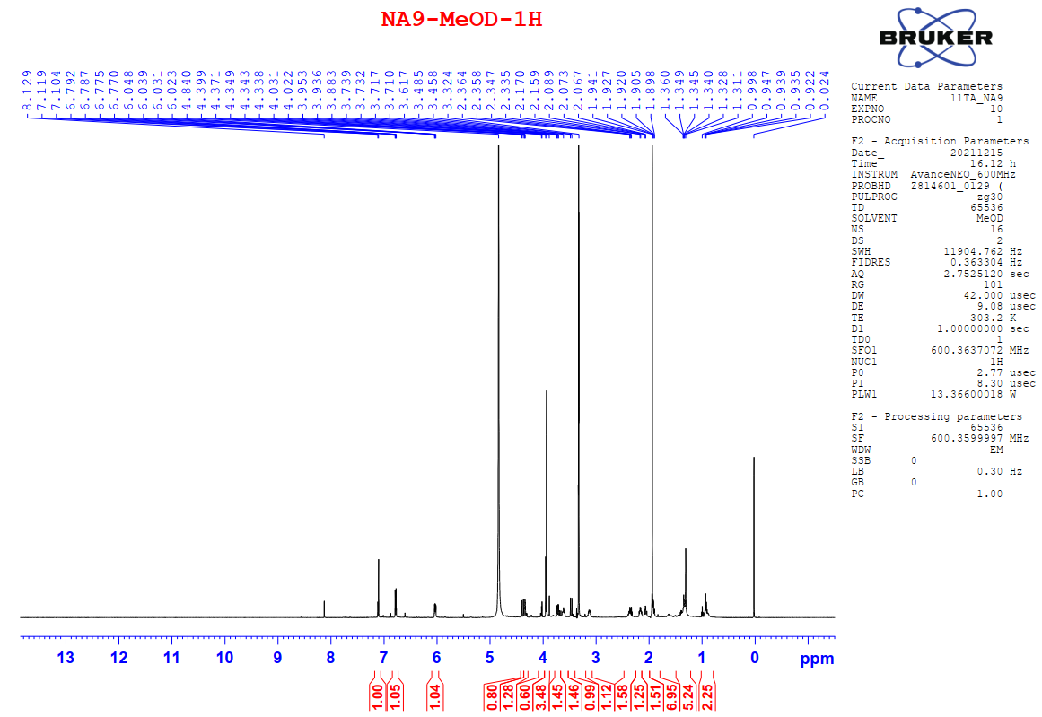
Figure S 1.¹H - NMR spectrum of compound 1 (600 MHz, MeOD)
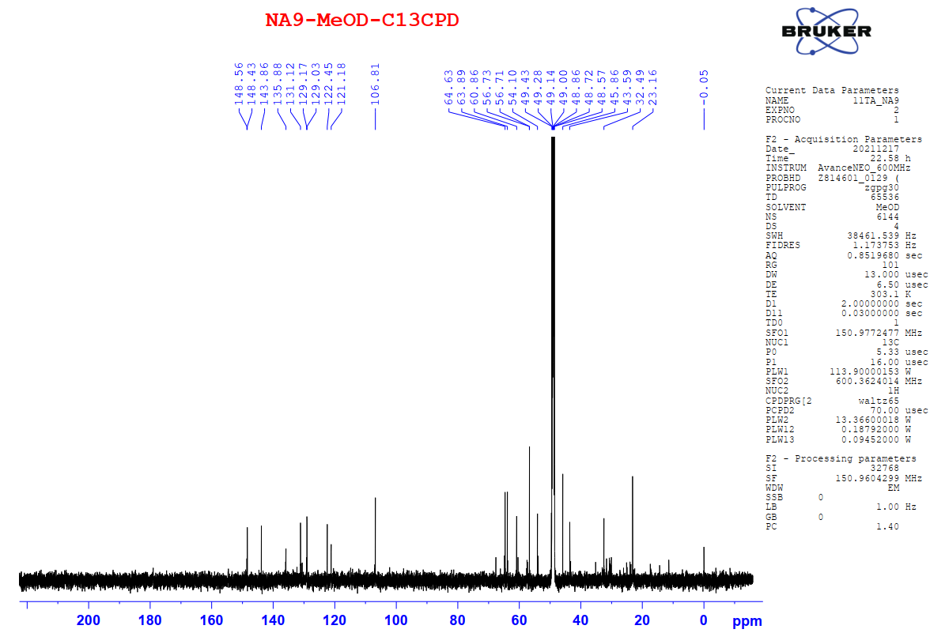
Figure S 2.¹³C - NMR spectrum of compound 1 (150 MHz, MeOD)
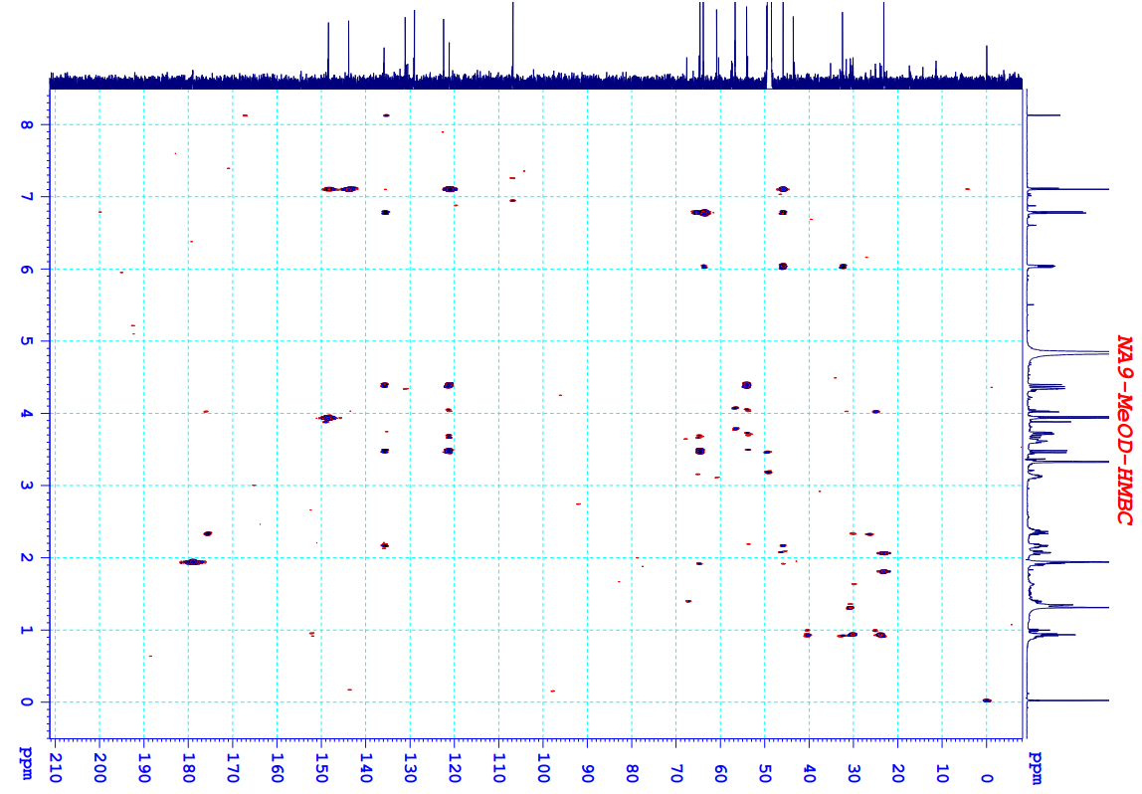
Figure S 3. HMBC spectrum of compound 1
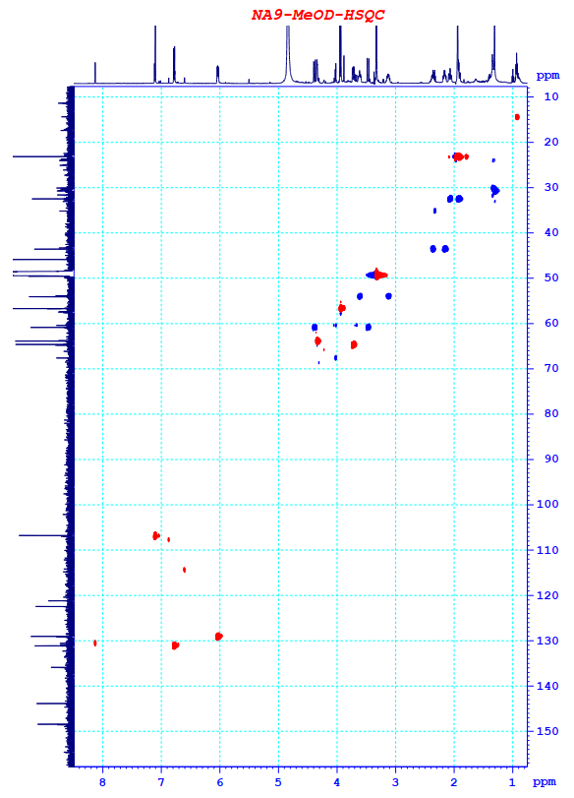
Figure S 4. HSQC spectrum of compound 1

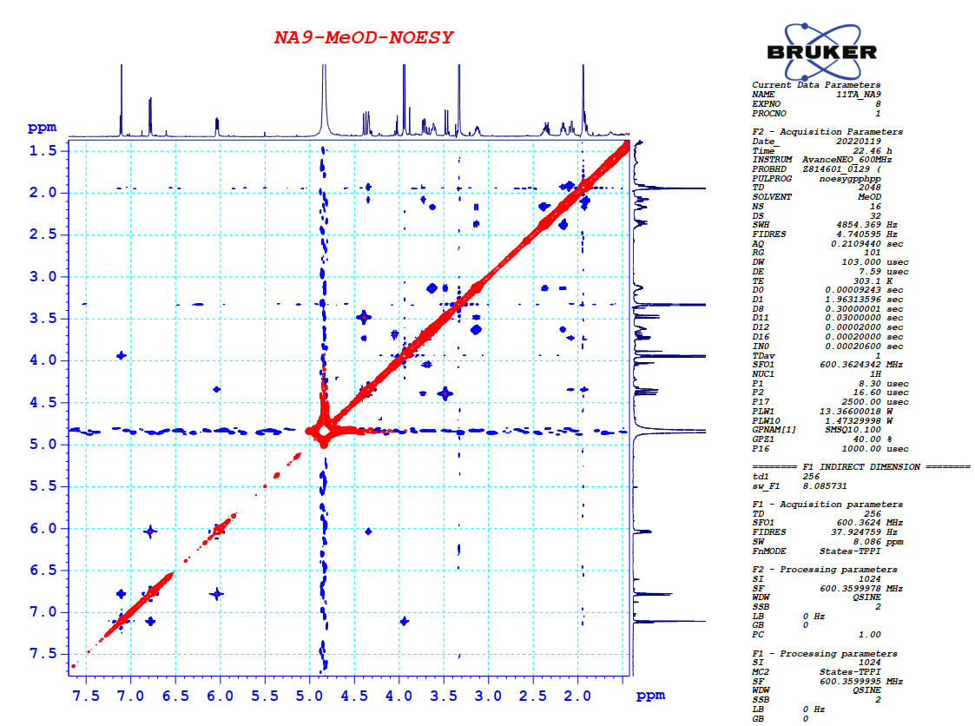
Figure S 5. NOESY spectrum of compound 1
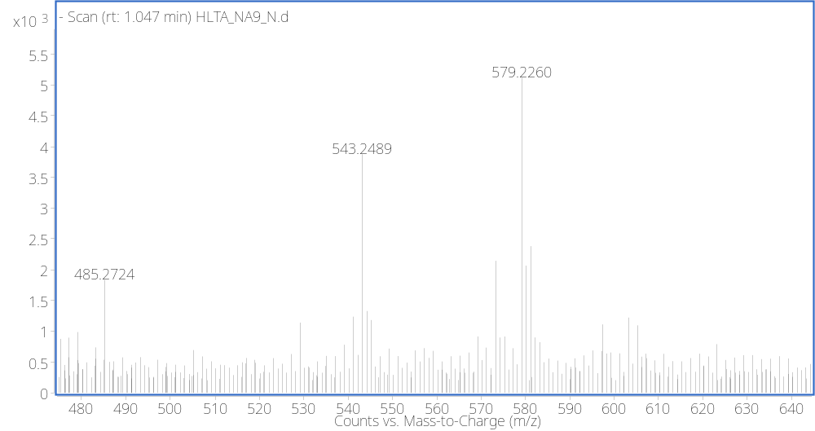
Figure S 6. HR-ESI-TOF-MS spectrum of compound 1
Acetylcholinesterase inhibitory activity testing
The AChE inhibitory activities of 2–8 were evaluated using Pohanka’s method with a slight modification (Pohanka et al. 2008). The mixture containing 25 μL of sample solution (diluted in buffer A), 50 μL of buffer B, and 25 μL of AChE (EC3.1.1.7, Sigma product no. C3389, 0.22 U/mL in buffer B) was incubated at 37°C for 25 min. Then 125 μL of 5,5'- dithiobis(2-nitrobenzoic acid (DTNB, 3 mM in buffer C) was added, and reaction was initiated by the addition of 25 μL of acetylthiocholine iodide (15 mM in water). On account of the hydrolysis of acetylthiocholine iodide, yellow 5-thio-2-nitrobenzoate anion was generated, and the absorbance was recorded at a wavelength of 405 nm after incubation at 37°C for 35 min. The control was set up by adding 25 μL of buffer A instead of 25 μL of sample solution.
The blank was set up by adding 25 μL of buffer A instead of 25 μL of sample solution and 25
μL of buffer B instead of 25 μL of enzyme solution in order to deduct background. Galanthamine hydrobromide was used as positive control. All the reactions were performed in triplicate.
The percentage inhibition was calculated as follows:
Inhibition % = (C - SA)/(C - SB) × 100%
Where: C is the absorbance of control;
SA is the absorbance of sample solution;
SB is the absorbance of blank.
The following buffers were used: buffer A, 50 mM Tris-HCl (pH = 8); buffer B, 50 mM Tris-HCl (pH = 8) containing 0.1% bovine serum albumin V fraction; buffer C, 50 mM Tris-HCl (pH = 8) containing 0.10 M NaCl and 0.02 M MgCl2·6H2O.

