Supplementary Figure. 1
Depression emotion is contagious between mice.
a, Illustration of depression contagion and behavioral tests procedures. b-h, Summary data for open field test, elevated plus maze test, tail suspension test, forced swimming test, social interaction test, sucrose preference test and novelty-suppressed feeding test of Con, defeated, and observer mice. of GLT1 shRNA injected in mPFC of observer mice. n= 15. Data are mean ± s.e.m. Statistical analysis was performed using one-way ANOVA. **P < 0.01.
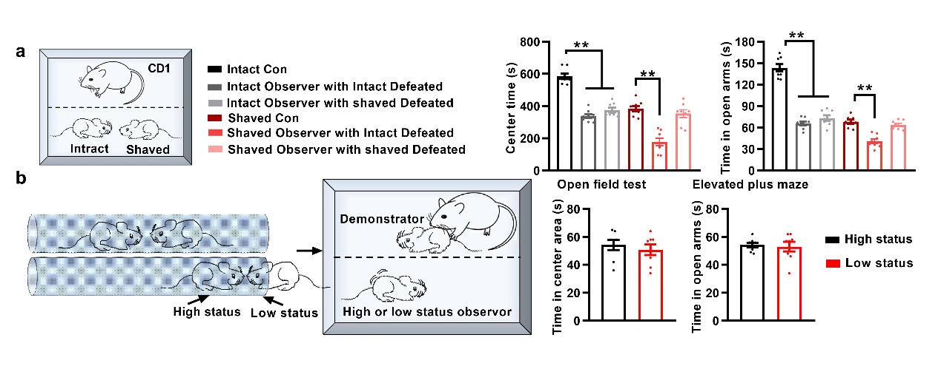
Supplementary Figure. 2
Shaving whiskers but not social status affected depression contagion.
a, Whiskers shaving induced anxiety like behaviors in both Con, defeated, and observer mice. Depression contagion could not be blocked by shaving whiskers of one of defeated or observer mice, but blocked by shaving whiskers of both. n= 8. b, High and low social status mice were divided by tube test. No difference in depression contagion between high and low social status mice was found. n= 8. Data are mean ± s.e.m. Statistical analysis was performed using one-way ANOVA (a) and two-tailed unpaired t-tests (b). **P < 0.01.

Supplementary Figure. 3
Activation of different brain areas in low and high empathy demonstrator mice.
a, Representative images showing cFos⁺ neurons in different brain areas and nuclei. cFos is immunostained with an Alexa488-anti- cFos antibody and nuclei with green. b, Quantification of the number of c-Fos⁺ cells in different groups. n= 3. Data are mean ± s.e.m. Statistical analysis was performed using one-way ANOVA. **P < 0.01. PVN, paraventricular nucleus of hypothalamus; anterior cingulate cortex; PVA, paraventricular thalamus.
Supplementary Figure.4
Activation of different brain areas in low and high empathy demonstrator mice.
a, Representative images showing cFos⁺ neurons in different brain areas and nuclei. cFos is immunostained with an Alexa488-anti- cFos antibody and nuclei with green. b, Quantification of the number of c-Fos⁺ cells in different groups. n= 3. Data are mean ± s.e.m. Statistical analysis was performed using two-tailed unpaired t-tests (a) and one-way ANOVA (b-d). **P < 0.01. PVN, paraventricular nucleus of hypothalamus; anterior cingulate cortex; PVA, paraventricular thalamus.
Supplementary Figure. 5
Increased frequency and ampitude of sEPSC by MUP1 was disrupted by astrocytic toxicant L-AAA.
a, Representative traces and average data showing that the frequency and amplitude of sEPSCs of mPFC neurons. n =12 neurons from three mice. L-AAA, L-alpha-aminoadipic acid, a specific astrocytic toxicity. b, Summary data for frequency and amplitude of sEPSCs of mPFC neurons after MUP1, UCPH-101, SCH-23390, CGS 15943, and MPEP. n =12 neurons from three mice. n =12 neurons from three mice. Data are mean ± s.e.m. Statistical analysis was performed using two-tailed unpaired t-tests (a) and one-way ANOVA (b-d). Statistical analysis was performed using one-way Kruskal–Wallis H-test with Nemenyi multiple comparisons test (line grams in a), two-tailed unpaired t-tests (histograms in a) and one-way ANOVA (b). **P < 0.01. UCPH-101, excitatory amino acid transporter 1 inhibitor; SCH-23390, dopamine D1-like receptor antagonist; CGS 15943, adenosine receptor antagonist; MPEP, mGlu5 receptor antagonist.

Supplementary Figure. 6
MUP1 did not affect mEPSC, sIPSC, sIPSC, or PPR of IPSC.
a, Representative traces and average data showing that the frequency and amplitude of mEPSCs of mPFC neurons before and after MUP1 treatment. n =10 neurons from three mice. b, Representative traces and average data showing that the frequency and amplitude of sIPSCs of mPFC neurons before and after MUP1 treatment. n =12 neurons from three mice. c, Representative traces and average data showing that the frequency and amplitude of mIPSCs of mPFC neurons before and after MUP1 treatment. n =10 neurons from three mice. d, Representative traces and average data showing PPR of IPSC of mPFC neurons before and after MUP1 treatment. n =10 neurons from three mice. Statistical analysis was performed using two-tailed paired t-tests. **P < 0.01.
Supplementary Figure. 7
Molecular docked pose of MUP1 with different potential targets.
a-j, Computer assistant molecular docked pose of MUP1 in the STXBP1, GLT1, Synapsin1, Glyt1, SYT1, GAT1, GLAST, SYT7, CAMKV, and Syntaxin1A respectively. STXBP1, syntaxin-binding protein 1; GLT1, sodium-dependent glutamate/aspartate transporter 2; Glyt1, sodium- and chloride-dependent glycine transporter 1; SYT1, synaptotagmin-1; GAT1, sodium- and chloride-dependent GABA transporter 1; GLAST, excitatory amino acid transporter 1; SYT7, synaptotagmin-7; CAMKV, CaM kinase-like vesicle-associated protein.

Supplementary Figure. 8
BLI detecting binding affinity of MUP1 to GLT1 (aa143-234) and STXBP1.
a, Representative Biolayer Interferometry Assay (BLI) response of MUP1 to GLT1 (aa143-234) at different concentrations. b, Representative BLI response of MUP1 to STXBP1 at different concentrations.
Supplementary Figure. 9
Protein mass spectrometry screened human PAEP and LCN9 binding protein in human brain tissue.
a, Representative of coomassie brilliant blue for detecting protein binding with His-tagged human PAEP (hPAEP) protein and human LCN9 (hLCN9) for the following LS/MS analysis. hPAEP, progestagen-associated endometrial protein; hLCN9, epididymal-specific lipocalin-9; b, Number of proteins and different protein coverage with different molecular weight of hPAEP binding proteins detected by LS/MS. c, Number of proteins and different protein coverage with different molecular weight of hLCN9 binding proteins detected by LS/MS. d, Signaling pathways of detected hPAEP binding proteins enriched by KEGG analysis uncovered amino acid transport and metabolism and intracellular trafficking, secretion, and vesicular transport pathways. e, Signal pathways of detected hLCN9 binding proteins enriched by KEGG analysis uncovered amino acid transport and metabolism and intracellular trafficking, secretion, and vesicular transport pathways. KEGG, Kyoto Encyclopedia of Genes and Genomes.
Supplementary Figure. 10
Computer assistanted screening regulator for MUP1 function targeting GLT1.
a, Workflow of virtual screening for new regulators of GLT1. b, Summary of intracellular glutamate concentrations after MUP1 and top 30 compounds treatment detected by ELISA. n =3. c and d, Chemical structures of Compound 11 (C11) and Compound 25 (C25). Statistical analysis was performed using one-way ANOVA. **P < 0.01 versus Saline, #P < 0.05 and # #P < 0.01 versus Saline + MUP1.
Supplementary Figure. 11
Computer assistanted screening regulator for MUP1 function targeting GLT1.
a, Representative traces and average data showing that the frequency and amplitude of sEPSCs of mPFC neurons before and after different compounds C23, C11, and C25 treatment. n =10 neurons from three mice. b, Representative traces and average data showing effects of C11, and C25 on MUP1 induced increase of sEPSCs frequency and amplitude. n =10 neurons from three mice. Statistical analysis was performed using two-tailed paired t-tests (a) and one-way ANOVA (b). **P < 0.01.

