Supplementary information
Apremilast reverses the profibrotic phenotype of dermal fibroblasts derived from patients with systemic sclerosis and prevents the progression of bleomycin-induced dermal fibrosis in mice

Tomoaki Higuchi ^{1,2,} *, Kae Takagi¹, Akiko Tochimoto¹, Yuki Ichimura^{1,3}, Hikaru Hirose¹, Tatsuo Sawada⁴, Nobuyuki Shibata⁴, Masayoshi Harigai¹, and Yasushi Kawaguchi ¹
¹Division of Rheumatology, Department of Internal Medicine, Tokyo Women's Medical University School of Medicine, Tokyo, Japan
²Division of Multidisciplinary Management of Rheumatic Diseases, Tokyo Women's Medical University School of Medicine, Tokyo, Japan
³Department of Dermatology, Graduate School of Medical and Dental Sciences, Tokyo Medical and Dental University, Tokyo, Japan
⁴Department of Pathology, Tokyo Women’s Medical University School of Medicine, Tokyo, Japan
*E-mail: higuchi.tomoaki@twmu.ac.jp

Supplementary Table 1

Gene | Primer sequence (5’ > 3’) | Primer bank ID | Product size (bp)
PDE4A F | ACACACCTGTCAGAAATGAGC | 341572546c1 | 99
PDE4A R | GGGTGATGGGATCTCCACTTC
PDE4B F | AGATGAGCCGATCAGGGAAC | 82799485c2 | 101
PDE4B R | CCTGTCTTTCTGGGTAGGAGA
PDE4C F | CAAGGCCATGTCTCGGAACTC | 341604763c1 | 243
PDE4C R | AGCTCGTCTAGCGTCTCCAA
PDE4D F | ACGGACCGGATAATGGAGGAG | 308387383c3 | 106
PDE4D R | ATTTTTCCACGGAAGCATTGTG
β-actin F | CATGTACGTTGCTATCCAGGC | 4501885a1 | 250
β-actin R | CTCCTTAATGTCACGCACGAT

Supplementary Table 1: Specific primer pairs for phosphodiesterase (PDE) 4A–D and β-actin. The website Primer Bank (http://pga.mgh.harvard.edu/primerbank) was used to design the primers for reverse-transcription polymerase chain reaction (PCR) and quantitative PCR.

Supplementary Figure 2
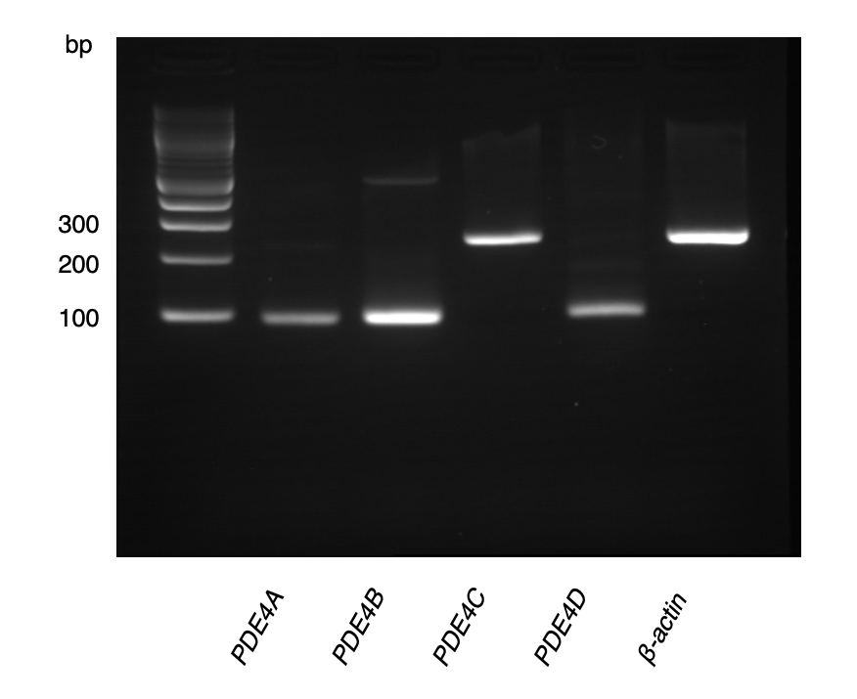
Supplementary Figure 1: The representative gel image of polymerase chain reaction amplified products of phosphodiesterase (PDE) 4A–D and β-actin in healthy dermal fibroblasts. bp, base pair.

Supplementary Figure 2

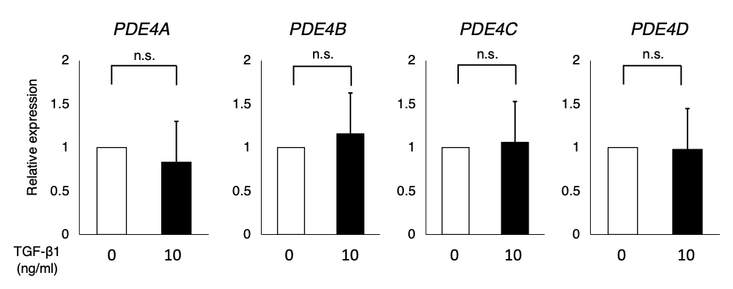
Supplementary Figure 2: Relative expression of phosphodiesterase (PDE) 4A–D mRNA in healthy dermal fibroblasts (n=3). Healthy dermal fibroblasts were incubated with or without TGF-β1 (10 ng/ml) for 24 h. β-actin was served as internal control. Results were representative of at least two independent experiments. The data are expressed as mean ± SD. The Mann-Whitney U test was used for statistical analysis. n.s.: not significant.

