Figure S1: High-level TLK2 expression is strongly associated with overall survival of GC and TLK2 is located in the nucleus of GC cells.
A-B: High-level TLK2 expression is strongly associated with overall survival and progression free survival of GC; C: TLK2 is located in the nucleus of GC cells.

Figure S2: Apoptosis-stimulating protein BAX was upregulated after TLK2 knockdown.
Figure S3: Compared with the control group, 142 metabolites were downregulated, and 62 metabolites were upregulated following TLK2 knockdown in HGC27 cells, including purine, and pyrimidine.

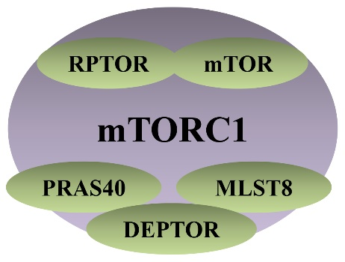
Figure S4: Schematic diagram of the components of the mTORC1.

Figure S5: AKT and p-AKT were used to determine the appropriate concentration of Fostamatinib and found its lowest effective concentration was 5uM
Variables | Number of patients | Multivariate analysis
Variables | Number of patients | HR (95%CI ) | P
Gender
male | 71 | Reference
female | 36 | 0.864(0.463-1.611) | 0.646
Age (y)
<61 | 43 | Reference
≥61 | 64 | 0.947(0.525-1.709) | 0.856
Tumor diameter (cm)
<6 | 48 | Reference
≥6 | 59 | 2.715(1.470-5.0.13) | 0.001
Differentiation
high/middle | 41 | Reference
low | 66 | 0.648(0.321-1.309) | 0.227
Location
upper | 36 | Reference | 0.055
lower | 71 | 1.969(0.984-3.940) | 0.055
Depth of invision
T1/T2 | 29 | Reference
T3/T4 | 78 | 1.892(0.743-4.820) | 0.181
Lymph node metastasis
no | 23 | Reference
yes | 84 | 0.321(0.099-1.038) | 0.058
TNM stages
I/II | 34 | Reference
III/IV | 73 | 0.698(0.266-1.833) | 0.465
TLK2 expression
low | 49 | Reference
high | 58 | 0.157(0.076-0.321) | 0.001
Table S1 Clinicopathological parameters and Cox regression analysis of enrolled patients (n=107)
Abbreviations: HR: hazard ratio; CI: confidence interval.

