Generalization of the Local Diabatization Approach for Propagating Electronic Degrees of Freedom in Nonadiabatic Dynamics
Mohammad Shakiba and Alexey V. Akimov*
Department of Chemistry, University at Buffalo, State University of New York, Buffalo, New York 14260 United States
S1. Proof of the equivalence of the TD-SE in the adiabatic and diabatic bases.
We start with Eq. 7b:
$iℏS\frac{∂C_{dia}}{∂t}=H_{vib}^{dia}C_{dia}$. (S1)
Using the invariance of the wavefunction with respect to representation, Eq. 2, and the basis transformation, Eq. 4, we obtain the relationship between adiabatic and diabatic amplitudes:
$C_{dia}=UC_{adi}$, (S2a)
and using $U^{-1}=U^{+}S$,:
$C_{adi}=U^{-1}C_{dia}=U^{+}SC_{dia}$. (S2b)
Substituting Eq. S2a into S1, we obtain:
$iℏS\frac{∂C_{dia}}{∂t}=iℏSU\frac{∂C_{adi}}{∂t}+iℏS\frac{∂U}{∂t}C_{adi}=H_{vib}^{dia}UC_{adi}$, (S3a)
$iℏSU\frac{∂C_{adi}}{∂t}=[H_{vib}^{dia}U-iℏS\frac{∂U}{∂t}]C_{adi}$, (S3b)
$iℏ\frac{∂C_{adi}}{∂t}=[U^{+}H_{vib}^{dia}U-iℏU^{+}S\frac{∂U}{∂t}]C_{adi}$. (S3c)
Comparing, Eq. S3c to the TD-SE in adiabatic representation, Eq. 7a, we establish the condition of equivalence of the two equations:
$U^{+}H_{vib}^{dia}U-iℏU^{+}S\frac{∂U}{∂t}=H_{vib}^{adi}$. (S4)
On the other hand, considering the definition of the vibronic Hamiltonian, we find:
$H_{adi}^{vib}=\left[E_{adi}-iℏD_{adi}\right]=U^{+}H_{dia}U-iℏ \left\langle ψ_{adi} | \frac{∂}{∂t} | ψ_{adi}\right\rangle = U^{+}H_{dia}U-iℏ U^{+}\left\langle ψ_{dia} | \frac{∂}{∂t} | ψ_{dia}\right\rangle U-iℏ U^{+}S\frac{∂U}{∂t}=U^{+}H_{vib}^{dia}U-iℏ U^{+}S\frac{∂U}{∂t}$, (S5)
which is the required condition.
S2. Example of inequivalence of the TD-SE integration in adiabatic and diabatic representations.
In this section, we demonstrate that although the quantum-classical TD-SE written in adiabatic and diabatic representations are equivalent to each other, the numerical solutions may be different.
First, consider a possible integration scheme of Eq. 7a. The formal solution is:
$C_{adi}\left(t+Δt\right)=\exp\left(-\frac{i}{ℏ}\int_{0}^{Δt}{dτH_{vib}^{adi}\left(t+τ\right)}\right)C_{adi}\left(t\right)$. (S6)
Using a mid-point integration approximation, one would obtain:
$C_{adi}\left(t+Δt\right)≈\exp\left(-\frac{i}{ℏ}Δt H_{vib}^{adi}\left(t+\frac{Δt}{2}\right)\right)C_{adi}\left(t\right)$. (S7a)
Converting the adiabatic amplitudes to the diabatic ones at the beginning and the end of the integration interval, using Eq. S2b, obtains:
$U^{-1}\left(t+Δt\right)C_{dia}\left(t+Δt\right)≈\exp\left(-\frac{i}{ℏ}Δt H_{vib}^{adi}\left(t+\frac{Δt}{2}\right)\right)U^{-1}(t)C_{dia}(t)$. (S7b)
That is, the evolution of the diabatic amplitudes would be:
$C_{dia}\left(t+Δt\right)≈U\left(t+Δt\right)\exp\left(-\frac{i}{ℏ}Δt H_{vib}^{adi}\left(t+\frac{Δt}{2}\right)\right)U^{+}\left(t\right)S(t)C_{dia}\left(t\right)$. (S8a)
On the other hand, the direct integration of Eq. 7b (using the same mid-point approximation) yields:
$C_{dia}\left(t+Δt\right)≈\exp\left(-\frac{i}{ℏ}Δt \left[S^{-1}\left(t+\frac{Δt}{2}\right)H_{vib}^{dia}\left(t+\frac{Δt}{2}\right)\right]\right)C_{dia}\left(t\right)$. (S8b)
When adiabatic states exhibit trivial crossing, the matrix $U(t+Δt)$ will have some columns reordered with respect to $U(t)$ in Eq. S8a, which would lead to an effective reordering of the amplitudes. Analogously, any arbitrariness of the phase factors in adiabatic states would be reflected through $U(t)$ and $U(t+Δt)$ terms in Eq. S8a. On the contrary, Eq. S8b does not depend on such parameters and would not be sensitive to any state reordering and phase ambiguities encountered in the adiabatic representation.
S3. Derivation of the interpolation-based integration formula.
Let’s assume we need to compute the integral $\exp\left(-\frac{i}{ℏ}\int_{0}^{Δt}{dτA(t+τ)}\right)$. We usually know the values of the matrix $A$ at the ends of the integration interval, that is $A(t)$ and $A(t+Δt)$. We then assume that the matrix (all matrix elements) behaves in this integral linearly, that is:
$A\left(t+τ\right)=A\left(t\right)+\frac{A\left(t+Δt\right)-A(t)}{Δt}τ$, (S9)
which agrees with the boundary conditions above. Then, we use this interpolation formula to compute the integral:
$\exp\left(-\frac{i}{ℏ}\int_{0}^{Δt}{dτA(t+τ)}\right)=\exp\left(-\frac{i}{ℏ}\int_{0}^{Δt}{dτ\left[A\left(t\right)+\frac{A\left(t+Δt\right)-A(t)}{Δt}τ\right]}\right)=\exp\left(-\frac{i}{ℏ}\left[A\left(t\right)Δt+\frac{A\left(t+Δt\right)-A(t)}{Δt}\frac{Δt^{2}}{2}\right]\right)=\exp\left(-\frac{i}{ℏ}\left[\frac{A\left(t+Δt\right)+A(t)}{2}Δt\right]\right)$. (S10)
S4. Derivation of the basis re-projection matrix.
Using Eq. 13a, the Eq. 11 of the main text can be re-written as:
$T^{+}\left(t\right)\left\langle ψ\left(t\right) | ψ\left(t+Δt\right)\right\rangle T\left(t+Δt\right)=T^{+}\left(t\right)P(t,t+Δt)T\left(t+Δt\right)≈I$, (S11)
where the time-overlap matrix in the globally-adiabatic basis, $P(t,t+Δt)$, is given by:
$P\left(t,t+Δt\right)=\left\langle ψ\left(t\right) | ψ\left(t+Δt\right)\right\rangle$. (S12)
Solving Eq. S11 for $T(t+Δt)$, we obtain:
$T\left(t+Δt\right)={\left[T^{+}\left(t\right)P\left(t,t+Δt\right)\right]}^{-1}$. (S13)
In our experience, evolving the cumulative basis ordering matrix $T$ according to Eq. S13 leads to an accumulation of errors in the long-time dynamics, because the explicit time-dependence of the adiabatic basis states introduced via the matrix $T(t)$ is neglected in the TD-SE (e.g. by neglecting the time-derivative elements in the vibronic Hamiltonian). Thus, we restricted this approach to a single time-step, by assuming $T\left(t\right)=I$ at the beginning of each of the TD-SE integration step. This specific approximation reduces the general framework outlined above to the well-known local diabatization approach of Granucci and Persico.¹ Within this locally-diabatic approximation, Eq. S13 reduces to:
$T\left(t+Δt\right)={\left[P\left(t,t+Δt\right)\right]}^{-1}$. (S14)
As discussed in the main text, the integration algorithm involves: a) transforming basis from the globally-adiabatic to the locally-diabatic at time $t$ with $T\left(t\right)=I$; b) unitary transformation of the wavefunction in the locally-diabatic basis; c) transforming from locally-diabatic to the globally-adiabatic basis at time $t+Δt$ with $T(t+Δt)$. The last of these transformation $\left.|ψ_{adi}(t+Δt)\right\rangle =\left.|{\tilde{ψ}}_{adi}(t+Δt)\right\rangle T^{-1}(t+Δt)$ with the $T\left(t+Δt\right)$ given by Eq. S14 may be not conserving the basis norm:
$Tr\left[\left\langle ψ\left(t+Δt\right) | ψ\left(t+Δt\right)\right\rangle \right]=Tr\left[{\left(T^{-1}\right)}^{+}\left\langle \tilde{ψ}\left(t+Δt\right) | \tilde{ψ}\left(t+Δt\right)\right\rangle T^{-1}\right]=Tr\left[\left\langle \tilde{ψ}\left(t+Δt\right) | \tilde{ψ}\left(t+Δt\right)\right\rangle T^{-1}{\left(T^{-1}\right)}^{+}\right]=Tr\left[\left\langle \tilde{ψ}\left(t+Δt\right) | \tilde{ψ}\left(t+Δt\right)\right\rangle T^{-1}{\left(T^{+}\right)}^{-1}\right]=Tr\left[\left\langle \tilde{ψ}\left(t+Δt\right) | \tilde{ψ}\left(t+Δt\right)\right\rangle {\left(T^{+}T\right)}^{-1}\right]≠ Tr\left[\left\langle \tilde{ψ}\left(t+Δt\right) | \tilde{ψ}\left(t+Δt\right)\right\rangle \right]$. (S15)
This can be corrected by normalizing the transformation matrix $T$:
$T→\tilde{T}=TA$. (S16)
So, we require that:
${\tilde{T}}^{+}\left(t+Δt\right)\tilde{T}\left(t+Δt\right)=A^{+}T^{+}\left(t+Δt\right)T\left(t+Δt\right)A=I$. (S17)
The matrix $A$ can be taken as:
$A={\left(T^{+}\left(t+Δt\right)T\left(t+Δt\right)\right)}^{-1/2}$. (S18)
So the orthogonalized $T$ matrix is:
$\tilde{T}(t+Δt)=T(t+Δt){\left(T^{+}\left(t+Δt\right)T\left(t+Δt\right)\right)}^{-1/2}$. (S19)

S5. Derivations of the propagators corresponding to Eqs. 16 of the main text
We aim to evaluate the integral $U\left(t,t+Δt\right)=\left\langle ψ_{adi}(t+Δt)|\right.\left[\int_{0}^{Δt}{dτ}\exp\left(-\frac{iτ}{ℏ}\hat{H}\left(t+τ\right)\right)\right]\left.|ψ_{adi}(t)\right\rangle$ in Eq. 10b using one of the approximations in Eqs. 16. We start with Eq. 16a, in which $\left[\int_{0}^{Δt}{dτ}\exp\left(-\frac{iτ}{ℏ}\hat{H}\left(τ\right)\right)\right]=\left[\exp\left(-\frac{iΔt}{2ℏ}\hat{H}\left(t+Δt\right)\right)\right]\left[\exp\left(-\frac{iΔt}{2ℏ}\hat{H}\left(t\right)\right)\right]$:
So, the propagator would be:
$U\left(t,t+Δt\right)=\left\langle ψ_{adi}(t+Δt)|\right.\left[\exp\left(-\frac{iΔt}{2ℏ}\hat{H}\left(t+Δt\right)\right)\right]\left[\exp\left(-\frac{iΔt}{2ℏ}\hat{H}\left(t\right)\right)\right]\left.|ψ_{adi}(t)\right\rangle$. (S20)
Relying on the property of the dynamically-consistent adiabatic states, Eq. 11, one can also write the resolution-of-identity as:
$|\left.{\tilde{ψ}}_{adi}\left(t+Δt\right)\right\rangle \left\langle {\tilde{ψ}}_{adi}(t)|\right.≈|\left.{\tilde{ψ}}_{adi}\left(t\right)\right\rangle \left\langle {\tilde{ψ}}_{adi}(t+Δt)|\right.≈\hat{I}$. (S21)
Using this equation in S20, and then the transformation between “raw” and dynamically-consistent states as given by Eqs. 13 of the main text, we obtain:
$U\left(t,t+Δt\right)=\left\langle ψ_{adi}(t+Δt)|\right.\left[\exp\left(-\frac{iΔt}{2ℏ}\hat{H}\left(t+Δt\right)\right)\right]\left.|{\tilde{ψ}}_{adi}\left(t+Δt\right)\right\rangle \left\langle {\tilde{ψ}}_{adi}(t)|\right.\left[\exp\left(-\frac{iΔt}{2ℏ}\hat{H}\left(t\right)\right)\right]\left.|ψ_{adi}(t)\right\rangle =\left\langle ψ_{adi}(t+Δt)|\right.\left[\exp\left(-\frac{iΔt}{2ℏ}\hat{H}\left(t+Δt\right)\right)\right]|\left.ψ_{adi}\left(t+Δt\right)\right\rangle T\left(t+Δt\right)T^{+}\left(t\right)\left\langle ψ_{adi}(t)|\right.\left[\exp\left(-\frac{iΔt}{2ℏ}\hat{H}\left(t\right)\right)\right]\left.|ψ_{adi}(t)\right\rangle =A\left(t+Δt\right)T\left(t+Δt\right)A\left(t\right)$. (S22)
where
$A\left(t\right)=\left\langle ψ_{adi}(t)|\right.\left[\exp\left(-\frac{iΔt}{2ℏ}\hat{H}\left(t\right)\right)\right]\left.|ψ_{adi}(t)\right\rangle =\left[\exp\left(-\frac{iΔt}{2ℏ}H\left(t\right)\right)\right]$. (S23)
Here, $H\left(t\right)=\left\langle ψ_{adi}(t)|\right.\hat{H}\left(t\right)\left.|ψ_{adi}(t)\right\rangle$ is the matrix representation of the Hamiltonian at time $t$.
Using the Trotter factorization, Eq. 16b, the approximation for the propagator could be:
$U\left(t,t+Δt\right)=\left\langle ψ_{adi}(t+Δt)|\right.\left[\exp\left(-\frac{iΔt}{4ℏ}\hat{H}\left(t\right)\right)\right]\left[\exp\left(-\frac{iΔt}{2ℏ}\hat{H}\left(t+Δt\right)\right)\right]\left[\exp\left(-\frac{iΔt}{4ℏ}\hat{H}\left(t\right)\right)\right]\left.|ψ_{adi}(t)\right\rangle$. (S24)
Using the above approaches, we obtain:
$U\left(t,t+Δt\right)=\left\langle ψ_{adi}(t+Δt)|\right.\left.|{\tilde{ψ}}_{adi}\left(t+Δt\right)\right\rangle \left\langle {\tilde{ψ}}_{adi}(t)|\right.\left[\exp\left(-\frac{iΔt}{4ℏ}\hat{H}\left(t\right)\right)\right]\left.|{\tilde{ψ}}_{adi}\left(t\right)\right\rangle \left\langle {\tilde{ψ}}_{adi}(t+Δt)|\right.\left[\exp\left(-\frac{iΔt}{2ℏ}\hat{H}\left(t+Δt\right)\right)\right]\left.|{\tilde{ψ}}_{adi}\left(t+Δt\right)\right\rangle \left\langle {\tilde{ψ}}_{adi}(t)|\right.\left[\exp\left(-\frac{iΔt}{4ℏ}\hat{H}\left(t\right)\right)\right]\left.|ψ_{adi}(t)\right\rangle$. (S25)
$U\left(t,t+Δt\right)=\left\langle ψ_{adi}(t+Δt)|\right.\left.|ψ_{adi}\left(t+Δt\right)\right\rangle T\left(t+Δt\right)T^{+}\left(t\right)\left\langle ψ_{adi}(t)|\right.\left[\exp\left(-\frac{iΔt}{4ℏ}\hat{H}\left(t\right)\right)\right]\left.|ψ_{adi}\left(t\right)\right\rangle T\left(t\right)T^{+}\left(t+Δt\right)\left\langle ψ_{adi}(t+Δt)|\right.\left[\exp\left(-\frac{iΔt}{2ℏ}\hat{H}\left(t+Δt\right)\right)\right]\left.|ψ_{adi}\left(t+Δt\right)\right\rangle T\left(t+Δt\right)T^{+}(t)\left\langle ψ_{adi}(t)|\right.\left[\exp\left(-\frac{iΔt}{4ℏ}\hat{H}\left(t\right)\right)\right]\left.|ψ_{adi}(t)\right\rangle =T\left(t+Δt\right)B(t)T^{+}\left(t+Δt\right)A(t+Δt)T\left(t+Δt\right)B(t)$. (S26)
Here, the matrix $A$ is defined as above, and the matrix $B$ is defined as:
$B\left(t\right)=\left\langle ψ_{adi}(t)|\right.\left[\exp\left(-\frac{iΔt}{4ℏ}\hat{H}\left(t\right)\right)\right]\left.|ψ_{adi}\left(t\right)\right\rangle =\exp\left(-\frac{iΔt}{4ℏ}H\left(t\right)\right)=A^{1/2}$. (S27)
S6. Derivations of the QCLE and mapping to the tetradic notation
We first start with a rather standard derivation of the QCLE from the corresponding TD-SE. This is primarily to ensure that that one should be using the vibronic Hamiltonian in the commutator on the right-hand side of the equation. For clarity, we consider the derivation in the orthonormal adiabatic basis, although the extension to other representations is straightforward.
The TD-SE in adiabatic representation is:
$iℏ\frac{∂C_{adi}}{∂t}=H_{vib}^{adi}C_{adi}$, (S28)
with the density matrix in this representation given by:
$ρ_{adi}=C_{adi}C_{adi}^{+}$. (S29)
One can then consider:
$iℏ\frac{∂ρ_{adi}}{∂t}=iℏ\frac{∂C_{adi}}{∂t}C_{adi}^{+}+iℏC_{adi}\frac{∂C_{adi}^{+}}{∂t}=iℏ\frac{∂C_{adi}}{∂t}C_{adi}^{+}-C_{adi}{\left(iℏ\frac{∂C_{adi}}{∂t}\right)}^{+}=H_{vib}^{adi}C_{adi}C_{adi}^{+}-C_{adi}{\left(H_{vib}^{adi}C_{adi}\right)}^{+}=H_{vib}^{adi}C_{adi}C_{adi}^{+}-C_{adi}C_{adi}^{+}{\left(H_{vib}^{adi}\right)}^{+}=H_{vib}^{adi}ρ_{adi}-ρ_{adi}{\left(H_{vib}^{adi}\right)}^{+}$. (S30a)
or
$\frac{∂ρ_{adi}}{∂t}=-\frac{i}{ℏ}\left[H_{vib}^{adi}ρ_{adi}-ρ_{adi}{\left(H_{vib}^{adi}\right)}^{+}\right]=\frac{i}{ℏ}\left[ρ_{adi}{\left(H_{vib}^{adi}\right)}^{+}-H_{vib}^{adi}ρ_{adi}\right]=\frac{i}{ℏ}\left[ρ_{adi}H_{vib}^{adi}-H_{vib}^{adi}ρ_{adi}\right]=\frac{i}{ℏ}\left[ρ_{adi},H_{vib}^{adi}\right]$. (S30b)
Thus, we can see that the $H_{vib}^{adi}$ present in the TD-SE has migrated into the QCLE, even though the QLE involves only the Hamiltonian. This transformation occurs because the nuclear degrees of freedom are treated classically.
We now want to transform Eq. S30b to the form that resembles TD-SE and may be easier to integrate analytically, namely:
$\frac{∂ρ_{adi}}{∂t}=-\frac{i}{ℏ}\left[H_{vib}^{adi},ρ_{adi}\right]=-\frac{i}{ℏ}Lρ_{adi}$. (S31)
Here, $L$ is a Liovillian super-operator, which we want to derive. Indeed, consider an arbitrary matrix element, $ρ_{ij}$, and its time-derivatives:
$\frac{∂ρ_{ij}}{∂t}=-\frac{i}{ℏ}{\left[H_{vib}ρ-ρH_{vib}\right]}_{ij}=-\frac{i}{ℏ}\left[{\left(H_{vib}ρ\right)}_{ij}-{\left(ρH_{vib}\right)}_{ij}\right]=-\frac{i}{ℏ}\sum_{k}{\left[H_{vib, ik}ρ_{kj}-ρ_{ik}H_{vib,kj}\right]}=-\frac{i}{ℏ}\sum_{k}{\left[H_{vib, ik}\sum_{a,b}{δ_{ak}δ_{bj}ρ_{ab}}-\sum_{a,b}{δ_{ai}δ_{bk}ρ_{ab}}H_{vib,kj}\right]}=-\frac{i}{ℏ}\sum_{k,a,b}{ρ_{ab}\left[H_{vib,ik}δ_{ak}δ_{bj}-H_{vib,kj}δ_{ai}δ_{bk}\right]}=-\frac{i}{ℏ}\sum_{a,b}{\left[H_{vib,ia}δ_{bj}-H_{vib,bj}δ_{ai}\right]ρ_{ab}}=-\frac{i}{ℏ}\sum_{a,b}{L_{ij,ab}ρ_{ab}}$. (S32)
Here, we used the following reductions:
$\sum_{a,b}{δ_{ak}δ_{bj}ρ_{ab}}=ρ_{kj}$, (S33a)
$\sum_{a,b}{δ_{ai}δ_{bk}ρ_{ab}}=ρ_{ik}$. (S33b)
As follows from Eq. S42:
$L_{ij,ab}=\left[H_{vib,ia}δ_{bj}-H_{vib,bj}δ_{ai}\right]$. (S34)
S7. Illustration of the density matrix elements evolution integrated with different time-step values.
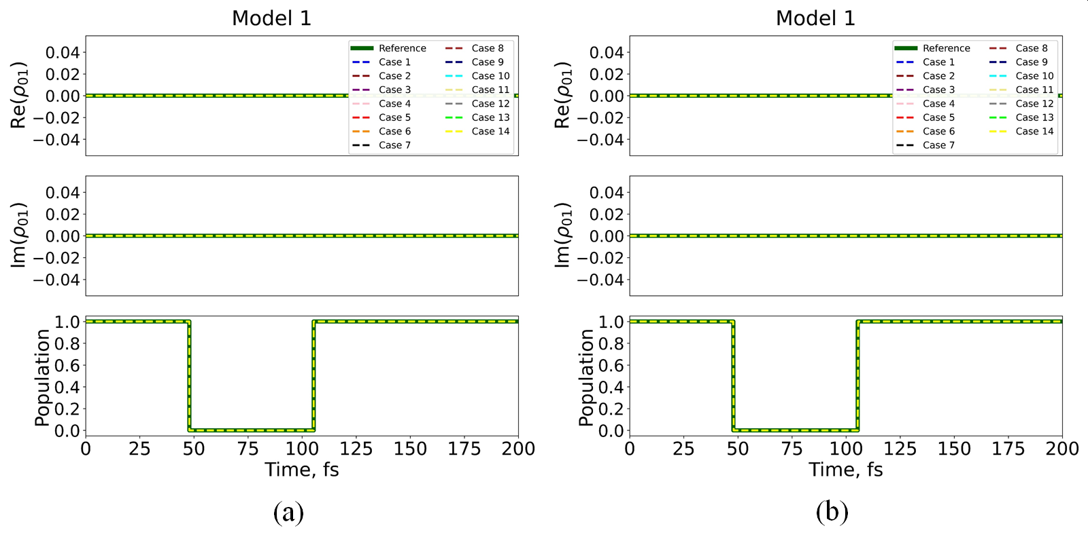
Figure S1. Evolution of density matrix elements $ρ_{00}$ (population) and $ρ_{01}$(coherence, real and imaginary parts) in model Hamiltonian given by Model 1, as computed by different integration schemes. The comparison is illustrated for two integration time-steps of (a) $Δt=0.001$; and (b) $Δt=10.0$. Many methods yield numerically equivalent results, so only few types of curves are visible, especially in the cases with the smallest $Δt$.

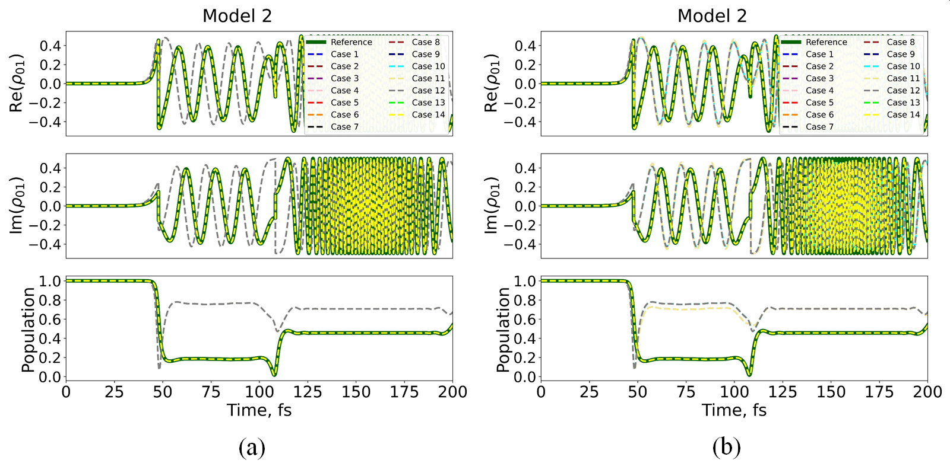
Figure S2. Evolution of density matrix elements $ρ_{00}$ (population) and $ρ_{01}$(coherence, real and imaginary parts) in model Hamiltonian given by Model 2, as computed by different integration schemes. The comparison is illustrated for two integration time-steps of (a) $Δt=0.001$; and (b) $Δt=10.0$. Many methods yield numerically equivalent results, so only few types of curves are visible, especially in the cases with the smallest $Δt$.

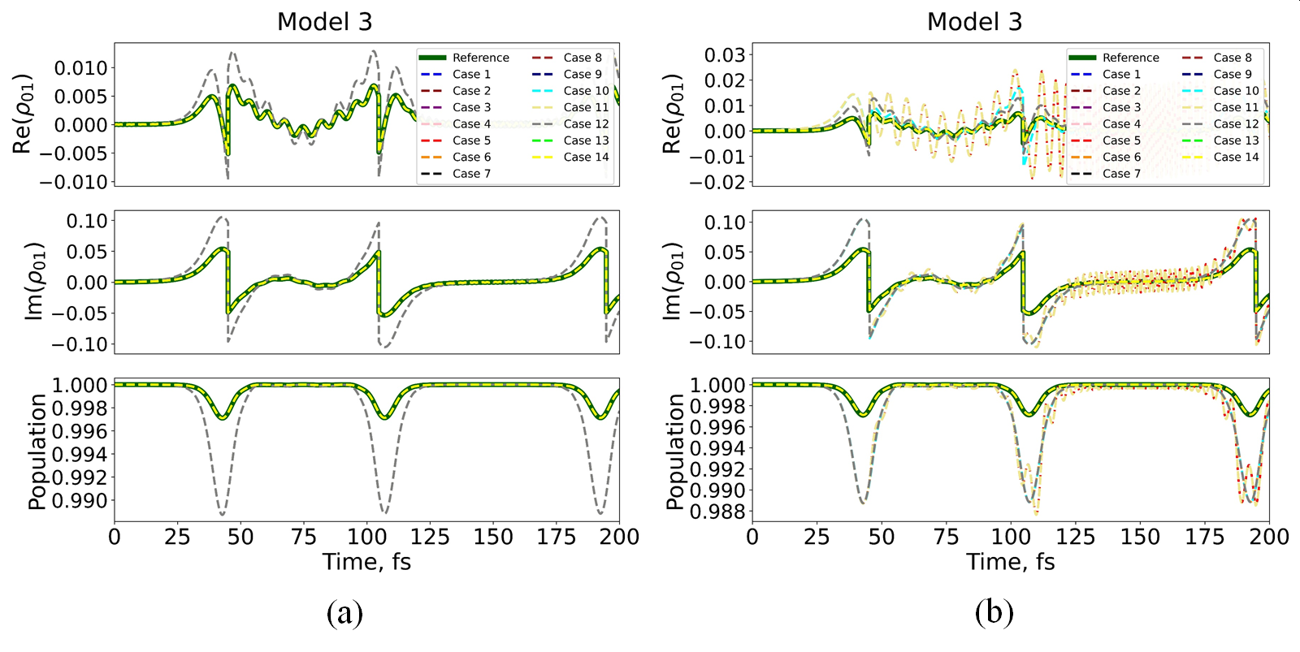
Figure S3. Evolution of density matrix elements $ρ_{00}$ (population) and $ρ_{01}$(coherence, real and imaginary parts) in model Hamiltonian given by Model 3, as computed by different integration schemes. The comparison is illustrated for two integration time-steps of (a) $Δt=0.001$; and (b) $Δt=10.0$. Many methods yield numerically equivalent results, so only few types of curves are visible, especially in the cases with the smallest $Δt$.

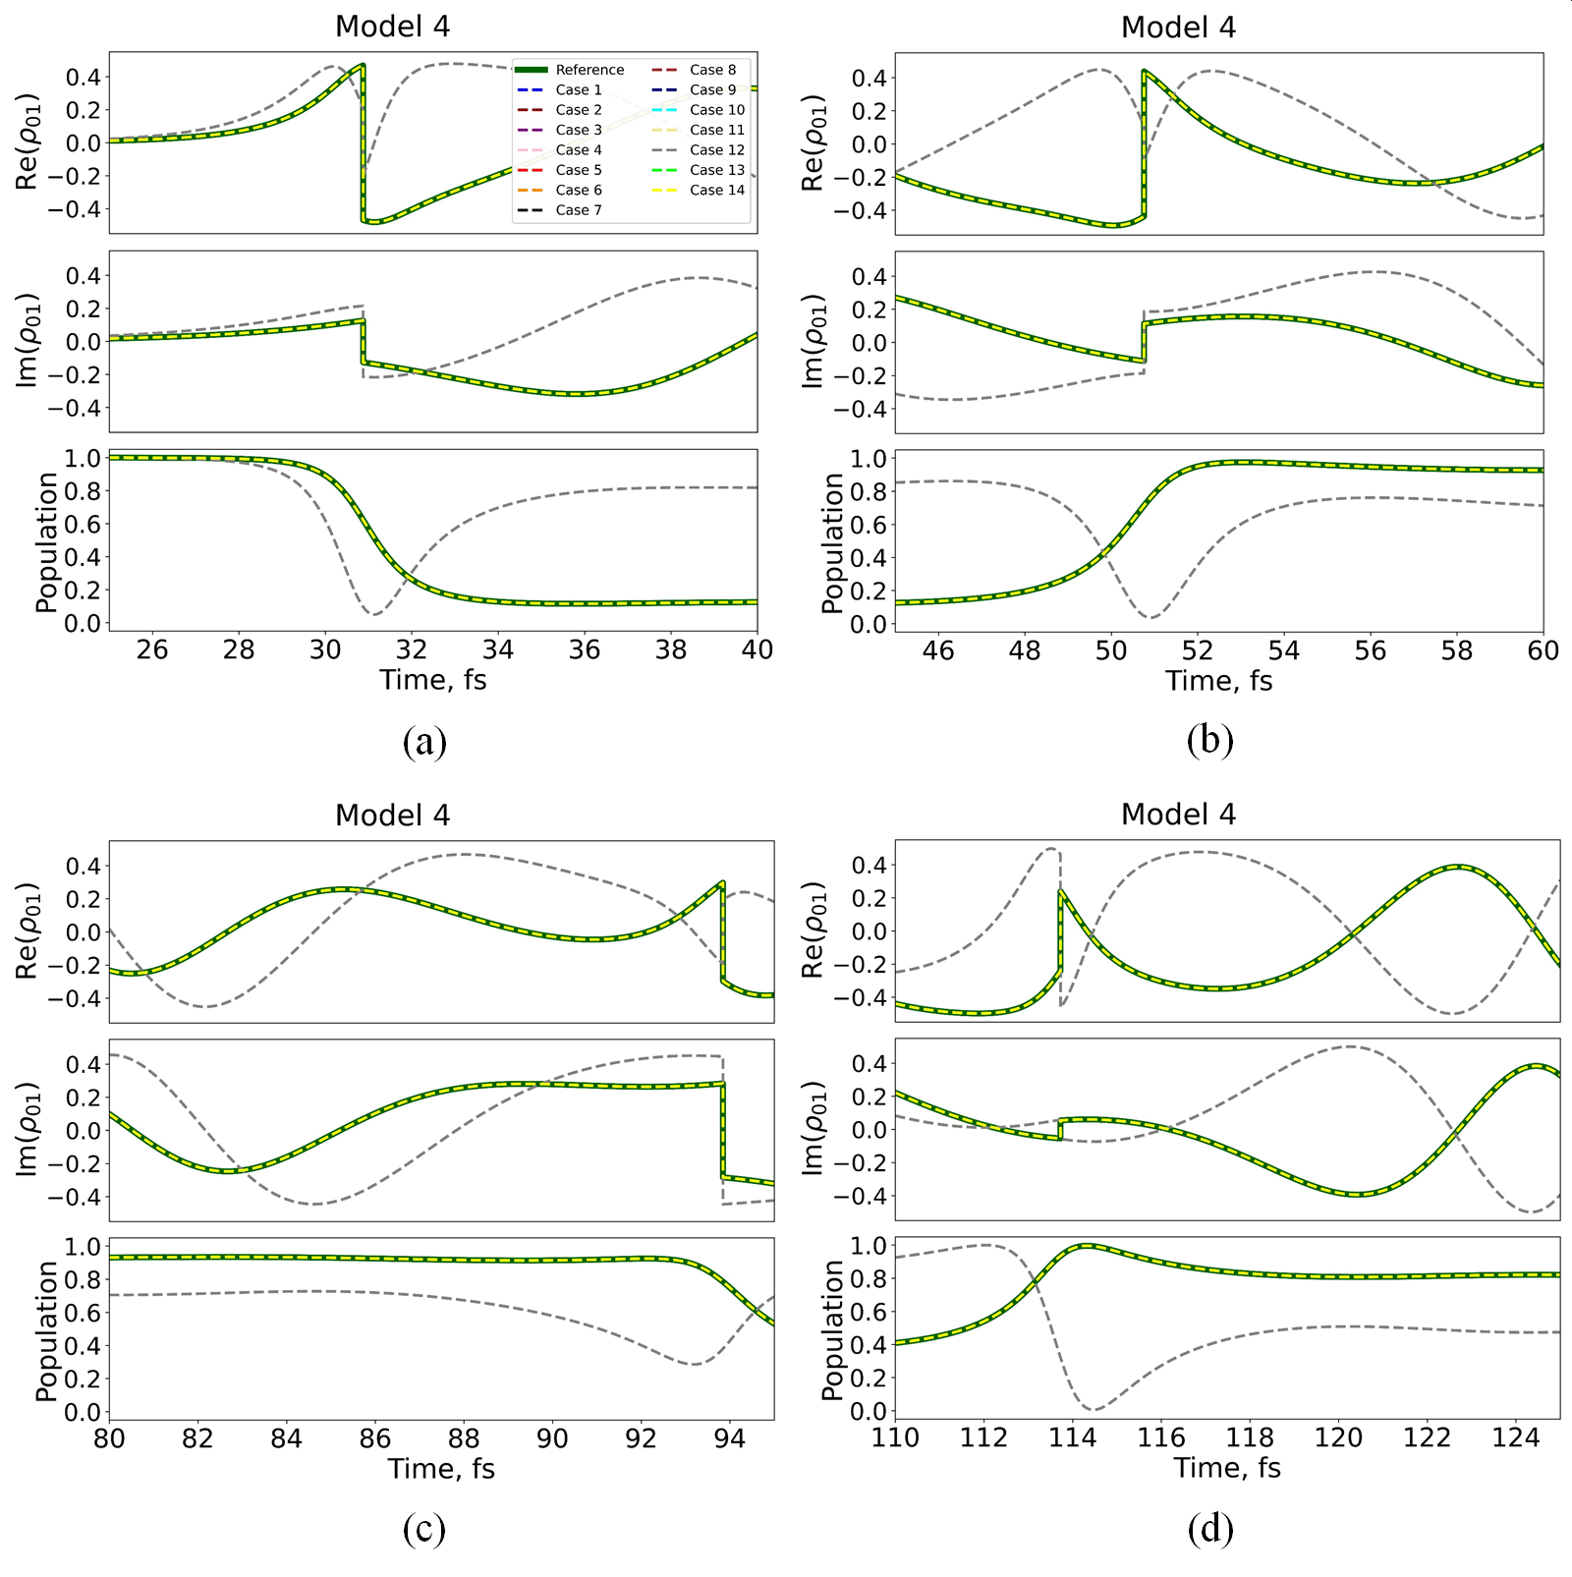
Figure S4. Snapshots of the evolution of density matrix elements $ρ_{00}$ (population) and $ρ_{01}$(coherence, real and imaginary parts) in model Hamiltonian given by Model 4, as computed by different integration schemes for $Δt=10.0 a.u$. The curves are shown for the red boxes in Figure 5 of times (a) 25-40, (b) 45-60, (c) 80-95, and (d) 110-125 fs.

References
(1) Granucci G, Persico M (2007) Critical appraisal of the fewest switches algorithm for surface hopping. J Chem Phys 126:134114

