Impact of sugars on kidney stone formation
Odin Bottrill¹, Alex Graham¹, Matthew Boon¹, Franca Jones¹*

Supplementary information

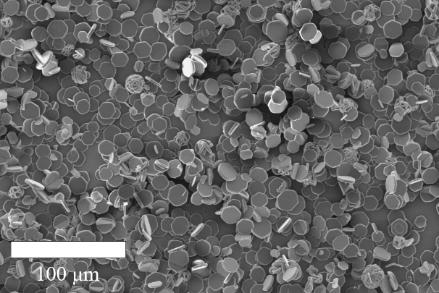  (a) | 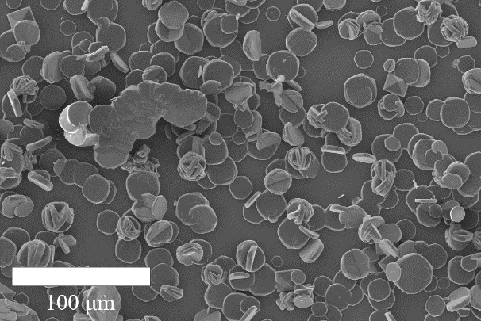  (b)
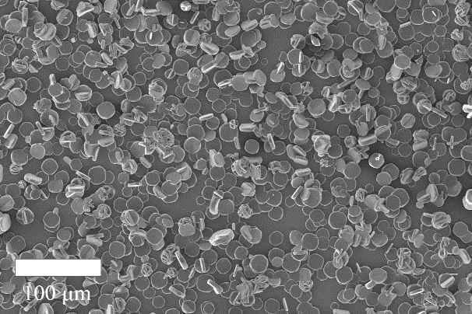  (c) | 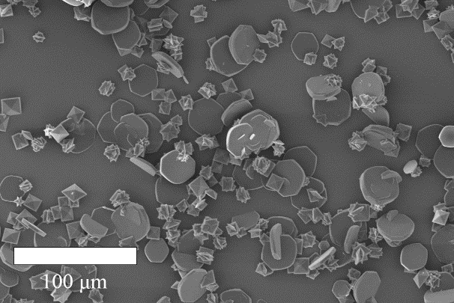  (d)
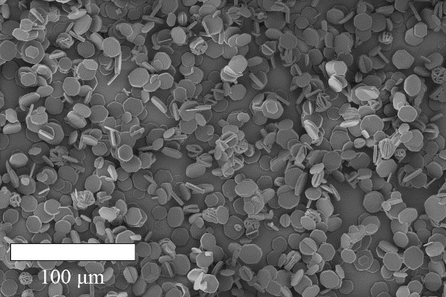  (e) | 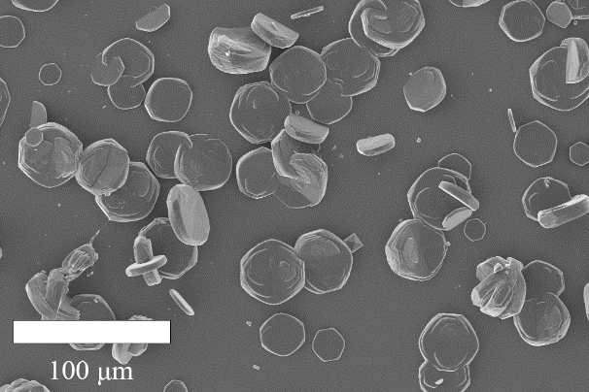  (f)
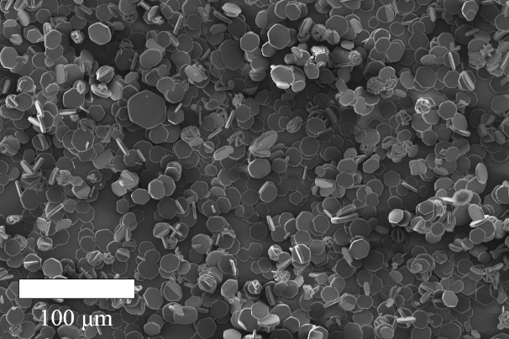  (g) | 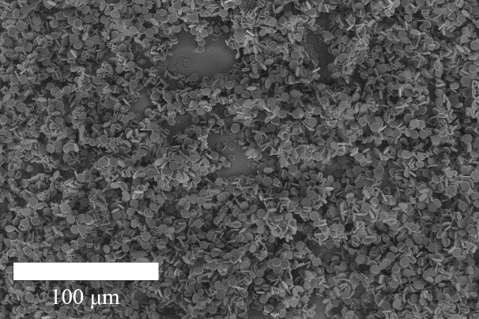  (h)
Supplementary Figure 1. CaOx morphology impacted by sugar additives; (a) pure SUM, (b) SUM+Zn²⁺, (c) galactose (20 mM), (d) galactose (10 mM)+Zn²⁺, (e) fructose (20 mM), (f) fructose (10 mM)+Zn²⁺, (g) glucose (20 mM), (h) glucose (10 mM)+Zn²⁺

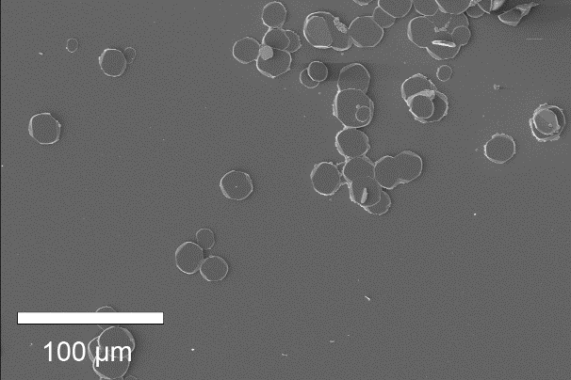  (a) | 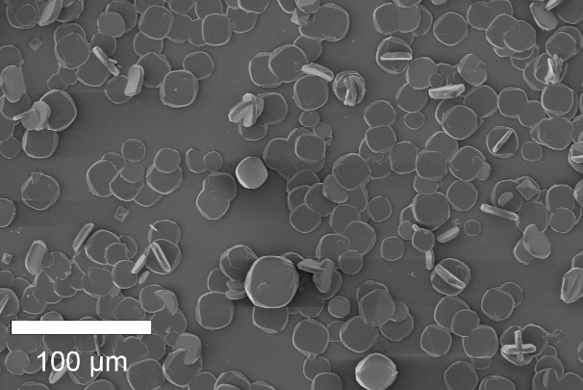  (b)
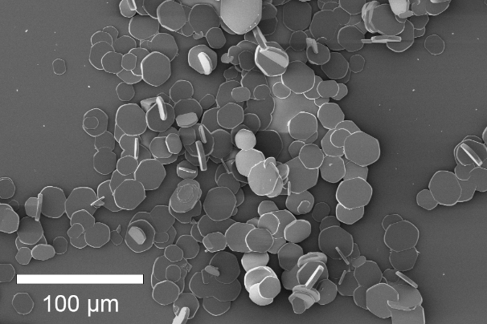  (c) | 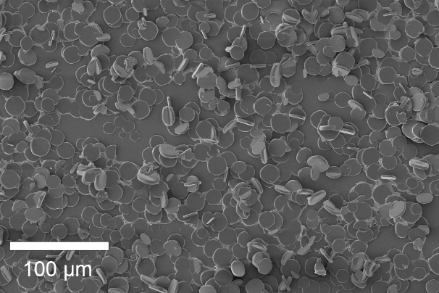  (d)
Supplementary Figure 2. CaOx morphology impacted by sugar additives; (a) sucrose (20mM), (b) sucrose (10mM)+Zn²⁺, (c) lactose (20 mM), (d) lactose (10 mM)+Zn²⁺

Supplementary Table 1. Recorded impact of the additives in SUM (additives at 20 mM) on the aspect ratio of CaOx formed.
Species | Aspect Ratio
 | SUM |  | SUM+Zn²⁺
Control | 1.15 |  | 1.13
Fru | 1.19 |  | 0.98
Gal | 0.94 |  | 0.96
Glu | 1.21 |  | 1.02
Suc | 1.15 |  | 0.99
Lac | 1.22 |  | 0.96

Supplementary Table 2. Recorded impact of the additives in SUM (additives at 20 mM) on the size of COM formed.
Species | Area (μm²)
 | SUM |  | SUM+Zn²⁺
Control | 187 ± 7 |  | 355 ± 20
Fru | 226 ± 6 |  | 1144 ± 58
Gal | 331 ± 9 |  | 750 ± 16
Glu | 227 ± 9 |  | 310 ± 10
Suc | 346 ± 6 |  | 448 ± 6
Lac | 623 ± 42 |  | 238 ± 27

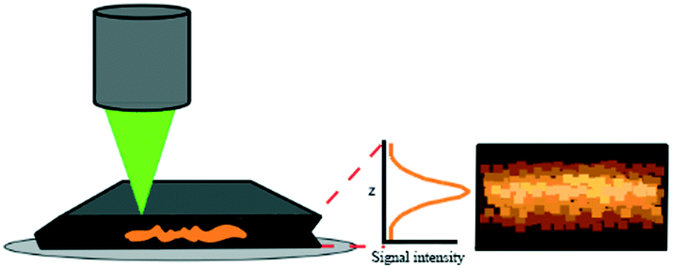
Supplementary Figure 3. Depth analysis depiction providing a heatmap based on signal intensity (from ref [9])

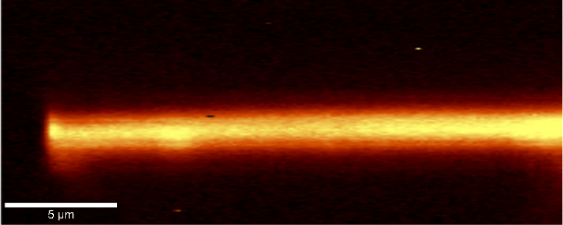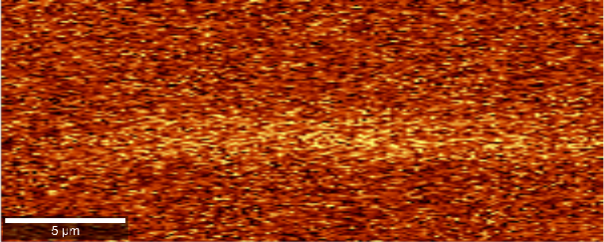
A. B.
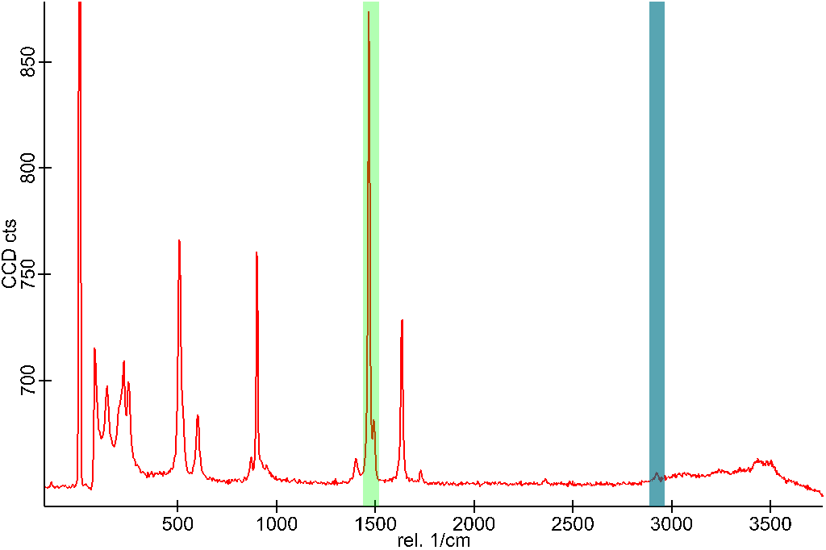
Supplementary Figure 4. Depth analysis of COM crystal grown in the presence of fructose (10 mM) and Zn²⁺ (1 mM) showing heatmap (5 µm scale) of highlighted signals (a) 1500 cm⁻¹ (green), and (b) 2900 cm⁻¹ (teal) on the Raman spectrum below. The 1500 cm⁻¹ signal shows the presence of oxalate and the 2900 cm⁻¹ is unique to the sugar.

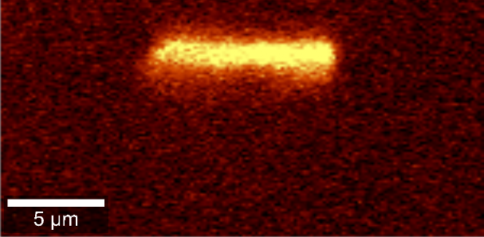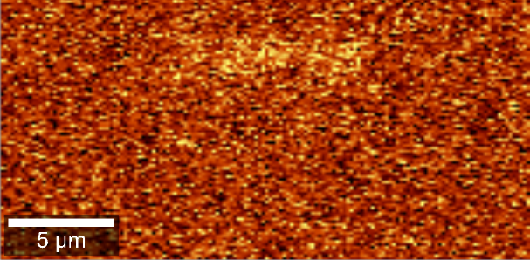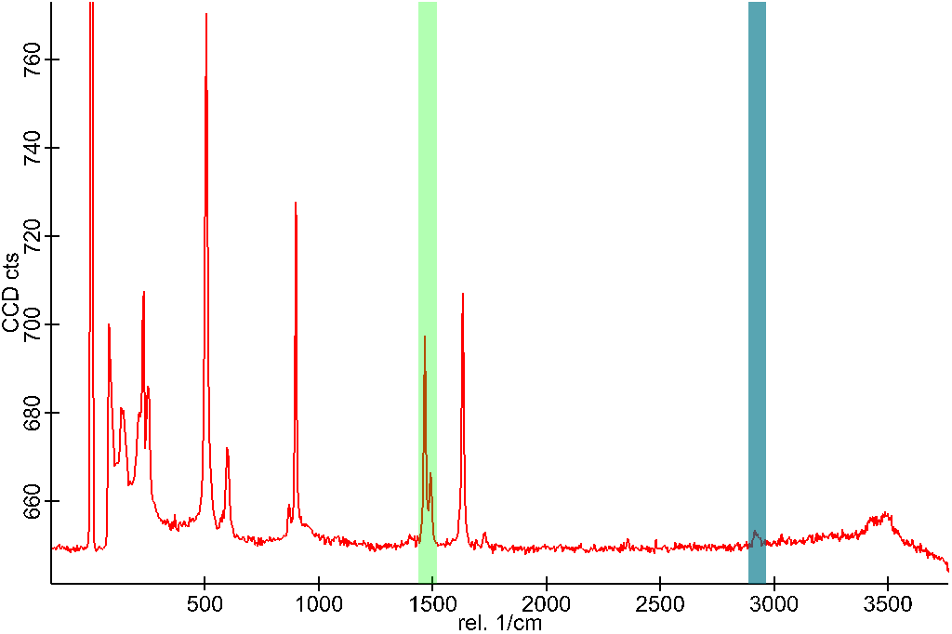
A. B.
Supplementary Figure 5. Depth analysis of COM crystal grown in the presence of galactose (10 mM) and Zn²⁺ (1 mM) showing heatmap (5 µm scale) of highlighted signals (a) 1460-1500 cm⁻¹ (green), and (b) 2900 cm⁻¹ (teal) on the Raman spectrum below. The 1500cm⁻¹ signal shows the presence of oxalate and the 2900cm⁻¹ is unique to the sugar.
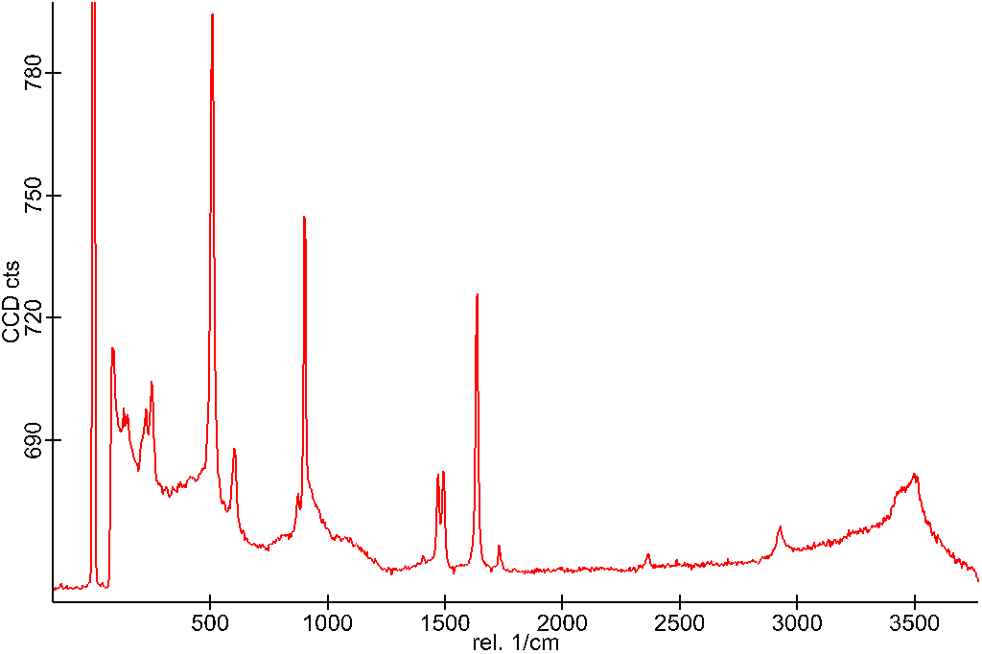
Supplementary Figure 6. Average spectrum of COM crystal grown with the presence of sucrose (10mM)

Supplementary Figure 7. Infrared Spectrum of the solutions grown with sucrose (10 mM) and sucrose (10mM) with zinc ions (1mM) compared to the control with just the SUM and the SUM with zinc ions (1 mM)

