Supplementary Material A)
Survey attached as pdf: “supplementary_survey_global_dive_study.pdf”

Supplementary Material B)

Table B1) Presenting all global and regional estimates for all identified scuba dive operators. All ranges refer to quantile 1 - quantile 3 from the final jackknife results.
Region | Number  in millions of SCUBA clients (tourists) | Expenditure (Total Revenue) in million USD |  |  | Employment (FTEs) in Thousands
Region | Number  in millions of SCUBA clients (tourists) | Diving trips | Gear rental | Certification | Low season | High season
Africa | 0.6 -1.1 | 48 - 104 | 12 -40 | 25 - 46 | 4 - 11 | 6 - 12
Americas | 2.9 -4.2 | 105 - 652 | 40 -174 | 86 - 493 | 8 - 21 | 12 - 31
Asia | 3.0 - 4.6 | 162 - 502 | 17 - 87 | 72 - 297 | 9 - 29 | 13 - 59
Europe | 2.0 -3.3 | 85 - 364 | 19 - 95 | 67 - 186 | 5 - 8 | 9 - 17
Oceania | 0.3 - 0.3 | 31 - 55 | 4 - 11 | 23 - 31 | 3 - 4 | 3 - 6
Global | 8.9 - 13.6 | 532 - 1,677 | 91 - 406 | 273 - 1,053 | 28 - 73 | 42 - 124

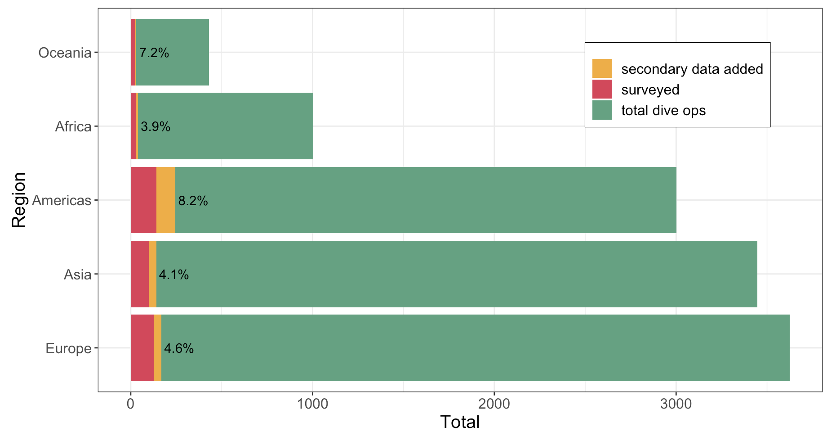
Figure B1) Total number of dive operators per region the percentage indicates the total dive operators sampled (including surveys and secondary sources)

Table B2) Mean tourist expenditure per day in 2020 USD by country found in the literature
Year | Author | Title | Location | Country | Mean Expenditure by Trip
2020 | Mustika, PLK et al. | The Economic Value of Shark and Ray Tourism in Indonesia and Its Role in Delivering Conservation Outcomes | Indonesia | Indonesia | 906
2006 | Pendleton, Linwood H | Understanding the Potential Economic Impact of SCUBA Diving and Snorkeling: California | California | United States | 203
2014 | Dicken, Ml | Socio-economic aspects of the Sodwana Bay SCUBA diving industry, with a specific focus on sharks | Sodwana Bay | South Africa | 1747
2008 | Tapsuwan and Asafu-Adjaye | Estimating the Economic Benefit of SCUBA Diving in the Similan Islands, Thailand | Similan Islands | Thailand | 190
 |  |  |  |  | 1570
2017 | Huveneers, C et al. | The economic value of shark-diving tourism in Australia | Port Lincoln | Australia | 2256
2017 | Haas et al. | The contemporary economic value of elasmobranchs in The Bahamas: Reaping the rewards of 25 years of stewardship and conservation | Bahamas | Bahamas, The | 3546
2012 | Vianna et al. | Socio-economic value and community benefits from shark-diving tourism in Palau: A sustainable use of reef shark populations | Palau | Palau | 2081
2016 | Northern Economics, Inc. | Economic Impact of Washington State Resident Scuba Divers | Washington State | United States | 533
2009 | Dicken and Hosking | Socio-economic aspects of the tiger shark diving industry within the Aliwal Shoal Marine Protected Area, South Africa | Aliwal Shoal Marine Protected Area | South Africa | 2514
2017 | Saayman and Saayman | Are there economic benefits from marine protected areas?  An analysis of scuba diver expenditure | Portofino | Italy | 393
2017 | Fedler, Anthony | The Economic Impact of Shark Diving in Florida | Florida | United States | 115
2017 | Fedler, Anthony | The Economic Impact of Shark Diving in Florida | Florida | United States | 209
2017 | Wayan et al. | The Impact of Direct Expenditures of Diving Tourism Towards The Economy of Coastal Balinese | Bali | Indonesia | 951
2017 | De Brauwer et al. | The economic contribution of the muck dive industry to tourism in Southeast Asia |  | Indonesia | 2134
2015 | Beaver and Keily | THE SCUBA DIVE INDUSTRY  IN AUSTRALIA: T O W A R D S E S T I M A T E S O F E C O N O M I C S I Z E A N D I M P A C T | Australia | Australia | 3930
 |  |  |  |  | 2321
 |  |  |  |  | 5324
2019 | Zimmerhackel et al. | Evidence of increased economic benefits from shark-diving tourism in the Maldives | Maldives | Maldives | 4712
2017 | Trujillo et al. | Valuing Coral Reef Preservation in a Caribbean Marine Protected Area. Economic Impact of Scuba Diving in Corals of Rosario and San Bernardo National Natural Park, Colombia | San Bernardo National Park | Colombia | Foreign: 1905
 |  |  |  |  | Domestic: 417
2017 | Torres et al. | Dead or alive: The growing importance of shark diving in the Mid-Atlantic region | Azores | Portugal | 4018
2016 | Pires et al. | The economic role of sharks in a major ecotourism archipelago in the western South Atlantic | Fernando de Noronha | Brazil | 1259
2010 | Catlin et al. | Consolidation in a Wildlife Tourism Industry: The Changing Impact of Whale Shark Tourist Expenditure in the Ningaloo Coast Region | Ningaloo Marine Park | Australia | 655
2021 | Wallmo et al. | Economic Impact Analysis of Recreational Fishing, SCUBA Diving, and Snorkeling on Florida's Coral Reefs | SE Florida | United States | 243
2015 | Wei et al. | A Comparison Study Between Domestic and International  Rural Tourist Profile and Travel Expenditures in Semporna, Sabah | Semporna, Sabah | Malaysia | 381
 |  |  |  |  | 559
2021 | Drakakis et al. | Multipliers and impacts of active sport tourism in the Greek region of Messinia | Messinia | Greece | 482

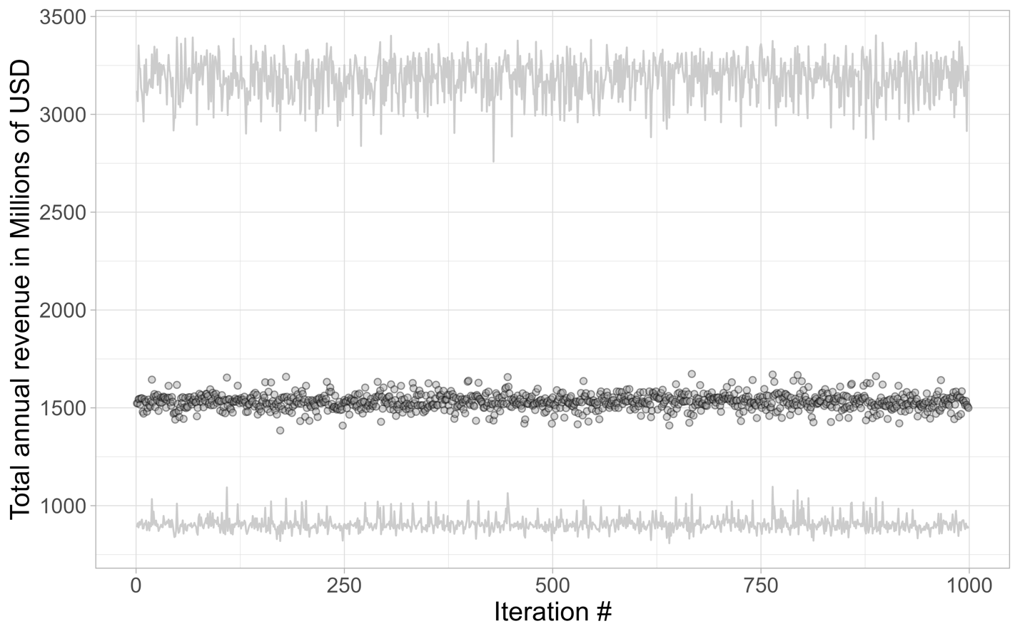
Figure B2) Total global annual revenue over each jackknife iteration numbers capturing lower quantiles (Q1), median and upper quantiles (Q3). Results were presented after 999
iterations; 5% of original data points were omitted for each iteration.

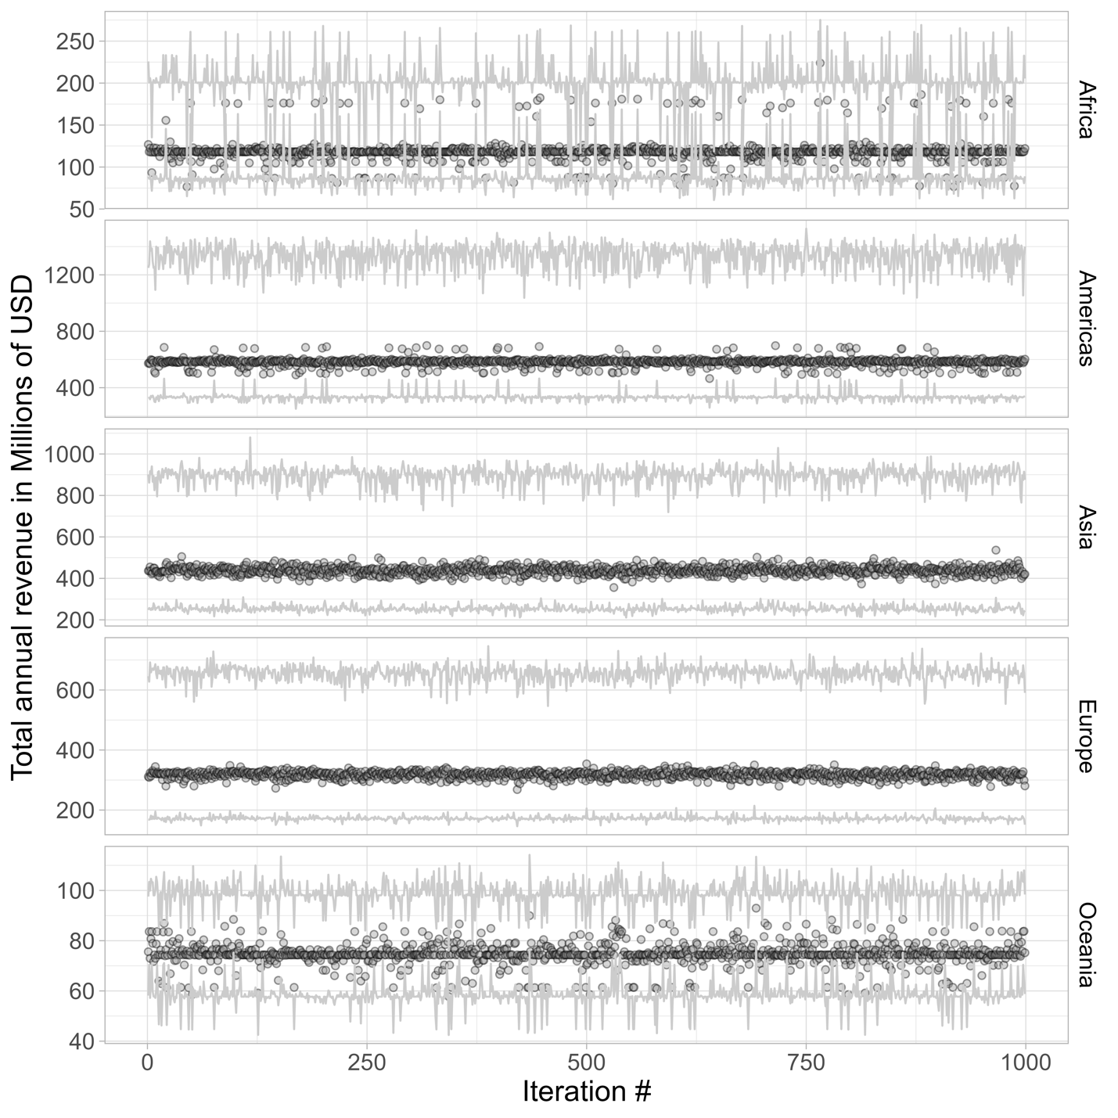
Figure B3) Total annual revenue over each jackknife iteration number capturing lower quantiles (Q1), median, and upper quantile (Q3) presented for each major geographic region. Results were presented after 999 iterations; 5% of original data points were omitted for each iteration.

