Table 4. Summary statistics of platelets, AST, ALT, hematocrit and hemoglobin for healthy versus Dengue patients
Biochemical tests | Patient status | Median | Mean | Standard deviation | Coefficient of Variation | Standard Error | Bar plot for mean  (margin of error 99%) Green healthy, Red dengue
Platelets | Dengue | 96,000 | 105,103 | 64,516 | 0.6 | 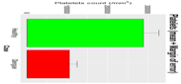  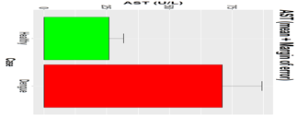  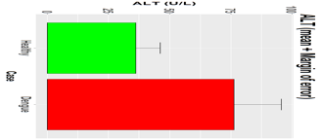  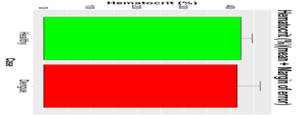  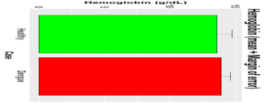 | 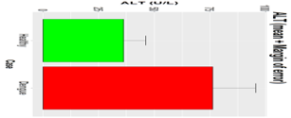
  8,471
Platelets | Healthy | 286,000 | 288,800 | 63,783 | 0.2 | 16,469
AST | Dengue | 62 | 71.1 | 42.8 | 0.6 | 6.8
AST | Healthy | 23 | 25.9 | 9.8 | 0.4 | 2.5
ALT | Dengue | 58 | 76.3 | 55.7 | 0.7 | 8.3
ALT | Healthy | 35 | 36.3 | 16.4 | 0.5 | 4.2
Hematocrit | Dengue | 41 | 41.4 | 14.6 | 0.4 | 2.1
Hematocrit | Healthy | 42.9 | 42.2 | 4 | 0.1 | 1
Hemoglobin | Dengue | 14 | 13.9 | 1.9 | 0.1 | 0.3
Hemoglobin | Healthy | 13.2 | 13.6 | 1.1 | 0.1 | 0.5

