Table 1. CDC reaction of isochroman with different sulfur-containing aliphatic and aromatic compounds
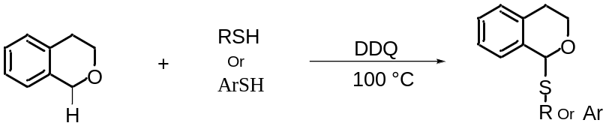

Entry | Isochroman | Nucleophile | Product | Yield (%)
1 | 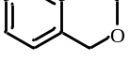 | 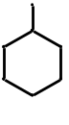 | 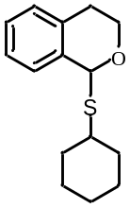 | 75
2 | 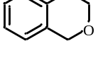 | 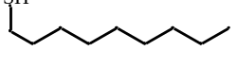 | 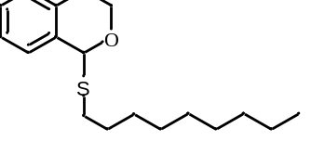 | 88
3 |  | 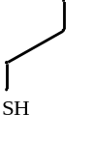 | 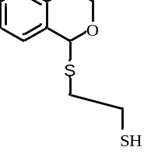 | 50
4 |  | 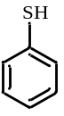 | 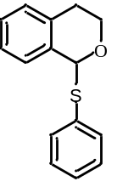 | 70
5 |  | 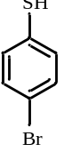 | 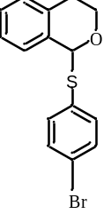 | 80

Table 1. Continued.
Entry | Isochroman | Nucleophile | Product | Yield (%)
6 |  | 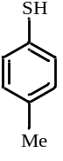 | 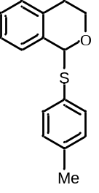 | 75
7 |  | 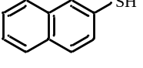 | 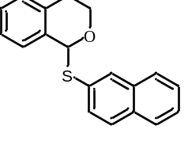 | 60
8 |  | 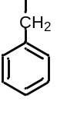 | 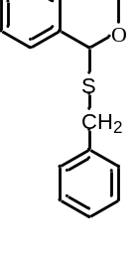 | 70
9 |  | 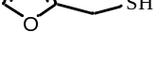 | 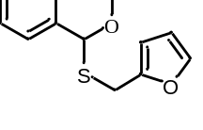 | 75
10 |  | 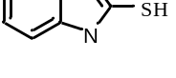 | 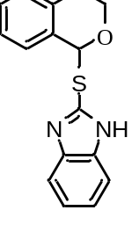 | 70

Table 2. CDC reaction of isochroman with 4-toluen-sulfinic acid sodium salt
Entry | Isochroman | Nucleophile | Product | Yield (%)
1 |  | 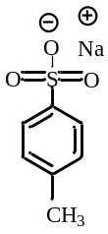 | 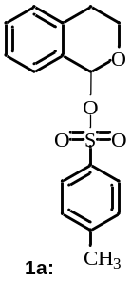 | 25
2 |  | 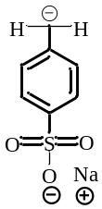 | 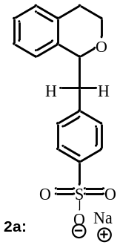 | 30

