Supporting Information

DDQ-mediated direct cross-dehydrogenative-coupling (CDC) reaction of thiols with isochroman: A serendipitous metal-free route to C-S bond formation
Soraya Rezaei,^{1*} Abdolhamid Alizadeh^{2*} and Gisya Abdi³
¹Department of Animal Science, College of Agricultural Engineering Science-Kifri, Garmian University, Kalar, As Sulaymaniyah, KRG
² Department of Organic Chemistry, Faculty of Chemistry, Alzahra University, Tehran, Iran
³ Academic Centre for Materials and Nanotechnology, AGH University of Science and Technology, al. Adama Mickiewicza 30, 30-059 Krakow, Poland

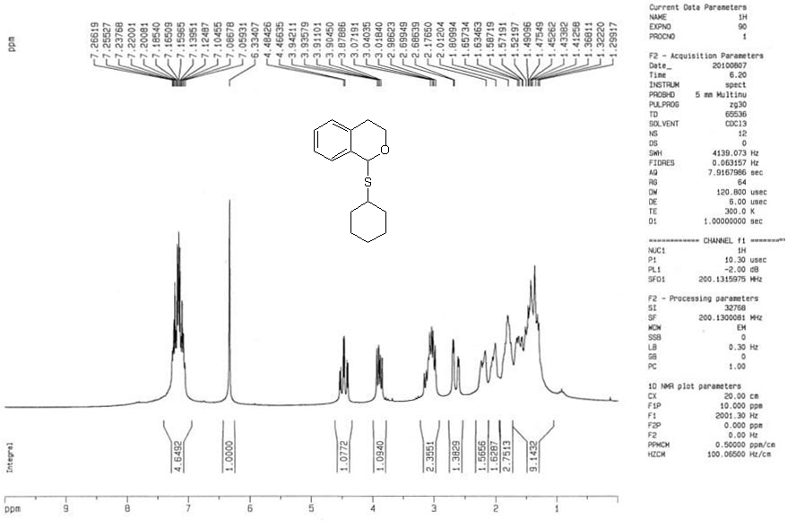
Number 1: ¹H NMR compound 1c (in CDCl₃)

¹H NMR, (CDCl₃, 200 MHz), δ (ppm): 1.29-2.17 (m, 10H), 2.68 (ddd, J = 2.6, 2.6, 15.6 Hz, 1H), 2.98-3.07 (m, 2H), 3.90 (ddd, J = 5.1, 9.5, 11.0 Hz, 1H), 4.47 (ddd, J = 3.7, 6.3, 10.6 Hz, 1H), 6.33 (s, 1H), 7.05-7.26 (m, 4H, H_{ar}).

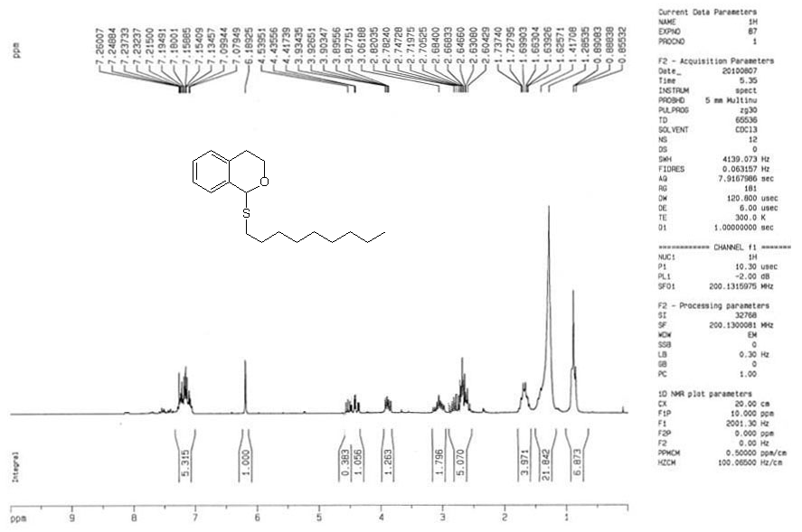
Number 2: ¹H NMR compound 2c (in CDCl₃)

¹H NMR, (CDCl₃, 200 MHz), δ (ppm): 0.85-0.89 and 1.28-1.73 (m, 9H), 2.60-2.82 (m, 5H), 3.06 (m, 2H), 3.90 (ddd, J = 3.8, 9.5, 11.0 Hz, 1H), 4.41-4.53 (m, 2H), 6.18 (s, 1H), 7.07-7.26 (m, 4H, H_{ar}).

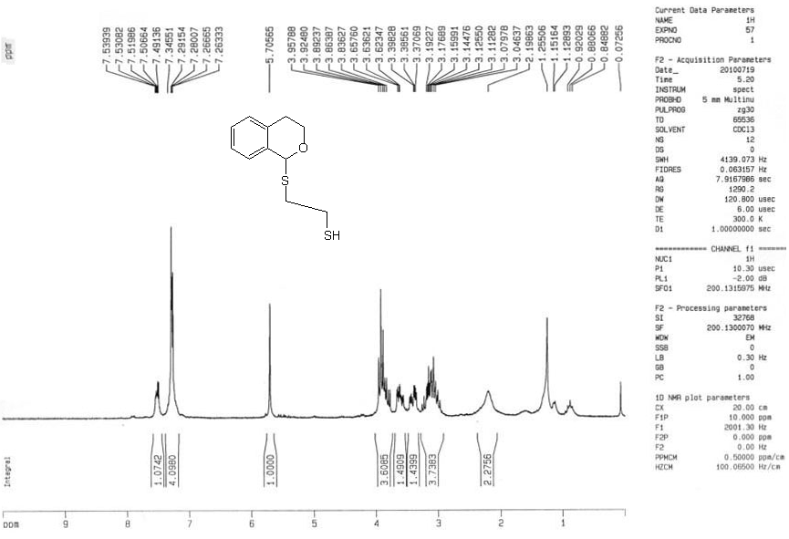
Number 3: ¹H NMR compound 3c (in CDCl₃)

¹H NMR, (CDCl₃, 200 MHz), δ (ppm): 0.88 (t, J = 7.9 Hz, 1H, SH), 3.04-3.19 (m, 2H), 3.37-3.39 (m, 2H), 3.62-3.83 (m, 2H), 3.86-3.95 (m, 2H), 5.70 (s, 1H), 7.26-7.53 (m, 4H, H_{ar}).

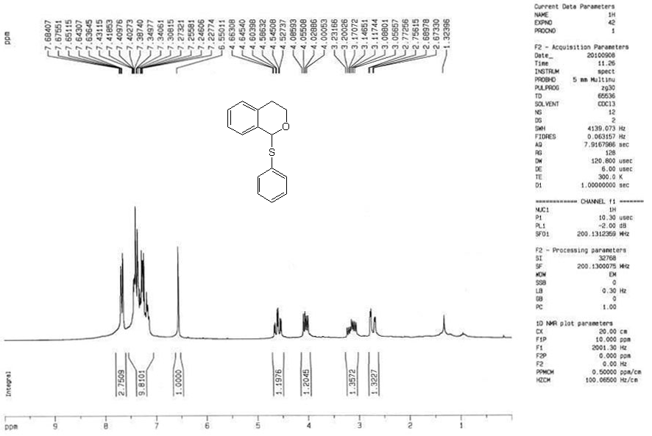
Number 4: ¹H NMR compound 4c (in CDCl₃)

¹H NMR, (CDCl₃, 200 MHz), δ (ppm): 2.72 (ddd, J = 3.2, 3.2, 16.5 Hz, 1H), 3.05 (ddd, J = 5.4, 9.4. 15.4 Hz, 1H), 4.43 (ddd, J = 5.2, 11.1, 9.5 Hz, 1H), 4.59 (ddd, J = 11.7, 3.5, 5.3 Hz, 1H), 6.55 (s, 1H), 7.22-7.68 (m, 9H, H_{ar}).

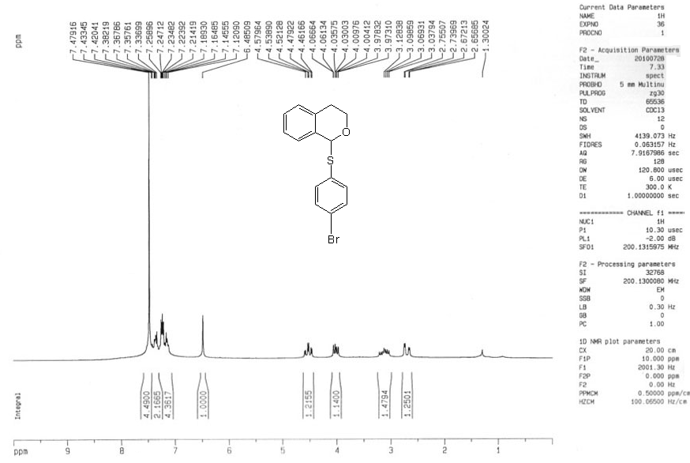
Number 5: ¹H NMR compound 5c (in CDCl₃)

¹H NMR, (CDCl₃, 200 MHz), δ (ppm): 2.70 (ddd, J = 3.0, 3.0, 16.5 Hz, 1H), 3.07 ( ddd, J = 5.9, 11.9, 15.4 Hz, 1H), 4.01 (ddd, J = 3.4, 6.2, 11.4 Hz, 1H), 4.51 (ddd, J = 3.5, 5.3, 11.9 Hz, 1H), 6.48 (s, 1H), 7.12-7.47 (m, 8H, H_{ar}).

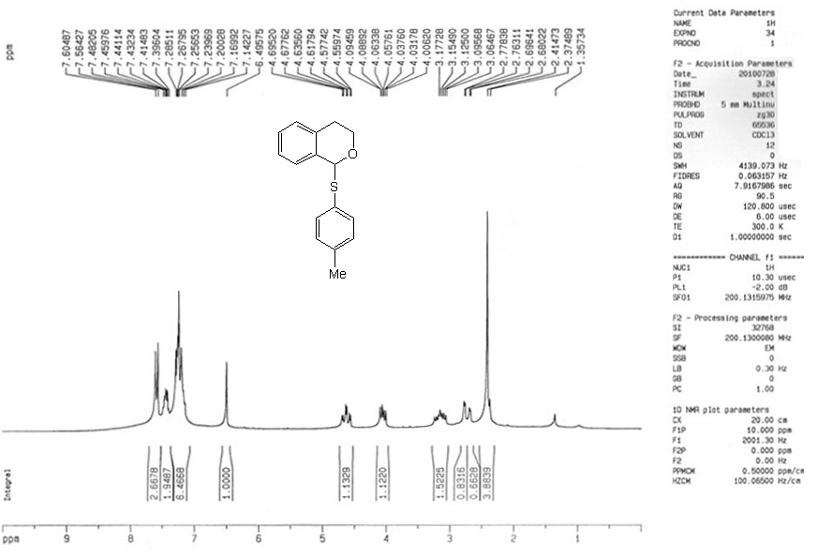
Number 6: ¹H NMR compound 6c (in CDCl₃)

¹H NMR, (CDCl₃, 200 MHz), δ (ppm): 2.41 (s, 3H, CH₃), 2.72 (ddd, J = 6.0, 9.6, 15.4 Hz, 1H), 4.04 (ddd, J = 5.1, 9.5, 11.0 Hz, 1H), 4.62 (ddd, J = 11.9, 5.2, 3.5 Hz, 1H), 6.49 (s, 1H), 7.14-7.60 (m, 8H, H_{ar}).

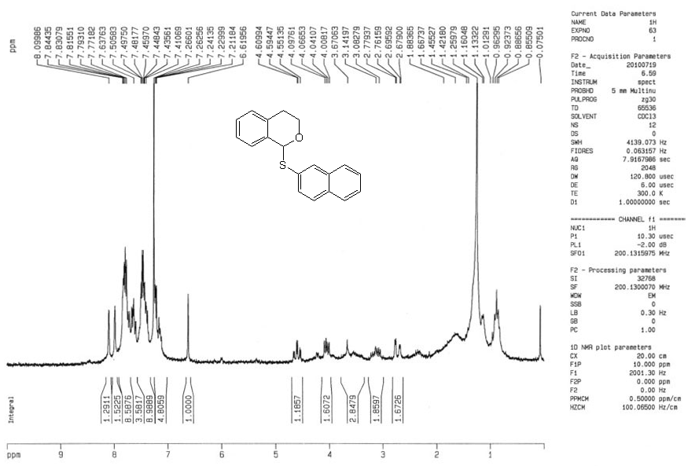
Number 7: ¹H NMR compound 7c (in CDCl₃)

¹H NMR, (CDCl₃, 200 MHz), δ (ppm): 2.72 (ddd, J = 3.3, 3.3, 16.6 Hz, 1H), 3.11 (ddd, J = 5.4, 9.4, 15.4 Hz, 1H), 4.05 (ddd, J = 11.4, 6.2, 3.2 Hz, 1H), 4.58 (ddd, J = 10.6, 6.2, 3.2 Hz, 1H), 6.61 (s, 1H), 7.21-8.09 (m, 11H, H_{ar}).

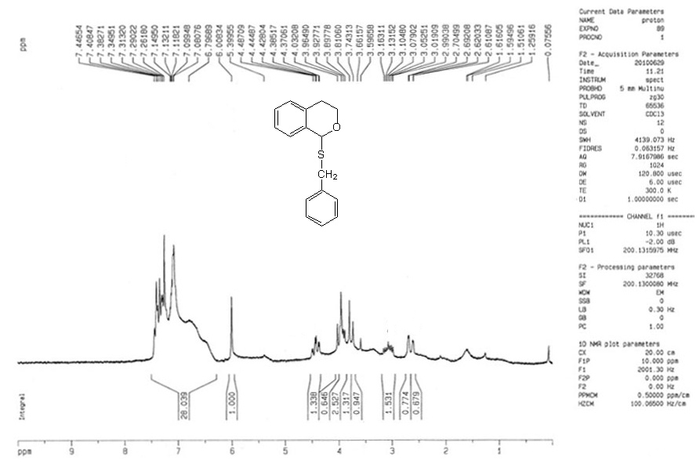
Number 8: ¹H NMR compound 8c (in CDCl₃)

¹H NMR, (CDCl₃, 200 MHz), δ (ppm): 2.65 (ddd, J = 2.5, 2.5, 16.2 Hz, 1H), 3.07 (ddd, J = 5.4, 9.4, 15.4 Hz, 1H), 3.66-4.03 (m, 2H_{benzyli}, H), 4.42 (ddd, J = 2.9, 5.3, 11.7 Hz, 1H), 6.00 (s, 1H), 6.79-7.44 (m, 9H, H_{ar}).

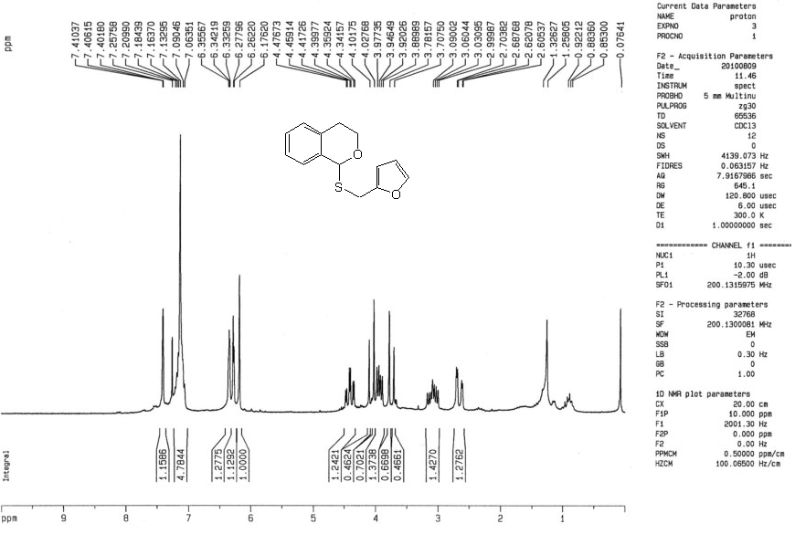
Number 9: ¹H NMR compound 9c (in CDCl₃)

¹H NMR, (CDCl₃, 200 MHz), δ (ppm): 2.65 (ddd, J = 3.2, 3.2, 16.5 Hz, 1H), 3.04 (ddd, J = 5.9, 8.4, 12.5 Hz, 1H), 3.70-4.10 (m, 3H), 4.40 (ddd, J = 11.8, 5.3, 3.5 Hz, 1H), 6.17 (s, 1H), 6.25-6.35 (m, 3H), 7.06-7.41 (m, 4H, H_{ar}).

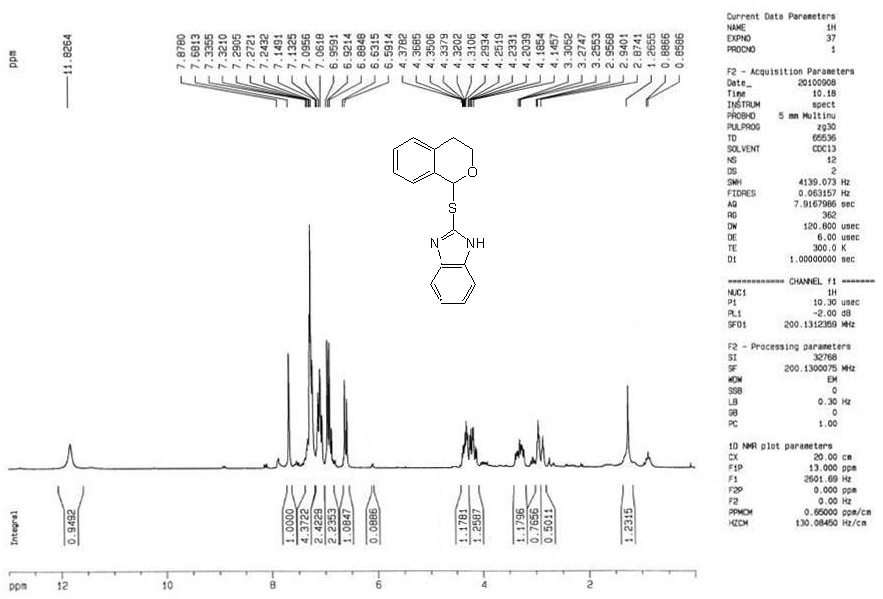
Number 10: ¹H NMR compound 10c (in CDCl₃)

¹H NMR, (CDCl₃, 200 MHz), δ (ppm): 2.91 (ddd, J = 3.3, 3.3, 16.3 Hz, 1H), 3.28 (ddd, J = 3.8, 9.5, 15.5 Hz, 1H), 4.14-4.37 (m, 2H), 6.59-6.63 and 6.88-7.33 (m, 8H, H_{ar}), 7.87(s, 1H), 11.82 (broad, 1H, NH).

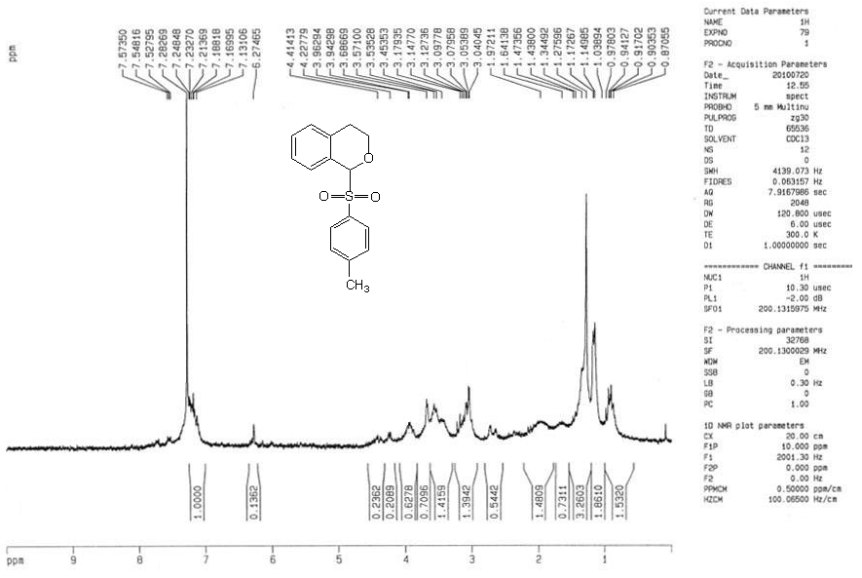
Number 11: ¹H NMR compound 11c (in CDCl₃)

¹H NMR, (CDCl₃, 200 MHz), δ (ppm): 1.34 (s, 3H, CH₃), 2.82 (ddd, J = 16.2, 3.4, 3.4, 1H), 3.10 (ddd, J.= 5.4, 9.4, 15.4, 1H), 3.56 (ddd, 1H), 3.95 (ddd, 1H), 6.27 (s, 1H), 7.13-7.57 (m, 8H, H_{ar}).

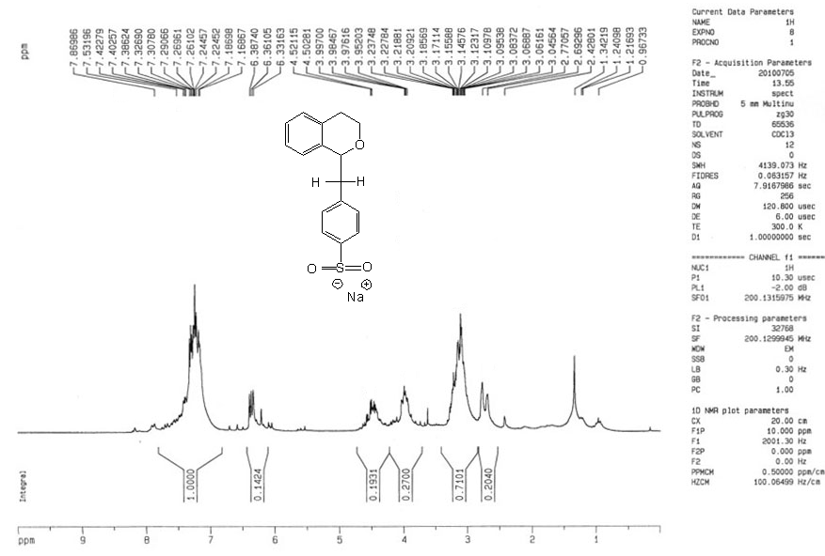
Number 12: ¹H NMR compound 12c (in CDCl₃)

¹H NMR, (CDCl₃, 200 MHz), δ (ppm): 2.66 (ddd, J = 2.4, 2.4, 16.4 Hz, 1H), 2.97-3.20 (m, 2H_{benzyli}, 1H), 3.91 (ddd, J = 3.8, 9.5, 11.0 Hz, 1H), 4.41 (ddd, J = 3.7, 5.3, 10.6 Hz, 1H), 6.28 (t, J = 5.2 Hz, 1H), 7.09-7.48 (m, 8H, H_{ar}).

