Supplementary Information
MC1R signaling through the cAMP-CREB/ATF-1 and ERK-NFκB pathways accelerates G1/S transition promoting breast cancer progression
Vipin Shankar Chelakkotª, Kiara Thomasª, Todd Romighª, Andrew Fongª, Lin Li^{b}, Shira Ronen^{c}, Shuyang Chenª, Pauline Funchain^{d}, Ying Ni^{b}*, Joshua Arbesman^{a,e,f} *#
ªDepartment of Cancer Biology, Lerner Research Institute, Cleveland Clinic, Cleveland, Ohio, USA
^{b}Center for Immunotherapy & Precision Immuno-Oncology, Lerner Research Institute, Cleveland Clinic, Cleveland Clinic, Cleveland, Ohio, USA
^{c}Department of Anatomic Pathology, Pathology and Laboratory Medicine Institute, Cleveland Clinic, Cleveland, Ohio, USA
^{d}Department of Hematology & Oncology, Taussig Cancer Center, Cleveland Clinic, Cleveland, Ohio, USA
^{e}Department of Dermatology, Dermatology and Plastic Surgery Institute, Cleveland Clinic, Cleveland, Ohio, USA
^{f}Department of Dermatology, Cleveland Clinic Lerner College of Medicine, Case Western Reserve University, Cleveland, Ohio, USA
*Corresponding Authors: Joshua Arbesman: arbesmj@ccf.org, Ying Ni: niy@ccf.org

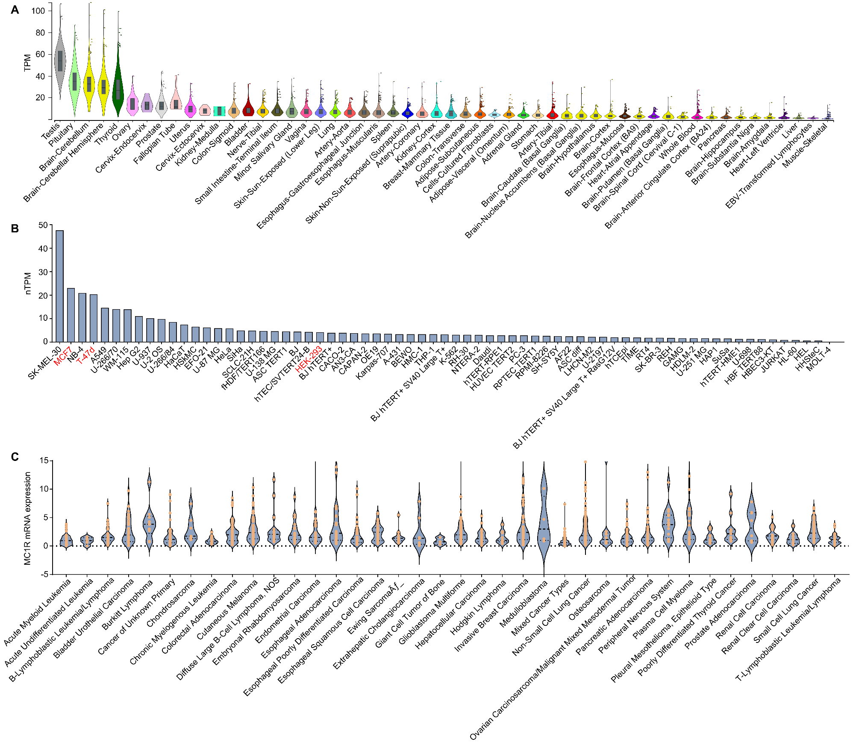
Fig S1. MC1R is widely expressed in human tissues and human cancer cell lines
A. Bulk tissue gene expression of MC1R (ENSG00000258839.3) in human tissues. Data Source: GTEx Analysis Release V8 (dbGaP Accession phs000424.v8.p2). Expression values are shown in TPM (Transcripts Per Million), calculated from a gene model with isoforms collapsed to a single gene. No other normalization steps have been applied. Box plots show the median and 25th and 75th percentiles; points are displayed as outliers if they are above or below 1.5 times the interquartile range. The testis, brain, thyroid, and ovary showed high expression, while the expression in the skin (sun-exposed lower leg) was much lower.
B, C. MC1R expression in cancer cell lines (B) data from The Human Protein Atlas (C) data from the cancer cell encyclopedia analyzed using cBioPortal. nTPM: normalized Transcripts Per Million. The cell lines used in this study are indicated using red font in B.

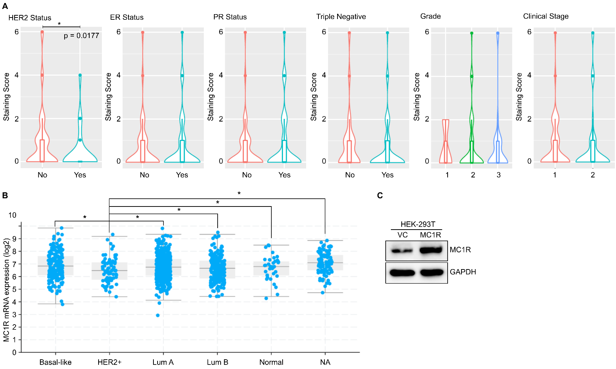
Fig S2. A. Plots comparing MC1R staining score with HER2 status, ER status, PR status, Triple Negative status, Grade, and the clinical stage (1= IIA or below, local/primary disease; 2= IIB and above, local or distant metastasis) of breast cancer tissue in the tumor microarray. A significant association between HER2-negative breast cancers and high MC1R staining was observed.
B. Plot comparing MC1R mRNA expression (RSEM, Batch normalized from Illumina HiSeq_RNASeqV2; log2) with the breast cancer types. Data from TCGA. (NA: Type not available) *p<0.05, one-way ANOVA with Dunnett’s multiple comparisons).
C. Representative western blot showing transient overexpression of MC1R in HEK-293T cells transfected with an MC1R plasmid. GAPDH expression is shown as the loading control.

MC1R R (Disruptive variant) | p.R | Mutation
D84E | p.D84E | 16:89985918 C / A (rs1805006)
R142H | p.R142H | 16:89986091 G / A (rs11547464)
R151C | p.R151C | 16:89986117 C / T (rs1805007)
I155T | p.I155T | 16:89986130 T / C (rs1110400)
R160W | p.R160W | 16:89986144 C / T (rs1805008)
D294H | p.D294H | 16:89986546 G / C (rs1805009)
Y152X | p.Y152X | 16:89986122 C / A
S83P | p.S83P | 16:89985913 T / C (rs34474212)
G89R | p.G89R | 16:89985931 G / A (rs34540312)
T95M | p.T95M | 16:89985950 C / T (rs34158934)
D121E | p.D121E | 16:89986029 C / G
A149T | p.A149T | 16:89986111 G / A
V156L | p.V156L | 16:89986132 G / C (rs3212365)
V156A | p.V156A | 16:89986133 T / C
I168M | p.I168M | 16:89986170 C / G (rs34612847)
R306H | p.R306H | 16:89986583 G / A
Q23X | p.Q23X | 16:89985733 C / T
Y74X | p.Y74X | 16:89985888 C / A
Y207X | p.Y207X | 16:89986287 C / G
A28fs | p.A28fs | 16:89985750 dupA
F179fs | p.F179fs | 16:89986202 T / TC
A212fs | p.A212fs | 16:89986301 delCCCGGGCCTGCCAGCACGC
I221fs | p.I221fs | 16:89986329 delCGCCCGGCTCCACAAGAGGCAG
R229fs | p.R229fs | 16:89986350 GC / G
L237fs | p.L237fs | 16:89986377 dupA

Table S1. List of MC1R disruptive (R) variants.

Cancer Type | Abbreviation | R% count by allele | Total Allele | R Allele | Non-R Allele | Odd’s Ratio (OR) | OR. Lower CI | OR. Upper CI | p-value  (Fisher’s Exact Test) | Adjusted p-value (BH)
Uterine Carcinosarcoma | UCS | 0.2955 | 88 | 26 | 62 | 1.7158 | 1.0410 | 2.7550 | 0.0305 | 0.0837
Skin Cutaneous Melanoma | SKCM | 0.2864 | 894 | 256 | 638 | 1.6418 | 1.4121 | 1.9042 | 1.72E-10 | 5.67E-09
Rectum Adenocarcinoma | READ | 0.2375 | 160 | 38 | 122 | 1.2744 | 0.8606 | 1.8491 | 0.1953 | 0.4027
Kidney Renal Papillary Cell Carcinoma | KIRP | 0.2181 | 408 | 89 | 319 | 1.1416 | 0.8912 | 1.4498 | 0.2874 | 0.5042
Pancreatic Adenocarcinoma | PAAD | 0.2063 | 320 | 66 | 254 | 1.0632 | 0.7976 | 1.4002 | 0.6719 | 0.8623
Bladder Urothelial Carcinoma | BLCA | 0.2034 | 654 | 133 | 521 | 1.0445 | 0.8557 | 1.2676 | 0.6558 | 0.8623
Head & Neck Squamous Cell Carcinoma | HNSC | 0.2030 | 872 | 177 | 695 | 1.0420 | 0.8772 | 1.2326 | 0.6363 | 0.8623
Liver Hepatocellular Carcinoma | LIHC | 0.2016 | 372 | 75 | 297 | 1.0332 | 0.7903 | 1.3366 | 0.7934 | 0.8788
Prostate Adenocarcinoma | PRAD | 0.2007 | 294 | 59 | 235 | 1.0273 | 0.7581 | 1.3731 | 0.8255 | 0.8788
Mesothelioma | MESO | 0.2000 | 160 | 32 | 128 | 1.0229 | 0.6712 | 1.5179 | 0.9206 | 0.9415
ExAC Non-TCGA, Non-Finnish European Ancestry (ExACNon-TCGA NFE) Control Population |  | 0.1963
Pheochromocytoma and Paraganglioma | PCPG | 0.1926 | 296 | 57 | 239 | 0.9758 | 0.7171 | 1.3088 | 0.9415 | 0.9415
Brain Lower Grade Glioma | LGG | 0.1907 | 944 | 180 | 764 | 0.9640 | 0.8137 | 1.1372 | 0.6794 | 0.8623
Uterine Corpus Endometrial Carcinoma | UCEC | 0.1905 | 740 | 141 | 599 | 0.9631 | 0.7949 | 1.1606 | 0.7442 | 0.8788
Lung Adenocarcinoma | LUAD | 0.1872 | 780 | 146 | 634 | 0.9422 | 0.7805 | 1.1313 | 0.5548 | 0.8623
Acute Myeloid Leukemia | LAML | 0.1865 | 252 | 47 | 205 | 0.9381 | 0.6677 | 1.2945 | 0.7507 | 0.8788
Kidney Chromophobe | KICH | 0.1810 | 116 | 21 | 95 | 0.9045 | 0.5350 | 1.4634 | 0.8148 | 0.8788
Lung Squamous Cell Carcinoma | LUSC | 0.1796 | 696 | 125 | 571 | 0.8957 | 0.7312 | 1.0902 | 0.2903 | 0.5042
Colon Adenocarcinoma | COAD | 0.1745 | 424 | 74 | 350 | 0.8651 | 0.6632 | 1.1157 | 0.2696 | 0.5042
Cholangiocarcinoma | CHOL | 0.1711 | 76 | 13 | 63 | 0.8443 | 0.4261 | 1.5506 | 0.6659 | 0.8623
Thymoma | THYM | 0.1667 | 204 | 34 | 170 | 0.8183 | 0.5484 | 1.1891 | 0.3310 | 0.5461
Kidney Renal Clear Cell Carcinoma | KIRC | 0.1661 | 548 | 91 | 457 | 0.8148 | 0.6426 | 1.0235 | 0.0832 | 0.2112
Sarcoma | SARC | 0.1518 | 448 | 68 | 380 | 0.7322 | 0.5566 | 0.9509 | 0.0168 | 0.0503
Thyroid Carcinoma | THCA | 0.1492 | 650 | 97 | 553 | 0.7177 | 0.5717 | 0.8931 | 0.0024 | 0.0098
Breast Invasive Carcinoma | BRCA | 0.1490 | 1430 | 213 | 1217 | 0.7161 | 0.6151 | 0.8305 | 4.75E-06 | 5.23E-05
Adrenocortical Carcinoma | ACC | 0.1474 | 156 | 23 | 133 | 0.7076 | 0.4334 | 1.1079 | 0.1307 | 0.2875
Stomach Adenocarcinoma | STAD | 0.1426 | 554 | 79 | 475 | 0.6805 | 0.5288 | 0.8660 | 0.0012 | 0.0057
Glioblastoma Multiforme | GBM | 0.1395 | 674 | 94 | 580 | 0.6631 | 0.5269 | 0.8269 | 0.0001 | 0.0010
Uveal Melanoma | UVM | 0.1364 | 110 | 15 | 95 | 0.6461 | 0.3478 | 1.1207 | 0.1193 | 0.2812
Testicular Germ Cell Tumors | TGCT | 0.1303 | 238 | 31 | 207 | 0.6128 | 0.4056 | 0.8974 | 0.0088 | 0.0321
Cervical Squamous Cell Carcinoma and Endocervical Adenocarcinoma | CESC | 0.1292 | 418 | 54 | 364 | 0.6070 | 0.4470 | 0.8103 | 0.0004 | 0.0022
Ovarian Serous Cystadenocarcinoma | OV | 0.1279 | 688 | 88 | 600 | 0.6001 | 0.4737 | 0.7525 | 3.11E-06 | 5.13E-05
Esophageal Carcinoma | ESCA | 0.1009 | 228 | 23 | 205 | 0.4591 | 0.2844 | 0.7085 | 0.0001 | 0.0010
Lymphoid Neoplasm Diffuse Large B-cell Lymphoma | DLBC | 0.0500 | 40 | 2 | 38 | 0.2154 | 0.0252 | 0.8335 | 0.0158 | 0.0503

Table S2. R% allele frequency among 10,391 patients with cancer housed in TCGA grouped based on 33 cancer types. The cancer types, their R% allele frequencies, and the p-values compared to the control population determined by Fisher’s exact test and Benjamini–Hochberg (BH) multiple comparison adjustment are shown. The cancer types are listed in the decreasing order of their R% allele frequencies. The R% allele frequency of the control Exome Aggregation Consortium (ExAC) Non-TCGA, Non-Finnish European Ancestry (ExACNon-TCGA NFE) population was 0.1963 (Indicated using orange font in the table). Skin Cutaneous Melanoma with a significantly higher R% allele frequency than the control population is indicated using red font, and cancers with significantly lower R% allele frequencies than the control population are indicated using blue font. Of the nine cancers that showed a significantly different R% allele frequency compared to the control population, eight cancer types (thyroid carcinoma, breast invasive carcinoma, stomach adenocarcinoma, glioblastoma multiforme, testicular germ cell tumors, cervical squamous cell carcinoma and endocervical adenocarcinoma, ovarian serous cystadenocarcinoma, and esophageal carcinoma) showed significantly lower R% allele frequencies. Breast Invasive Carcinoma, which showed one of the lowest p-values (p=5.23E-05), was chosen for further exploration of the association between MC1R and cancer progression.

Genotype | 0,0 | 0,r | R,0 | r,r | R,r | R,R | Total | RR% count by individual | R% count by Allele | Total Allele | No. of R | No. of non-R | p-Value
Frequency | 43 | 29 | 18 | 7 | 9 | 4 | 110 | 0.03636364 | 0.15909091 | 220 | 35 | 185 | 0.32

Table S3. Analysis of R% allele frequency in the Breast Cancer Genome Guided Therapy Study (BEAUTY) (dbGaP accession phs001050.v1.p1) dataset of patients with breast cancer. The R% allele frequency was 0.1591, which is lower than that of the control population (0.1963), although not statistically significant (p-value = 0.32, Chi-squared test).

