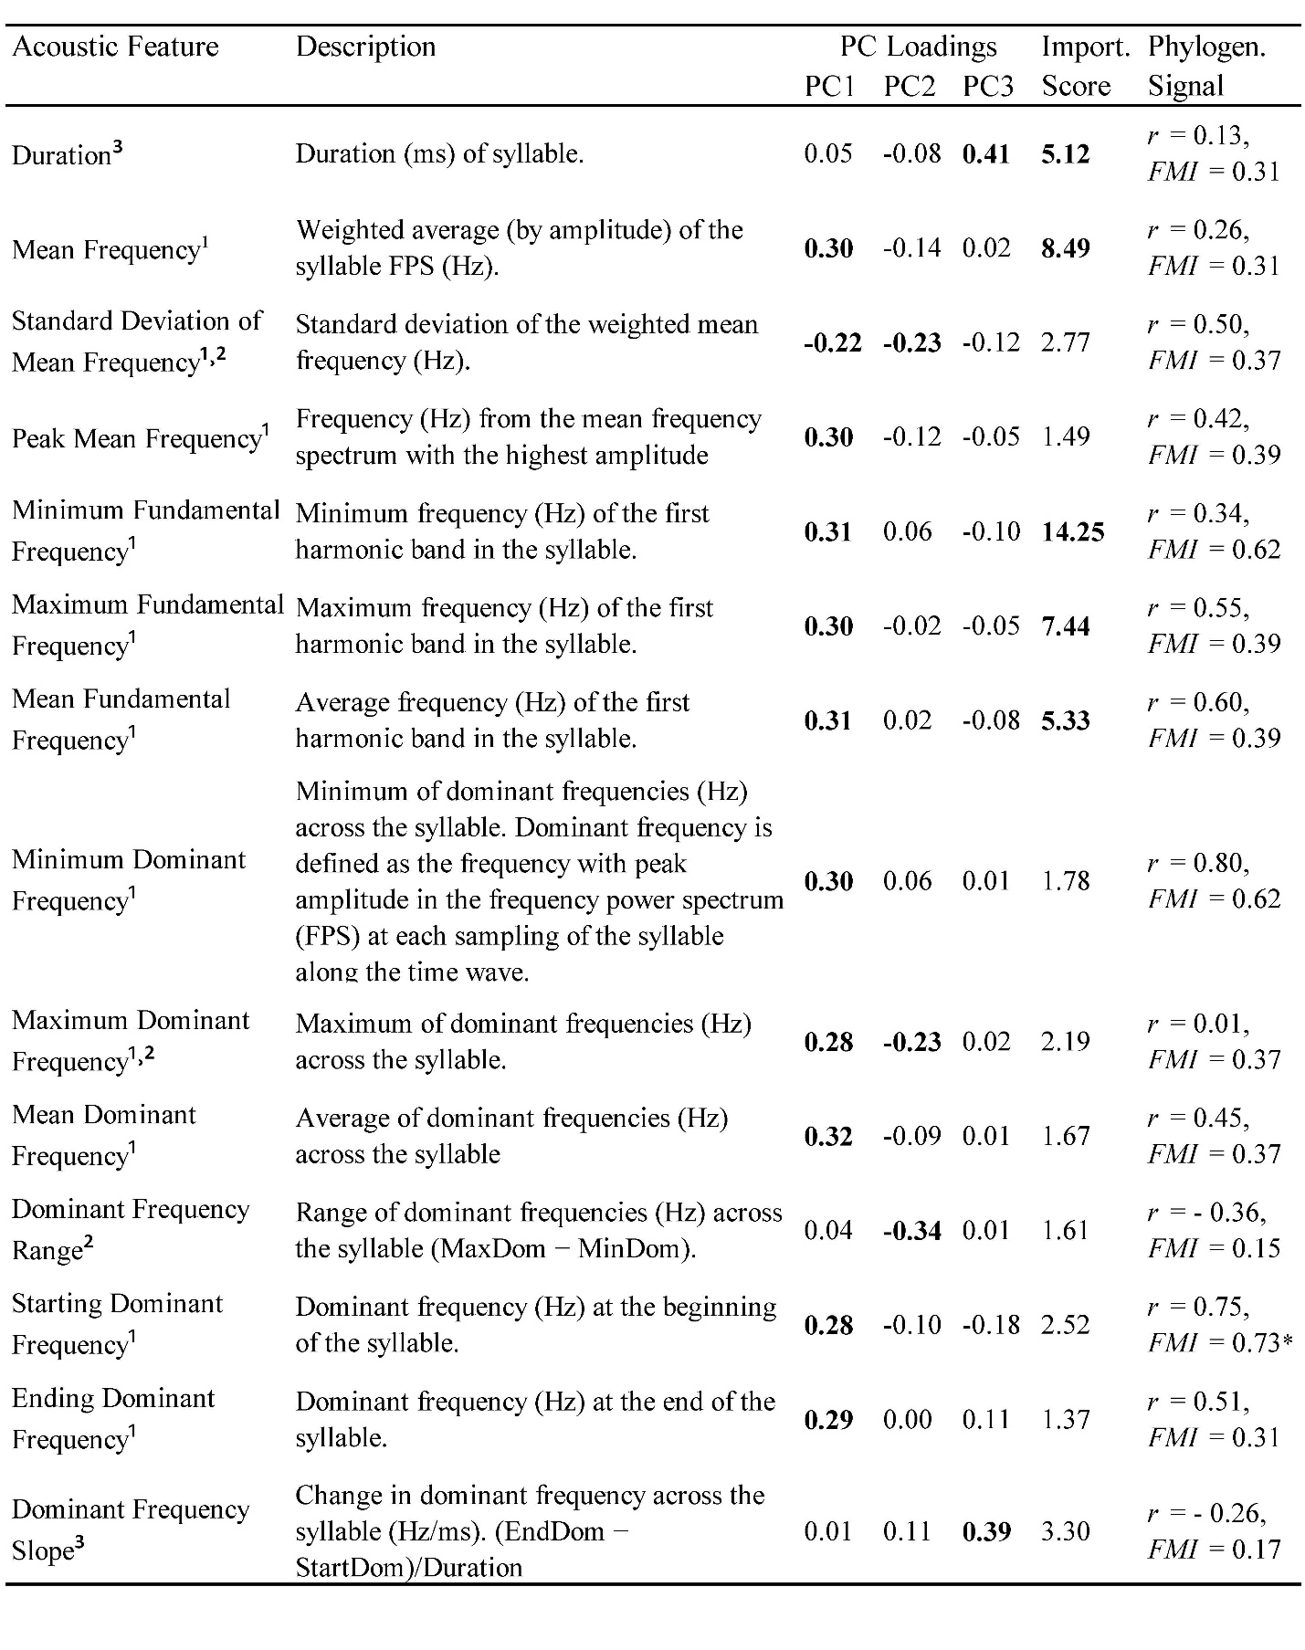
Supplementary Table S1. Features, descriptions, PC loadings, feature importance scores, EM-Mantel correlation coefficients (r), and Fowlkes-Mallows indices (FMI) for each of the 21 acoustic features measured from songs of the seven species.
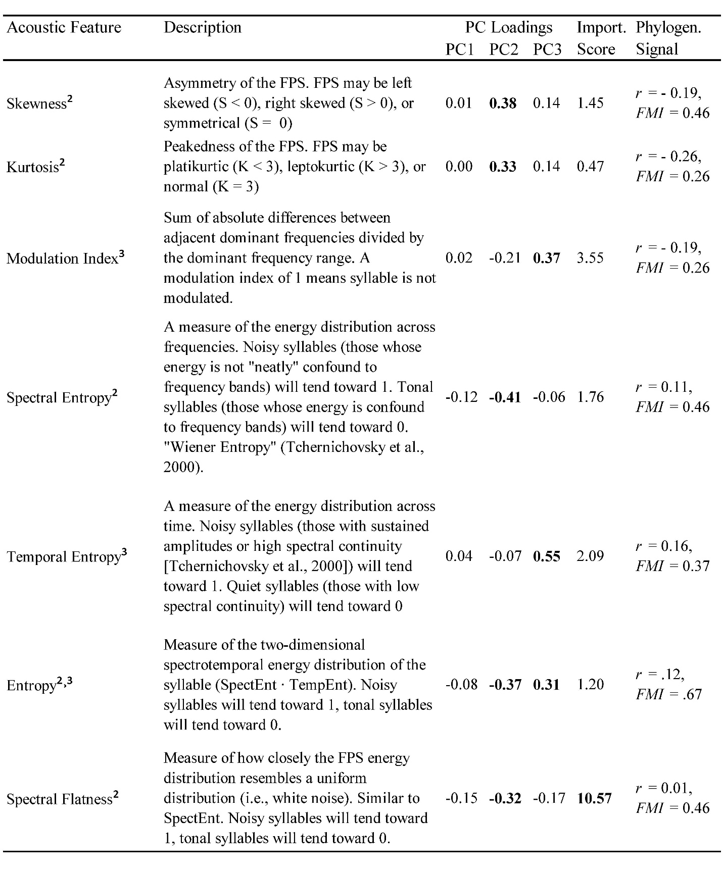
Superscripts denote features as spectral (¹), spectral shape (²), or spectrotemporal (³). Significant PC loadings (|Loading| > 0.218) and feature importance scores (i.e., first six rank-ordered scores) appear in bold. Significant phylogenetic measures following false discovery rate p-value correction for multiple testing denoted by asterisks at their corresponding alpha levels (* < 0.05, ** < 0.01, *** < 0.001).
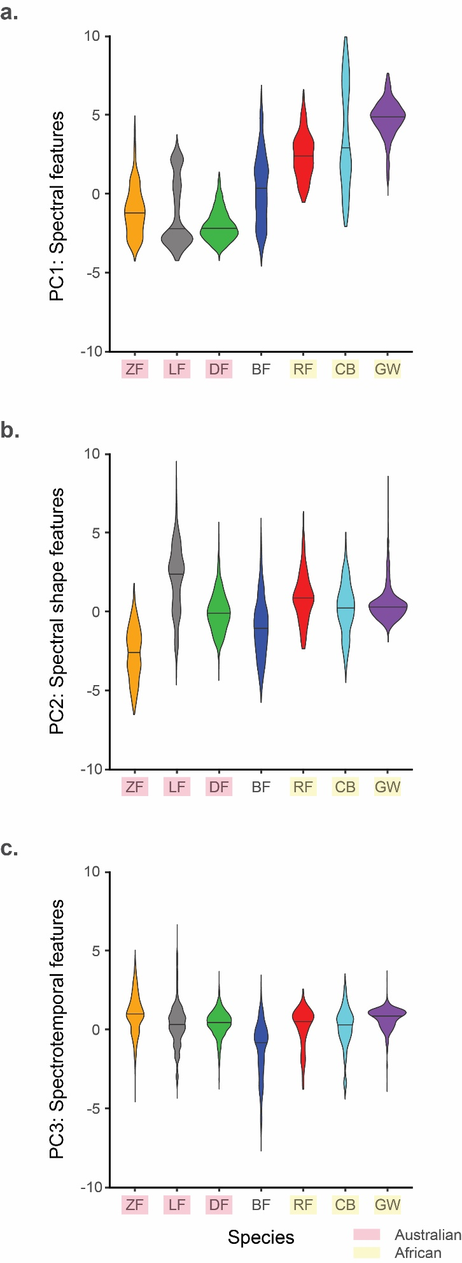
Supplementary Figure S1. Violin plots for species distributions along the 3 acoustic feature components. Horizontal line across each violin shows the distribution’s median value. (a) Spectral features clustered species according to their biogeographic clades: Australian species (ZF, LF, DF) have low spectral values, African species (RF, CB, GW) have high spectral values range, and the Southeast Asian species (BF) spans the range between both clades. (b) Spectral shape features do not cluster species according to biogeographic clades, on average: ZFs have the lowest values, consistent with the abundance of noisy (high entropy/spectral flatness), broadband harmonic syllables in their songs; LFs have the highest values, consistent with the abundance of low-harmonicity and low-noise (tonal) syllables in their song; all other species showed intermediate values (near PC2 = 0). (c) Spectrotemporal features do not cluster species according to biogeographic clades, on average: BFs had the lowest values, consistent with the abundance of very short durations and down-sweeping syllables in their songs; all other species showed similar values to each other.
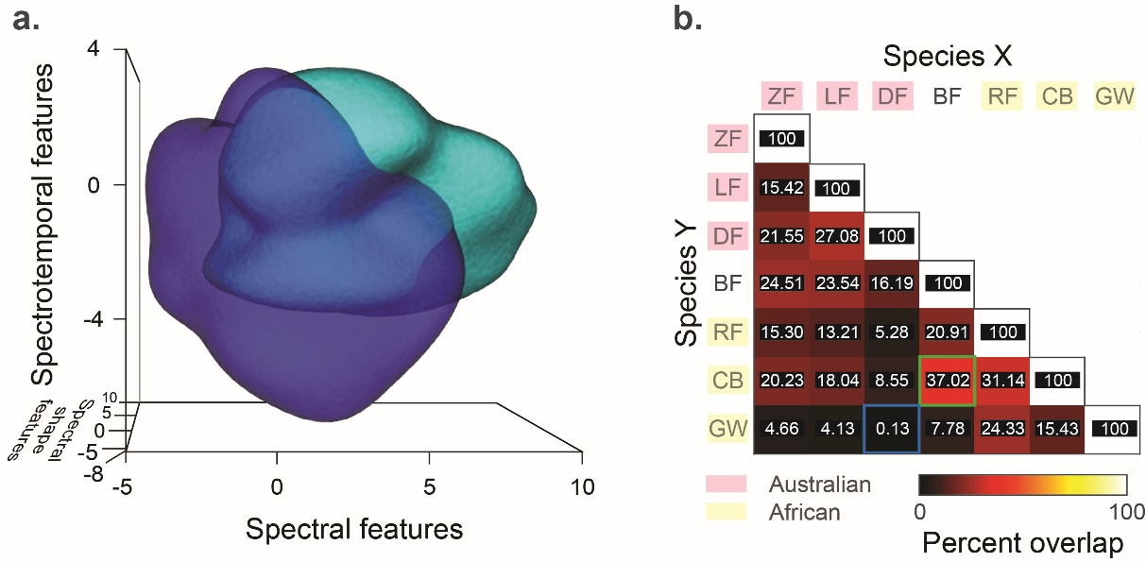
Supplementary Figure S2. Overlap of volumes in PC space differed in pairwise species comparisons. (a) The feature volumes of BF (blue) and CB (cyan) syllables show high overlap volume (> 37%). (b) Pair-wise Jaccard similarity indices between species. Jaccard similarity index provides a percentage of the total volume occupied by the two species that is shared between them. The highest overlap volume is between BF and CB (green square), while the lowest is between DF and GW (0.13%; blue square). High overlap between BF and CB is likely due to the moderate-to-high frequency harmonics and variable entropy in syllables – characteristics shared by both species. CB syllables tend to be higher in frequencies and have more upsweeps than BF syllables. Low overlap between DF and GW is due to the opposing characteristics of these songs. BF syllables are harmonic with relatively low fundamental frequencies and slower spectrotemporal modulations, while GW syllables are inharmonic, with have fundamental frequencies and faster spectrotemporal modulations.

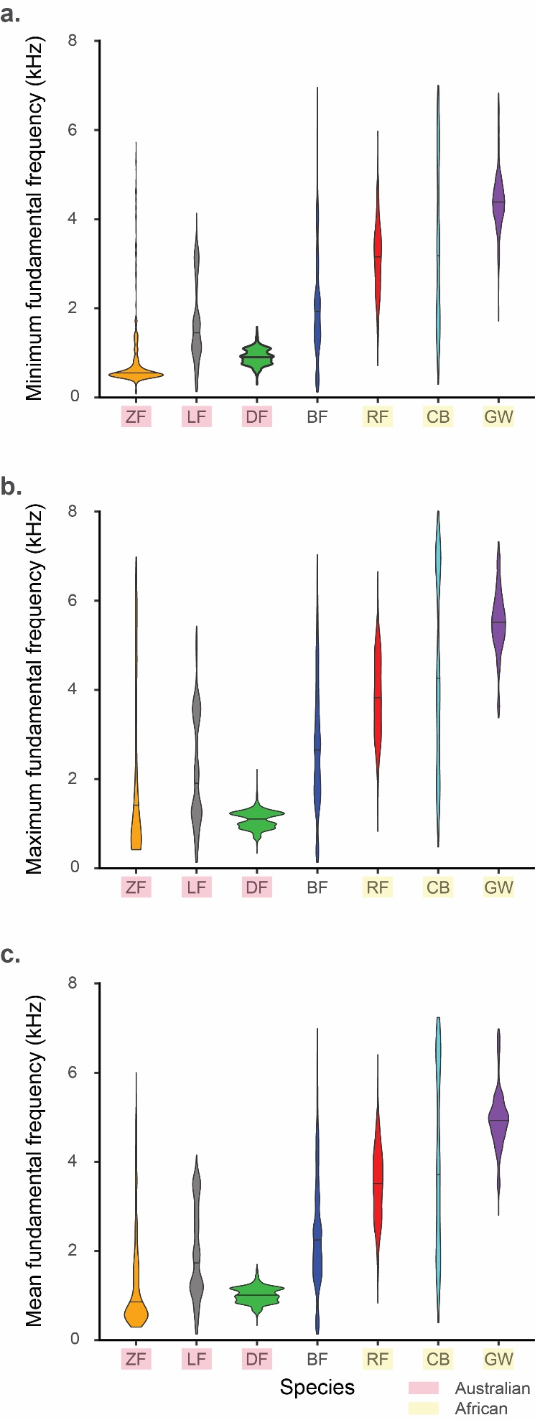
Supplementary Figure S3. Species distributions for syllable (a) minimum, (b) maximum, and (c) mean fundamental frequencies. Horizontal line across each violin shows the distribution’s median value. Overall, Australian species (ZF, LF, DF) have lower fundamental frequencies than African species (RF, CB, GW), and BF spans the range between these two clades.
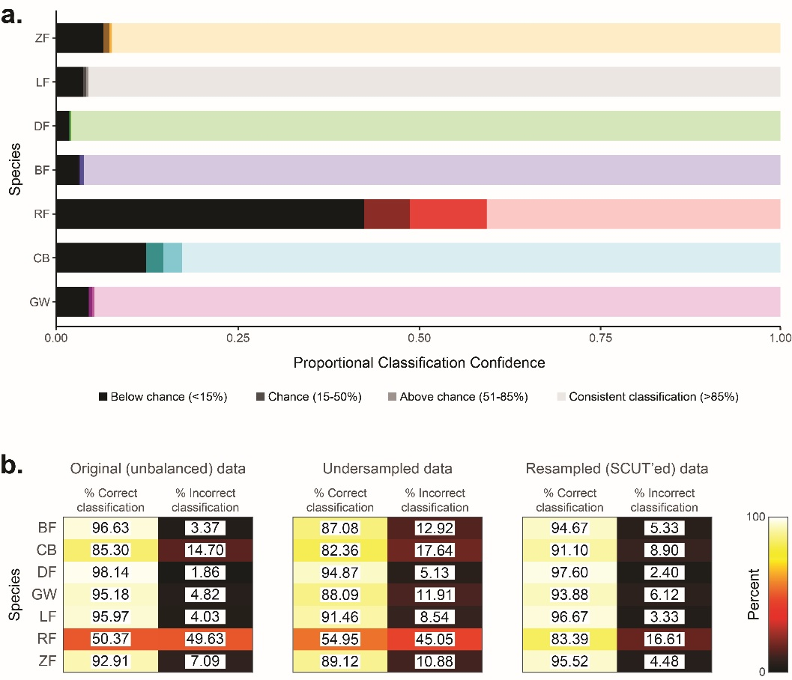
Supplementary Figure S4. Random forest model performance was robust across iterations and with unbalanced sample sizes. (a) Classification confidence for species syllables across 100 iterations of random forest in the 6-feature model. The percent of random forests that correctly classified each syllable across the 100 iterations represents the consistency with which syllables are correctly labelled. We calculated the proportion of syllables that were classified at four levels of confidence within each species: Below Chance (<15%), Chance (15-50%), Above Chance (51-85%), Consistent Classification (>85%). 15% represents the minimum majority needed to assign a species label assuming uniform probabilities (1/(no. species) = 1/7 = 14.29 < 15). 51% represents the minimum majority needed to assign a species label assuming dichotomous probability (i.e., 50% chance it will be correctly labelled, 50% chance it will not). 86% (i.e., >85%) represents the minimum majority needed to accept syllable labelling beyond significant consideration for any other single species (i.e., a syllable correctly labelled as belonging to species X 86% of the time could at most only be labelled as belonging to species Y 14% of the time, which is below our 15% threshold for chance). Overall, there was high consistency in the classification of syllables across random forest iterations, with RF classifications being the least consistent, followed by CB. (b) Percent correct and incorrect classifications for each species in the 6-feature model using the original (left), under-sampled (centered), and resampled (right) data sets. Classification decreased for all species except RFs, which showed an increase from 50% to 55%, using the under-sampled data set. Classification using the resampled dataset showed changes in species consistent with their resampling: over-sampled species (CB, RF, ZF) increased in classifications, while under-sampled species (BF, DF) decreased in classification. Changes in LF (0.7% increase) and GW (1.3% decrease) classifications inconsistent with their resampling are minor compared to considerable increases in classifications of CB (6% increase) and RF (33% increase) syllables. Overall, our results suggest that although the random forest model is robust against unbalanced sample sizes among species, species-wise classifications could be improved with greater sample sizes.

