- Supplementary materials and methods
1.1 Real-time quantitative reverse-transcription PCR (qRT-PCR)
Total RNA was isolated using TRIzol™ reagent (Invitrogen, CA, USA) and reverse-transcribed (10 µL) using the PrimeScript RT Reagent kit (TaKaRa, Tokyo, Japan). The real-time qRT-PCR experiments were performed using SYBR® Green Premix Ex Taq (TaKaRa, Tokyo, Japan), with β-Actin as internal control for normalization.
1.2 Oligonucleotide transfection
All targeting siRNAs or negative control siRNAs (siNCs) were synthesized by RiboBio (Guangzhou, China). Cells were seeded into six-well plates and grown for one night. At 40-50% confluence, cells were transfected with 5μl of siRNA or siNC (20 μM) using Lipofectamine RNAiMAX (Invitrogen, CA, USA). After 36h, cells were harvested for further experiments.
1.3 Lentivirus packaging and transduction
The lentivirus was produced by co-transfecting HEK-293T cells with the target vector, packaging plasmid (pAX2), and VSV-G envelope plasmid (pMD2.G) for 48h. Subsequent purification was performed by ultracentrifugation. Huh7 and MHCC-97H cells were plated in 10 mm² dishes and transduced with lentivirus. The stable cell lines were cultured with medium containing 2 μg/ml puromycin (Invitrogen, CA, USA).
1.4 Cell lines and functional experiments in vitro
HCC cell lines (Hep3B, SNU-449, Huh7 and PLC-PRF-5) and HEK293T were obtained from ATCC. MHCC-97H was kindly provided by Zhongshan Hospital Fudan University, Shanghai, China. All the cells were cultured in DMEM (Invitrogen, USA) with 10% FBS (Gibico, USA) under recommended culture conditions of 37 °C and 5% CO₂. Cell lines were periodically tested for mycoplasma via the qPCR analysis.
CCK-8, colony formation, transwell and wound healing assays were performed as previously described[1],[2].
1.5 In vivo assays for tumor formation
A total of 5×10⁶ Huh7 cells were suspended in 200μl serum-free DMEM and subcutaneously injected into the flank of each nude mouse (female BALB/c-nu/nu). The tumor sizes were measured twice a week and the tumor volumes were calculated: V (mm³) = width² (mm²) x length (mm)/2. The mice were euthanized after 3 weeks and the tumors were harvested for further analysis. All procedures were approved by the Animal Ethic Review Committee of FUSCC.
1.6 Western blotting
The collected cells or tissues were lysed with RIPA lysis buffer. The Nuclei EZ prep nuclei isolation kit was used for cytoplasmic and nuclear fractionation, (Sigma-Aldrich, Missouri, USA), according to the manufacturer’s Instructions. Protein concentration was measured using a BCA protein assay kit (Bio-Rad, CA, USA). The lysates were boiled for 10 minutes with Omni-Easy™ Protein Sample Loading Buffer (Epizyme, Shanghai, China). The western blotting was performed as previously described[3].
1.7 Immunofluorescence assays
Cells samples were fixed in 4% formaldehyde, incubated in 0.3% Triton X-100 and blocked in 5% FBS. The samples were incubated with primary antibodies at 4 °C overnight, followed by incubation with the appropriate secondary antibody (Invitrogen). The nuclei were counterstained with DAPI (Thermo Fisher Scientific, USA). The intensity of fluorescence was detected by confocal laser scanning microscopy (Olympus Corporation, Tokyo, Japan).
1.8 Chromatin immunoprecipitation (ChIP)
ChIP assays were performed as previously described[4], with a minor modification, in that cross-linked chromatin was sonicated to ~ 400 bp fragments using a Bioruptor. ChIP DNA was eluted using MinElute Spin Columns for qPCR examination.
1.9 Cleavage under targets and tagmentation (CUT&Tag)
CUT&Tag was performed according to the manufacturer's protocol (Novoprotein, China). Bowtie was used with standard alignment parameters to align 150-bp paired-end reads to the reference human genome for CUT&Tag analyses. The Picard "Mark Duplicates" utility was used to identify PCR duplicates and to omit them from further examination. deepTools was used to convert Bam files to BigWig files. Peaks were located using the Homer-annotated MACS2 peak caller. IGV was used to display the peak distribution of interest genes along genomic regions.
1.10 RNA-seq and Analysis
Total RNA was extracted from cells using TRIzol reagent (Invitrogen, USA) according to the manufacturer’s protocol. Using the Illumina HiSeq platform, paired-end sequencing was performed on the sequencing library after it had been created using the Illumina mRNA-seq sample preparation kit. Utilizing STAR, the paired-end reads were aligned to hg38. In order to use the UCSC Genome Browser or IGV for visualization, Bam files obtained from STAR were first converted into bedGraph format using BEDTools. In order to perform a differential expression analysis, normalized profiling data were obtained after calculating the raw levels of gene expression (raw read counts) with FeatureCounts. DEGs were identified as those with an absolute fold change ≥ 2.0 and t test FDR < 0.05.
1.11 Statistical analysis
Data analyses were performed using SPSS version 19.0 (IBM SPSS, Armonk, NY, USA), GraphPad Prism version 8.0 (GraphPad Software Inc., San Diego, CA, USA) and R project (https://www.rproject.org/). All data are expressed as the means ± standard deviations (SD). All statistical tests were two-tailed, and differences were considered statistically significant at P < 0.05.
1.12 Data availability
The mRNA expression profiles of 50 paired HCC tissues were downloaded from TCGA data portal (http://gdac.broadinstitute.org/). Public gene expression data ware retrieved from the GEO. A GEO dataset (Accession no: GSE77314) with data for 50 paired samples from Chinese HCC patients was used for the analysis of NSF expression. Other data supporting the finding of the current study are listed in NCBI Gene Expression Omnibus (Accession no: GSE184797).

- Supplementary Figures
Supplementary Fig. S1
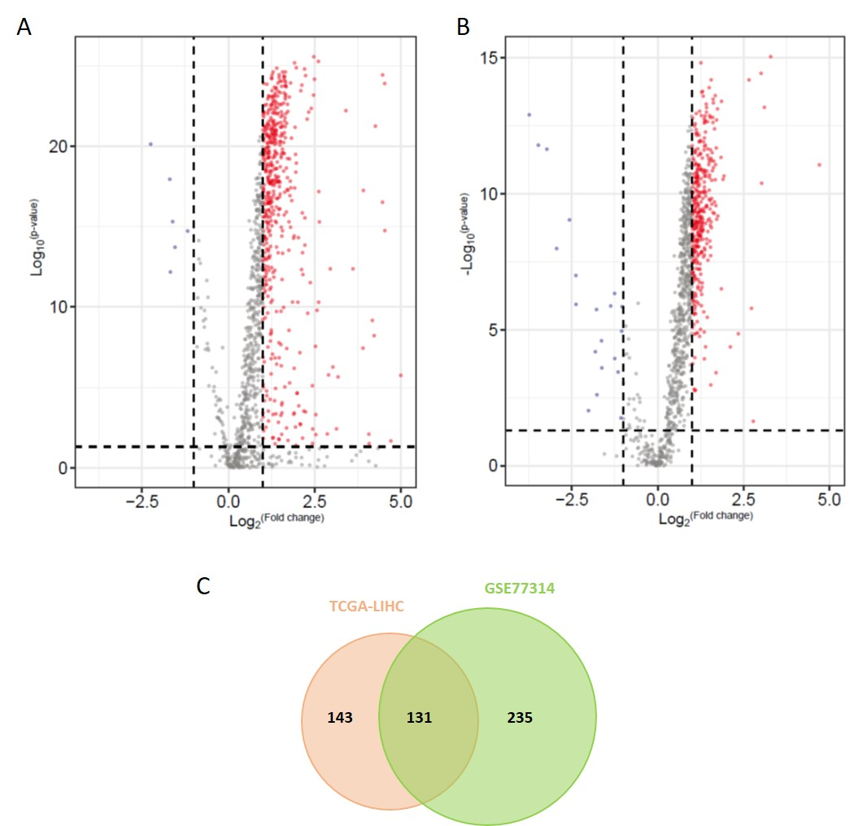
Fig. S1 Expression of IT-associated genes in hepatocellular carcinoma (HCC). A, Volcano plot showing the differentially expressed IT-associated genes in HCC compared with adjacent tissues from TCGA-LIHC cohort. The cut-off was |Log₂(fold change)|≥1 and P value <0.01. B, Volcano plot showing the differentially expressed IT-associated genes in 50 paired HCC-adjacent normal tissues from GSE77314. The cut-off was |Log₂(fold change)|≥1 and P value <0.01. C, Venn diagram showing the overlapping differentially expressed genes between A and B.

Supplementary Fig. S2
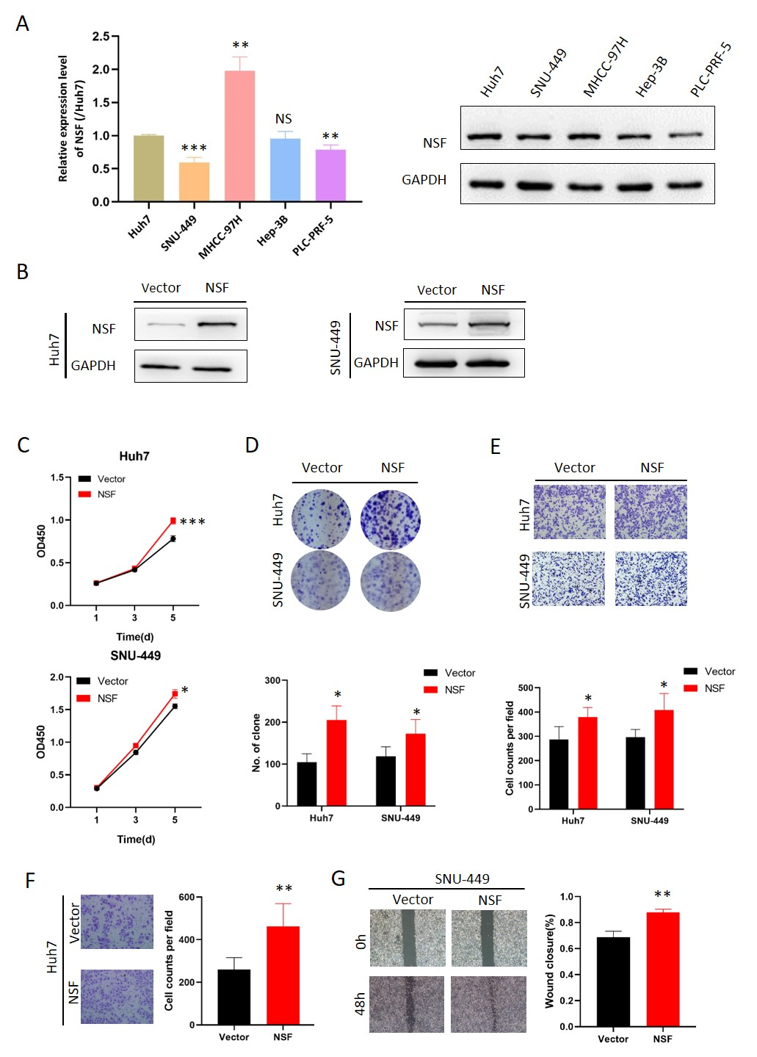
Fig. S2 NSF promotes tumor proliferation and metastasis in vitro. A, The mRNA and protein levels of NSF in five HCC cell lines were determined by qRT-PCR and Western blotting. B, Ectopic expression of NSF in Huh7 and SNU-449 cells was confirmed by Western blotting. C, CCK-8 assays of the Huh7 and SNU-449 cells with stable NSF overexpression. D, Ectopic expression of NSF in Huh7 and SNU-449 cells promoted colony formation. E, Transwell invasion assays of Huh7 and SNU-449 cells with NSF overexpression. F, Transwell migration assays of Huh7 with NSF overexpression. G, Wound healing assay showed the effect of NSF overexpression on SNU-449 cell metastasis. NS: Not significant, *P < 0.05, **P < 0.01, ***P < 0.001 by two-tailed Student’s t-test.

Supplementary Fig. S3
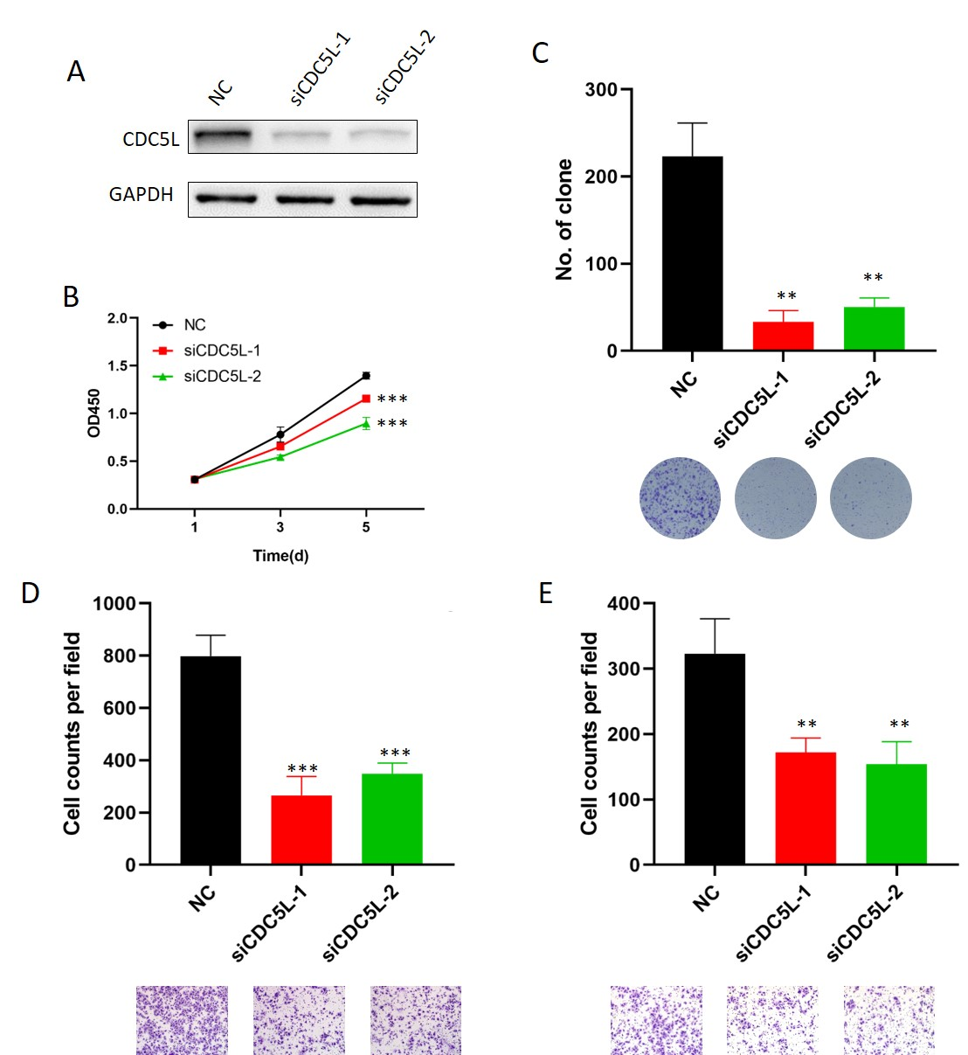
Fig. S3 CDC5L is required for HCC cell proliferation and metastasis. A, Following CDC5L knockdown in Huh7 cells, CDC5L expression was detected by Western blotting. GAPDH was used as a loading control. B, CCK-8 assays were performed to monitor cell proliferation after CDC5L knockdown in Huh7 cells. C, The tumorigenic potential of Huh7 cells after CDC5L knockdown was assessed by colony formation assays. Colony quantification result is also presented. D-E, Transwell migration (D) and invasion (E) assays of Huh7 cells with CDC5L knockdown. **P < 0.01, ***P < 0.001 by two-tailed Student’s t-test.

- Supplementary Table
Supplementary Table S1. Association between NSF expression and clinicopathological variables of 123 HCC patients.
 | High NSF expression | Low NSF expression | P value
Variables | n(%) | n(%)
Gender |  |  | 0.580
male | 24(50.0) | 42(56.0)
female | 24(50.0) | 33(44.0)
Age(years) |  |  | 0.584
≤60 | 25(52.1) | 35(46.7)
>60 | 23(47.9) | 40(53.3)
HBV |  |  | 1.000
negative | 11(22.9) | 18(24.0)
positive | 37(77.1) | 57(76.0)
Cirrhosis |  |  | 0.668
no | 13（27.1） | 17（22.7）
yes | 35（72.9） | 58（77.3）
AFP(ng/ml) |  |  | 0.099
<20 | 9（18.8） | 25（33.3）
≥20 | 39（81.3） | 50（66.7）
Tumor number |  |  | 0.535
single | 42（87.5） | 69（92.0）
multiple | 6（12.5） | 6（8.0）
Tumor size(cm) |  |  | 0.017
≤5 | 16（33.3） | 42（56.0）
＞5cm | 32（66.7） | 33（44.0）
Tumor capsule |  |  | 0.046
Complete | 6（12.5） | 22（29.3）
Incomplete | 42（87.5） | 53（70.7）
Microvascular invasion |  |  | 0.441
no | 29（60.4） | 51（68.0）
yes | 19（39.6） | 24（32.0）
TNM stage |  |  | 0.011
I | 9（18.8） | 31（41.3）
II/III | 39（81.3） | 44（58.7）
Histological grade |  |  | 0.043
I/II | 9(18.8) | 28(37.3)
III/IV | 39(81.3) | 47(62.7)

Supplementary Table S2. Univariate and multivariate analysis of factors associated with overall survival in FUSCC cohort.
 | Univariate analysis |  |  | Multivariate analysis
Clinical variables* | HR[95%CI] | P value |  | HR[95%CI] | P value
Gender  (male vs female) | 0.871[0.570-1.333] | 0.526
Age  (≤60 vs >60years) | 1.001[0.656-1.528] | 0.996
HBV  (positive vs negative) | 1.100[0.664-1.824] | 0.711
Cirrhosis  (no vs yes) | 0.809[0.494-1.325] | 0.399
AFP  (<20 vs ≥20ng/ml) | 0.653[0.392-1.087] | 0.101
Tumor number  (1 vs >1) | 0.563[0.298-1.064] | 0.077
Tumor size  (≤5 vs >5cm) | 0.665[0.432-1.024] | 0.064
Tumor capsule  (yes vs no) | 0.964[0.587-1.527] | 0.821
Microvascular invasion  (no vs yes) | 0.659[0.419-1.037] | 0.072
TNM stage  (I vs II/III) | 0.543[0.338-0.872] | 0.011
Histological grade  (I/II vs III/IV) | 0.422[0.255-0.697] | 0.001 |  | 0.473[0.284-0.788] | 0.004
NSF expression  (high vs low) | 2.250[1.451-3.490] | <0.001 |  | 1.988[1.275-3.102] | 0.002
*Clinical variables were analyzed by Cox proportional hazards regression model. All the clinical variables might be associated with overall survival in univariate analysis with 0.05 level were included into the multivariate Cox regression model.

Supplementary Table S3. 17 Potential interacting proteins.
Accession | Gene Name | -10lgP | Unique Peptide(s) | #Spec IP-NSF | #Spec IP-IgG
Q09666 | AHNAK | 309.68 | 97 | 122 | 0
Q9UEY8 | ADD3 | 296.22 | 44 | 98 | 0
P48634 | PRRC2A | 231.93 | 36 | 41 | 0
O43823 | AKAP8 | 212.73 | 20 | 30 | 0
Q99459 | CDC5L | 186.62 | 22 | 24 | 0
Q96JB3 | HIC2 | 213.65 | 18 | 23 | 0
Q01780 | EXOSC10 | 168.9 | 17 | 20 | 0
P54920 | NAPA | 189.58 | 13 | 19 | 0
P62701 | RPS4X | 157.62 | 13 | 15 | 0
P49792 | RANBP2 | 121.48 | 14 | 15 | 0
P02679 | FGG | 166.35 | 10 | 14 | 0
P46087 | NOP2 | 159.96 | 13 | 14 | 0
Q9NVP1 | DDX18 | 126.48 | 10 | 11 | 0
Q99747 | NAPG | 149.99 | 8 | 10 | 0
Q12849 | GRSF1 | 129.7 | 9 | 10 | 0
Q99570 | PIK3R4 | 120.5 | 10 | 10 | 0
P42285 | SKIV2L2 | 115.12 | 10 | 10 | 0

Supplementary Table S4. Sequences of qPCR primers
Identifier | Forward Primer (5'-3') |  | Reverse Primer (5'-3')
β-actin |  | TTGTTACAGGAAGTCCCTTGCC | ATGCTATCACCTCCCCTGTGTG
NSF |  | CCCCCAGGTTGTGGTAAGAC | ACTGTTAGCACCAAGCCTCC
CDC5L |  | CTTCCTGCCCCTCAGATTTCA | AAGAGCAACGCTGTTGTTGG
CACUL1 |  | ACATGGGTCGGATTTTCCCC | AGCAGCTGGTGACAGACATC
Myco-qPCR1 |  | GTGCTGGATATCCCGGGCTAAGC | AGGCGAACCGTTCACTCCCC
Chr-CACUL1 |  | CAGTCCACAGCTACTGCCAA | CGCGTTCGCAATCTGGTTAC

Supplementary Table S5. Sequences of siRNAs used in this study
Identifier | Sequences (5'-3')
siNSF-1 | GGATAGGAATCAAGAAGTT
siNSF-2 | GATCCTGAATACCGTGTGA
siCDC5L-1 | CAGCGCGGCCTGATCCAATTGATAT
siCDC5L-2 | CAATGCTTCATTATGACCTTCTACA
Nonsense | AGAAGAGGGGAUCCACAUGTT

Supplementary Table S6. Sequences of primers used in this study
Identifier | Sequences (5'-3')
NSF_F | AGCGAATTCGCCACCATGGCGGG
NSF_R | GATTTTGATTGAATTTAAATCGG
CDC5L_F | ATGCCTCGAATTATGATCAA
CDC5L_R | TCAGAATTTTGACTTTAAAG
HA-NSF-FL_F | CAGATTACGCTAGCCCGGGCGGATCCATGGCGGGCCGGAGCATGCAA
HA-NSF-FL_R | AGAGATCTGTCGACGATATCGAATTCTCAATCAAAATCAAGGGGGC
HA-NSF-1#_F | CAGATTACGCTAGCCCGGGCGGATCCATGGCGGGCCGGAGCATGCAA
HA-NSF-1#_R | AGAGATCTGTCGACGATATCGAATTCTCAGGTTTTAGCTTTGCCAA
HA-NSF-2#_F | CAGATTACGCTAGCCCGGGCGGATCCATGAAGGAAAATCGCCAATC
HA-NSF-2#_R | AGAGATCTGTCGACGATATCGAATTCTCAGTTCTTAGTCTGCTGCAC
HA-NSF-3#_F | CAGATTACGCTAGCCCGGGCGGATCCATGAGTGACCGCACACCATTG
HA-NSF-3#_R | AGAGATCTGTCGACGATATCGAATTCTCAATCAAAATCAAGGGGGC
FLAG-CDC5L-FL_F | ACGACGATAAGAGCCCGGGCGGATCCATGCCTCGAATTATGATCAAGGGG
FLAG-CDC5L-FL_R | AGAGATCTGTCGACGATATCGAATTCTCAGAATTTTGACTTTAAAG
FLAG-CDC5L-1#_F | ACGACGATAAGAGCCCGGGCGGATCCATGCCTCGAATTATGATCAAGGGG
FLAG-CDC5L-1#_R | AGAGATCTGTCGACGATATCGAATTCTCATTGTCGCTGTGGAGTTAC
FLAG-CDC5L-2#_F | ACGACGATAAGAGCCCGGGCGGATCCATGGTTGTACAGACTCCAAAC
FLAG-CDC5L-2#_R | AGAGATCTGTCGACGATATCGAATTCTCAGAATTTTGACTTTAAAG
CACUL1_F | ATGGAGGAAAGCATGGAAGA
CACUL1_R | TCAATACATTCACTATCTGTACCC
promoter-CACUL1_F | TTTCTCTATCGATAGTGGGTTGCTGGCCTTAGT
promoter-CACUL1_R | AGTACCGGAATGCCACCCTCCTCCTCTTCCATG
shNSF_F1 | CACCGGATAGGAATCAAGAAGTTTTCAAGAGAAACTTCTTGATTCCTATCCTTTTTT
shNSF_R1 | AAACAAAAAAGGATAGGAATCAAGAAGTTTCTCTTGAAAACTTCTTGATTCCTATCC
shNSF_F2 | CACCGCCGCAAGCTTCTTATCATTTCAAGAGAATGATAAGAAGCTTGCGGCTTTTTT
shNSF_R2 | AAACAAAAAAGCCGCAAGCTTCTTATCATTCTCTTGAAATGATAAGAAGCTTGCGGC

Supplementary Table S7. Antibodies used in this study
Identifier | Catalog Number | Company
GAPDH | 97166 | CST
LaminA/C | 10298-1-AP | Proteintech
NSF | 21172-1-AP | Proteintech
CACUL1 | 26321-1-AP | Proteintech
CDC5L | ab129114 | Abcam
Goat anti-Mouse IgG (H+L), HRP conjugate | SA00001-1 | Proteintech
Goat anti-Rabbit IgG (H+L), HRP conjugate | SA00001-2 | Proteintech
Flag Tag | F1804 | Sigma-aldrich
HA Tag | 51064-2-AP | Proteintech
IgG | I5381 | Sigma-aldrich
TGN46 | ET1702-56 | HUABio
STX6 | 2869 | CST

Reference:
1. Seneviratne AK, Xu M, Aristizabal Henao JJ, Fajardo VA, Hao Z, Voisin V, et al. The Mitochondrial Transacylase, Tafazzin, Regulates AML Stemness by Modulating Intracellular Levels of Phospholipids. Cell Stem Cell. 2019;24(6):1007.
2. Chen J, Rajasekaran M, Xia H, Zhang X, Kong SN, Sekar K, et al. The microtubule-associated protein PRC1 promotes early recurrence of hepatocellular carcinoma in association with the Wnt/beta-catenin signalling pathway. Gut. 2016;65(9):1522-1534.
3. Flanagan DJ, Barker N, Costanzo NSD, Mason EA, Gurney A, Meniel VS, et al. Frizzled-7 Is Required for Wnt Signaling in Gastric Tumors with and Without Apc Mutations. Cancer Res. 2019;79(5):970-981.
4. Drobic B, Perez-Cadahia B, Yu J, Kung SK, Davie JR. Promoter chromatin remodeling of immediate-early genes is mediated through H3 phosphorylation at either serine 28 or 10 by the MSK1 multi-protein complex. Nucleic Acids Res. 2010;38(10):3196-3208.

