High-Performance PE/Graphene Composites with Improved Atomic Oxygen Resistance via Synergistic Effect of Graphene Defects and Structure

Wensheng Gao ^{a*}, Wenjie Wang ª, Yi Li^{b*}, Min Xu*, Kefeng Xie ^{c*}

ªKey Laboratory of advanced catalysis, Gansu Province, State Key Laboratory of Applied Organic Chemistry, College of Chemistry and Chemical Engineering, Lanzhou University, Lanzhou, Gansu 730000, China
^{b}Science and Technology on Vacuum Technology and Physics Laboratory, Lanzhou Institute of Physics, China Academy of Space Technology, Lanzhou 730000, China
^{c}School of Chemistry and Chemical Engineering, Lanzhou Jiaotong University, Lanzhou, 730070, China

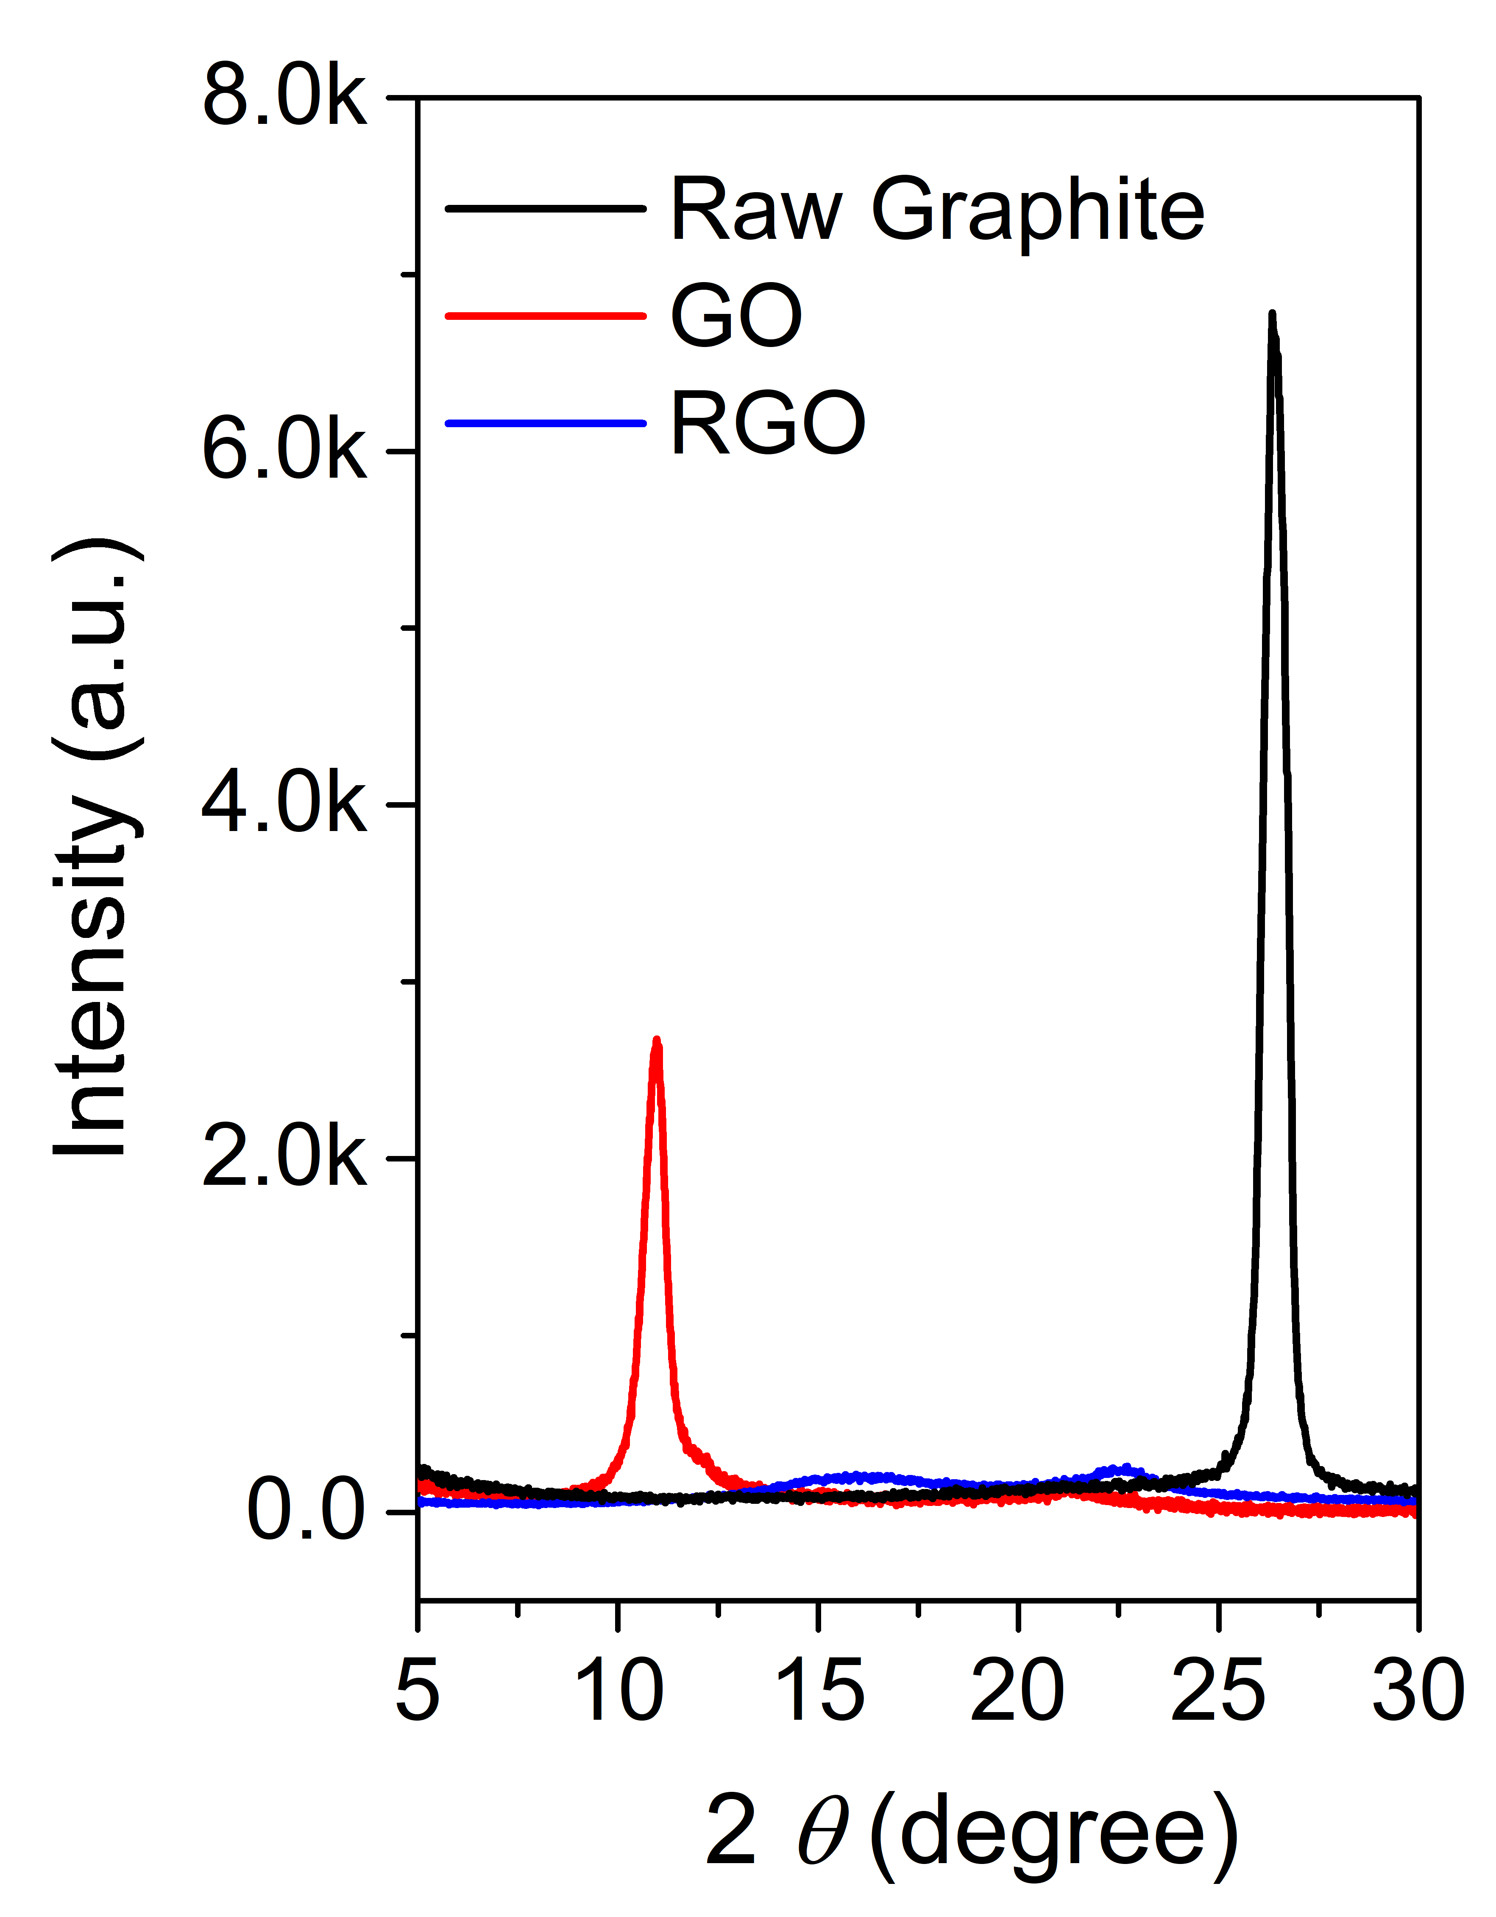
Figure S1 The XRD patterns of the raw graphite, precursor GO and RGO. The graphite displays the typical peak at 26.5°, which belongs to the (002) plane of the graphite as a plane distance of 0.34 nm. After oxidized into precursor GO, the diffraction peak of the (002) plane moves to 10.7° ascribed to the crystal plane expansion due to oxide intercalation. After the precursor GO was further exfoliated into RGO by low-temperature thermal expansion, the peak obviously gets weakened and moves to 22° (close to 26.5°), demonstrating the successful synthesis of the highly exfoliated RGO.

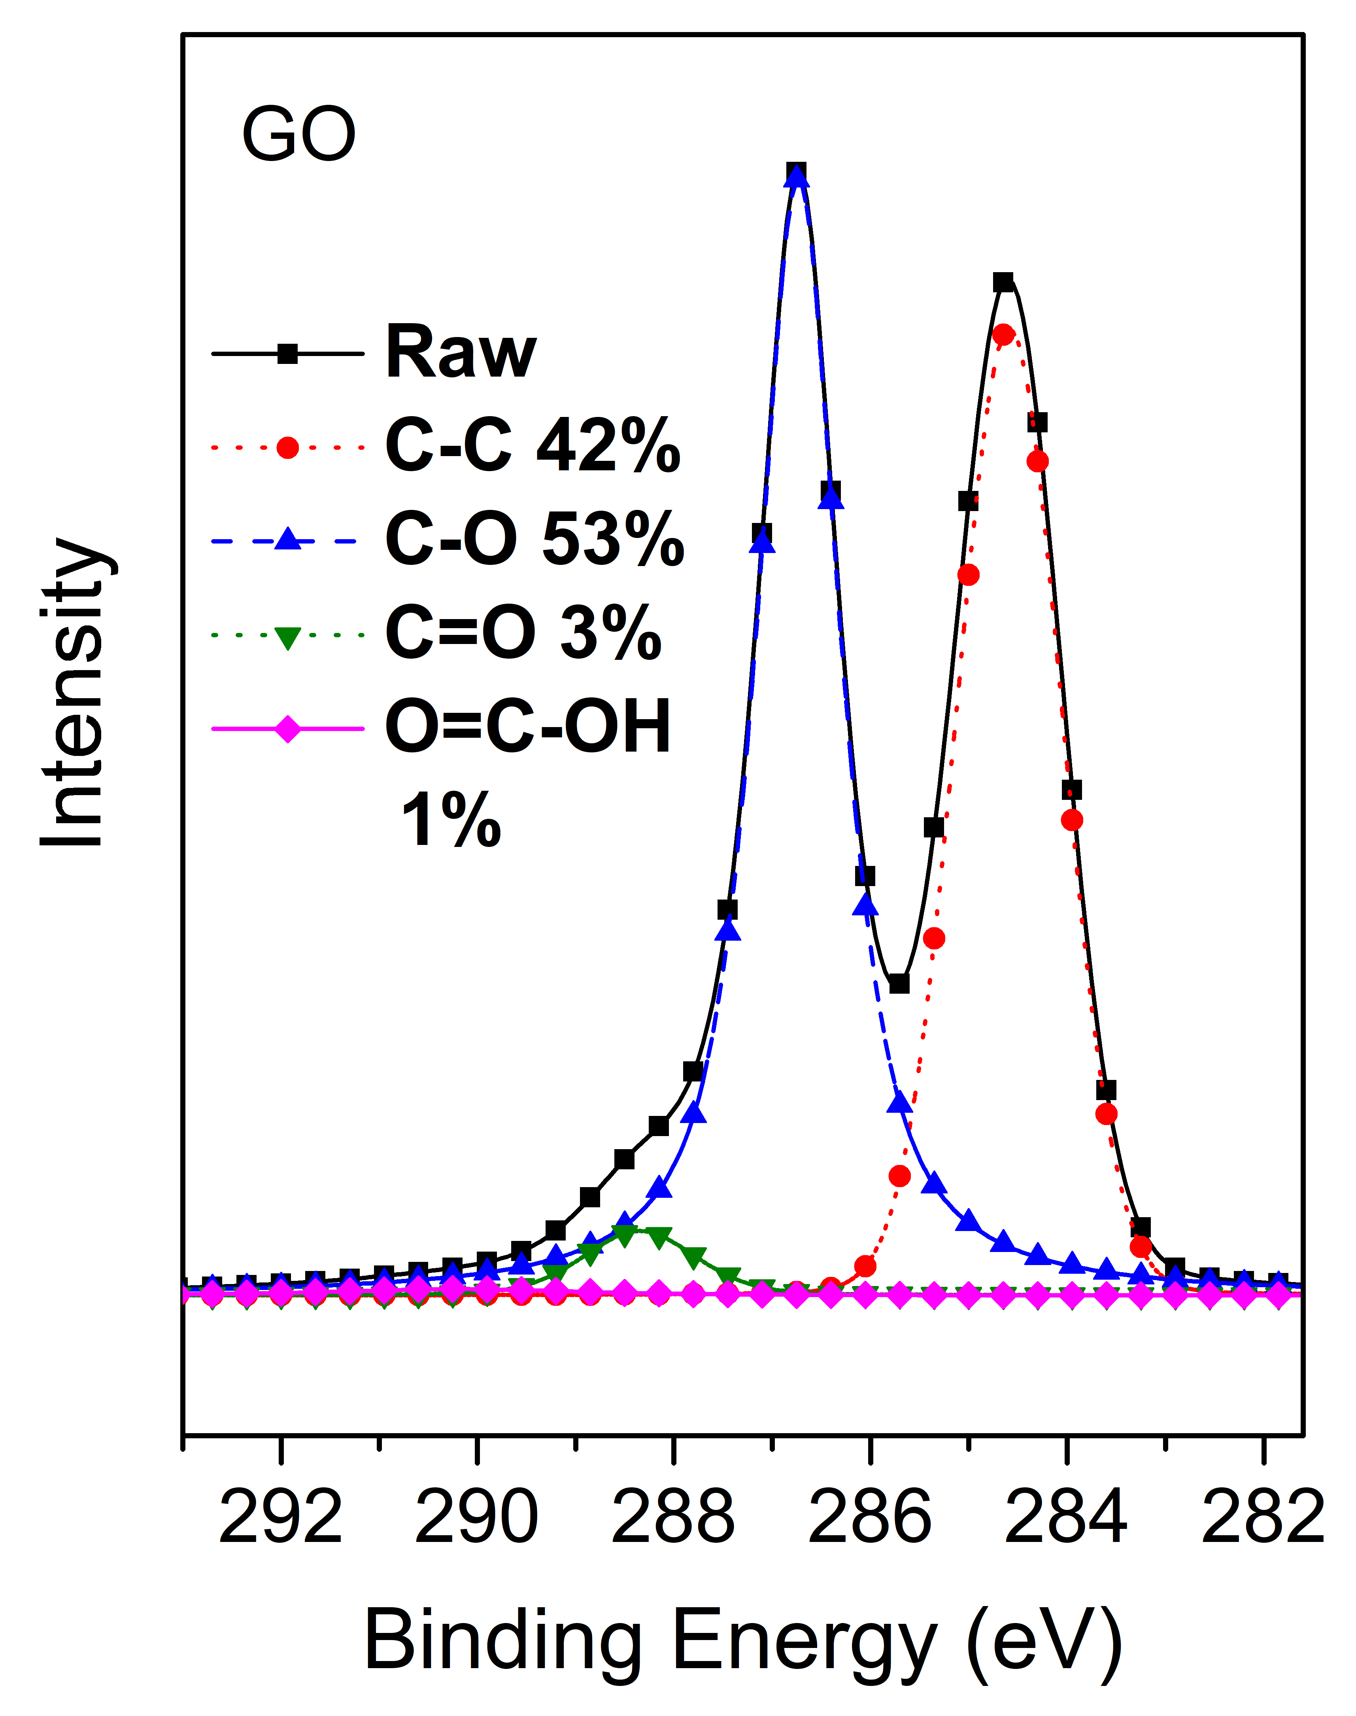
Figure S2 The XPS C1s fine spectrum of the GO. When graphite was oxidized into precursor GO, the graphite SP₂ C was oxidized into the C-O and C=O, C=O-OH.
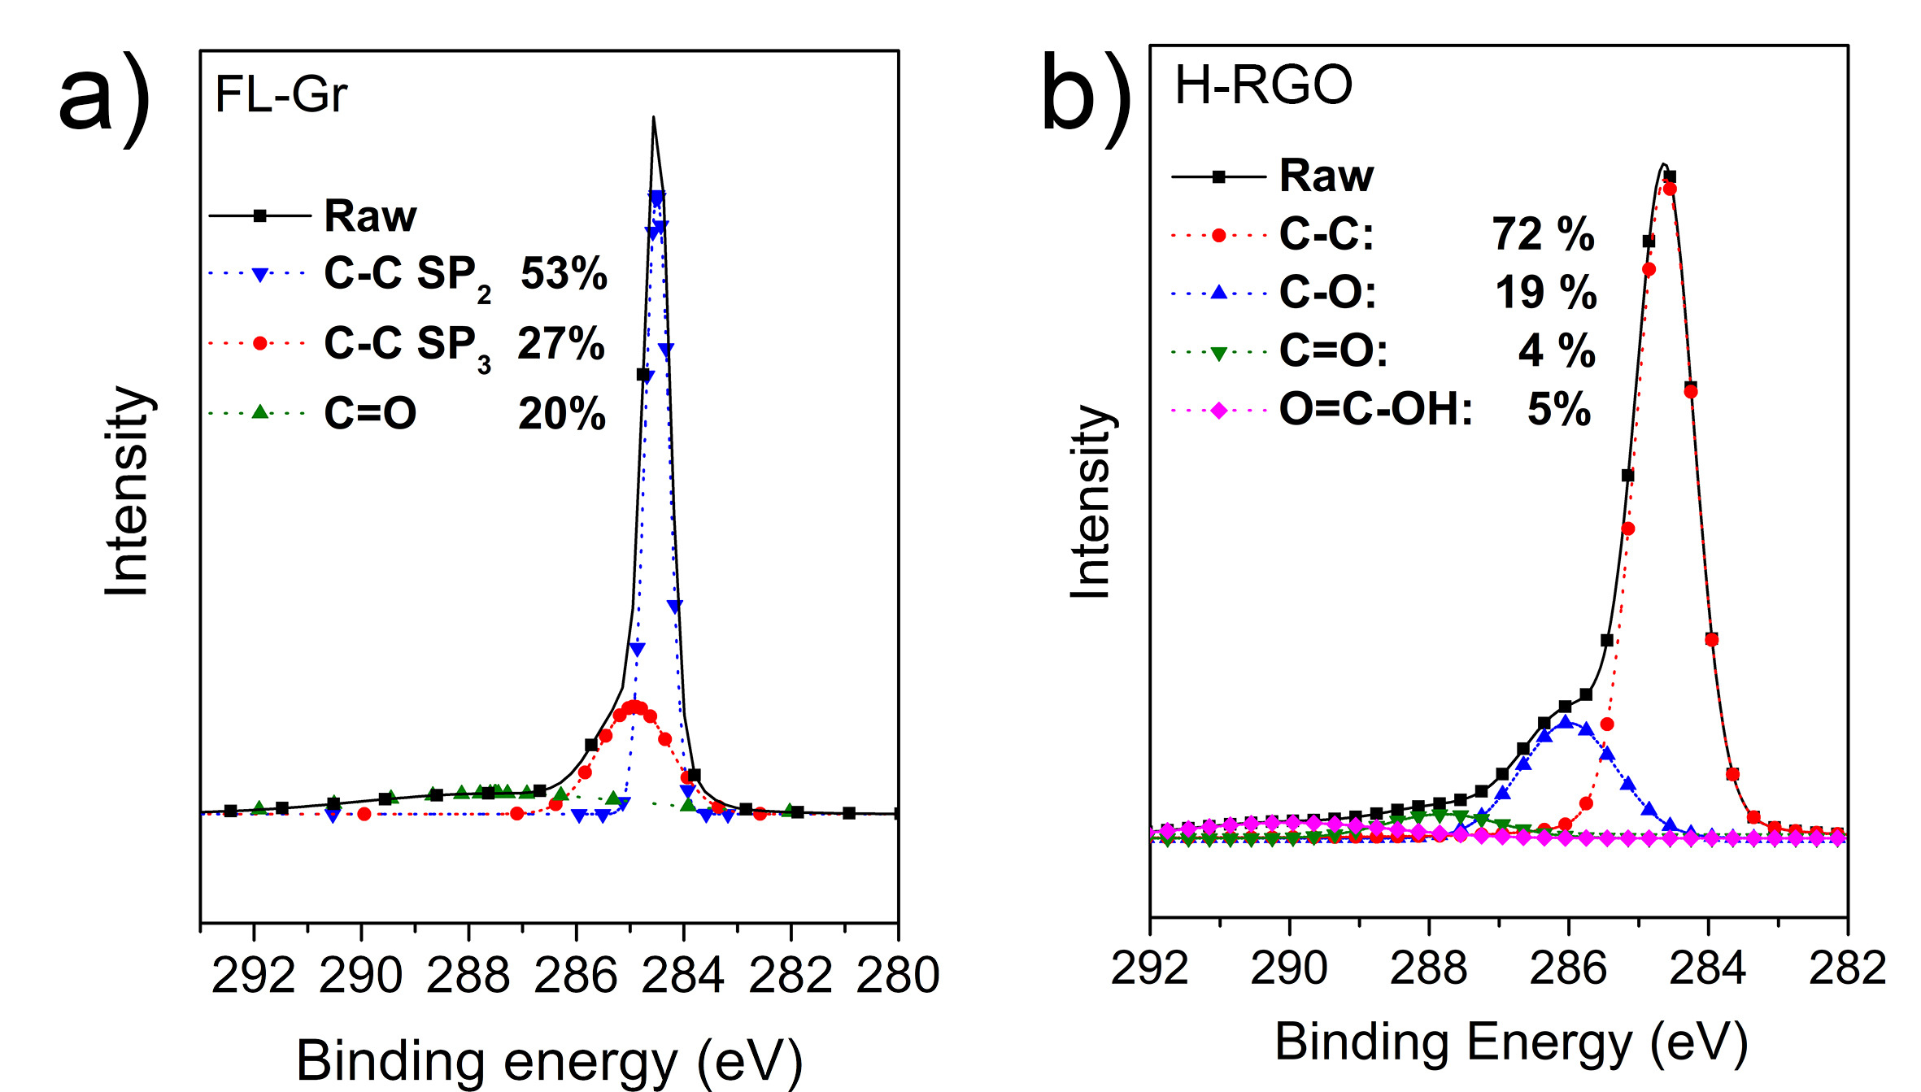 Figure S3 The XPS C1s fine spectrum of the FL-Gr and A-RGO. Compared with GO (Figure S2), the FL-Gr has little oxidation degree. After the precursor GO was further exfoliated into RGO by low-temperature thermal expansion, the fitting C-O peak obviously weakened, demonstrating the successful reduction for the GO.

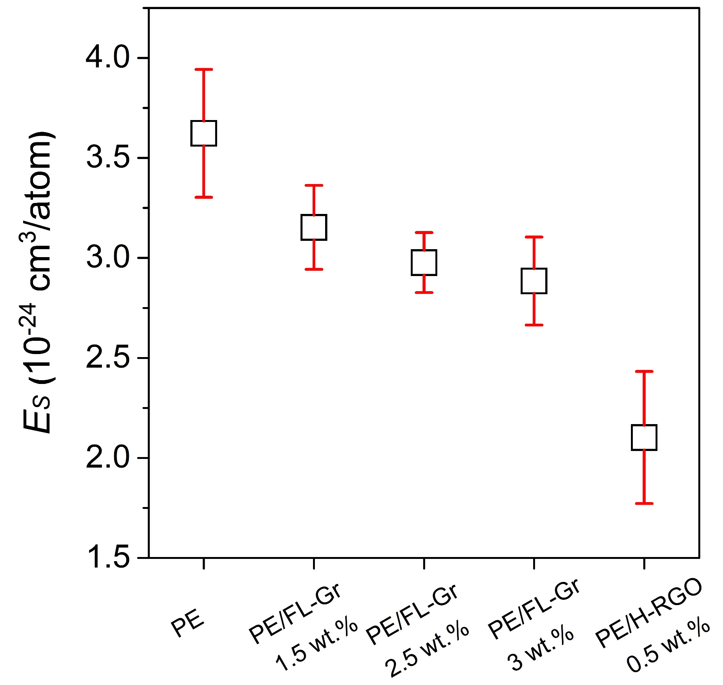
Figure S4 The AO erosion yield of the PE, PE/FL-Gr and PE/H-RGO composites under the expoure flux of 5.8×10²⁰ O-atoms/cm².

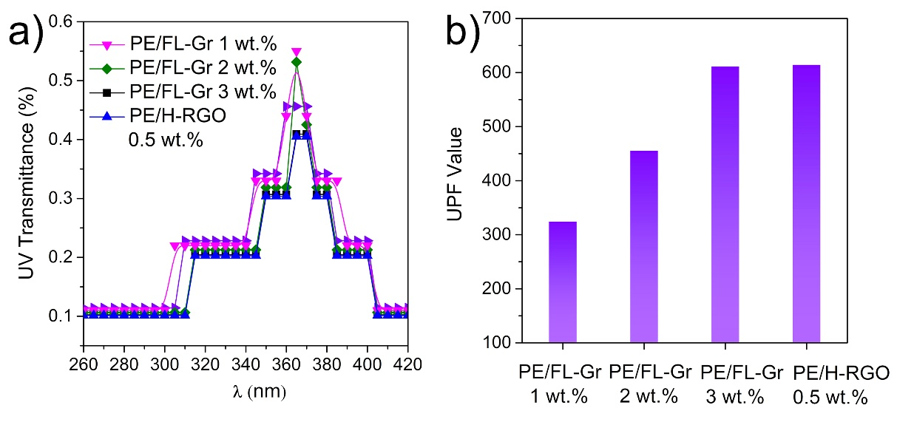
Figure S5 UV transmittance spectra and the calculated UPF value of the PE/RGO nanocomposite of the PE/FL-Gr with different loading and PE/RGO nanocomposites.
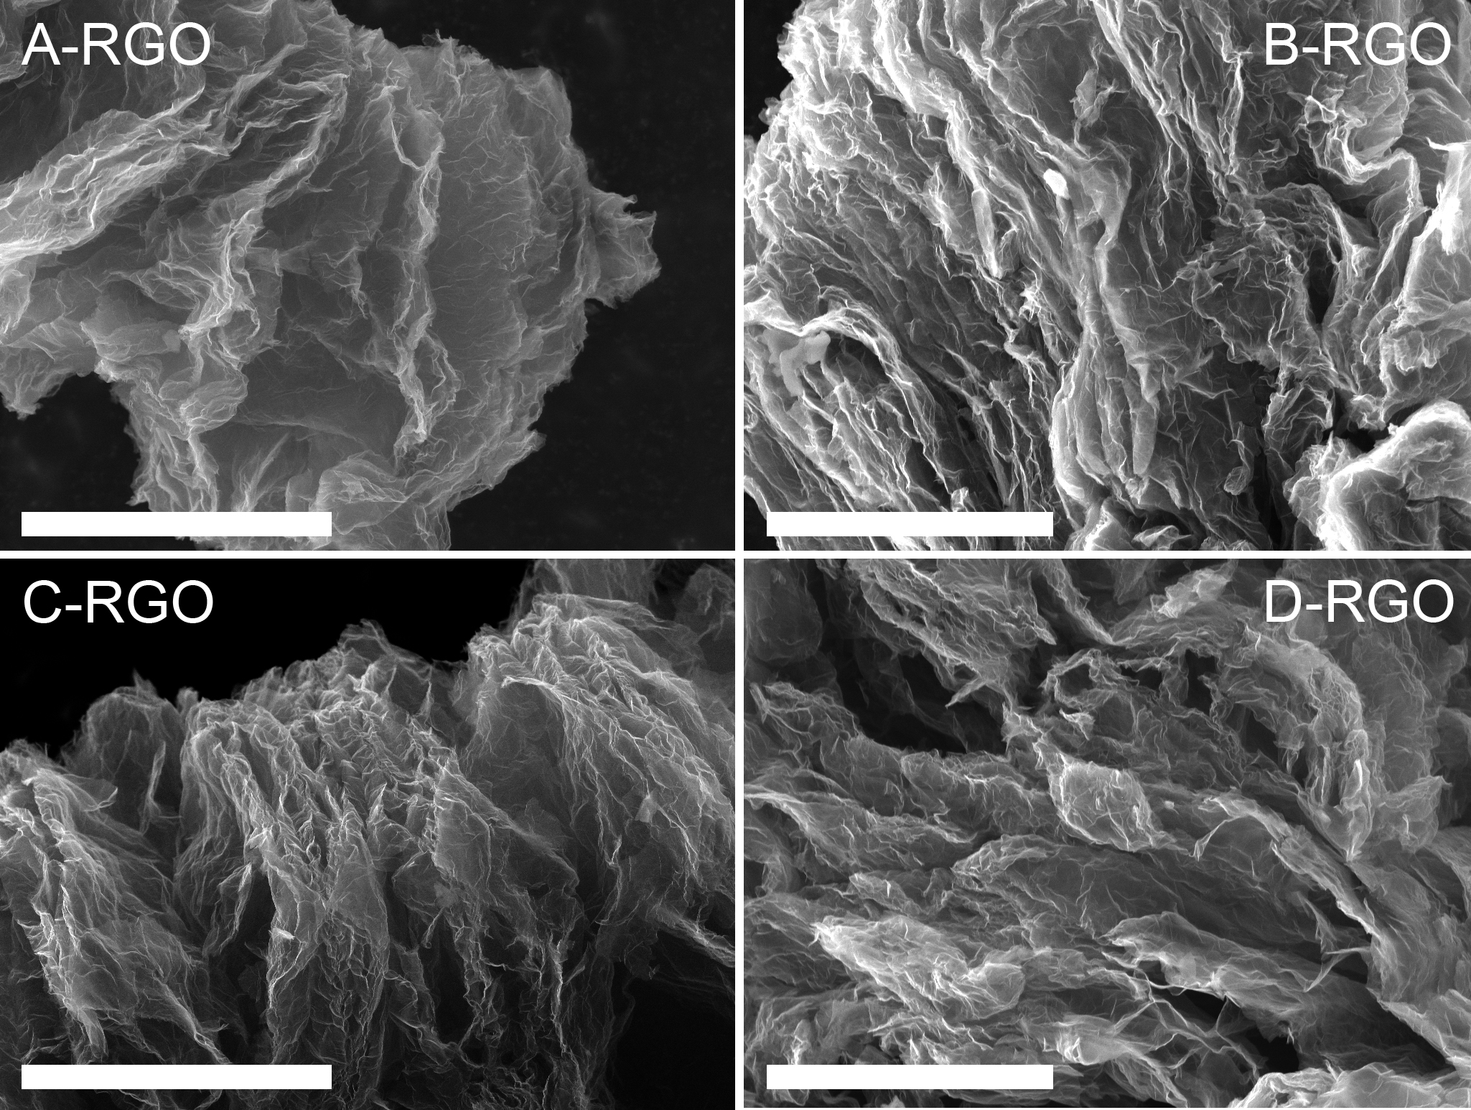
Figure S6 The SEM images of the defective RGO with different oxidation time for precursor, the scale bar is 10 μm.

*Corresponding author. E-mail: gaowsh13@lzu.edu.cn; xiekefeng@mail.lzjtu.cn

