Supplementary Material

Dispersal versus local recruitment −
the central role of seed banks for meta- populaton dynamics in an aquatic plant

Tomowski M., Lozada-Gobilard S., Jeltsch F., Tiedemann R.

Table of Contents:
Results
Genetic diversity measures and location information | Page 2
Heat maps of significant departures from Hardy-Weinberg-Equilibrium (HWE) | Page 3
Pairwise comparisons of diversity parameters  (extant vs. seed bank populations) | Page 3
Self-assignment based on GENECLASS2 analysis | Page4
Pairwise values of genetic divergence (Hedrick’s G’st, 2005) | Page 5-7
Isolation by distance (IBD) | Page 8
Generalized linear models (GLMs) for effects of habitat configuration  measures on genetic diversity (He, Ho,Ar, Fis) | Page 9-10
Methods
Details of primers used for microsatellite analyses | Page 10

Results
Table s1 Genetic diversity measures and location information. Sample size (n), observed and expected heterozygosity (Ho,He), allelic richness (Ar), mean number of alleles (n.all), and inbreeding coefficient (Fis) as well as multilocus linkage disequilibrium (rd) and effective population size (Ne; with 95% confidence limits) are listed for each cohorts sample of each population. Patch size (Area) and distance to nearest-neighbor patch (nN_dist) are given for each location.
.
Location  ID_{ZALF} | Label | Location ID | n | rd | p_rd | Cohort | n | Ar | Ho | He | Fis | Ne (C_{l}-C_{u}) | Area  [m²] | nN_dist  [m]
911 | P01_2019 | P01 | 9 | 0.038 | 1 | 2019 | 9 | 3.903 | 0.444 | 0.580 | 0.208 | 14.6 (5.6-172.8) | 1,876.86 | 156.00
814 | P02_2019 | P02 | 20 | -0.021 | 1 | 2019 | 20 | 4.567 | 0.631 | 0.702 | 0.115 | inf | 400.60 | 296.44
814 | P02_S1 | P02 | 7 | - | - | Soil1 | 7 | - | - | - | - | -
814 | P02_S2 | P02 | 21 | -0.003 | 1 | Soil2 | 21 | 4.509 | 0.607 | 0.675 | 0.079 | 201.7 (42.4-inf)
807 | P03_2019 | P03 | 20 | 0.022 | 0.526 | 2019 | 20 | 4.13 | 0.527 | 0.664 | 0.205 | 24.9 (15-52.6) | 2,401.11 | 138.73
807 | P03_S1 | P03 | 4 | - | - | Soil1 | 4 | - | - | - | - | -
807 | P03_S2 | P03 | 9 | -0.011 | 1 | Soil2 | 9 | 4.475 | 0.644 | 0.662 | 0.009 | inf
807 | P03_2016 | P03 | 25 | 0.029 | 0.03 | 2016 | 25 | 4.018 | 0.599 | 0.658 | 0.085 | 35.9 (20.4-93.6)
287 | P04_2019 | P04 | 20 | 0.006 | 1 | 2019 | 20 | 4.644 | 0.646 | 0.682 | 0.062 | inf | 3,942.56 | 182.57
287 | P04_S1 | P04 | 14 | -0.009 | 1 | Soil1 | 14 | 4.527 | 0.576 | 0.665 | 0.148 | 79.2 (20.3-inf)
287 | P04_S2 | P04 | 2 | - | - | Soil2 | 2 | - | - | - | - | -
260 | P05_2019 | P05 | 20 | 0.004 | 1 | 2019 | 20 | 4.141 | 0.596 | 0.667 | 0.102 | inf | 522.21 | 108.22
260 | P05_S1 | P05 | 7 | -0.037 | 1 | Soil1 | 7 | - | - | - | - | -
260 | P05_S2 | P05 | 10 | 0.06 | 0.045 | Soil2 | 10 | 4.248 | 0.589 | 0.677 | 0.087 | 13 (6.1-43.3)
1189 | P06_2019 | P06 | 15 | 0.026 | 0.832 | 2019 | 15 | 4.43 | 0.590 | 0.675 | 0.133 | 34.3 (16.4-252.3) | 1,849.69 | 216.47
1189 | P06_S1 | P06 | 1 | - | - | Soil1 | 1 | - | - | - | - | -
1189 | P06_S2 | P06 | 15 | 0.009 | 1 | Soil2 | 15 | 4.623 | 0.585 | 0.684 | 0.158 | inf
1189 | P06_2016 | P06 | 25 | 0.01 | 1 | 2016 | 25 | 4.314 | 0.644 | 0.651 | 0.018 | 61.8 (30.4-430.9)
2484 | P07_2019 | P07 | 18 | -0.001 | 1 | 2019 | 18 | 3.771 | 0.568 | 0.595 | 0.072 | 217.4 (36-inf) | 11,266.48 | 165.24
2489 | P08_2019 | P08 | 2 | - | - | 2019 | 2 | - | - | - | - | - | 1,341.99 | 272.73
599 | P09_2019 | P09 | 20 | 0.003 | 1 | 2019 | 20 | 4.299 | 0.608 | 0.615 | 0.004 | 117.3 (37.6-inf) | 1,169.28 | 76.66
599 | P09_S1 | P09 | 9 | 0.041 | 0.5 | Soil1 | 9 | 3.867 | 0.581 | 0.579 | -0.028 | 23.3 (7.5-inf)
599 | P09_S2 | P09 | 12 | 0.038 | 0.324 | Soil2 | 12 | 3.993 | 0.484 | 0.554 | 0.109 | 31.4 (11.1-inf)
1165 | P10_2019 | P10 | 20 | 0.004 | 1 | 2019 | 20 | 3.825 | 0.492 | 0.627 | 0.228 | inf | 3,755.79 | 461.10
2544 | P11_2019 | P11 | 20 | -0.017 | 1 | 2019 | 20 | 3.743 | 0.542 | 0.582 | 0.051 | inf | 756.33 | 111.99
2544 | P11_S1 | P11 | 11 | -0.002 | 1 | Soil1 | 11 | 3.643 | 0.545 | 0.575 | 0.045 | inf
2544 | P11_S2 | P11 | 10 | -0.008 | 1 | Soil2 | 10 | 4.822 | 0.532 | 0.634 | 0.118 | 59.6 (10-inf)
2547 | P12_2019 | P12 | 17 | 0.058 | 0.017 | 2019 | 17 | 3.392 | 0.430 | 0.570 | 0.279 | 20.5 (10.9-58.2) | 2,865.01 | 593.00
12 | P13_2019 | P13 | 20 | -0.008 | - | 2019 | 20 | 4.087 | 0.569 | 0.577 | 0.014 | inf | 9,000.60 | 201.36
12 | P13_S1 | P13 | 10 | -0.013 | 1 | Soil1 | 10 | 3.891 | 0.562 | 0.632 | 0.104 | inf
12 | P13_S2 | P13 | 8 | -0.044 | 1 | Soil2 | 8 | 5.846 | 0.490 | 0.598 | 0.152 | inf
13 | P14_2019 | P14 | 19 | -0.004 | 1 | 2019 | 19 | 4.169 | 0.563 | 0..612 | 0.058 | inf | 273.95 | 78.21
37 | P15_2019 | P15 | 20 | 0.035 | 0.085 | 2019 | 20 | 4.931 | 0.681 | 0.653 | -0.048 | 91 (27.5-inf) | 848.98 | 105.76
37 | P15_S1 | P15 | 5 | - | - | Soil1 | 5 | - | - | - | - | -
37 | P15_S2 | P15 | 16 | 0.009 | 1 | Soil2 | 16 | 4.58 | 0.635 | 0.651 | 0.016 | inf
36 | P16_2019 | P16 | 20 | -0.005 | 1 | 2019 | 20 | 3.937 | 0.554 | 0.599 | 0.075 | 84.0 (29.6-inf) | 2,315.28 | 93.37
1598 | P17_2019 | P17 | 17 | 0.033 | 0.221 | 2019 | 17 | 4.293 | 0.566 | 0.641 | 0.125 | 29.5 (16.7-78.7) | 2,905.34 | 116.2
1598 | P17_2016 | P17 | 19 | 0.043 | 0.01 | 2016 | 19 | 4.219 | 0.555 | 0.645 | 0.134 | 20.9 (13.3-38.3)
1598 | P17_S1 | P17 | 2 | - | - | Soil1 | 2 | - | - | - | - | -
1597 | P18_2019 | P18 | 20 | 0.014 | 1 | 2019 | 20 | 4.147 | 0.558 | 0.698 | 0.202 | 50.2 (24.3-393) | 743.10 | 152.08
1597 | P18_S2 | P18 | 19 | 0.024 | 1 | Soil2 | 19 | 4.16 | 0.611 | 0.664 | 0.068 | 31.2 (16.6-104)
1597 | P18_S1 | P18 | 2 | - | - | Soil1 | 2 | - | - | - | - | -

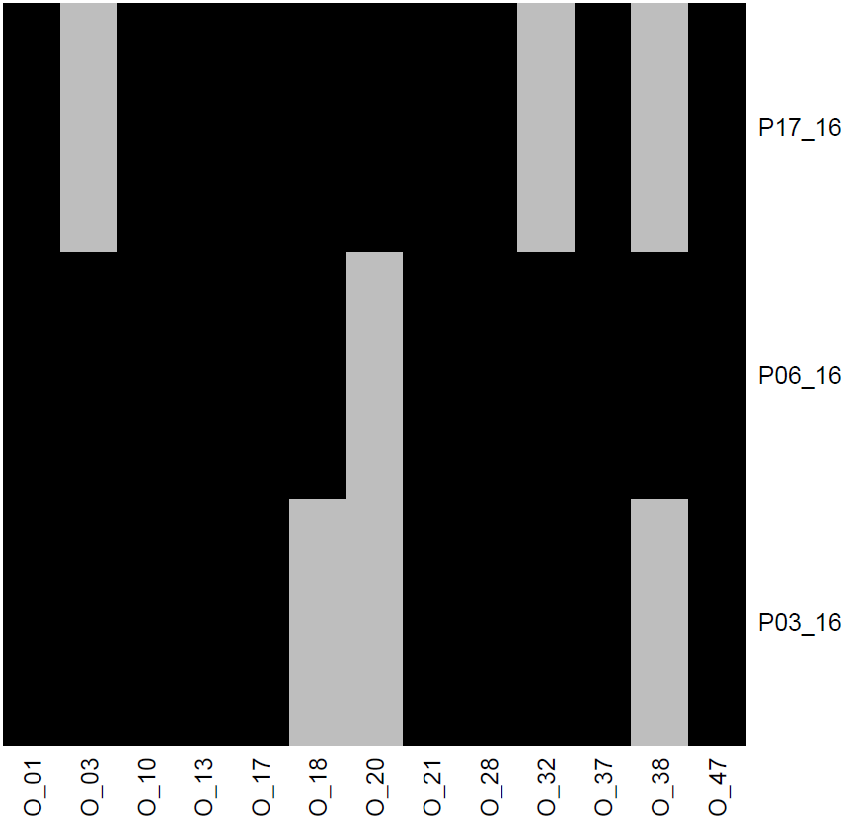
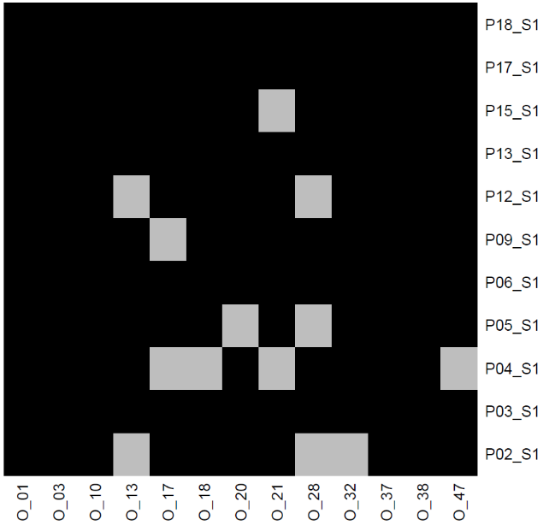
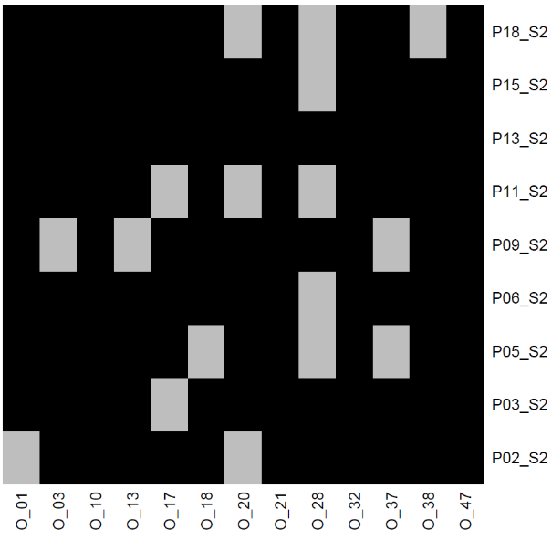
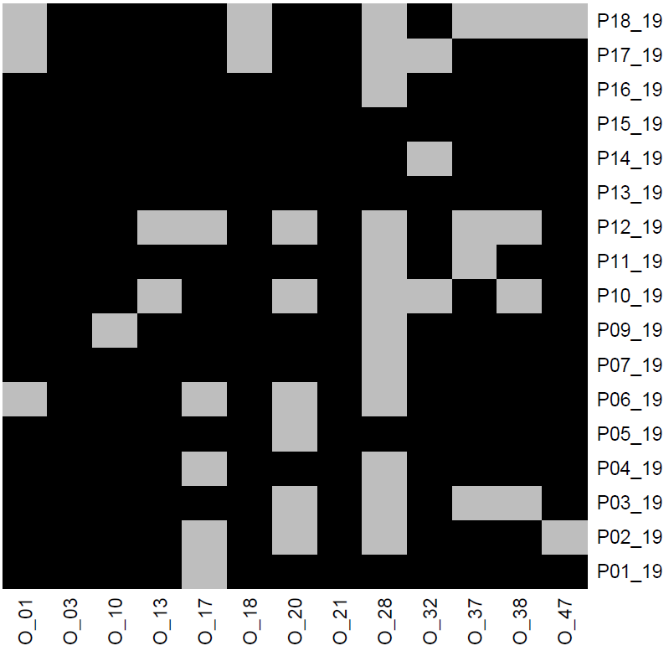
Figure s1 Heat maps showing significant departures from Hardy-Weinberg-Equilibrium (HWE) with single loci in columns and cohorts of local populations denoted as ‘19’ (2019), ‘16’ (2016), ’S1’ and ’S2’ in rows; grey indicates loci presumed of not being in HWE with p ≤ 0.05 in the indicated cohort.
Table s2 Results of the paired Wilcoxon test for the genetic diversity parameters expected heterozygosity (He), observed heterozygosity (Ho), allelic richness (Ar), and Inbreeding coefficient (Fis) among extant (cohort 2019) and soil (cohort Soil 2) populations of Oenanthe aquatica.
Wilcoxon paired
 | group1 | group2 | n1 | n2 | statistic | p | p signif
He
value | Cohort 2019 | Cohort S2 | 9 | 9 | 25 | 0.820 | ns
Ho
value | Cohort 2019 | Cohort S2 | 9 | 9 | 31 | 0.359 | ns
Ar
value | Cohort 2019 | Cohort S2 | 9 | 9 | 14 | 0.359 | ns
Fis
value | Cohort 2019 | Cohort S2 | 9 | 9 | 20 | 0.820 | ns

Table s3 Results of self-assignment test conducted in GENECLASS2. Shown are individuals with a high probability to belong to a population other than their sampling population.
Individual ID | Sampled Population | Reference Population
911_9 | P01 | P02
911_6 | P01 | P02
814_4u_6 | P02 | P05
814_4u_2 | P02 | P01
814_3_3o | P02 | P01
807_26 | P03 | P02
807_22 | P03 | P05
807_1_1o | P03 | P02
260_4o_2a | P05 | P02
260_3u_3 | P05 | P04
260_1_3u | P05 | P02
1189_9_3u | P06 | P02
2484_7 | P07 | P06
2484_3 | P07 | P06
2489_2 | P08 | P15
599_9 | P09 | P02
1165_29 | P10 | P06
1165_14 | P10 | P15
1165_11 | P10 | P15
2544_8 | P11 | P02
2544_4_4u | P11 | P01
2544_18 | P11 | P18
2544_16 | P11 | P02
2547_7 | P12 | P02
2547_3 | P12 | P02
12_7_4o | P13 | P18
12_4u_4 | P13 | P05
12_3_4u | P13 | P15
12_2 | P13 | P02
12_18 | P13 | P15
12_17 | P13 | P15
13_18 | P14 | P06
36_6 | P16 | P02
36_21 | P16 | P02
1598_1_4o | P17 | P18
1598_1_2o | P17 | P02
1597_3 | P18 | P17
1597_2_3u | P18 | P04
1597_15 | P18 | P17
1597_1_3u | P18 | P02

Table s4 Pairwise values of genetic divergence (Hedrick’s G’st, 2005) as well as upper and lower confidence limits calculated among single populations (pooled across cohorts). ‘BC’ is indicative for bias corrected estimates.
comparison |  |  | Mean G’st | BC  Mean G’st | Lower  95%CI | Upper  95%CI | BC Lower  95%CI | BC Upper 95%CI
P01 | vs. | P02 | 0.3509 | 0.2989 | 0.2706 | 0.4385 | 0.2186 | 0.3864
P01 | vs. | P03 | 0.4291 | 0.3869 | 0.358 | 0.5106 | 0.3158 | 0.4684
P01 | vs. | P04 | 0.4702 | 0.4268 | 0.3788 | 0.5566 | 0.3354 | 0.5132
P01 | vs. | P05 | 0.4065 | 0.3555 | 0.3171 | 0.5124 | 0.2661 | 0.4614
P01 | vs. | P06 | 0.2882 | 0.2359 | 0.2136 | 0.3784 | 0.1613 | 0.3261
P01 | vs. | P07 | 0.4188 | 0.3668 | 0.3359 | 0.5147 | 0.2839 | 0.4627
P01 | vs. | P09 | 0.4925 | 0.4604 | 0.4004 | 0.599 | 0.3683 | 0.567
P01 | vs. | P10 | 0.3551 | 0.296 | 0.2671 | 0.4524 | 0.208 | 0.3933
P01 | vs. | P11 | 0.3709 | 0.3238 | 0.3032 | 0.456 | 0.2561 | 0.4089
P01 | vs. | P12 | 0.4759 | 0.4284 | 0.398 | 0.5679 | 0.3505 | 0.5204
P01 | vs. | P13 | 0.4168 | 0.3744 | 0.3311 | 0.5106 | 0.2887 | 0.4682
P01 | vs. | P14 | 0.5321 | 0.4901 | 0.4543 | 0.623 | 0.4123 | 0.5811
P01 | vs. | P15 | 0.455 | 0.4148 | 0.3661 | 0.5497 | 0.3259 | 0.5095
P01 | vs. | P16 | 0.5132 | 0.4711 | 0.4349 | 0.6086 | 0.3927 | 0.5664
P01 | vs. | P17 | 0.2982 | 0.241 | 0.2329 | 0.3823 | 0.1757 | 0.325
P01 | vs. | P18 | 0.4012 | 0.3518 | 0.3012 | 0.5105 | 0.2518 | 0.4612
P02 | vs. | P03 | 0.1856 | 0.1595 | 0.1488 | 0.2216 | 0.1227 | 0.1955
P02 | vs. | P04 | 0.2014 | 0.1697 | 0.1627 | 0.2428 | 0.131 | 0.2111
P02 | vs. | P05 | 0.262 | 0.2302 | 0.2073 | 0.3176 | 0.1755 | 0.2858
P02 | vs. | P06 | 0.1956 | 0.1725 | 0.1552 | 0.2393 | 0.132 | 0.2162
P02 | vs. | P07 | 0.3319 | 0.3014 | 0.2692 | 0.3925 | 0.2388 | 0.362
P02 | vs. | P09 | 0.3388 | 0.3197 | 0.2893 | 0.3865 | 0.2702 | 0.3674
P02 | vs. | P10 | 0.2846 | 0.2484 | 0.2234 | 0.3535 | 0.1872 | 0.3173
P02 | vs. | P11 | 0.3207 | 0.2993 | 0.2708 | 0.3756 | 0.2494 | 0.3542
P02 | vs. | P12 | 0.4183 | 0.391 | 0.3403 | 0.4955 | 0.313 | 0.4682
P02 | vs. | P13 | 0.3709 | 0.3507 | 0.3096 | 0.4326 | 0.2893 | 0.4124
P02 | vs. | P14 | 0.3813 | 0.352 | 0.3198 | 0.45 | 0.2904 | 0.4206
P02 | vs. | P15 | 0.3505 | 0.3288 | 0.2924 | 0.4154 | 0.2707 | 0.3937
P02 | vs. | P16 | 0.3237 | 0.2932 | 0.2672 | 0.385 | 0.2367 | 0.3546
P02 | vs. | P17 | 0.3462 | 0.3234 | 0.2966 | 0.3995 | 0.2738 | 0.3768
P02 | vs. | P18 | 0.2623 | 0.2344 | 0.2111 | 0.3187 | 0.1832 | 0.2908
P03 | vs. | P04 | 0.2625 | 0.2365 | 0.2223 | 0.3121 | 0.1962 | 0.286
P03 | vs. | P05 | 0.2936 | 0.2661 | 0.2398 | 0.3481 | 0.2122 | 0.3206
P03 | vs. | P06 | 0.2358 | 0.2159 | 0.1942 | 0.2808 | 0.1743 | 0.2609
P03 | vs. | P07 | 0.3866 | 0.3608 | 0.3301 | 0.446 | 0.3043 | 0.4201
P03 | vs. | P09 | 0.2994 | 0.2824 | 0.2601 | 0.347 | 0.243 | 0.33
P03 | vs. | P10 | 0.3191 | 0.2873 | 0.2554 | 0.3875 | 0.2235 | 0.3556
P03 | vs. | P11 | 0.4068 | 0.3888 | 0.3584 | 0.4542 | 0.3405 | 0.4363
P03 | vs. | P12 | 0.3938 | 0.365 | 0.3275 | 0.4641 | 0.2987 | 0.4353
P03 | vs. | P13 | 0.3325 | 0.3122 | 0.2834 | 0.3857 | 0.2631 | 0.3654
P03 | vs. | P14 | 0.3748 | 0.3467 | 0.33 | 0.4225 | 0.3019 | 0.3945
P03 | vs. | P15 | 0.3419 | 0.3229 | 0.2902 | 0.3956 | 0.2711 | 0.3765
P03 | vs. | P16 | 0.3227 | 0.296 | 0.2678 | 0.3858 | 0.2412 | 0.3591
P03 | vs. | P17 | 0.4084 | 0.3911 | 0.3601 | 0.4614 | 0.3428 | 0.4441
P03 | vs. | P18 | 0.3175 | 0.2945 | 0.2703 | 0.3685 | 0.2473 | 0.3455
P04 | vs. | P05 | 0.353 | 0.3239 | 0.2999 | 0.4101 | 0.2709 | 0.381
P04 | vs. | P06 | 0.3359 | 0.3145 | 0.2922 | 0.3829 | 0.2709 | 0.3615
P04 | vs. | P07 | 0.4001 | 0.3701 | 0.3361 | 0.4695 | 0.3061 | 0.4395
P04 | vs. | P09 | 0.4031 | 0.3846 | 0.3588 | 0.45 | 0.3403 | 0.4315
P04 | vs. | P10 | 0.3348 | 0.2996 | 0.2731 | 0.4031 | 0.2379 | 0.3678
P04 | vs. | P11 | 0.3836 | 0.3624 | 0.3389 | 0.4371 | 0.3177 | 0.4158
P04 | vs. | P12 | 0.4317 | 0.4015 | 0.3636 | 0.5037 | 0.3334 | 0.4735
P04 | vs. | P13 | 0.4325 | 0.4129 | 0.3806 | 0.4901 | 0.361 | 0.4704
P04 | vs. | P14 | 0.4473 | 0.4189 | 0.3837 | 0.5114 | 0.3553 | 0.4831
P04 | vs. | P15 | 0.3957 | 0.373 | 0.3431 | 0.4503 | 0.3204 | 0.4277
P04 | vs. | P16 | 0.3776 | 0.3476 | 0.3205 | 0.4365 | 0.2905 | 0.4065
comparison |  |  | Mean G’st | BC  Mean G’st | Lower  95%CI | Upper  95%CI | BC Lower  95%CI | BC Upper 95%CI
P04 | vs. | P17 | 0.3976 | 0.3754 | 0.3439 | 0.4538 | 0.3217 | 0.4316
P04 | vs. | P18 | 0.3518 | 0.3267 | 0.2991 | 0.4041 | 0.274 | 0.3791
P05 | vs. | P06 | 0.2916 | 0.2652 | 0.2475 | 0.3416 | 0.221 | 0.3151
P05 | vs. | P07 | 0.4591 | 0.4287 | 0.4053 | 0.5185 | 0.3749 | 0.4881
P05 | vs. | P09 | 0.3769 | 0.3542 | 0.3243 | 0.4265 | 0.3016 | 0.4038
P05 | vs. | P10 | 0.3187 | 0.2799 | 0.2637 | 0.382 | 0.225 | 0.3433
P05 | vs. | P11 | 0.3728 | 0.348 | 0.3263 | 0.4212 | 0.3015 | 0.3963
P05 | vs. | P12 | 0.4104 | 0.3775 | 0.3497 | 0.4755 | 0.3169 | 0.4427
P05 | vs. | P13 | 0.3009 | 0.2737 | 0.2484 | 0.3583 | 0.2211 | 0.3311
P05 | vs. | P14 | 0.2994 | 0.2605 | 0.2465 | 0.3616 | 0.2076 | 0.3227
P05 | vs. | P15 | 0.3221 | 0.2934 | 0.275 | 0.3741 | 0.2464 | 0.3454
P05 | vs. | P16 | 0.3111 | 0.2761 | 0.2626 | 0.3644 | 0.2276 | 0.3294
P05 | vs. | P17 | 0.3517 | 0.3247 | 0.2997 | 0.4062 | 0.2726 | 0.3791
P05 | vs. | P18 | 0.2732 | 0.2405 | 0.2245 | 0.3227 | 0.1918 | 0.2901
P06 | vs. | P07 | 0.2501 | 0.2187 | 0.2016 | 0.3048 | 0.1702 | 0.2733
P06 | vs. | P09 | 0.3856 | 0.3726 | 0.3351 | 0.4426 | 0.3221 | 0.4297
P06 | vs. | P10 | 0.2757 | 0.2431 | 0.2184 | 0.3373 | 0.1859 | 0.3048
P06 | vs. | P11 | 0.312 | 0.2936 | 0.2678 | 0.3567 | 0.2494 | 0.3383
P06 | vs. | P12 | 0.3348 | 0.305 | 0.2791 | 0.3942 | 0.2493 | 0.3644
P06 | vs. | P13 | 0.3572 | 0.3392 | 0.311 | 0.403 | 0.293 | 0.385
P06 | vs. | P14 | 0.3429 | 0.3153 | 0.29 | 0.3987 | 0.2624 | 0.3712
P06 | vs. | P15 | 0.3623 | 0.3436 | 0.3109 | 0.4134 | 0.2922 | 0.3947
P06 | vs. | P16 | 0.3847 | 0.3623 | 0.3195 | 0.4471 | 0.2971 | 0.4247
P06 | vs. | P17 | 0.2635 | 0.2404 | 0.2249 | 0.3084 | 0.2018 | 0.2852
P06 | vs. | P18 | 0.2901 | 0.2663 | 0.2453 | 0.3399 | 0.2216 | 0.3162
P07 | vs. | P09 | 0.4388 | 0.4185 | 0.3827 | 0.4986 | 0.3624 | 0.4783
P07 | vs. | P10 | 0.3278 | 0.2858 | 0.2687 | 0.391 | 0.2268 | 0.349
P07 | vs. | P11 | 0.36 | 0.331 | 0.2917 | 0.4267 | 0.2627 | 0.3977
P07 | vs. | P12 | 0.3619 | 0.3204 | 0.2697 | 0.4515 | 0.2283 | 0.41
P07 | vs. | P13 | 0.439 | 0.4132 | 0.3852 | 0.4976 | 0.3594 | 0.4718
P07 | vs. | P14 | 0.454 | 0.421 | 0.4046 | 0.5054 | 0.3716 | 0.4725
P07 | vs. | P15 | 0.4657 | 0.4401 | 0.413 | 0.5228 | 0.3874 | 0.4972
P07 | vs. | P16 | 0.5675 | 0.5446 | 0.5016 | 0.6341 | 0.4787 | 0.6113
P07 | vs. | P17 | 0.4238 | 0.3964 | 0.377 | 0.4804 | 0.3496 | 0.453
P07 | vs. | P18 | 0.3466 | 0.3128 | 0.2894 | 0.4079 | 0.2556 | 0.374
P09 | vs. | P10 | 0.3905 | 0.3665 | 0.3404 | 0.4475 | 0.3163 | 0.4235
P09 | vs. | P11 | 0.3977 | 0.3831 | 0.3508 | 0.445 | 0.3362 | 0.4304
P09 | vs. | P12 | 0.4004 | 0.3749 | 0.3488 | 0.4621 | 0.3234 | 0.4367
P09 | vs. | P13 | 0.3205 | 0.3024 | 0.2778 | 0.3688 | 0.2597 | 0.3507
P09 | vs. | P14 | 0.395 | 0.3696 | 0.3425 | 0.4514 | 0.317 | 0.426
P09 | vs. | P15 | 0.3703 | 0.3516 | 0.3249 | 0.4216 | 0.3061 | 0.4028
P09 | vs. | P16 | 0.4295 | 0.4097 | 0.3592 | 0.4983 | 0.3394 | 0.4785
P09 | vs. | P17 | 0.4795 | 0.4652 | 0.4355 | 0.5261 | 0.4212 | 0.5118
P09 | vs. | P18 | 0.3918 | 0.374 | 0.3445 | 0.4426 | 0.3268 | 0.4248
P10 | vs. | P11 | 0.3642 | 0.3349 | 0.3079 | 0.4246 | 0.2786 | 0.3953
P10 | vs. | P12 | 0.319 | 0.2768 | 0.2446 | 0.402 | 0.2024 | 0.3598
P10 | vs. | P13 | 0.2384 | 0.2027 | 0.1765 | 0.3228 | 0.1408 | 0.2871
P10 | vs. | P14 | 0.3037 | 0.2609 | 0.2334 | 0.3923 | 0.1906 | 0.3495
P10 | vs. | P15 | 0.3311 | 0.2988 | 0.2592 | 0.4147 | 0.2269 | 0.3824
P10 | vs. | P16 | 0.3312 | 0.2916 | 0.2586 | 0.4121 | 0.219 | 0.3725
P10 | vs. | P17 | 0.3686 | 0.3363 | 0.3098 | 0.438 | 0.2776 | 0.4057
P10 | vs. | P18 | 0.2659 | 0.2265 | 0.2117 | 0.3309 | 0.1722 | 0.2914
P11 | vs. | P12 | 0.3266 | 0.2955 | 0.2727 | 0.3879 | 0.2416 | 0.3568
P11 | vs. | P13 | 0.415 | 0.398 | 0.3669 | 0.4585 | 0.3498 | 0.4414
P11 | vs. | P14 | 0.4633 | 0.4402 | 0.4159 | 0.5122 | 0.3928 | 0.4891
P11 | vs. | P15 | 0.4496 | 0.4323 | 0.4032 | 0.4946 | 0.3859 | 0.4773
P11 | vs. | P16 | 0.5194 | 0.5012 | 0.4603 | 0.5764 | 0.442 | 0.5581
P11 | vs. | P17 | 0.4374 | 0.4192 | 0.3862 | 0.4844 | 0.368 | 0.4662
P11 | vs. | P18 | 0.3607 | 0.3394 | 0.3139 | 0.4036 | 0.2925 | 0.3823
P12 | vs. | P13 | 0.2487 | 0.2123 | 0.1958 | 0.3081 | 0.1595 | 0.2717
comparison |  |  | Mean G’st | BC  Mean G’st | Lower  95%CI | Upper  95%CI | BC Lower  95%CI | BC Upper 95%CI
P12 | vs. | P14 | 0.308 | 0.2664 | 0.2443 | 0.3794 | 0.2027 | 0.3379
P12 | vs. | P15 | 0.3673 | 0.3357 | 0.3089 | 0.4286 | 0.2773 | 0.397
P12 | vs. | P16 | 0.5128 | 0.4876 | 0.4245 | 0.5977 | 0.3993 | 0.5724
P12 | vs. | P17 | 0.4753 | 0.4494 | 0.4098 | 0.5451 | 0.3838 | 0.5192
P12 | vs. | P18 | 0.3819 | 0.3507 | 0.3161 | 0.4478 | 0.2849 | 0.4167
P13 | vs. | P14 | 0.1661 | 0.1291 | 0.1226 | 0.2205 | 0.0856 | 0.1835
P13 | vs. | P15 | 0.2185 | 0.1936 | 0.1719 | 0.2656 | 0.1469 | 0.2406
P13 | vs. | P16 | 0.3378 | 0.3126 | 0.2714 | 0.4103 | 0.2462 | 0.3852
P13 | vs. | P17 | 0.3771 | 0.3575 | 0.3363 | 0.4259 | 0.3167 | 0.4063
P13 | vs. | P18 | 0.2578 | 0.2332 | 0.2038 | 0.3156 | 0.1791 | 0.291
P14 | vs. | P15 | 0.256 | 0.2201 | 0.2036 | 0.3183 | 0.1676 | 0.2824
P14 | vs. | P16 | 0.2659 | 0.2251 | 0.2055 | 0.3368 | 0.1647 | 0.296
P14 | vs. | P17 | 0.3895 | 0.3605 | 0.3235 | 0.4608 | 0.2946 | 0.4318
P14 | vs. | P18 | 0.2945 | 0.2604 | 0.2347 | 0.3652 | 0.2006 | 0.3311
P15 | vs. | P16 | 0.3686 | 0.3428 | 0.3079 | 0.4379 | 0.282 | 0.4121
P15 | vs. | P17 | 0.3297 | 0.3069 | 0.2816 | 0.3854 | 0.2588 | 0.3625
P15 | vs. | P18 | 0.2865 | 0.26 | 0.2311 | 0.344 | 0.2046 | 0.3175
P16 | vs. | P17 | 0.3811 | 0.3551 | 0.3217 | 0.4514 | 0.2957 | 0.4254
P16 | vs. | P18 | 0.3319 | 0.3031 | 0.266 | 0.402 | 0.2372 | 0.3732
P17 | vs. | P18 | 0.2627 | 0.2339 | 0.2101 | 0.3195 | 0.1813 | 0.2907

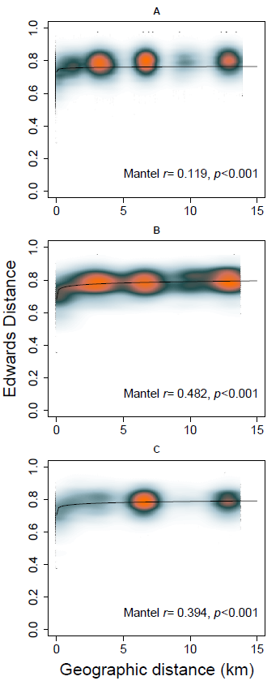
Figure s2 Isolation by distance (IBD) plots for cohort 2019 (A), S1 (B), and S2 (C) illustrate relationships between Edwards’ individual genetic distances and geographic distances among sampling sites. Colors represent the relative density of points with warmer colors indicating higher densities. The regression line and the Mantel coefficient (r) of correlation between geographic and genetic distances as well as the associated p‐value are shown for each cohort.
Table s5 Generalized linear models (GLMs) that fit the variation in expected and observed heterozygosity (He, Ho), inbreeding coefficient (Fis) and allelic richness (Ar) in cohorts 2019 and Soil 2 across populations. The explanatory variables nearest neighbor distance and kettle hole area were z-transformed. Shown are the full models as well as significant reduced models revealed by stepwise backward selection.
He 2019
 | Estimate | Std. Error | t value | p
(Intercept) | 0.641246 | 0.01091 | 58.776 | <2e-16 | ***
Area | -0.016133 | 0.009602 | -1.68 | 0.1168
Nearest Neighbor distance | -0.001741 | 0.007999 | -0.218 | 0.831
Area:Nearest Neighbor distance | -0.042938 | 0.023662 | -1.815 | 0.0927 | .
Residual deviance: 0.021261 on 13 degrees of freedom
He Soil2
 | Estimate | Std. Error | t value | p
(Intercept) | 0.63631 | 0.0192 | 33.149 | 4.70E-07 | ***
Area | -0.04103 | 0.03303 | -1.242 | 0.269
Nearest Neighbor distance | 0.08018 | 0.0753 | 1.065 | 0.336
Area:Nearest Neighbor distance | 0.06946 | 0.11157 | 0.623 | 0.561
Residual deviance: 0.0080105 on 5 degrees of freedom
Ar 2019
 | Estimate | Std. Error | t value | p
(Intercept) | 4.20625 | 0.09371 | 44.886 | 1.21E-15 | ***
Area | -0.08266 | 0.08247 | -1.002 | 0.334
Nearest Neighbor distance | -0.11195 | 0.0687 | -1.629 | 0.127
Area:Nearest Neighbor distance | -0.21004 | 0.20324 | -1.033 | 0.32
Residual deviance: 1.5686 on
13 degrees of freedom
Ar Soil2
 | Estimate | Std. Error | t value | p
(Intercept) | 4.6223 | 0.1406 | 32.883 | 4.89E-07 | ***
Area | 0.2619 | 0.2419 | 1.083 | 0.328
Nearest Neighbor distance | 0.645 | 0.5514 | 1.17 | 0.295
Area:Nearest Neighbor distance | 0.7797 | 0.817 | 0.954 | 0.384
Residual deviance: 0.42958 on
5 degrees of freedom
Fis 2019
 | Estimate | Std. Error | t value | p
(Intercept) | 0.10874 | 0.01946 | 5.589 | 8.79E-05 | ***
Area | -0.01685 | 0.01712 | -0.984 | 0.34303
Nearest Neighbor distance | 0.04748 | 0.01426 | 3.329 | 0.00544 | **
Area:Nearest Neighbor distance | -0.02574 | 0.0422 | -0.61 | 0.55235
Residual deviance: 0.067613 on 13 degrees of freedom
Fis 2019
 | Estimate | Std. Error | t value | p
(Intercept) | 0.10332 | 0.01725 | 5.991 | 2.47E-05 | ***
Nearest Neighbor distance | 0.04464 | 0.01372 | 3.252 | 0.00536 | **
Residual deviance: 0.074467 on 15 degrees of freedom
Fis Soil2
 | Estimate | Std. Error | t value | p
(Intercept) | 0.06976 | 0.02292 | 3.043 | 0.0287 | *
Area | -0.03728 | 0.03944 | -0.945 | 0.388
Nearest Neighbor distance | 0.15729 | 0.08993 | 1.749 | 1.41E-01
Area:Nearest Neighbor distance | 0.21999 | 0.13324 | 1.651 | 0.1596
Residual deviance: 0.011424 on
5 degrees of freedom
Ho 2019
 | Estimate | Std. Error | t value | p
(Intercept) | 0.572884 | 0.016285 | 35.178 | 2.81E-14 | ***
Area | -0.001061 | 0.014332 | -0.074 | 0.9421
Nearest Neighbor distance | -0.024991 | 0.01194 | -2.093 | 0.0565 | .
Area:Nearest Neighbor distance | -0.030108 | 0.03532 | -0.852 | 4.09E-01
Residual deviance: 0.047374 on 13 degrees of freedom
Ho 2019
 | Estimate | Std. Error | t value | p
(Intercept) | 0.56703 | 0.01414 | 40.111 | <2e-16 | ***
Nearest Neighbor distance | -0.02602 | 0.01125 | -2.313 | 0.0353 | *
Residual deviance: 0.050034 on 15 degrees of freedom
Ho Soil2
 | Estimate | Std. Error | t value | p
(Intercept) | 0.581965 | 0.029201 | 19.93 | 5.88E-06 | ***
Area | -0.009825 | 0.050246 | -0.196 | 0.853
Nearest Neighbor distance | -0.032595 | 0.114551 | -0.285 | 0.787
Area:Nearest Neighbor distance | -0.090943 | 0.169721 | -0.536 | 0.615
Residual deviance: 0.018538 on 5 degrees of freedom

Methods
Table s6 Details of primers used for microsatellite analyses of Oenanthe aquatica. Name, primer sequence, repeat motif, accession number, annealing temperature (T_{m}) and Dye used for multiplexing are given.
Locus name | Primer sequences (5′–3′) | Repeat motif | T_{m} (°C) | Dye | Accession no.
O_01 | F: AGTCGCAAGTTAAAGGGAAGC | (AGC)₆ | 54 | NED | KJ946205
O_01 | R: GGAGCATACTCTTGGGAGAGG
O_03 | F: AATGTCATTCATCCCACCAC | (TTG)₇ | 50 | VIC | KJ946207
O_03 | R: TGGGTTCCATGCAAAATTATC
O_10 | F: ACATCGATCTGGGCTGGTAA | (CA)₁₁ | 50 | 6-FAM | KJ946208
O_10 | R: ATTTAATTCAAGGCGTTGCG
O_13 | F: ACACAAGATTTATAATCTGGCAAA | (AC)₁₁ | 53 | NED | KJ946209
O_13 | R: GCAATGACATAGTCCAAGCTG
O_17 | F:ATCTCAGTGTTATGTGCTGTGTAGA | (TC)₁₂ | 52 | VIC | KJ946210
O_17 | R:TCACCGGGCGTTGAATAATA
O_18 | F: TACACGAAAGCGACGGTGAT | (AG)₁₂ | 52 | VIC | KJ946211
O_18 | R: CATCAGGGTCCGATATGACA
O_20 | F: TTACCGTATTGTTAATTTTACCGGAG | (TC)₁₂ | 52 | NED | KJ946212
O_20 | R:TTGCTCGAATTCCAACATAAA
O_21 | F: CACCCAACAAGAAACAGTACTATAAA | (AC)₁₂ | 52 | PET | KJ946213
O_21 | R: TCAAAGCATTCTTGGCCTTC
O_28 | F: GCACTGTCCCGGTAAGTCTG | (GT)₁₃ | 59 | 6-FAM | KJ946215
O_28 | R: AAGTTTGACTGATAAGGTTTCCA
O_32 | F: AGAAAACGGGGACGAAGAAG | (TG)₁₃ | 59 | 6-FAM | KJ946216
O_32 | R: CACCAAGAAGCGACTCCACT
O_37 | F: TCGATAGCCACAAGAGCAAA | (GA)₁₅ | 53 | PET | KJ946218
O_37 | R: TTACAATCATGGCTTCGTGA
O_38 | F: CAATCCAACACTCTCATTTTCC | (AC)₁₅ | 52 | NED | KJ946219
O_38 | R: TCCTAAGCAAAGTCATCAATGC
O_47 | F: CCATCGATAGCATCCAGGTA | (TG)₁₈ | 53 | PET | KJ946220
O_47 | R: AATAGTAATTAGGAATCTCACGCAC

