A Simple and Economic Limewater-based Conversion of Spirostanol Saponins: Using Paridis Rhizoma as a case study
Lizhen Yu^{1,†}, Fengjiao Bu^{2,†}, Xuebin Shen¹, Ying Xiong¹, Yong Fan³, Limin Liu^{4,*}, Sihui Nian^{1,*}

¹ School of pharmacy, Wannan Medicinal College, Wuhu 241002, China; yulizhen2006@163.com (L.-Z. Y.); sxbchn@163.com (X.-B. S.); xiongy158@sina.com (Y. X.)
² Department of Pharmacy, Eye&ENT Hospital, Fudan University, Shanghai 200031, China; bufengjiao123@126.com (F.-J. B.)
³ Novo Nordisk Foundation Center for Basic Metabolic Research, Faculty of Health and Medical Sciences, University of Copenhagen, Blegdamsvej 3B, 2200 Copenhagen, Denmark; yong.fan@sund.ku.dk (Y. F.)
⁴ Anhui College of Traditional Chinese Medicine, Wuhu 241000, China
Conflict of interest/Disclosure: All the authors declare no conflict of interest.

† Contributed equally in this study.
* Correspondence: liulm2005@163.com (L.-M. L.); niansihui@126.com ( S.-H. N.),Tel.: +86-553-3932129 (S.-H.N.); Fax: +86-553-3932622 (S.-H. N.)

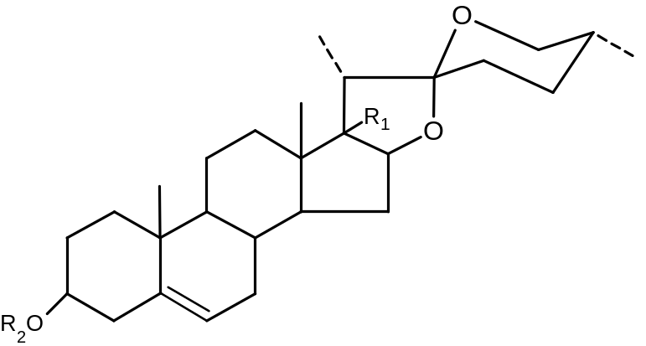
PolyphyllinⅦ R₁=OH R₂=Rha(1→4)-Rha(1→4)[Rha(1→2)]- Glc-
PolyphyllinⅡ R₁=H R₂=Rha(1→4)-Rha(1→4)[Rha(1→2)]- Glc-
Gracillin R₁=H R₂=Rha(1→2)-[Glc(1→3)]- Glc-
Dioscin R₁=H R₂=Rha(1→4)-[Rha(1→2)]- Glc-
PolyphyllinⅠ R₁=H R₂=Rha(1→2)-[Ara(1→4)]- Glc-
Figure S1 Chemical structures of five analytes

Table S1 The investigation of processing concentration of limewater based on contents of saponins (mg/g, n=3)
concentration | Content
concentration | Polyphyllin VII | Polyphyllin II | Dioscin | Gracillin | Polyphyllin I | TSS
Water | 0.92 ± 0.42 | 3.08 ± 0.57 | 1.04 ± 0.12 | 9.95 ± 2.52 | 9.84 ± 1.00 | 24.81 ± 0.40
Clear | 0.73 ± 0.25 | 2.97 ± 0.37 | 0.99 ± 0.15 | 9.63 ± 0.57 | 10.92 ± 0.14 | 25.23 ± 0.82
0.1% | 1.17 ± 0.43 | 4.39 ± 0.43 | 1.37 ± 0.13 | 16.79 ± 2.04 | 15.01 ± 1.25 | 38.74 ± 0.66
0.5% | 0.84 ± 0.12 | 2.63 ± 0.52 | 0.85 ± 0.22 | 10.15 ± 0.29 | 09.60 ± 2.32 | 24.06 ± 2.43
1.0% | 0.94 ± 0.09 | 2.87 ± 0.34 | 1.13 ± 0.23 | 11.94 ± 2.35 | 11.15 ± 1.45 | 28.02 ± 0.88

Table S2 The investigation of processing time of 0.1% limewater based on contents of saponins (mg/g, n=3)
program | Content
program | Polyphyllin VII | Polyphyllin II | Dioscin | Gracillin | Polyphyllin I | TSS
6h | 1.06± 0.46 | 3.33 ± 0.93 | 1.21 ± 0.03 | 9.10 ± 3.26 | 12.91 ± 2.66 | 27.61 ± 0.76
12h | 1.17 ± 0.02 | 3.13 ± 0.15 | 0.88 ± 0.21 | 13.27 ± 1.88 | 10.29 ± 0.88 | 28.74 ± 2.72
24h | 1.17 ± 0.43 | 4.39 ± 0.43 | 1.37 ± 0.13 | 16.79 ± 2.04 | 15.01 ± 1.25 | 38.74 ± 0.66
48h | 0.86 ± 0.23 | 4.11 ± 0.57 | 1.09 ± 0.09 | 10.47 ± 1.47 | 13.69 ± 1.27 | 30.23 ± 3.18

Figure S2 Response surface plots for the effects of: (a) limewater concentration/time (b) solvent volume/time (c) solvent volume/ limewater concentration on the yield of TSS.

